

**American International University- Bangladesh**

**CSC 2209: Object Oriented Programming 1 (JAVA)**

**CO1 Evaluation**

**Project Summary Report**

**Summer 18-19**

**Group No: 03**

**Project Title: Library Management System**

|  |  |
| --- | --- |
| Student Name | Student Id |
| DEWAN SAIFUL ISLAM | **18-37623-1** |
| HAMIM FAIEQ | **18-36153-1** |
| RASHID ROWNAK AL | **18-37645-1** |
| SHADMAN SHAKIB ADITTO | **18-38937-3** |

**Introduction:**

The name of our project is Library Management System, where we are dealing with a system regarding books. We are doing this project as it has a great importance in educational institutions. So, from the sake of learning and earning knowledge from books as well as for nowadays demand, we are greatly emphasized to do this project.

**User Category:**

There are two types of Users here. They are:

* Librarian.
* User.

**Feature List:**

In this project the “Librarian” has the following features:

* id
* name
* password

In this project the “User” has the following features:

* id
* name
* financial
* book1
* book2
* password

**GUI Description:**

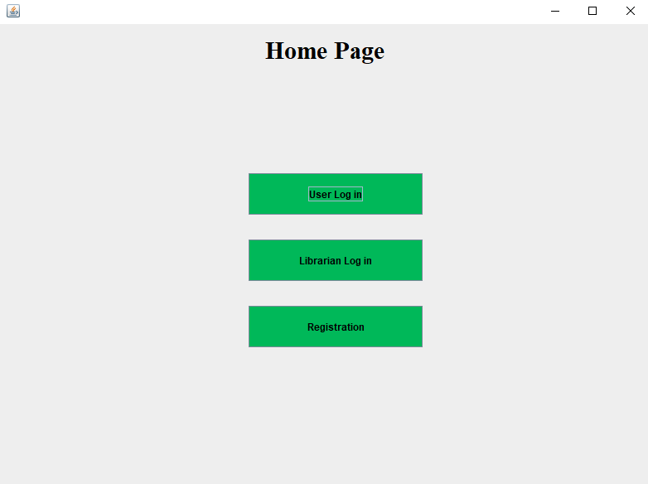

This is the Home Page for our project. Here are three buttons indicating “User Log In”, “Librarian Log In” and “Registration”. If we run Main.java file, we can see this home page.

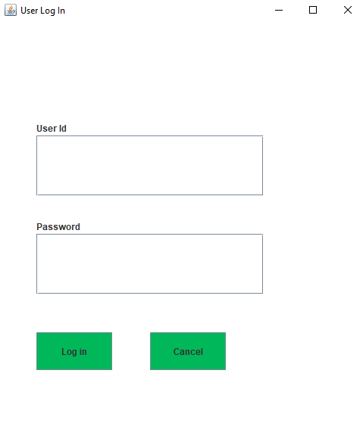

This is the interface for the “Registered” Users, where they have to identify themselves by providing their identification data stated as “User Id” and “Password”. After they input their valid data and press the button “Log In”, the system will verify their validity and they will have access of their database.

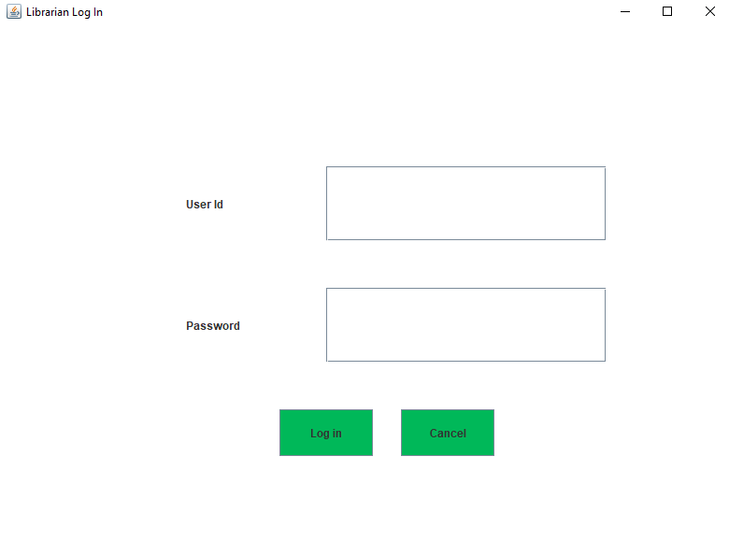

This is the interface for the Librarians, where they have to identify themselves by providing their identification data stated as “User Id” and “Password”. After they input their valid data and press the button “Log In”, the system will verify their validity and they will have access of their database.

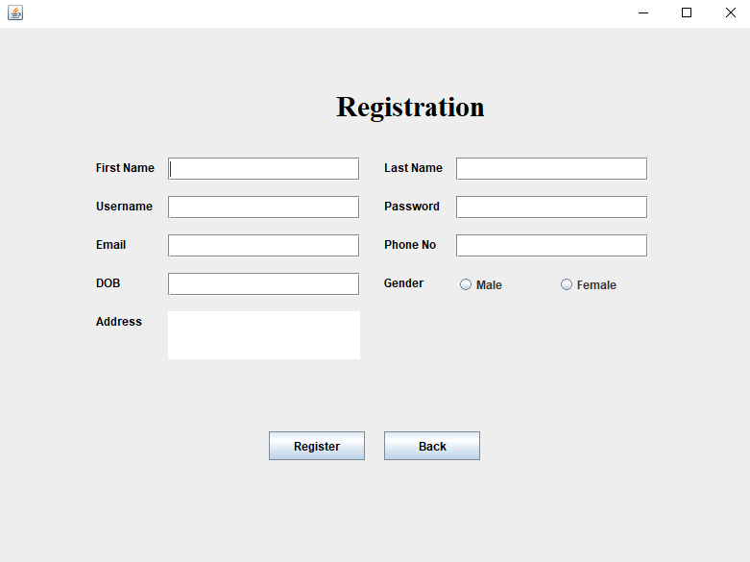

This is the interface for the “Registration” procedure, where one can register him/herself by providing his/her specified personal data stated as first name, user name, last name, password, email, phone no., dob, gender and address. After giving all data and pressing the “Register” button, he/she will be successfully registered as a new user and his/her all data’s will be stored in database.

**Database Table Description:**

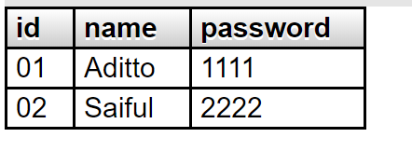

Figure 1: Database table for User.

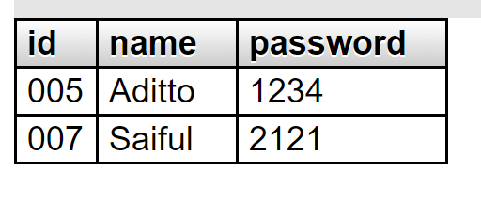

Figure 2: Database table for Librarian.

**Tools Used:**

To develop this project we have used the following:

* Notepad++.
* Xampp.
* JDK and JRE.

**OOP and Java Concepts Used:**

* Frame: Frames are used for interface like radio button, check box etc. Such frames used in this project are JButton, JOptionPane, Jlevel.
* Database connection: In JAVA here, we have added database thru a connector named mysql-connector-java-8.0.18.jar .Using this file we are accessing database with the help of java.
* Package: To access files in folder, we have used this concept by importing package utility in the main running file. Here to access the database files located in a separate folder, we have used this concept.
* .
* .
* Concept N: Explain in no more than two sentences.

**Impact of this Project:**

Impact of this project will be very positive in both society and in economy. Using this online automated system, both library authority and normal user can easily be benefitted. Also it is beneficial for managing all payments, dues regarding library transactions too.

People will be benefitted in many ways thru our project. Especially for knowledge seekers like students, poets, teachers this project can be a life changer. They can easily interact with this system to get their books in easier conditions.

**Limitations and Possible Future Improvements:**

We have tried our best to make this project a winning one, but still their remains a few limitations while implementing this project in day to day scenario. As we are implementing this for a limited amount of data, user will not be able to have his/her freedom to go for any book in our system. Also there are some methodical limitations too, which can result some problems in runtime.

Good news is, all the limitations will be overcommed thru our expected future improvements like, we will expand our data for better user experience while searching for their desired books, we will also improve methods used inside the project, we will ensure best security so that the users are ensured safety while roaming in the system.

***[Note: Make sure that your report is maximum 6 pages (including cover page). Print the report and do NOT even think of Spiral binding.]***