AutoLab Admin Screenshots
This document contains the provided screenshots with a short description below each one.
Screenshot 1
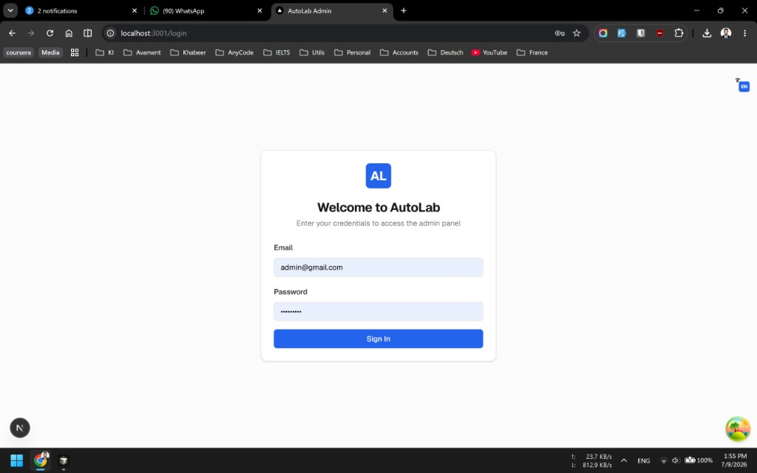
Login page of the AutoLab Admin panel with email and password fields and a Sign In button.
Screenshot 2
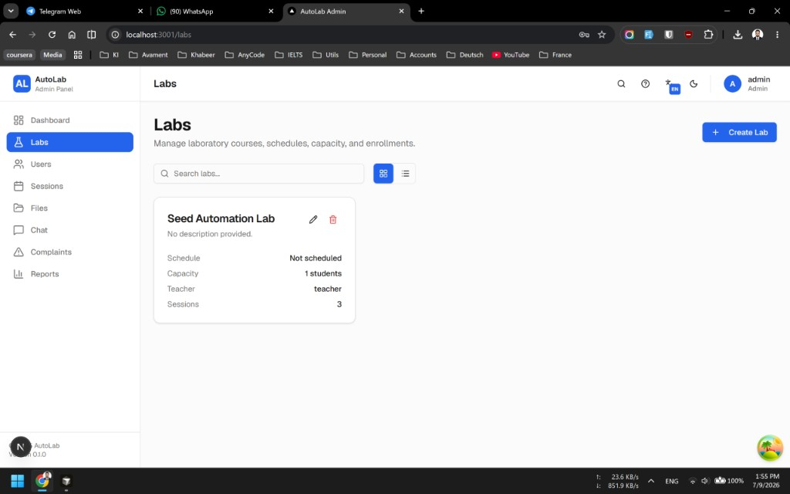
Labs page showing the list of labs, including Seed Automation Lab, with options to search and create a new lab.
Screenshot 3
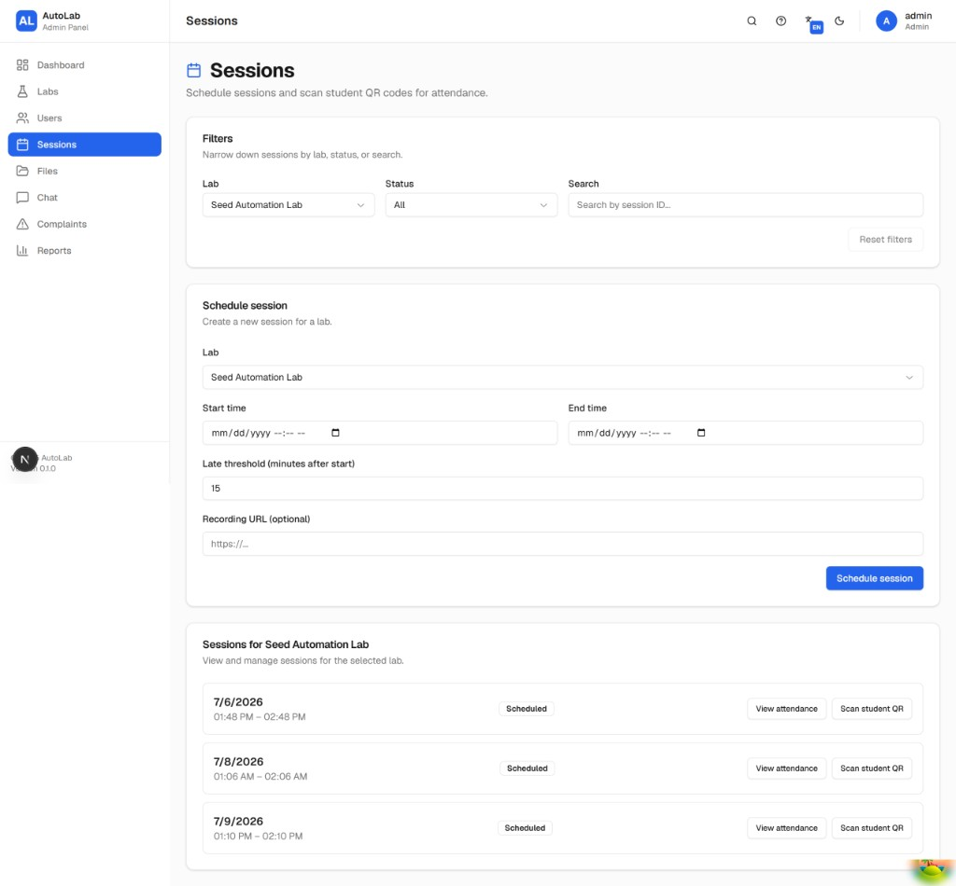
Sessions page used to filter sessions and schedule a new session with start/end time and optional recording URL.
Screenshot 4
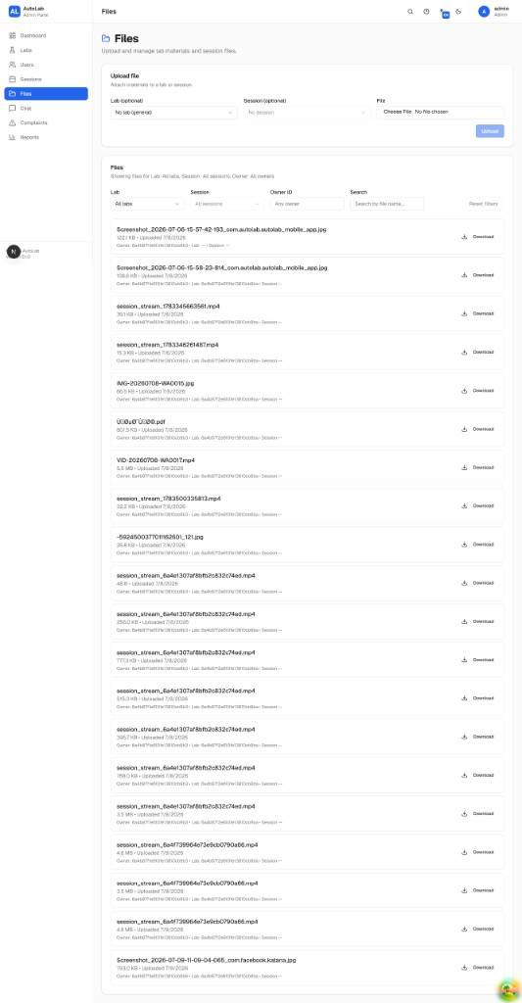
Files page showing upload controls and a list of uploaded lab/session files with download actions.
Screenshot 5

Files page (duplicate capture) displaying the same file management list and filters for lab, session, and owner.
Screenshot 6
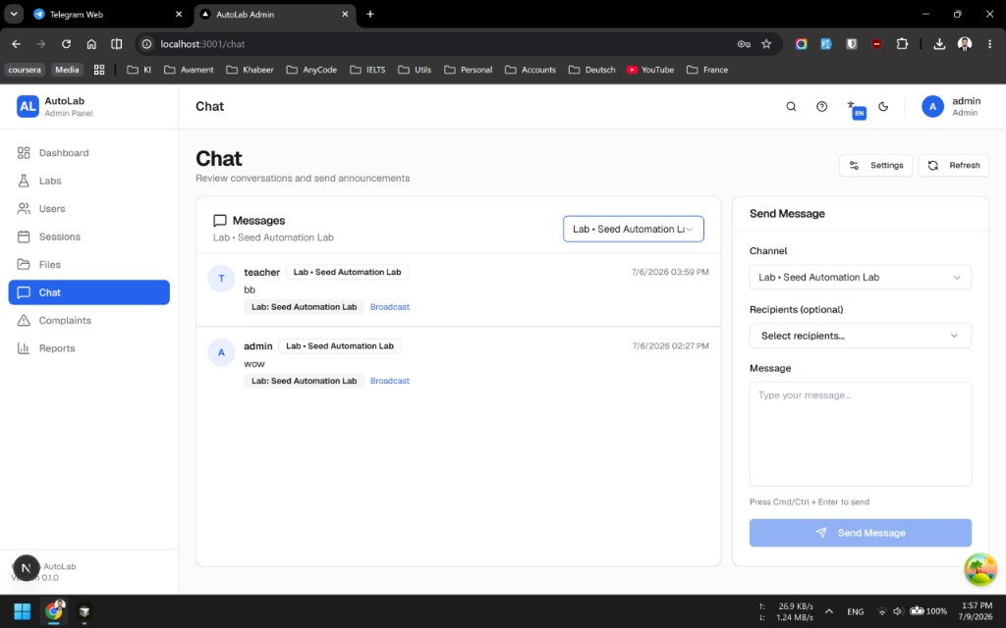
Chat page showing recent messages and the send message panel for lab-wide communication and broadcasts.
Screenshot 7
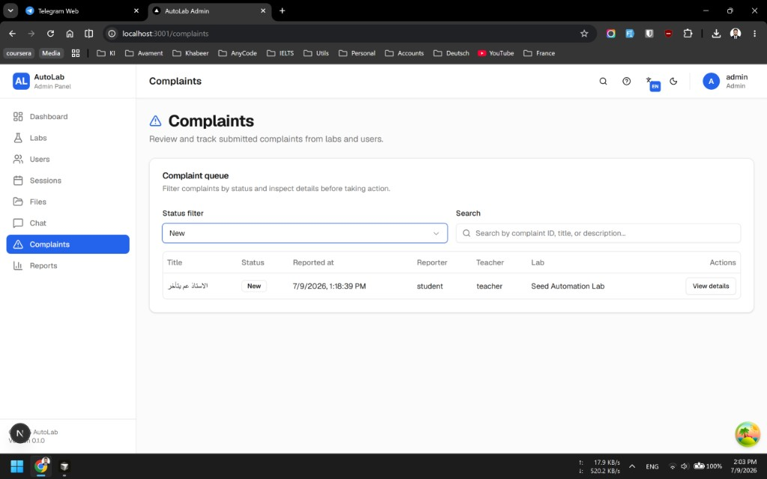
Complaints page showing the complaint queue with status filter, search, and an option to view complaint details.

