Real-Estate Technical Requirements:
Endpoints:
- POST /auth/register
Allowed: Public
Guard: None
Request DTO: { name: string, email: string, password: string }
Response DTO: { userId: string, role: "USER" }
Purpose: Create a new USER account.
- POST /auth/login
Allowed: Public
Guard: None
Request DTO: { email: string, password: string }
Response DTO: { accessToken: string, role: "USER" | "ADMIN" }
Purpose: Authenticate and issue an access token.
- GET /auth/me
Allowed: USER, ADMIN
Guard: Authenticated
Request DTO: —
Response DTO: { userId: string, role: "USER" | "ADMIN" }
Purpose: Return current session identity.

- GET /properties
Allowed: Authenticated-only
Guard: Authenticated
Request DTO: —
Response DTO: [{ propertyId: string, title: string, type: "HOUSE"|"APARTMENT"|string, status: "ACTIVE"|"RESERVED"|"CLOSED" }]
Purpose: List properties for browsing.
- GET /properties/:id
Allowed: Authenticated-only
Guard: Authenticated
Request DTO: —
Response DTO: { propertyId: string, ownerId: string, title: string, type: string, address?: string, description?: string, status: "ACTIVE"|"RESERVED"|"CLOSED", images: [{ imageId: string, fileName: string, url: string }]}
Purpose: View a property and its images.
- POST /properties
Allowed: USER
Guard: Authenticated AND role == USER
Request DTO: { title: string, type: string, address?: string, description?: string }
Response DTO: { propertyId: string }
Purpose: Create a property listing.
- PATCH /properties/:id
Allowed: USER, ADMIN
Guard: Admin OR (User AND property.ownerId == currentUser.id)
Request DTO: { title?: string, type?: string, address?: string, description?: string, status?: "ACTIVE"|"RESERVED"|"CLOSED" }
Response DTO: { success: boolean }
Purpose: Update property listing (owner/admin), Property status changes are typically managed by the admin as part of the transaction approval flow.
- DELETE /properties/:id
Allowed: USER, ADMIN
Guard: Admin OR (User AND property.ownerId == currentUser.id) AND property.status == "ACTIVE"
Request DTO: —
Response DTO: { success: boolean }
Purpose: Delete property listing.

- POST /properties/:id/images
Allowed: USER, ADMIN
Guard: Admin OR (User AND property.ownerId == currentUser.id)
Request DTO: multipart/form-data { image: File }
Response DTO: { imageId: string, fileName: string, url: string }
Purpose: Upload an image for a property.
- DELETE /properties/:id/images/:imageId
Allowed: USER, ADMIN
Guard: Admin OR (User AND property.ownerId == currentUser.id)
Request DTO: —
Response DTO: { success: boolean }
Purpose: Delete a property image.
- Image upload and deletion operations must ensure consistency between the file system and the database.

- POST /properties/:id/requests
Allowed: USER
Guard: Authenticated AND role == USER AND all true:
property.status == "ACTIVE" AND property.ownerId != currentUser.id AND no existing request by same user on same property with status in ["PENDING","APPROVED"]
Request DTO: { type: "BUY" | "RENT" }
Response DTO: { requestId: string, status: "PENDING" }
Purpose: Create a buy/rent transaction request.
- GET /me/requests
Allowed: USER
Guard: Authenticated AND role == USER
Request DTO: —
Response DTO: [{ requestId: string, propertyId: string, type: "BUY"|"RENT", status: "PENDING"|"APPROVED"|"REJECTED", createdAt: string }]
Purpose: List the current user’s transaction requests.
- GET /requests/:id
Allowed: USER, ADMIN
Guard: Admin OR (User AND (request.requesterId == currentUser.id OR property.ownerId == currentUser.id))
Request DTO: —
Response DTO: { requestId: string, propertyId: string, requesterId: string, type: "BUY"|"RENT", status: "PENDING"|"APPROVED"|"REJECTED", createdAt: string, decisionAt?: string }
Purpose: View a single transaction request (requester, property owner, or admin).

- GET /admin/requests?status=PENDING
Allowed: ADMIN
Guard: Authenticated AND role == ADMIN
Request DTO: —
Response DTO: [{ requestId: string, propertyId: string, requesterId: string, type: "BUY"|"RENT", createdAt: string }]
Purpose: Admin queue of pending transaction requests.
- POST /admin/requests/:id/approve
Allowed: ADMIN
Guard: Authenticated AND role == ADMIN AND atomic decision:
request is PENDING AND property is ACTIVE AND enforce “only one APPROVED per property” (DB transaction/lock)
Request DTO: { scheduledAt: string, latitude: number, longitude: number }
Response DTO: { requestId: string, newStatus: "APPROVED", meetingId: string }
Purpose: Approve one request, reject competing pending requests for the same property, update property status to RESERVED, and create a meeting.
This operation must be executed atomically to ensure that only one request per property can be approved.
- POST /admin/requests/:id/reject
Allowed: ADMIN
Guard: Authenticated AND role == ADMIN AND request.status == "PENDING"
Request DTO: { reason?: string }
Response DTO: { requestId: string, newStatus: "REJECTED" }
Purpose: Reject a pending request.

- GET /me/meetings
Allowed: USER
Guard: authenticated AND user is a participant (buyerId == me OR sellerId == me)
Request DTO: —
Response DTO: [{ meetingId: string, propertyId: string, scheduledAt: string, latitude: number, longitude: number, roleInMeeting: "BUYER"|"SELLER" }]
Purpose: List meetings the current user participates in.
- GET /meetings/:id
Allowed: USER, ADMIN
Guard: Admin OR (User AND (meeting.buyerId == currentUser.id OR meeting.sellerId == currentUser.id))
Request DTO: —
Response DTO: { meetingId: string, propertyId: string, buyerId: string, sellerId: string, scheduledAt: string, latitude: number, longitude: number, status: "SCHEDULED" }
Purpose: View meeting details (participants/admin).
Transaction Request Integrity Rules
- A user must not have more than one active request (PENDING or APPROVED) for the same property.
- A property must not have more than one approved request at any given time.
- These constraints are enforced to prevent duplicate requests and race conditions during approval.
Persistence & ORM Assumptions
- The backend uses Prisma ORM for database access.
- The database is assumed to be a relational database (e.g., PostgreSQL).
- All data integrity constraints described in this document must be enforced at:
  - the application level, and
  - the database level where possible.
- Administrative accounts are pre-seeded in the database and are not created through public registration.

Website By Role (Viable Scope):
USER website scope
- Register
- Login / Logout
- View properties list
- View property details (including images)
- Create property listing
- Edit own property listing
- Delete own property listing
- Upload images to own property
- Delete images from own property
- Request to buy a property (on others’ properties)
- Request to rent a property (on others’ properties)
- View “My Requests” (statuses: pending/approved/rejected)
- View “My Meetings”
- View meeting details (datetime + coordinates)

ADMIN website scope
- Login / Logout
- View pending transaction requests (queue)
- Approve a request (enter meeting datetime + coordinates)
- Reject a request
- View all meetings
- View all properties (read-only is enough)
Property Status Lifecycle
- Each property has a status field used to control transaction requests and prevent race conditions.
- Supported statuses are:
  - ACTIVE
  - RESERVED
  - CLOSED
Status Definitions
- ACTIVE
The property is available for browsing and can receive buy or rent transaction requests.
- RESERVED
One transaction request has been approved by the admin and a meeting has been scheduled. No new requests are allowed.
- CLOSED
The transaction process is considered completed. This state is included for completeness and future extension.
Status Transition Rules
- Properties are created with status ACTIVE.
- When an admin approves a transaction request, the property transitions from ACTIVE to RESERVED.
- Transition to CLOSED is optional and may be performed manually by an admin.
Atomic Operations
- The admin approval flow (approving one request, rejecting others, updating property status, and creating a meeting) is treated as a single atomic operation.
- If any step fails, the entire operation must be rolled back.
Meeting Role Derivation
- The roleInMeeting field is derived dynamically:
  - BUYER if the current user is the requester.
  - SELLER if the current user is the property owner.
Image Storage Strategy
- Property images are uploaded using a multipart/form-data request.
- Images are stored on the server using disk-based storage.
- Uploaded images are saved in a publicly accessible directory (e.g., public/uploads/).
- The database stores only the image file name, not the full file path.
- The full public image URL is constructed dynamically by the backend when returning responses.
- When an image is deleted:
  - The image file is removed from the file system.
  - The corresponding database record is deleted.
- Each uploaded image creates a database record with a unique imageId; the record stores fileName.
Error Handling Semantics
- Unauthorized access returns 401 Unauthorized.
- Forbidden operations return 403 Forbidden.
- Conflicting operations (e.g., duplicate requests, approving an already approved property) return 409 Conflict.
- Missing resources return 404 Not Found.
Mermaid ERD code:
erDiagram
USERS {
string id PK
string name
string email
string password_hash
string role
datetime created_at
}

PROPERTIES {
string id PK
string owner_id
string title
string type
string address
string description
string status
datetime created_at
datetime updated_at
}

PROPERTY_IMAGES {
string id PK
string property_id
string file_name
datetime created_at
}

TRANSACTION_REQUESTS {
string id PK
string property_id
string requester_id
string type
string status
datetime created_at
datetime decision_at
}

MEETINGS {
string id PK
string property_id
string transaction_request_id
string buyer_id
string seller_id
datetime scheduled_at
float latitude
float longitude
string status
datetime created_at
}

USERS ||--o{ PROPERTIES : owns
PROPERTIES ||--o{ PROPERTY_IMAGES : has
PROPERTIES ||--o{ TRANSACTION_REQUESTS : receives
USERS ||--o{ TRANSACTION_REQUESTS : creates

TRANSACTION_REQUESTS ||--|| MEETINGS : results_in
PROPERTIES ||--o{ MEETINGS : has
USERS ||--o{ MEETINGS : buyer
USERS ||--o{ MEETINGS : seller
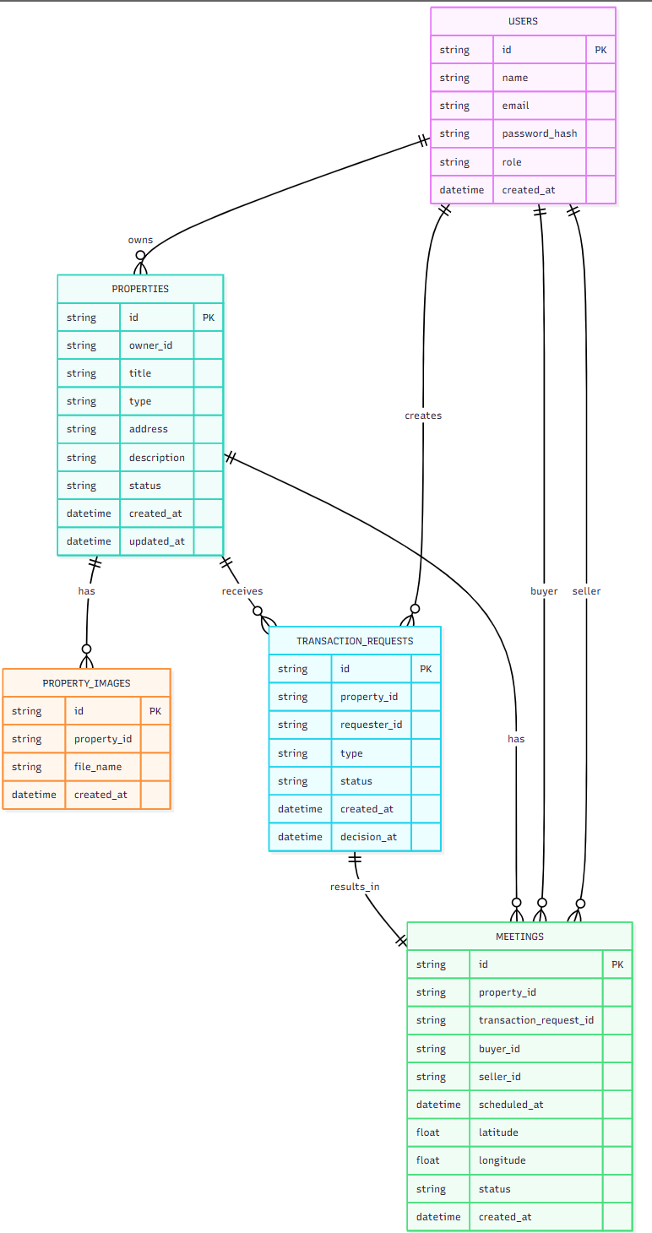
Mermaid Sequence Diagram Code:
sequenceDiagram
autonumber

actor Admin
participant UI as Admin Web UI
participant API as Backend API
participant DB as Database

%% View pending requests
Admin->>UI: Open Pending Requests
UI->>API: GET /admin/requests?status=PENDING
API->>DB: Query transaction_requests where status = PENDING
DB-->>API: Pending requests list
API-->>UI: 200 OK (pending requests)
UI-->>Admin: Display pending requests

%% Approve request
Admin->>UI: Approve request\n+ enter meeting details
UI->>API: POST /admin/requests/{requestId}/approve\n{scheduledAt, latitude, longitude}

%% Atomic approval transaction
API->>DB: BEGIN TRANSACTION
API->>DB: Load transaction_request and property
DB-->>API: request = PENDING, property = ACTIVE

API->>DB: Update selected request status = APPROVED
API->>DB: Update other requests for property status = REJECTED
API->>DB: Update property status = RESERVED
API->>DB: Insert meeting record
API->>DB: COMMIT

%% Response
DB-->>API: Commit success (meetingId)
API-->>UI: 200 OK { requestId, newStatus: APPROVED, meetingId }
UI-->>Admin: Show approval result and meeting details

note over API,DB: All operations occur atomically\nPreventing multiple approvals per property
