Cambodia | 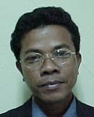 | 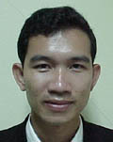 | 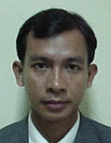 | 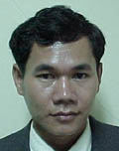 | 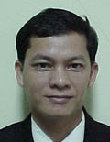
Cambodia | Mr.Srey Vuthy 209 | Mr. Hong Ponnaka 306 | Mr. Chet Sopheap 206 | Mr. Thay Sopheap 314 | Mr. Chhim Sareth
China | 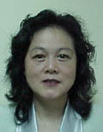 | 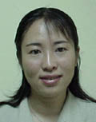 | 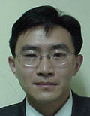 | 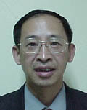 | 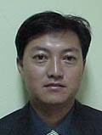
China | Ms. Guo Xing 305 | Ms. Zhao Jiuling 203 | Mr. Xu Li 215 | Mr. Xie Shuhui 310 | Mr. Tang Jiankun 302
Lao PDR | 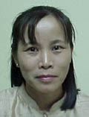 | 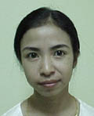 | 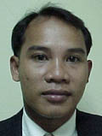 | 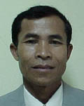 | 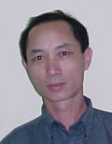
Lao PDR | Ms.Amphone Phannamvong 308 | Ms.Saynarone Chundara 208 | Mr.Sombat Chanthamath 212 | Mr. Khamphong Pholsena 312 | Mr.Vilaysack Phothichanh 211
Myanmar | 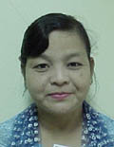 | 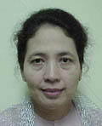 | 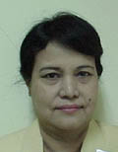 | 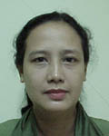 | 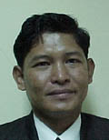
Myanmar | Daw Cho Cho 202 | Daw Khin Khin Nyunt 309 | Daw Tin Nwe Yu 316 | Daw San San Tint 205 | U Tun Tun Lwin 210
Thailand | 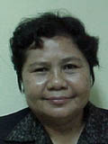 |  | 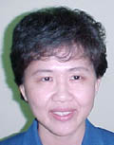 | 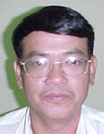 | 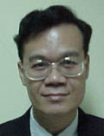
Thailand | Ms. Suthida Bunnag 216 | Ms. Valla Nutaman 204 | Ms. Wantana Sinsiri 311 | Mr. Chairat Dulyaphat 307 | Mr.Roengroi Chalermroj  303
Vietnam | 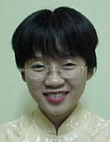 | 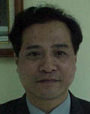 | 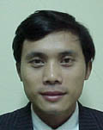 | 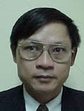 | 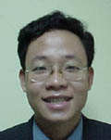
Vietnam | Ms. Tran Le Na  214 | Mr. Vo Van Son  313 | Mr. Le Tran Nguyen Hung  218 | Mr. Vu Ngoc Tan 207 | Mr. Dinh Quang Hieu  318

