JICA – funded course on

“Economies in Transition for Middle-Level Managers”

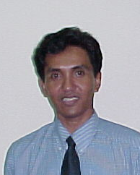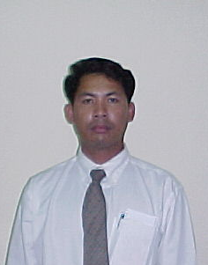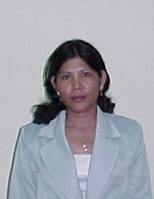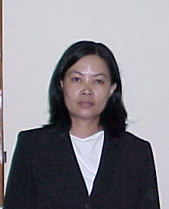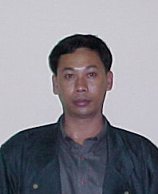Cambodia
 | Mr Sok Kanora 304 | Mr Khy Phyrum 206 | Ms In Boline 209 | Ms Sun Naly 314 | Mr Ker Bopha 306

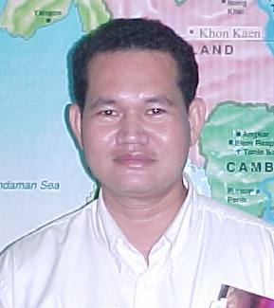
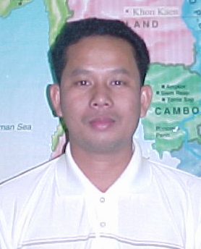
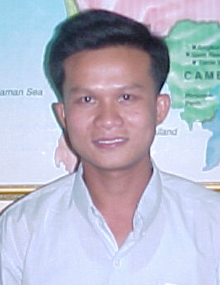
Cambodia
 | Ms Tek Sophy  302 | Mr Chhim Sokchin  308 | Mr Long Socheat  314 | Mr Mak Roath  211
JICA Funded Course “Tourism Management and Administration for the GMS”
7 January – 1 February 2002

