**Multiple Adaptive Regression Splines (MARS)**

*By - Divyansh Verma*

*Subject - Machine Intelligence (MI)*

*Roll no. - 16CO110*

*Email -* [*divyanshverma12@gmail.com*](mailto:divyanshverma12@gmail.com)

*Mobile - +91-8950992215*

**Definition** - Multivariate/Multiple Adaptive Regression Splines (MARS) is a form of regression analysis which was introduced by Jerome H. Friedman in 1991. It is a stepwise linear regression algorithm. It can be defined as an attempt to modify linear models to automatically fit over non linearities in a given dataset. So in layman language it is an extension of linear models that can easily model some non linearities.

*Terminology*

1. *Multivariate - Able to generate model based on several input variables*
2. *Adaptive - Generates flexible models in passes each adjusting the model*
3. *Regression - Estimation of relationship among independent and dependent variables*
4. *Spline - A piecewise defined polynomial function that is smooth (possess high order derivatives) where polynomial pieces connect*
5. *Knot - The point at which two polynomial pieces connect*

**Previous Methods**There are various linear modeling techniques like linear regression (<https://en.wikipedia.org/wiki/Linear_regression>), logistic regression (<https://en.wikipedia.org/wiki/Logistic_regression>) etc.

*Fig - 1 Image showing a comparison between Linear Regression and Multivariate Adaptive Regression Spline* 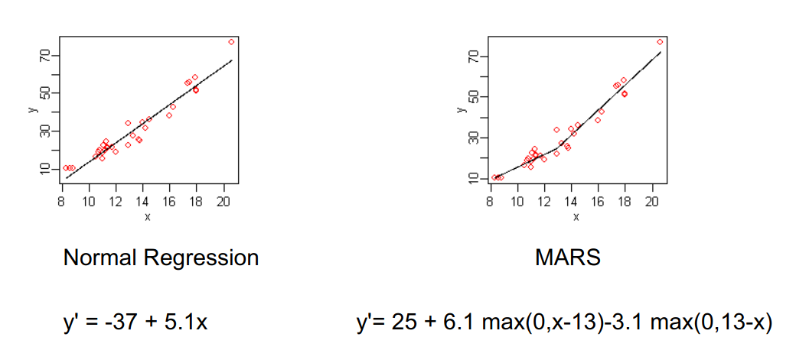

They are really fast and simple algorithms and many of such linear models can be easily adapted to non linear patterns in the data by adding non-linear terms (like higher order polynomials, interaction effects or any other transformation techniques applied to original features), however to such things we should know the specific nature of the non-linearities and interactions before building such models.

There are many Data Analysis models which are naturally nonlinear and these models can be used to extract non linearity from the given dataset without detecting or identifying non-linearity in such datasets and Multivariate Adaptive Regression Spline (MARS) is one such algorithm (*Fig - 1* shows a comparison between Normal regression model and MARS model). MARS can discover non-linearities in a dataset without explicitly defining or understanding non-linearity (It will search for it).

**Why to Use**

We need to use such non-linear regression models (MARS) as they are more flexible than linear regression models and although some non-linearity is added to the model, yet the MARS model is easy to understand and interpret and also MARS requires minimal features engineering like feature scaling or feature transformation and automatically performs features selection.

**Linear Regression** is the most basic regression model. Simple linear regression (SLR) assumes that statistical relationship between two continuous variables (let us say X and Y) is linear and can be defined using a simple equation:

$Y{}_{i} = β{}_{0} + β{}_{1} X{}_{i} + ε{}_{i} for i = 1,2,3,.....,n,$ (1)

Where Yi  represents the i-th prediction or value or Xi feature value and $β{}_{0}$ and $β{}_{1}$ are fixed but unknown constant and $ε{}_{i}$ represent noise or error. So, a simple linear regression model work is to estimate values of $β{}_{0}$ and $β{}_{1}$ such that (1)’s value will have least loss or error sum on a test dataset or real life values. Cost or error sum can be defined in various ways one of the easy and most used formulas to calculate loss in linear regression is Residual sum of squares.

$Let Ypred{}_{i} be the predicted value from SLR given by -$

$Ypred{}_{i} = β{}_{0} + β{}_{1} X{}_{i } for i = 1,2,3,.....,n,$

$and true value given by Ytrue{}_{i} and the Loss function is given by -$

$LOSS($ $β{}_{0}$, $β{}_{1}) = \sum_{i=1}^{n}{}[Ytrue{}_{i} - Ypred{}_{i}]{}^{2}$

So, what linear regression does is that is find appropriate values of $β{}_{0}$ and $β{}_{1}$ to get minimum loss over the given data points. Such models can be easily extended for multidimensional data points.

*Fig - 2 Images showing output of linear regression on two different datasets* 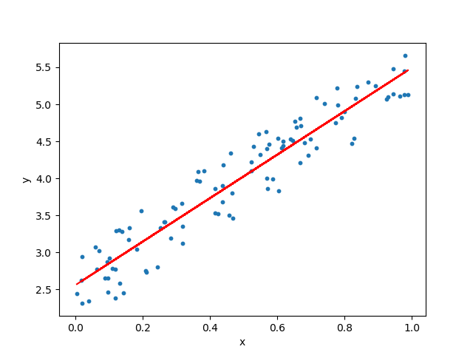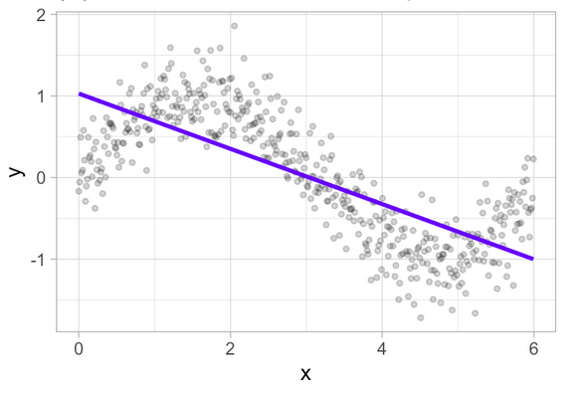

Problem with Logistic Regression - If you see fig - 2, when linear regression regression is applied on a dataset which is not linear (Fig - 2(b)), It under fits the datasets, so doesn’t provide a good generalization of the dataset. Such predictions will have little or no use on non-linear distribution of data points. As discussed above there are many regression techniques like polynomial regression which can overcome and can fit over such distribution but for such regressions required pre-knowledge of such data points and give explicit parameters. But MARS doesn’t require such explicit parameter initialization or pre-analysis of the dataset. It itself tries various configurations and tries to fit over the distribution.

*Fig - 3 Image shows fitting of a stepwise model over a non-linear distribution of data points*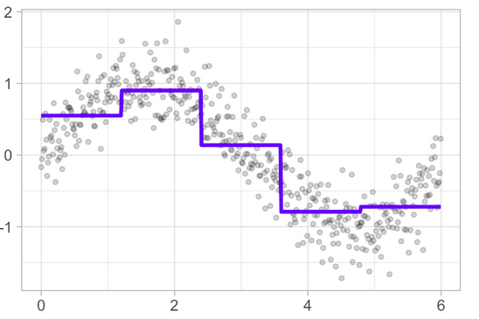

MARS uses piecewise linear basis functions of the form(given by an equation below)

$y{}_{i }=β{}_{0}+β{}_{1}C{}_{1}(x_{i}) +β{}_{2}C{}_{2}(x_{i})+β{}_{3}C{}_{3}(x_{i})+....+β{}_{d}C{}_{d}(x_{i}) + ϵ{}_{i}$ (2)

Where $C{}_{d}(x_{i})$ represents $x_{i}$ values ranging from $c{}_{d-1 }≤x_{i}<c{}_{d }$.

Fig - 3 shows an illustration of such stepwise linear basis function

**Multivariate adaptive regression splines (MARS)** is an easy and simple approach to capture the non-linear relationships in the data by setting the values of knots(cutpoints) similar to step functions also known as hinge functions. The procedure assesses each data point for each predictor as a knot and creates a linear regression model with the candidate feature(s).

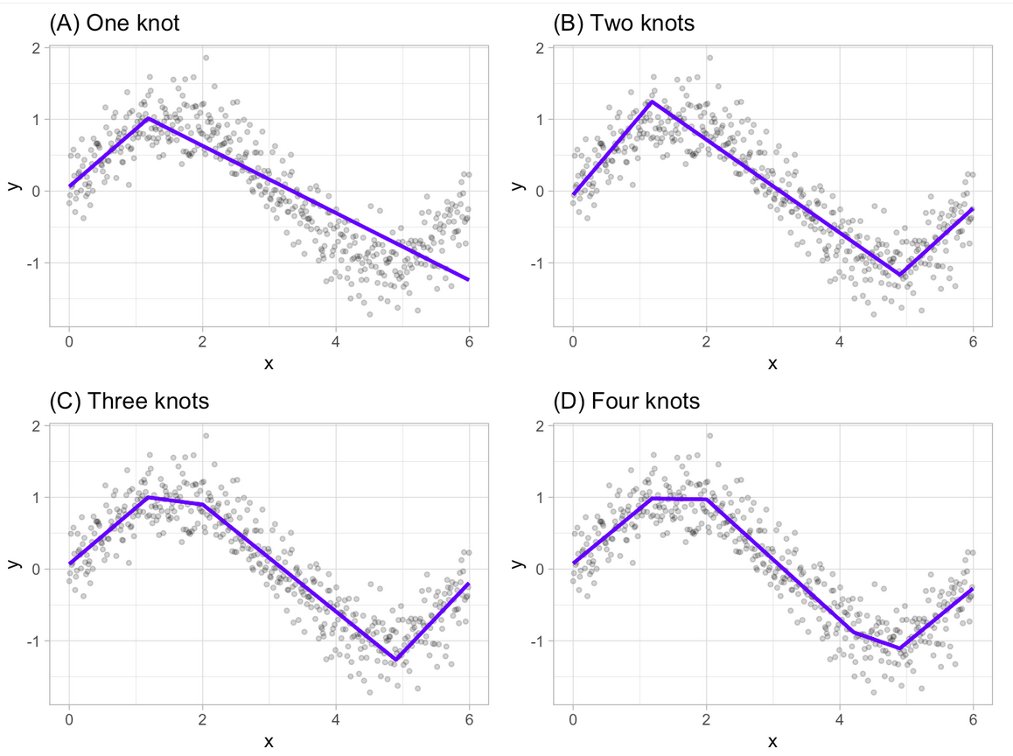

*Fig - 4 Image showing fitted regression splines of one (A), two (B), three (C) and four (D) knots*

**Example/Overview of working of algorithm -**

Consider a non-linear, non-monotonic dataset where $Y = f(X)$.

1. Look for the single point across the range of X values where 2 different linear relationships between Y and X achieve smallest error or loss.
2. The result of such finding is known as hinge which is given by $h(x-a)$ where $a$ is the cut-point value.

As shown in Fig - 4(A) our hinge function is $h(x-1.18)$ such that out two linear model for Y will be -

$Y = β{}_{0}+β{}_{1}(1.18-x) when x <1.18$

$Y = β{}_{0}+β{}_{1}(x -1.18) when x >1.18$

1. Once the first knot is found, algorithm will continue to find 2nd knot which in the given figure fig - 4(B) is x = 4.89 so,

$Y = β{}_{0}+β{}_{1}(1.18-x) when x <1.18$

$Y = β{}_{0}+β{}_{1}(x -1.18) when x >1.18$ and $x <4.89$

$Y = β{}_{0}+β{}_{1}(4.89 -x) when x >4.89$

1. Step III. continuous as long as many cutpoints(knots) are found, resulting in a good non-linear prediction equation.

**Generalization**

MARS model generalizes to $⇒ f(X) =β{}_{0}+\sum_{m=1}^{M}{}β{}_{m}f{}_{m}(X)$ (3)

Where ${}_{}f{}_{m}(X)$ is a basis function which is the product of two or more such hinge functions.

**Basis function -** Each basis function takes one of the three form

* A constant term
* A hinge function which has a form max(0,x-constant) or max(0,constant-x)
* A product of two or more hinge functions

$β{}_{i} 's$ for i = 0,1,2…,m are the coefficients of hinge functions estimated by minimizing the loss or error function (like defined in (1) above) and these coefficient can be defined as the weights that represent the importance of the variable in the MARS model to fit over a non-linear distribution of data-points.

**MARS Model Building Procedure**

1. Gather data i.e. x input variables or data-points from the dataset with y output for each x (i.e. input variable).
2. Calculate or find a set of basis functions by setting knots at observed values.
3. Constraint specification i.e. number of terms in the model and maximum allowable degree of interaction.
4. Forward Pass - Try out different or new hinge functions and their product combinations which decreases training error.
5. Backward Pass - Fix Overfitting over the training set.
6. Use of generalized cross validation technique to estimate the number of optimal terms in the MARS model.

**MARS Forward Pass**

1. MARS starts with a model which consists of an intercept term which can be defined as the mean of the response values.
2. Each step MARS adds a basis function in pairs to the model and finds a pair of basis functions that gives the maximum reduction in loss or error (i.e. sum of square error).
3. Each new basis function consists of a term already in the model multiplied by a new hinge function. As define above hinge function is defined by a variable and a knot so to add a new basis function, and MARS model search over all the combination of following
   1. Existing terms
   2. All variables
   3. All values of each variable
4. To calculate the coefficient of each term MARS applies a linear regression over the terms.

**MARS Backward Pass**

1. Forward Pass leads to an overfitted model (An overfitted model is a model that gives good accuracy on a test dataset used to build a model but does not generalize well to new data or real world data.
2. So to make a better model, pruning is used which is a major functionality of backward pass.
3. It removes one term at a time from the model.
4. Remove the term which increases the error or loss by minimum amount.
5. Continue removing terms until cross validation is satisfied. The MARS model uses Generalized Cross Validation (GCV).

**Generalized Cross Validation**

MARS backward pass uses generalized cross validation (GCV) for comparing the output/accuracy of model’s subsets in order to choose the best subset. GCV is a form of regularization i.e. it trades off goodness of fit against model complexity (As used in various neural network models). GCV is used to approximate the error or loss that will be there by removing one hinge function or a set of that.

There is nothing wrong in having a lot of hinge functions but a model that fits to noise in the dataset can give poor results on real world data.

Formula of GCV =

$( \sum_{i=1}^{n}{}[Ytrue{}_{i} - Ypred{}_{i}]{}^{2}) / (N*(1-(effective number of parameters)/N){}^{2})$

The effective number of parameters is defined in MARS context as

$(effective number of parameters) =(number of mars terms) +(penalty)*$

$((number of mars terms)-1)/2$

Where penalty can be set to 2 or 3 by the analyst or programmer.

**Assumptions**

No assumptions are made about the environment or distribution of data-points. The only requirement for the MARS model to perform well is that variables should not be highly correlated to one another as this can lead to difficulty in estimation.

**Advantages of MARS**

1. Automatically detects interactions between variables.
2. Fast and computationally efficient.
3. Easy to handle data with high dimensions.
4. Non-linear relationships are handled well.
5. More Flexible than linear models.
6. Simple to understand and interpret.
7. Both continuous and discrete data can be handled well.
8. Requires no data preparation.
9. As computationally fast, can handle large datasets.

**Output of MARS on a dataset**

Given dataset can be downloaded from this link ([Dataset](https://drive.google.com/file/d/1wvVc5DbFjWrLn5Hjt8vQIcqCAqkxfkd9/view?usp=sharing)). When plotted the dataset distribution looks like this

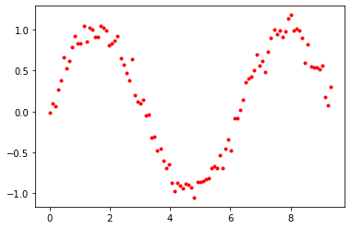

*Fig - 6 Image showing Dataset distribution*

Now when the MARS model is trained on this dataset with different parameters such as max_degree(i.e. Maximum degree of x in the equation (3)) and max_terms ( i.e. Maximum number of allowed hinge functions), we can get different outputs and those outputs were plotted and examined.

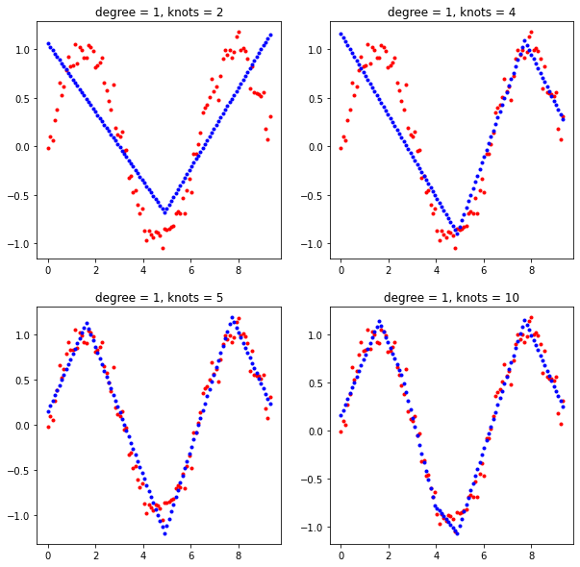

*Fig - 7 Image shows 4 different output of MARS model with max_degree = 1 and different values of knots allowed*

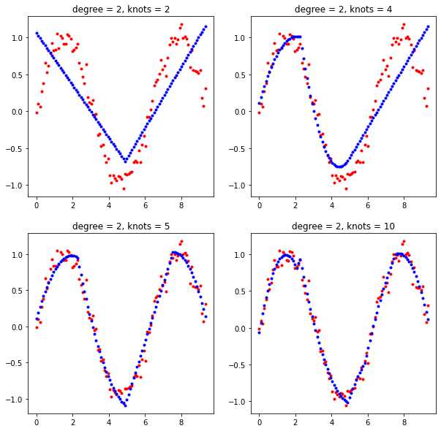

*Fig - 8 Image shows 4 different output of MARS model with max_degree = 2 and different values of knots allowed*

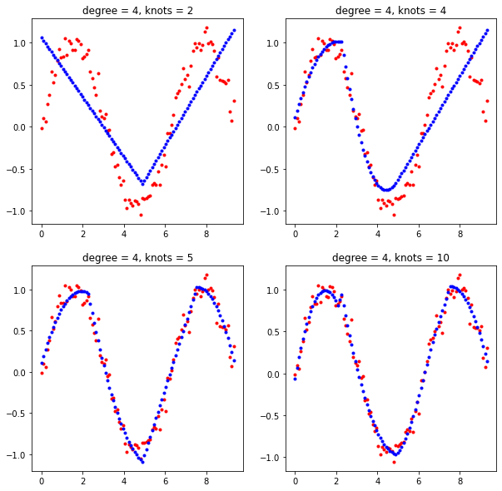

*Fig - 9 Image shows 4 different output of MARS model with max_degree = 4 and different values of knots allowed*

From Fig - 7,8,9 we can examine that increasing the number of knots helps in better fitting of data distribution and increasing degree brings smoothness in the model’s prediction (i.e. helps in fitting curves in the data distribution). By comparing all the models above (Fig 7,8,9) it can be found that the model with knots = 10 and degree = 4 fits the dataset best.

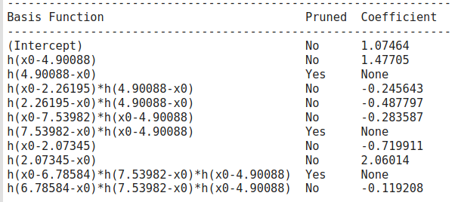

*Fig - 10 Image showing final MARS model output for dataset with max_degree = 3 and knots(max_terms) = 4*

**MARS with Logistic Regression**

Mars Model can be used with logistic regression to compute non-linear boundaries. Here are the examples on three different types of dataset.

**Steps -**

1. Get a nonlinear equation output from the MARS model.
2. Apply logistic regression for decision boundaries.

*Example 1 - (Simplified Iris dataset (petal length and sepal length)*

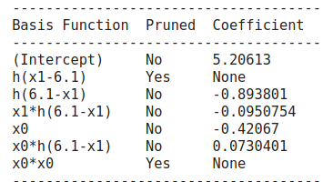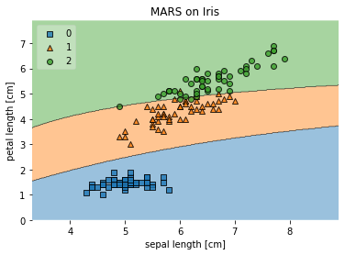

*Fig - 11 Showing output of MARS model Fig - 12 showing output of logistic regression*

*On equation given by MARS model*

*Example 2 - (make-moons dataset)*

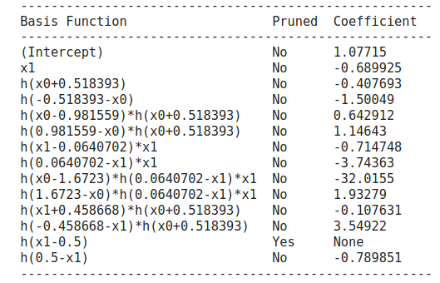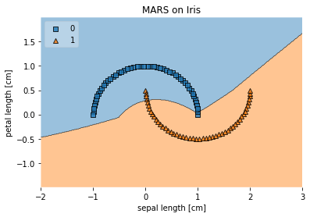

*Fig - 13 Showing output of MARS model Fig - 14 showing output of logistic regression*

*On equation given by MARS model*

**Implementation (Python)**

* MARS model is present in python pyearth library under name **EARTH.** It can be imported using this piece of code. Pyearth library can be downloaded from this link - <https://pypi.org/project/sklearn-contrib-py-earth/> and to learn more about this library - <https://contrib.scikit-learn.org/py-earth/>

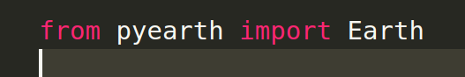

* To test and train with different parameters, we can define different knots (hinge functions) -

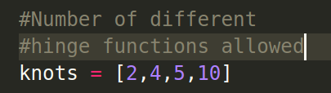

* Creating a simple MARS model using pyearth library with parameters such as max_terms(i.e. Maximum allowed different hinge functions), max_degree(i.e. Highest degree of polynomial function allowed) and verbose(which when set to 1 gives complete detail how our model learns different beta’s ($β's$)).



* Now to train or fit ours MARS model, we just need to write 1 function



* To know the parameters that MARS model learns while training on a dataset use model.summary() function.
* To trace pruning of different functions use model.trace().

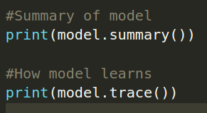

* *Complete code can be found here on the Google Colab Link -* [**https://colab.research.google.com/drive/1G-QeE9Fcr2qOaWimspiMTQdKfUrHyktd?usp=sharing**](https://colab.research.google.com/drive/1G-QeE9Fcr2qOaWimspiMTQdKfUrHyktd?usp=sharing)

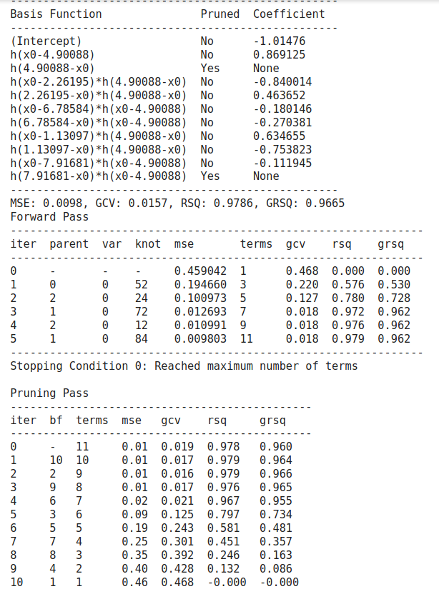

*Fig - 15 Image showing sample output of model.summary() and model.trace() functions .*

**Demo -**

A demo of MARS created using which can be downloaded from here - [Link](https://github.com/failedcoder12/MARS-Multivariate-Adaptive-Regession-Spline-). It is created in python using Tkinter GUI library. To download and play with it a ReadMe file has been attached in the github repo.

**Here are some screenshots from demo………**

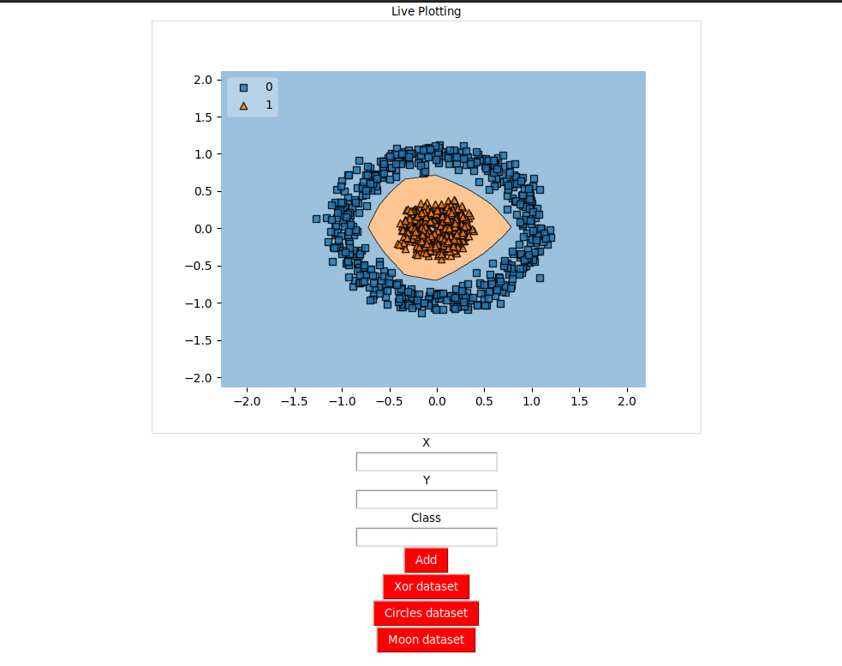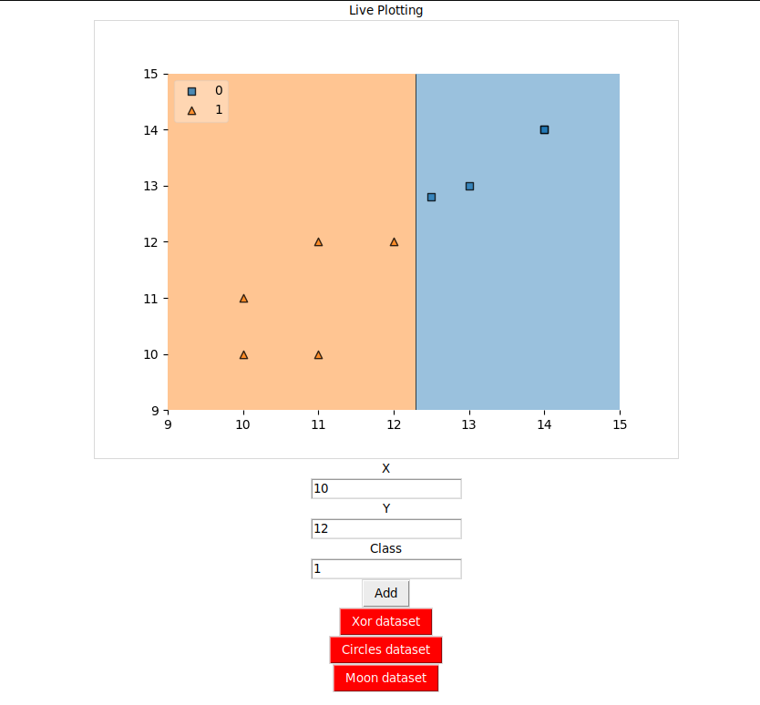

*Fig -16 Two Images showing GUI and working of Demo created using Python Tkinter library.*

**Comparison With Other Non linear classifiers -**

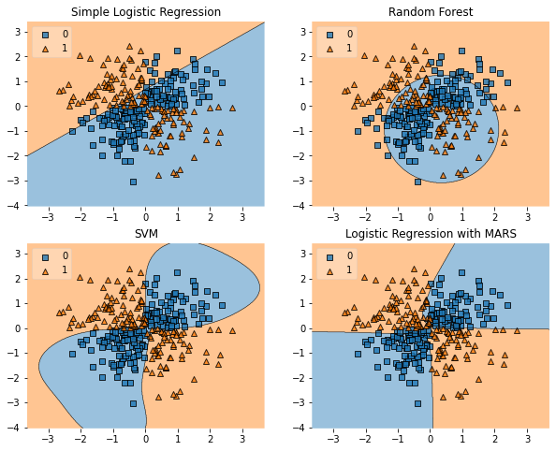

*Fig - 14 Showing output of various model on a given XOR dataset*

From Fig - 14 it can be seen that Logistic Regression with MARS clearly outperformed Simple Logistic Regression and Random forest and produces equivalent good results as SVM (yet MARS is a simple model than SVM)

**Research Implementation Related Papers -**

1. C. Briand and Bernd Freimut (2004). “Using multiple adaptive regression splines to support decision making in code inspections”. <https://www.sciencedirect.com/science/article/pii/S0164121204000068>
2. De Veaux, R.D., Psichogios, D.C., Ungar, L.H., 1993. A comparison of two nonparametric estimation schemes: MARS and neural networks. Computers Chemical Engineering 17 (8), 819–837.
3. Friedman, J. H. (1991). "Multivariate Adaptive Regression Splines". *The Annals of Statistics*. **19** (1): 1–67. [CiteSeerX](https://en.wikipedia.org/wiki/CiteSeerX_(identifier)) [10.1.1.382.970](https://citeseerx.ist.psu.edu/viewdoc/summary?doi=10.1.1.382.970). [doi](https://en.wikipedia.org/wiki/Doi_(identifier)):[10.1214/aos/1176347963](https://doi.org/10.1214%2Faos%2F1176347963). [JSTOR](https://en.wikipedia.org/wiki/JSTOR_(identifier)) [2241837](https://www.jstor.org/stable/2241837). [MR](https://en.wikipedia.org/wiki/MR_(identifier)) [1091842](https://www.ams.org/mathscinet-getitem?mr=1091842). [Zbl](https://en.wikipedia.org/wiki/Zbl_(identifier)) [0765.62064](https://zbmath.org/?format=complete&q=an:0765.62064). <http://www.stat.yale.edu/~lc436/08Spring665/Mars_Friedman_91.pdf>
4. Chi-Jie Lu ; Chih-Hsiang Chang ; Chien-Yu Chen ; Chih-Chou Chiu ; Tian-Shyug Lee “Stock index prediction: A comparison of MARS, BPN and SVR in an emerging market”

<https://ieeexplore.ieee.org/document/5373010>

1. Wengang Zhang, Anthony T.C.Goh. “Multivariate adaptive regression splines and neural network models for prediction of pile drivability”. <https://www.sciencedirect.com/science/article/pii/S1674987114001364>
2. Prasenjit Dey, Ajoy K.Das. “Application of Multivariate Adaptive RegressionSpline-Assisted”. <https://www.sciencedirect.com/science/article/pii/S1738573316300985>

**Other Links -**

1. Github Repo - <https://github.com/failedcoder12/MARS-Multivariate-Adaptive-Regession-Spline->
2. Graphs - <https://colab.research.google.com/drive/1G-QeE9Fcr2qOaWimspiMTQdKfUrHyktd?usp=sharing>
3. MARS Model - <https://colab.research.google.com/drive/1sW2pCjWeoJKQ0YHLYl26kLRfTRm1iRHV?usp=sharing>
4. GUI builder - <https://colab.research.google.com/drive/1f8GPYn-Tz-hcKvVAw1MxOrBW55pfXDSP?usp=sharing>

**References**

1. Friedman, J. H. (1991). "Multivariate Adaptive Regression Splines". *The Annals of Statistics*. **19** (1): 1–67. [CiteSeerX](https://en.wikipedia.org/wiki/CiteSeerX_(identifier)) [10.1.1.382.970](https://citeseerx.ist.psu.edu/viewdoc/summary?doi=10.1.1.382.970). [doi](https://en.wikipedia.org/wiki/Doi_(identifier)):[10.1214/aos/1176347963](https://doi.org/10.1214%2Faos%2F1176347963). [JSTOR](https://en.wikipedia.org/wiki/JSTOR_(identifier)) [2241837](https://www.jstor.org/stable/2241837). [MR](https://en.wikipedia.org/wiki/MR_(identifier)) [1091842](https://www.ams.org/mathscinet-getitem?mr=1091842). [Zbl](https://en.wikipedia.org/wiki/Zbl_(identifier)) [0765.62064](https://zbmath.org/?format=complete&q=an:0765.62064).
2. <https://bradleyboehmke.github.io/HOML/mars.html#final-thoughts-3>
3. <http://www.ideal.ece.utexas.edu/courses/ee380l_ese/2013/mars.pdf>
4. <https://support.bccvl.org.au/support/solutions/articles/6000118097-multivariate-adaptive-regression-splines>
5. Milborrow S (2015) Notes on the earth package. <http://www.milbo.org/doc/earth-notes.pdf>
6. Trevor Hastie, Stephen Milborrow. Derived from mda:mars by, and Rob Tibshirani. Uses Alan Miller’s Fortran utilities with Thomas Lumley’s leaps wrapper. 2019. *Earth: Multivariate Adaptive Regression Splines*. [https://CRAN.R-project.org/package=earth](https://cran.r-project.org/package=earth).
7. <http://media.salford-systems.com/library/MARS_V2_JHF_LCS-108.pdf>
8. Multivariate Adaptive Regression Splines. Wikipedia. <http://en.wikipedia.org/wiki/Multivariate_adaptive_regression_splines>
9. M. Nash and D. Bradford. Parametric and Nonparametric Logistic Regressions for Prediction of Presence/Absence of an Amphibian. EPA Oct. 2001. http:// [www.epa.gov/esd/land-sci/pdf/008leb02.pdf](http://www.epa.gov/esd/land-sci/pdf/008leb02.pdf).
10. The Elements of Statistical Learning (2nd ed.). Springer, 2009. <http://www-stat.stanford.edu/~hastie/pub.htm>.
11. Tklnter - <https://wiki.python.org/moin/TkInter>
12. Mlxtend-<http://rasbt.github.io/mlxtend/user_guide/plotting/plot_decision_regions/>
13. GUI Creation - [How to create a real-time plot with matplotlib and Tkinter](https://www.quora.com/How-do-I-create-a-real-time-plot-with-matplotlib-and-Tkinter)
14. Pyearth library - <https://pypi.org/project/sklearn-contrib-py-earth/>
15. Pyearth documentation - <https://contrib.scikit-learn.org/py-earth/>