3D Model Viewer – User Manual

CSC 478 - Spring 2014 - Group 1 Choppers

Andrew Baker

Adam Le

Todd Previte

# Introduction

The 3D model object viewer application renders 3D models in the OBJ file format. This is the only file format supported by this application. Included in the application are sample 3D models in the OBJ file format. The application can also load OBJ from other sources as long as the data is formatted correctly. The application can render the 3D model with or without lighting. The 3D model can be rendered with flat or smooth shading. The 3D model can be rendered with wireframes or with triangles. Surface normals can also be drawn based on settings. The application also supports panning and zooming of the 3D model using a mouse.

# Application Overview

Below is a screenshot of the 3D Model Viewer application. The form MeshViewer Control allows setting options for the rendering of the 3D model. The form OBJModelViewer will display the rendered 3D model based on the settings set in MeshViewer Control.

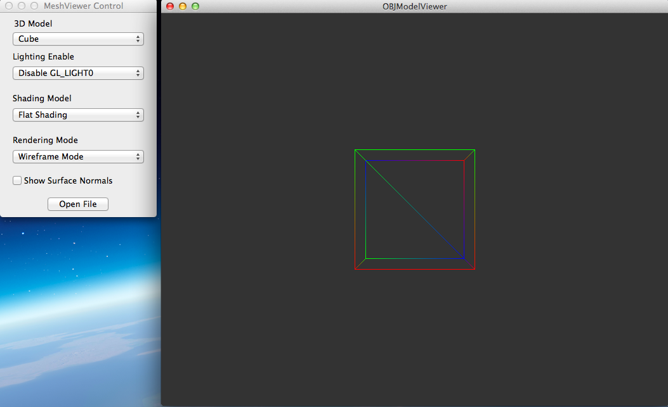

# Application Controls

## MeshViewer Control

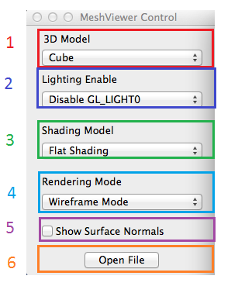

* Item 1 is a popup box that is loaded with a list of sample 3D models in the OBJ file format.
* Item 2 has two options “Disable GL_LIGHT0” and “Enable GL_LIGHT0”, which turns on or off the lighting.
* Item 3 has two options “Flat Shading” and “Smooth Shading”.
* Item 4 offers two rendering options “Wireframe Mode” and “Solid Mode (Triangles)”.
* Item 5 enables or disables the drawing of the surface normals.
* Item 6 allows the selection of a OBJ file not supplied with the application.

## Mouse Controls

* Clicking and holding down the left mouse button on the 3D model and moving the mouse rotates the 3D model corresponding to the mouse movement.
* Clicking in the OBJModelViewer form and then using the scroll wheel will zoom in and out on the 3D model.