Lahore Garrison University
DHA Phase 6 Lahore



Student Name | Faiqa Altaf
Student Roll No | Fa23/BSCS/155
Section | D
Subject | Web Technology
Instructor Name | Mr. Muhammad Yousaf

CODE:

<!DOCTYPE html>
<html lang="en">
<head>
<meta charset="UTF-8">
<meta name="viewport" content="width=device-width, initial-scale=1.0">
<title>Canvas & SVG Interactive Graphics</title>
<style>
body { text-align: center; font-family: Arial, sans-serif; }
canvas { border: 1px solid black; margin-top: 20px; }
button { margin: 10px; padding: 10px; font-size: 16px; cursor: pointer; }
#drawingCanvas { margin-top: 20px; }
svg { border: 1px solid #ddd; margin-top: 50px; }
</style>
</head>
<body>
<h1>Interactive Drawing App and SVG Animation</h1>

<!-- Drawing App Section -->
<h2>Canvas Drawing App</h2>
<canvas id="drawingCanvas" width="500" height="500"></canvas><br>
<button id="clearBtn">Clear</button>
<button id="saveBtn">Save as Image</button>

<!-- SVG Animation Section -->
<h2>SVG Animation</h2>
<svg width="500" height="500" id="svgCanvas">
<circle id="circle" cx="50" cy="50" r="20" fill="blue"></circle>
</svg>

<script>
// -----------------------------
// Canvas Drawing App Code
// -----------------------------
const canvas = document.getElementById('drawingCanvas');
const ctx = canvas.getContext('2d');

let drawing = false;

// Start drawing when mouse is pressed
canvas.addEventListener('mousedown', (e) => {
drawing = true;
ctx.beginPath(); // Start a new path
ctx.moveTo(e.offsetX, e.offsetY); // Move to mouse position
});

// Draw as mouse moves
canvas.addEventListener('mousemove', (e) => {
if (drawing) {
ctx.lineTo(e.offsetX, e.offsetY); // Draw line
ctx.stroke(); // Render the line
}
});

// Stop drawing when mouse is released
canvas.addEventListener('mouseup', () => {
drawing = false;
});

// Clear canvas functionality
document.getElementById('clearBtn').addEventListener('click', () => {
ctx.clearRect(0, 0, canvas.width, canvas.height); // Clears the entire canvas
});

// Save canvas as image
document.getElementById('saveBtn').addEventListener('click', () => {
const imageUrl = canvas.toDataURL(); // Get the image as a data URL
const a = document.createElement('a');
a.href = imageUrl;
a.download = 'drawing.png'; // Set file name
a.click(); // Trigger download
});

// -----------------------------
// SVG Animation Code
// -----------------------------
const circle = document.getElementById('circle');

// Animate circle using requestAnimationFrame
let x = 50;
let y = 50;
const radius = 20;
let speed = 2;

function animateCircle() {
x += speed; // Move circle horizontally
if (x + radius > 500 || x - radius < 0) {
speed = -speed; // Change direction when it reaches the boundary
}
circle.setAttribute('cx', x); // Update circle's position

requestAnimationFrame(animateCircle); // Recursively call for animation
}

animateCircle(); // Start animation
</script>
</body>
</html>

Output:

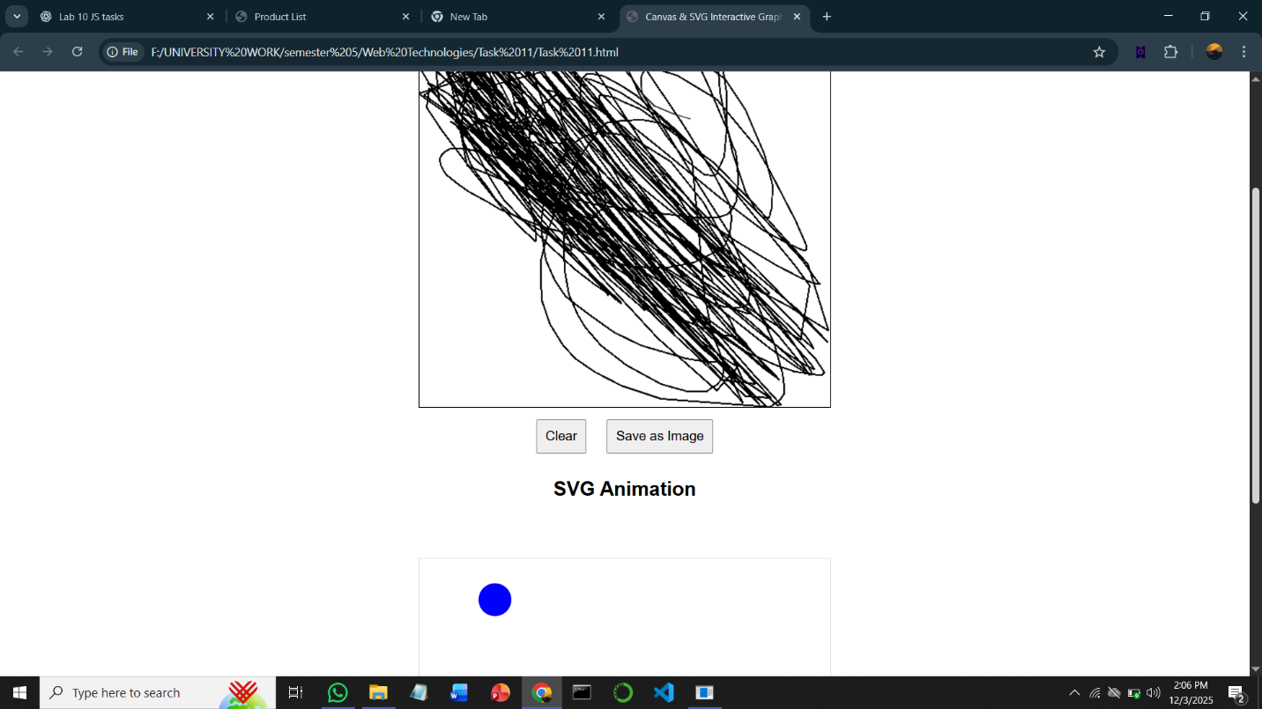

Conclusion:
In this project, we have successfully created an interactive drawing app using the Canvas API and a simple SVG animation using JavaScript. The app allows users to draw on the canvas using mouse events, clear their drawing, and save it as an image. Additionally, the SVG animation smoothly moves a circle across the screen, demonstrating basic animation techniques.

