Lahore Garrison University
DHA Phase 6 Lahore



Student Name | Faiqa Altaf
Student Roll No | Fa23/BSCS/155
Section | D
Subject | Web Technology
Instructor Name | Mr. Muhammad Yousaf

Step1:
Html Code for basic Structure
let products = [];

const fetchData = async () => {
const response = await fetch('https://fakestoreapi.com/products');
products = await response.json();
renderProducts(products);
};

const renderProducts = (products) => {
const productList = document.getElementById('product-list');
productList.innerHTML = '';

products.forEach(({ id, title, price, description, image }) => {
const productDiv = document.createElement('div');
productDiv.classList.add('product');
productDiv.innerHTML = `
<img src="${image}" alt="${title}" />
<h3>${title}</h3>
<p>${description}</p>
<p>Price: $${price}</p>
`;
productList.appendChild(productDiv);
});
};

const searchInput = document.getElementById('search');
searchInput.addEventListener('input', (e) => {
const searchTerm = e.target.value.toLowerCase();
const filteredProducts = products.filter(product =>
product.title.toLowerCase().includes(searchTerm)
);
renderProducts(filteredProducts);
});

const sortSelect = document.getElementById('sort');
sortSelect.addEventListener('change', (e) => {
const sortBy = e.target.value;
let sortedProducts;

if (sortBy === 'name') {
sortedProducts = products.sort((a, b) => a.title.localeCompare(b.title));
} else if (sortBy === 'price') {
sortedProducts = products.sort((a, b) => a.price - b.price);
}

renderProducts(sortedProducts);
});

window.onload = fetchData;

Step2:
JavaScript code:
let products = [];

const fetchData = async () => {
const response = await fetch('https://fakestoreapi.com/products');
products = await response.json();
renderProducts(products);
};

const renderProducts = (products) => {
const productList = document.getElementById('product-list');
productList.innerHTML = '';

products.forEach(({ id, title, price, description, image }) => {
const productDiv = document.createElement('div');
productDiv.classList.add('product');
productDiv.innerHTML = `
<img src="${image}" alt="${title}" />
<h3>${title}</h3>
<p>${description}</p>
<p>Price: $${price}</p>
`;
productList.appendChild(productDiv);
});
};

const searchInput = document.getElementById('search');
searchInput.addEventListener('input', (e) => {
const searchTerm = e.target.value.toLowerCase();
const filteredProducts = products.filter(product =>
product.title.toLowerCase().includes(searchTerm)
);
renderProducts(filteredProducts);
});

const sortSelect = document.getElementById('sort');
sortSelect.addEventListener('change', (e) => {
const sortBy = e.target.value;
let sortedProducts;

if (sortBy === 'name') {
sortedProducts = products.sort((a, b) => a.title.localeCompare(b.title));
} else if (sortBy === 'price') {
sortedProducts = products.sort((a, b) => a.price - b.price);
}

renderProducts(sortedProducts);
});

window.onload = fetchData;

Output:
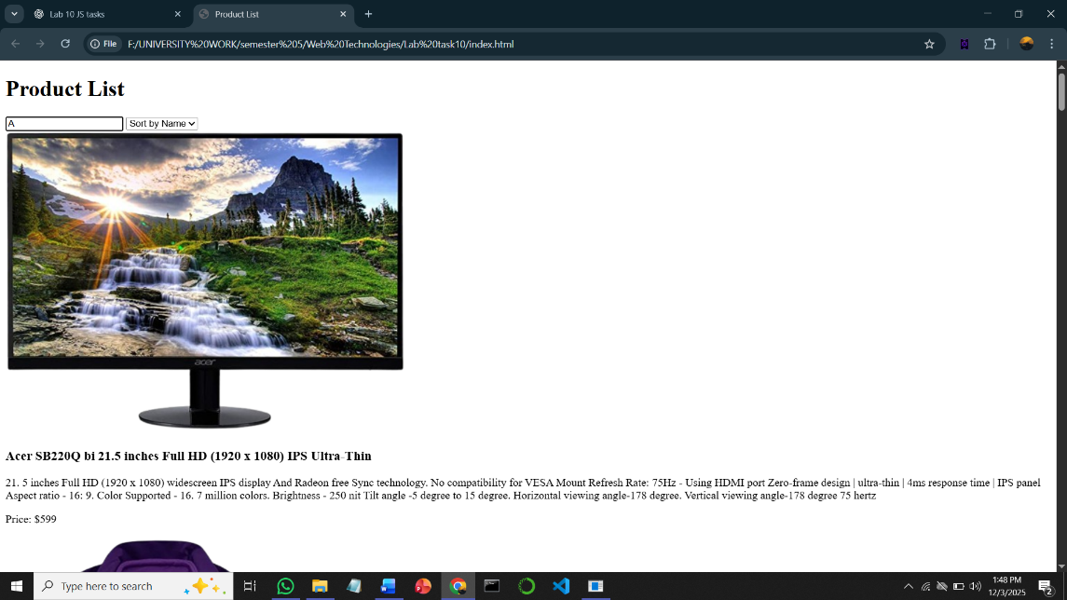
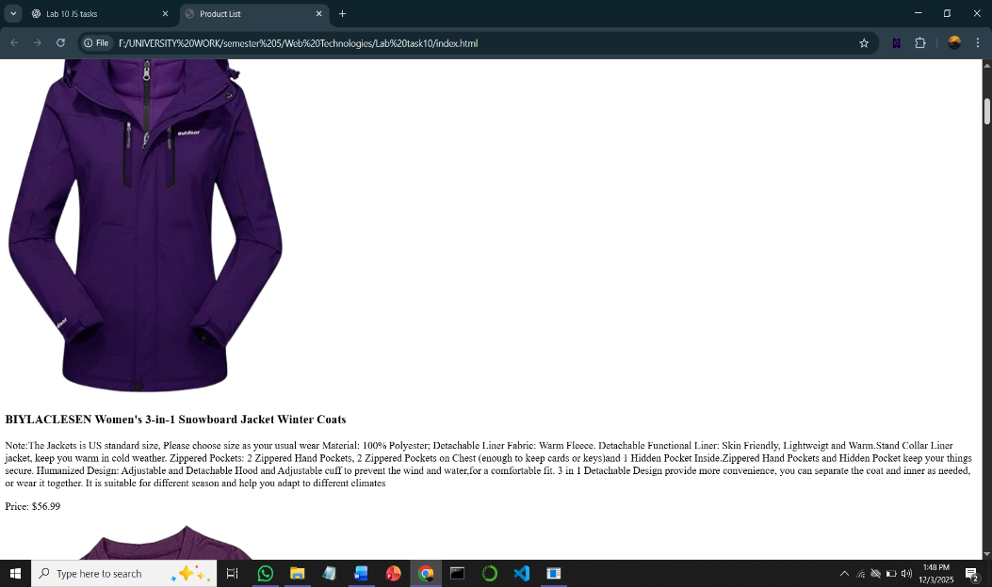
Conclusion:
By following these steps, you will create a simple but fully functional app that demonstrates your understanding of ES6 features and how to manipulate JSON data using JavaScript.
The key components will include:
- Fetching and displaying data from an API.
- Sorting and filtering the displayed data.
- Utilizing modern JavaScript features such as ES6 syntax (let/const, arrow functions, destructuring, etc.).

