Psychology


Assignment: Howard Gardener’s 8 factor

Name: Ali Ahmed
ID: SP11-BCS-071
Teacher: ma’am Shazia Gulzar

Department of Computer Science
COMSATS Institute of Information Technology, Lahore

Musical Intelligence:
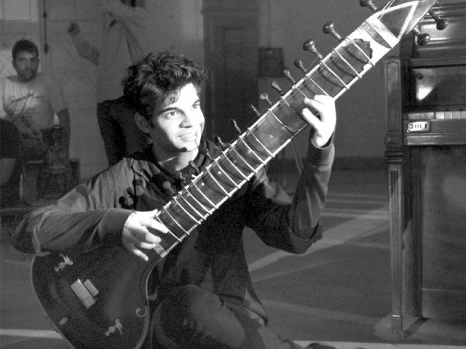
A Pakistan student at Berklee College of Music, Usman Riaz, just 22 years old is a multi-instrumentalist and can play a lot of musical instruments he has been named one of the 12 TED senior fellows who will present at the next four TED conferences, in 2014.
Born in Karachi, he was trained in piano at the early age of six. Later, Riaz taught himself percussive guitar, a style that relies on a sharp striking of both the strings and guitars body as well as harmonica, mandolin, harmonium, and percussion through the Internet due to the scarcity of music teachers in Pakistan.
Usman Riaz’s instrumental version of Junoon’s Saeen is my the one of the best thisng I have heard in a while.

Bodily kinesthetic intelligence

Sheema Kermani is in a league all by herself when it comes to classical dance. She has
been performing for 30 years but every time she is on stage there seems to be a distinct flavour to it. An avid crowd witnesses Kermani perform at the classical dance programme of the All Pakistan Music Conference (APMC).
Kermani’s movements and her posture are rhythmic and in sync with the raagas. Her performance of Pallavi, a dance which celebrates Basant, is greatly appreciated by the audience. Slowly its tempo increased. Kermani told the audience that Pallavi literally means blossoming.
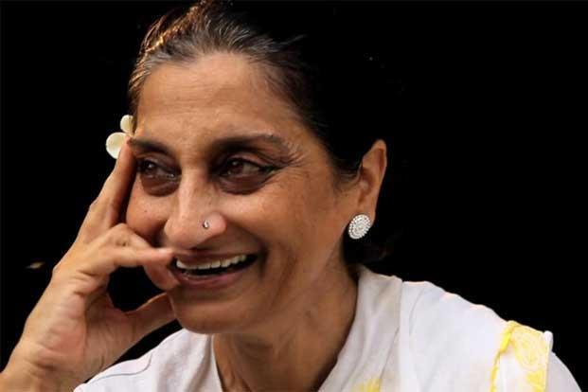
She talks about the transition of a woman from being brought up as a social companion for a man to having a more decisive identity as a human being. She also talks about taking this legacy forward and rethinking what it meant to be a woman in Karachi. The moderator of the session, Anis Haroon, ended the talk by sharing a personal experience from the 1980s, when General Ziaul Haq had put several restrictions on what women should wear.

Spatial intelligence
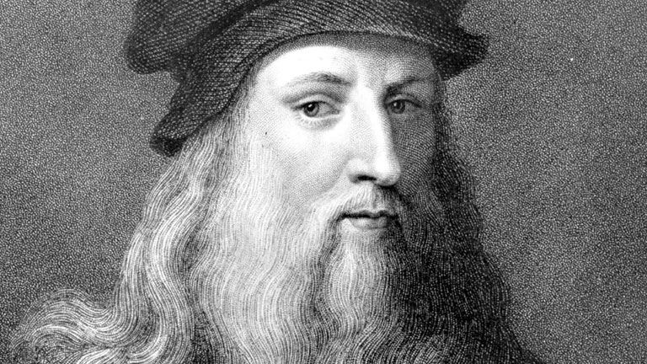
Leonardo Da Vinci, Born out of wedlock to a notary, Piero da Vinci, and a peasant woman, Caterina, in Vinci in the region of Florence, Leonardo was educated in the studio of the renowned Florentine painter Verrocchio. Much of his earlier working life was spent in the service of Ludovico il Moro in Milan. He later worked in Rome, Bologna and Venice, and he spent his last years in France at the home awarded him by Francis I. Leonardo was, and is, renowned primarily as a painter. Among his works, the Mona Lisa is the most famous and most parodied portrait and The Last Supper the most reproduced religious painting of all time, with their fame approached only by Michelangelo's The Creation of Adam. Leonardo's drawing of the Vitruvian Man is also regarded as acultural icon, being reproduced on items as varied as the euro coin, textbooks, and T-shirts. Perhaps fifteen of his paintings have survived, the small number because of his constant, and frequently disastrous, experimentation with new techniques, and his chronic procrastination. Nevertheless, these few works, together with his notebooks, which contain drawings, scientific diagrams, and his thoughts on the nature of painting, compose a contribution to later generations of artists rivalled only by that of his contemporary, Michelangelo. Leonardo is revered for his technological ingenuity. He conceptualised flying machines, an armoured vehicle,concentrated solar power, an adding machine, and the double hull, also outlining a rudimentary theory of plate tectonics. Relatively few of his designs were constructed or were even feasible during his lifetime, but some of his smaller inventions, such as an automated bobbin winder and a machine for testing the tensile strength of wire, entered the world of manufacturing unheralded. He made important discoveries in anatomy, civil engineering, optics, and hydrodynamics, but he did not publish his findings and they had no direct influence on later science.

Iinterpersonal intelligence
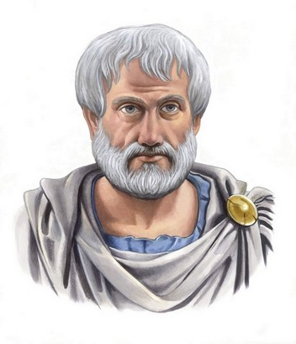
Aristotle was a Greek philosopher and scientist born in the Macedonian city of Stagirus, in 384 BCE. His father, Nicomachus, died when Aristotle was a child, whereafter Proxenus of Atarneus became his guardian. At eighteen, he joined Plato's Academy in Athens and remained there until the age of thirty-seven (c. 347 BCE). His writings cover many subjects – including physics, biology,zoology, metaphysics, logic, ethics, aesthetics, poetry, theater, music, rhetoric, linguistics, politics and government – and constitute the first comprehensive system of Western philosophy. Shortly after Plato died, Aristotle left Athens and, at the request of Philip of Macedon, tutored Alexander the Great between 356 and 323 BCE. According to theEncyclopdia Britannica, "Aristotle was the first genuine scientist in history every scientist is in his debt.Aristotle's psychology, given in his treatise On the Soul (peri psyche, often known by its Latin title De Anima), posits three kinds of soul ("psyches"): the vegetative soul, the sensitive soul, and the rational soul. Humans have a rational soul. This kind of soul is capable of the same powers as the other kinds: Like the vegetative soul it can grow and nourish itself; like the sensitive soul it can experience sensations and move locally. The unique part of the human, rational soul is its ability to receive forms of other things and compare them. For Aristotle, the soul (psyche) was a simpler concept than it is for us today. By soul he simply meant the form of a living being. Because all beings are composites of form and matter, the form of living beings is that which endows them with what is specific to living beings, e.g. the ability to initiate movement (or in the case of plants, growth and chemical transformations, which Aristotle considers types of movement.

intrapersonal intelligence
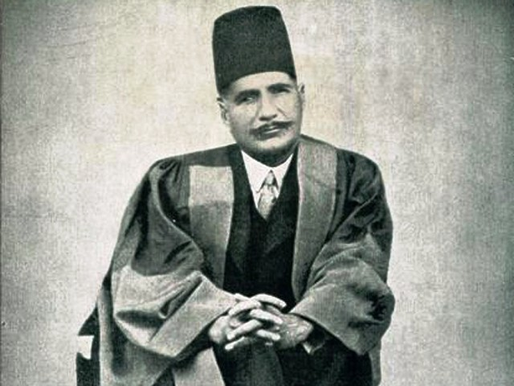
Sir Muhammad Iqbal widely known as Allama Iqbal was a philosopher, poet and politician in British India who is widely regarded as having inspired the Pakistan Movement. He is considered one of the most important figures in Urdu literature, with literary work in both the Urduand Persian languages. He is the national poet of Pakistan and Iran. Iqbal was born in Sialkot on 9 November 1877 within the Punjab Province of British India (now in Pakistan).
Iqbal’s “Asrare-i-Khudi” and famous “Bal-i-Jibreel” enjoy mass popularity in Iran and are taken as a way of life, while many scholars in Iran have recognized the importance of Iqbal's poetry in inspiring and sustaining the Iranian Revolution of 1979. During the early phases of the revolutionary movement, it was a common thing to see people gathering in a park or corner to listen to someone reciting Iqbal’s blood-warming Persian poetry, that is why people of all ages in Iran today are familiar with at least some of his poetry, notably "Az-zabur-e-Ajam". What Iqbal tries to explain is, his feeling that the physical part of man which is normally predominant, keeps man in a state of forgetfulness. He remains away from self-consciousness. Yet, through effort, he may shed forgetfulness and come to his own. This “coming to his own” is in Iqbal’s words, the emergence of his “I”, his ego, his self. For a while ego may get the better of his carnal companion. As long as this state continues all is not lost. A person asleep, anyway, is not a person dead. But when spiritual element surrenders to that of physical then the “I”, ego or self, meets its death. To remain sleepy is onething, to sleep away, the other.

Logical Mathematical Intelligence
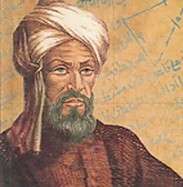
ʿAbdallāh Muḥammad ibn Mūsā al-Khwārizmī was a Persian mathematician, astronomer andgeographer during the Abbasid Caliphate, a scholar in the House of Wisdom in Baghdad.In the twelfth century, Latin translations of his work on the Indian numerals introduced the decimal positional number system to the Western world. His Compendious Book on Calculation by Completion and Balancing presented the first systematic solution of linear and quadratic equations in Arabic. In Renaissance Europe, he was considered the original inventor of algebra, although it is now known that his work is based on older Indian or Greek sources. He revisedPtolemy's Geography and wrote on astronomy and astrology. Some words reflect the importance of al-Khwarizmi's contributions to mathematics. "Algebra" is derived from al-jabr, one of the two operations he used to solve quadratic equations. Algorism and algorithm stem from Algoritmi, the Latinform of his name. His name is also the origin of (Spanish) guarismo and of (Portuguese) algarismo, both meaning digit.On the Calculation with Hindu Numerals written about 825, was principally responsible for spreading the Indian system of numeration throughout the Middle East and Europe. It was translated into Latin as Algoritmi de numero Indorum. Al-Khwārizmī, rendered as (Latin) Algoritmi, led to the term "algorithm". Some of his work was based on Persian and Babylonian astronomy, Indian numbers, and Greek mathematics. Al-Khwārizmī systematized and corrected Ptolemy's data for Africa and the Middle East. Another major book was Kitab surat al-ard ("The Image of the Earth"; translated as Geography), presenting the coordinates of places based on those in the Geography of Ptolemy but with improved values for the Mediterranean Sea, Asia, and Africa. He also wrote on mechanical devices like the astrolabe and sundial. He assisted a project to determine the circumference of the Earth and in making a world map for al-Ma'mun, the caliph, overseeing 70 geographers. When, in the twelfth century, his works spread to Europe through Latin translations, it had a profound impact on the advance of mathematics in Europe.

Linguistic Intelligence

Asad Shabbir (born June 22, 1995, in Ankara, Turkey) is a Pakistani young author. He is best known as the author of the Leo Solay saga, which consists of the book Leo Solay, it was published at his age of 16, which made him the youngest writer. He lived in Berlin, Germany where he wrote his first book and is working on the rest of the saga. He began writing his debut novel at the age of fifteen and published at the age of 16. Leo Solay, his debut work, is the first part in Shabbir's trilogy. The story was ignited and written in Sofia, Bulgaria and completed in Berlin, Germany. The novel was published on November 11, 2011 and released both as a paperback and ebook.
In 2012, work began on a series of short stories in which Shabbir plunges into a mind of a troubled teenager who is contemplating suicide. Ignoring the restricting rules of storytelling, Shabbir crossed the threshold and delved into matter of suicide and self-injury. The result was Entering the Abyss which was released in February 2012. He is currently a student at Lums Lahore and is working on his second book titled Blur and he is a very nice and cool dude.

Naturalist Intelligence
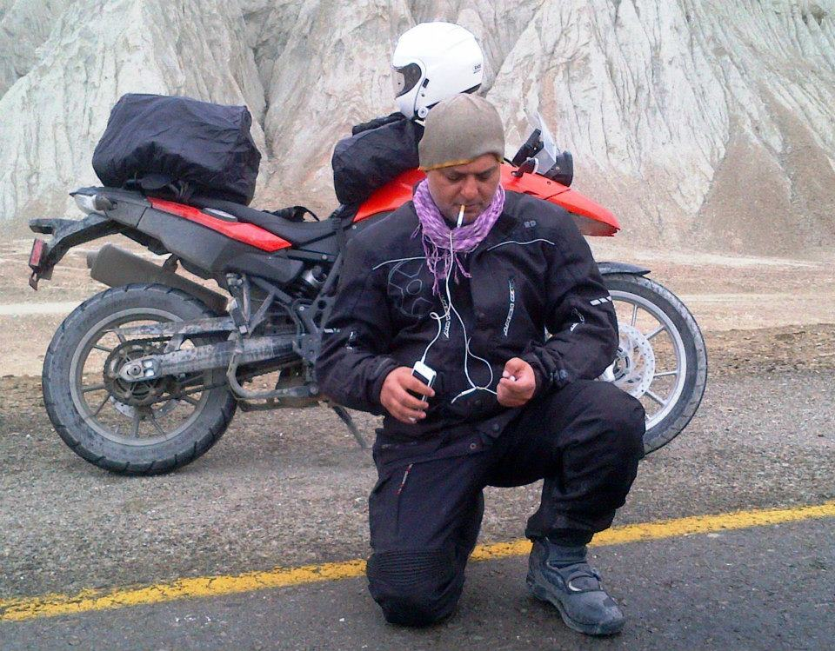
Ali Azmat (born April 20, 1970) is a Pakistani singer-song writer, musician and actor. He is best known as the lead singer for the influential Sufi rock band Junoon and for his subsequent solo career. In 2001, he become the first musician ever to perform at the United Nations General Assembly along with an Indian band choosing to sing his song "Dosti" (English: "Friendship"), an aptly chosen title to promote the UN's mission in bringing peace to the world.
Ali Azmat & Gang on Bike Tour Pakistan on their Heavy Bikes, As a part of Bike Tour Pakistan to explore
the Beauty.

