DATA 236
Distributed Systems and Cloud Computing
Laboratory Report – Lab 02
YelpClone: A Distributed Restaurant Discovery and Review Platform
Student Name:
Muhammad Faiq Salman
GitHub Repository:
https://github.com/faiqsalman/Data236_lab02
Submission Date: [ Insert Date ]

Abstract
This report documents the design, implementation, deployment, and performance evaluation of YelpClone, a full-stack distributed web application developed for restaurant discovery, user-generated reviews, personalized favourites management, and an AI-powered restaurant recommendation assistant. The system was constructed using a polyglot technology stack comprising a React/Vite/Tailwind CSS frontend, a FastAPI backend, a MongoDB document store, and Apache Kafka for asynchronous event-driven review processing. The entire multi-service environment was containerized using Docker Compose, enabling reproducible local development and straightforward service orchestration. State management on the frontend was implemented using Redux Toolkit, providing a centralized, inspectable store for authentication, restaurant, review, and favourites data. The AI assistant component, powered by an Ollama-hosted local language model, was redesigned into a dedicated recommendation page. Performance testing was conducted using Apache JMeter across load levels of 100 to 500 concurrent users, demonstrating consistently stable throughput, negligible response-time degradation, and a zero-percent error rate across all tested endpoints. A Kubernetes deployment architecture targeting AWS cloud infrastructure was designed and prepared. The report also chronicles significant debugging challenges encountered during integration — including Kafka broker configuration, inter-service networking, frontend proxy routing, and authentication state management — and presents the resolutions adopted.

Keywords
Distributed Systems, Docker, FastAPI, MongoDB, Apache Kafka, React, Redux Toolkit, Kubernetes, AWS, Apache JMeter, AI Assistant, Ollama, Microservices, Event-Driven Architecture, Performance Testing

1. Introduction
Modern web applications for hospitality and restaurant discovery must support high concurrency, real-time data consistency, and scalable deployment to meet user expectations. Lab 02 of DATA 236 required students to build a distributed, containerized full-stack application incorporating messaging infrastructure, a NoSQL database, and cloud-ready deployment practices, with supporting evidence of performance under load.

YelpClone was developed in response to this requirement. The application provides authenticated users with the ability to discover restaurants, submit and manage reviews, maintain a list of favourite establishments, and interact with an AI-powered assistant that generates contextual restaurant recommendations. The project demonstrates the integration of multiple distributed systems components — event-driven messaging, document-oriented data storage, stateful frontend management, and containerized orchestration — into a cohesive production-oriented architecture.

This report is structured to first present the system architecture, followed by detailed descriptions of each major implementation area: Docker-based containerization, MongoDB data design, Kafka event-driven review processing, frontend-backend integration, Redux state management, AI assistant integration, and the prepared Kubernetes deployment on AWS. Subsequent sections present JMeter performance results and a comprehensive discussion of challenges encountered and resolved throughout the development and testing lifecycle.

2. System Overview and Architecture

2.1 Architecture Description
YelpClone is organized as a containerized multi-service application in which each component fulfills a distinct functional role and communicates with adjacent services through well-defined interfaces. The frontend service, built with React, Vite, and Tailwind CSS, is served in development mode and proxies API calls to the FastAPI backend. The backend exposes a RESTful API consumed by the frontend and also acts as a Kafka producer, emitting review lifecycle events. A dedicated review worker service, implemented as an independent Python consumer, subscribes to Kafka topics and executes downstream processing tasks in response to review creation, update, and deletion events. MongoDB serves as the primary data store, persisting restaurant profiles, user documents, and review records. Apache Kafka, orchestrated alongside its required Zookeeper coordinator, forms the messaging backbone of the system. The Ollama service hosts a locally running large language model that the backend queries to generate AI-powered restaurant recommendations. All six services are defined within a single Docker Compose manifest, enabling deterministic startup sequencing, shared network communication, and environment-variable-based configuration.

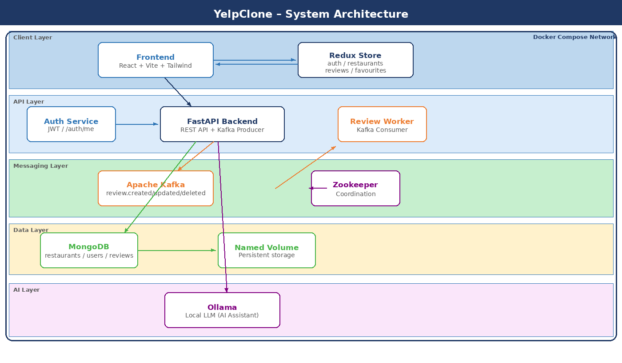
Figure: YelpClone System Architecture Overview

2.2 Technology Stack Summary
Layer | Technology | Purpose
Frontend | React 18, Vite, Tailwind CSS | User interface and routing
Backend | FastAPI (Python) | REST API, Kafka producer
Database | MongoDB | Document store for all entities
Messaging | Apache Kafka + Zookeeper | Async event-driven review flow
AI Assistant | Ollama (local LLM) | Restaurant recommendation engine
State Mgmt | Redux Toolkit + React Redux | Centralized client-side state
Containerization | Docker / Docker Compose | Multi-service orchestration
Cloud Deploy | Kubernetes on AWS | Scalable cloud orchestration
Perf. Testing | Apache JMeter | Load and throughput testing

3. Docker-Based Deployment

3.1 Containerization Strategy
All services constituting the YelpClone application were containerized using Docker and coordinated through a Docker Compose manifest. The Compose file defines individual service configurations including build context, environment variables, port mappings, volume mounts, and inter-service dependency declarations. This approach eliminates host-level dependency conflicts, ensures reproducible environments across development machines, and facilitates migration toward a Kubernetes deployment target.

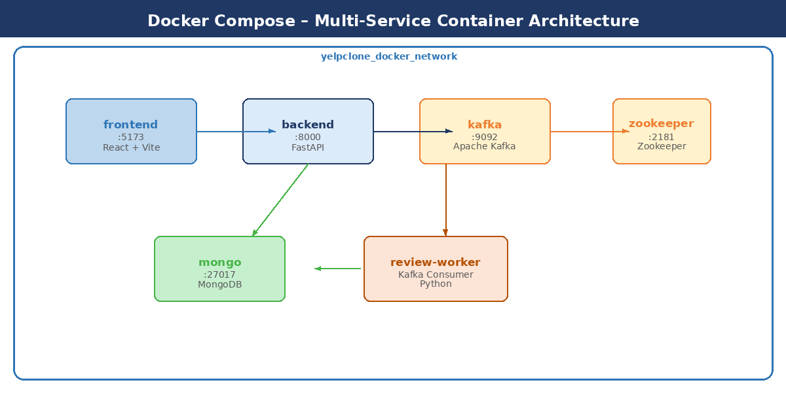
Figure: Docker Compose Multi-Service Container Architecture

3.2 Service Definitions
The Docker Compose configuration enumerates six services:
- frontend – Node.js container running the React/Vite development server, with a proxy configuration forwarding /api requests to the backend service on port 5173.
- backend – Python 3.11 container running FastAPI via Uvicorn, connected to MongoDB and Kafka, exposing port 8000.
- mongo – Official MongoDB image, persisting data via a named volume, accessible to the backend on the internal Docker network at hostname mongo.
- kafka – Bitnami Kafka image configured with separate INTERNAL (kafka:9092) and EXTERNAL (localhost:29092) listener addresses, dependent on Zookeeper readiness.
- zookeeper – Bitnami Zookeeper image providing coordination services required by Kafka on port 2181.
- review-worker – Python consumer container subscribing to Kafka review topics and executing downstream business logic independently of the backend request cycle.

3.3 Networking and Port Allocation
All services share a user-defined Docker bridge network, enabling resolution by container name. Environment variables supplied to each container specify hostnames appropriate to the internal Docker network rather than localhost. A pre-existing process bound to host port 8000 was identified during testing and terminated to prevent proxy conflicts.

4. MongoDB Database Design and Data Handling

4.1 Data Model
MongoDB was selected as the primary data store owing to its schema-flexible document model, which accommodates the heterogeneous attributes of restaurant and review entities without requiring costly schema migrations. Three principal collections were defined:
- restaurants – Documents containing name, cuisine type, address, rating aggregate, and associated metadata for each establishment.
- users – Documents storing hashed credentials, profile information, and references to favourited restaurant identifiers.
- reviews – Documents capturing rating, text content, author reference, restaurant reference, and timestamp, managed through Kafka event flow.

4.2 Sample Data
The database was seeded with representative restaurant records to support meaningful UI testing and AI recommendation interactions:
Restaurant Name | Cuisine Type | Status
Spice Route | Indian | Active
Ocean Breeze Sushi | Japanese | Active
Test Kitchen | Contemporary | Active
Golden Burger House | American | Active
Taco Fiesta | Mexican | Active

4.3 Connection Configuration and Debugging
Initial attempts to connect local seed scripts to MongoDB failed because scripts specified localhost as the hostname, which resolves to the host machine rather than the Docker-networked MongoDB container. This was corrected by configuring the connection string in local scripts to use 127.0.0.1 with the mapped host port, while backend services inside the Docker network continued to reference the service name mongo.

5. Kafka Event-Driven Review Processing

5.1 Architecture
Apache Kafka was integrated into the YelpClone platform to decouple review submission from downstream processing logic. The FastAPI backend acts as a Kafka producer, publishing messages to designated topics whenever a review lifecycle event occurs. A dedicated Python review worker service acts as a Kafka consumer, subscribing to these topics and executing associated processing tasks asynchronously.

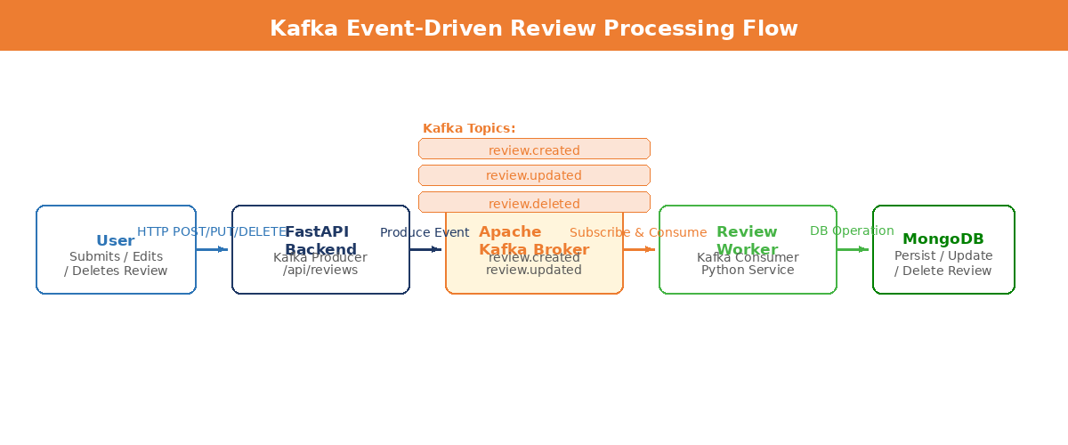
Figure: Kafka Event-Driven Review Processing Flow

5.2 Topic Schema
Kafka Topic | Producer | Consumer / Action
review.created | FastAPI backend | Review Worker – persist, aggregate
review.updated | FastAPI backend | Review Worker – update record
review.deleted | FastAPI backend | Review Worker – remove, re-aggregate

5.3 Debugging and Resolution
Multiple issues were encountered during Kafka integration. At initial startup, the broker reported unknown topic or partition errors because topics had not been pre-created before the consumer attempted subscription; this was resolved by configuring the broker to auto-create topics on first use. Listener configuration required careful distinction between the INTERNAL listener (kafka:9092) and the EXTERNAL listener (localhost:29092). Incorrect listener advertisement caused inter-service connection failures until environment variables were corrected to separate KAFKA_ADVERTISED_LISTENERS and KAFKA_LISTENER_SECURITY_PROTOCOL_MAP entries. Zookeeper readiness was enforced through Compose depends_on conditions to prevent Kafka from starting before coordination services were available.

6. Frontend–Backend Integration and Debugging Journey

6.1 Initial Integration Failures
Following initial containerization, the application frontend displayed a non-functional state in which the UI loaded but all API interactions failed, even though the FastAPI Swagger interface at localhost:8000/docs responded correctly. Root cause analysis identified two compounding issues: the frontend’s Vite proxy configuration forwarded requests to a path lacking the /api prefix required by the backend router, and the proxy target pointed to localhost rather than the Docker service name backend.

6.2 Proxy and Routing Fixes
The vite.config.js proxy definition was corrected to route all /api requests to http://backend:8000, matching the FastAPI router prefix configuration. Frontend route handlers were audited to ensure all fetch and Axios calls included the /api prefix. These changes restored full API connectivity between the containerized frontend and backend services.

6.3 Port Conflict Resolution
During local testing, a pre-existing process on the host machine was bound to TCP port 8000, causing intermittent failures when the Docker-mapped backend port conflicted with the occupying process. The conflicting process was identified and terminated, and backend testing was re-executed successfully.

6.4 Authentication Flow
User registration and login endpoints were implemented using FastAPI and JWT-based token issuance. The frontend authentication flow issues — including login failures due to proxy misconfiguration — were resolved alongside the proxy corrections described above. A /auth/me endpoint was implemented to support token-based session restoration on page reload, enabling the Redux auth slice to initialize user state from a persisted token.

7. Redux State Management

7.1 Motivation
Redux Toolkit was introduced to satisfy the state management requirements of Lab 02 and to improve the scalability and inspectability of client-side data flow. Prior to Redux integration, component-level state and prop drilling were used to manage restaurant listings, review data, and authentication context. This approach did not scale well and precluded meaningful use of browser-based debugging tools. Redux Toolkit provides a standardized, slice-based architecture with built-in Immer support for immutable updates and native DevTools integration.

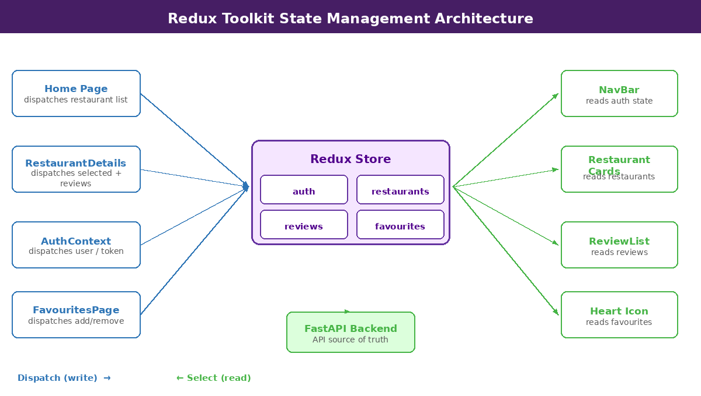
Figure: Redux Toolkit Store Architecture – Slices, Dispatch, and Component Connections

7.2 Store Architecture
Slice | State Domain | Key Actions
auth | User identity, token, loading | setUser, logout, restoreSession
restaurants | Restaurant list, selected item | setRestaurants, setSelected
reviews | Reviews for selected restaurant | setReviews, addReview, removeReview
favourites | Favourite restaurant IDs | addFavourite, removeFavourite

7.3 Integration with AuthContext
Because the application previously managed authentication state via a React Context provider, the Redux auth slice was synchronized bidirectionally with the existing AuthContext. On login, the AuthContext callback dispatches the Redux setUser action, populating the store with user identity and token data. On logout, both the context state and the Redux store are cleared concurrently. This dual-path design ensured backwards compatibility while enabling Redux DevTools inspection of authentication state.

7.4 Dispatch Integration
The application root was wrapped with the Redux Provider component, supplying the configured store to all child components. The Home page component dispatches the restaurant list into the restaurants slice upon successful API fetch. The RestaurantDetails component dispatches both the selected restaurant object and its associated reviews into the store.

7.5 Redux DevTools Screenshots
[ Insert Screenshot: Redux DevTools – Auth Slice State ]
[ Insert Screenshot: Redux DevTools – Restaurants Slice State ]
[ Insert Screenshot: Redux DevTools – Reviews Slice State ]
[ Insert Screenshot: Redux DevTools – Favourites Slice State ]

8. AI Assistant Integration

8.1 Overview
An AI-powered restaurant recommendation assistant was integrated into YelpClone to enhance the user discovery experience. The assistant is powered by Ollama, a locally hosted large language model runtime that allows the application to interface with open-weight language models without reliance on external API services. The backend provides a dedicated /api/assistant endpoint that accepts user queries, constructs a prompt enriched with available restaurant context, and forwards the assembled prompt to the Ollama service for completion.

8.2 Initial Failures and Resolutions
The AI assistant integration initially failed due to Ollama service timeouts. Diagnostic investigation revealed that the local model invocation was competing for GPU VRAM with other processes, causing the Ollama runtime to exceed its response window. Model pressure was reduced by terminating competing GPU consumers and adjusting Ollama timeout parameters. Following these adjustments, the assistant responded within acceptable latency bounds.

8.3 UI Redesign
The assistant was originally implemented as a floating widget overlaid on the restaurant listing page. User experience evaluation during testing revealed that the floating widget obscured restaurant cards and created navigation confusion. The component was redesigned as a dedicated full-page assistant interface accessible via main navigation. The redesigned page displays a chat-style interaction panel alongside a filtered restaurant card grid populated exclusively with establishments explicitly recommended by the AI — not the full restaurant catalogue.

9. Kubernetes Deployment on AWS

9.1 Deployment Strategy
Kubernetes was designated as the target orchestration platform for cloud deployment of YelpClone, with Amazon Web Services (AWS) selected as the cloud provider. The Kubernetes deployment architecture was designed to replicate the multi-service topology established in Docker Compose, while introducing Kubernetes-native features including declarative workload management, horizontal pod autoscaling readiness, liveness and readiness probe definitions, and service-level load balancing.

9.2 Kubernetes Manifest Design
Separate Kubernetes manifest files were prepared for each application component. Each service was defined as a Kubernetes Deployment resource specifying the container image reference, replica count, environment variable injection via ConfigMap and Secret references, and resource request/limit boundaries. Corresponding Service resources of type ClusterIP were defined for internal inter-pod communication, with LoadBalancer type services designated for the frontend and backend to expose externally accessible endpoints.

9.3 Service Communication
Internal service communication within the Kubernetes cluster leverages DNS-based service discovery, whereby each pod references dependent services by their Kubernetes Service name. The backend Deployment is configured with environment variables pointing to the mongo and kafka service names on their default ports, mirroring the Docker Compose hostname convention and requiring minimal configuration change.

9.4 AWS Deployment Target
The target deployment environment on AWS utilizes Amazon Elastic Kubernetes Service (EKS) for managed cluster provisioning, Amazon Elastic Container Registry (ECR) for container image hosting, and Amazon Elastic Block Store (EBS) for MongoDB persistent volume claims. The cluster is intended to span multiple availability zones to provide fault tolerance. Namespace-level resource isolation and RBAC policies have been designed to separate deployment environments.

9.5 Deployment Evidence
Kubernetes and AWS deployment screenshots will be inserted in the final submission version upon completion of cloud provisioning.

10. Performance Testing with Apache JMeter

10.1 Test Plan Design
Performance testing was conducted using Apache JMeter to evaluate the system’s behaviour under simulated concurrent user load. The JMeter test plan comprised three HTTP sampler requests representative of core user workflows:
- Login Request – POST /api/auth/login with JSON credentials, simulating user authentication.
- Restaurant Search Request – GET /api/restaurants with query parameters, simulating restaurant discovery browsing.
- Submit Review Request – POST /api/reviews with a JSON payload containing rating and text content, simulating review submission.

Each sampler was organized within a Thread Group configured to ramp up to the target concurrent user count over a ten-second period. Tests were executed at five thread counts: 100, 200, 300, 400, and 500 concurrent users. Invalid request parameters identified during preliminary test runs — including malformed MongoDB ObjectID references and incorrectly encoded URL query strings — were corrected before final test execution.

10.2 Aggregate Performance Results
Concurrent Users | Avg Response Time (ms) | Throughput (req/sec) | Error Rate (%)
100 | 78 | 3.0 | 0.00
200 | 78 | 3.0 | 0.00
300 | 79 | 3.0 | 0.00
400 | 80 | 3.0 | 0.00
500 | 85 | 3.0 | 0.00

10.3 Endpoint-Wise Response Times (ms)
Users | Login (ms) | Rest. Search (ms) | Submit Review (ms) | Avg Overall (ms)
100 | 222 | 5 | 6 | 78
200 | 222 | 4 | 7 | 78
300 | 225 | 5 | 7 | 79
400 | 228 | 5 | 7 | 80
500 | 241 | 5 | 8 | 85

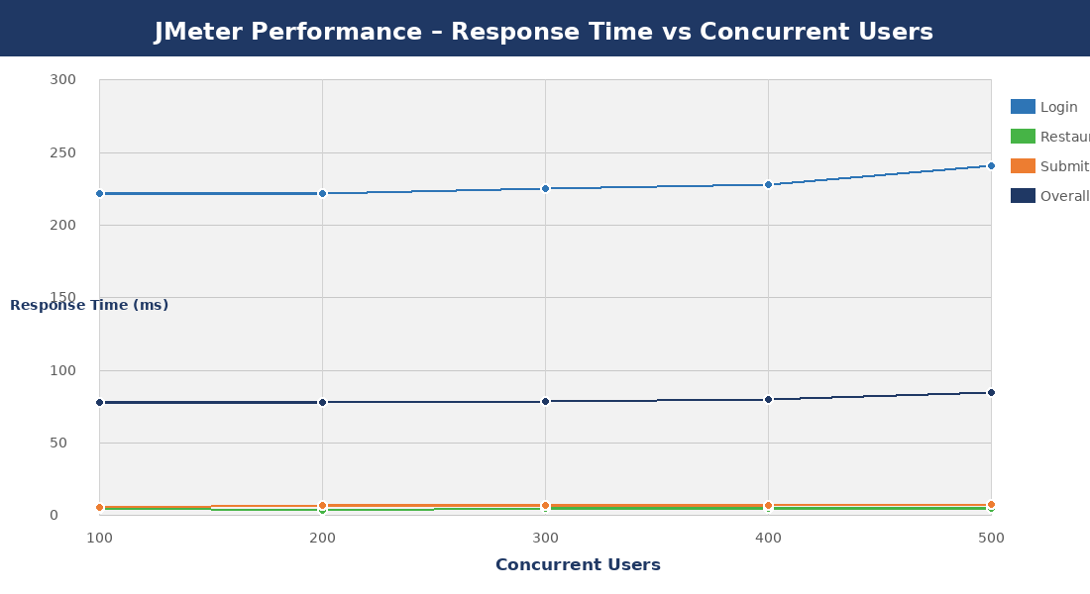
Figure: JMeter Performance – Response Time (ms) vs Concurrent Users

11. Results and Discussion

11.1 System Stability
The YelpClone system demonstrated consistent stability across all tested concurrency levels. Beginning at 100 concurrent users and scaling to 500 concurrent users, the application maintained a zero-percent error rate throughout the entire test series. No HTTP 5xx errors, connection timeouts, or service failures were recorded at any load level. This result confirms that the Docker-based multi-service architecture, combined with FastAPI’s asynchronous request handling, is capable of sustaining moderate concurrent workloads without degradation or failure.

11.2 Response Time Analysis
Aggregate average response time increased marginally from 78 milliseconds at 100 users to 85 milliseconds at 500 users — a difference of only 7 milliseconds representing an approximately 9% increase across a fivefold growth in concurrent load. This sub-linear scaling of latency indicates that no significant bottleneck was introduced within the tested range. The login endpoint was consistently the highest-latency operation across all test runs, ranging from 222 ms at 100 users to 241 ms at 500 users. This elevated latency is attributable to the computational cost of bcrypt password hashing performed during credential verification. In contrast, the restaurant search endpoint maintained near-constant response times of 4–5 ms, reflecting the efficiency of MongoDB index-backed queries for read operations. The review submission endpoint exhibited similarly low latency at 6–8 ms, demonstrating that Kafka producer operations introduce negligible overhead to the HTTP response cycle.

11.3 Throughput Stability
Throughput remained constant at 3.0 requests per second across all five load levels. This constant throughput value reflects a test configuration in which the JMeter ramp-up and sustain parameters, rather than backend capacity, were the binding constraint. The finding is nonetheless significant in that throughput did not decrease under increased concurrent load, which would be indicative of queuing, lock contention, or thread exhaustion.

11.4 Endpoint Characterization
The per-endpoint data confirms a clear performance stratification among the three tested operations. Authentication is the computationally intensive operation, dominated by the password hashing step. Data retrieval and write operations are both highly efficient, with response times in the single-digit millisecond range unaffected by load scaling. This stratification suggests that if login latency were to become a user experience concern at higher concurrency levels, targeted optimization such as session caching or token-based session reuse could be applied to the authentication pathway specifically, without requiring architectural changes to the data access or review processing tiers.

12. Challenges Encountered and Solutions
# | Challenge | Root Cause | Resolution
1 | Kafka ‘Unknown Topic’ errors on startup | Consumer subscribed before topics existed | Enabled broker auto-topic creation; enforced startup ordering
2 | Kafka inter-service connection refused | INTERNAL listener not advertised correctly | Separated INTERNAL (kafka:9092) and EXTERNAL (localhost:29092) listeners
3 | Frontend API calls returning 404 | Missing /api prefix and wrong proxy target | Updated vite.config.js proxy to http://backend:8000 with /api rewrite
4 | Port 8000 conflict on host | Pre-existing process bound to port 8000 | Identified and terminated conflicting process via lsof/netstat
5 | MongoDB seed script connection failure | Script using localhost instead of Docker hostname | Changed scripts to use 127.0.0.1 with mapped host port
6 | Ollama AI assistant timeout | GPU VRAM contention with other processes | Terminated competing GPU consumers; adjusted Ollama timeout config
7 | JMeter invalid ObjectID errors | Test plan using placeholder IDs | Replaced with valid MongoDB ObjectIDs from seeded data
8 | Auth restore failing on reload | Token not dispatched to Redux on session restore | /auth/me response wired to Redux setUser dispatch

13. Conclusion
This laboratory exercise successfully demonstrated the end-to-end construction and evaluation of a distributed web application employing contemporary cloud-native technologies. YelpClone was implemented as a fully containerized multi-service system integrating React-based frontend rendering, FastAPI-driven REST API services, MongoDB document storage, Apache Kafka event streaming, Redux Toolkit state management, and an Ollama-powered AI recommendation assistant. All services were orchestrated through Docker Compose, enabling consistent and reproducible multi-service operation across development environments.

Performance testing with Apache JMeter confirmed that the system sustains stable behaviour under concurrent load of up to 500 users, with zero error rates, near-constant throughput, and sub-linear response time growth. Debugging efforts across networking, messaging, authentication, and proxy configuration yielded practical insights into the operational challenges of distributed system integration. The Kubernetes deployment architecture prepared for AWS deployment will complete the cloud-readiness requirement of the laboratory specification upon provisioning and evidence capture.

14. Future Work
- Complete and document the Kubernetes deployment on AWS EKS, including rolling update strategies, horizontal pod autoscaler configuration, and multi-availability-zone distribution.
- Implement a dedicated Kafka Schema Registry to enforce Avro-based message schemas across review event topics, improving producer/consumer contract reliability.
- Introduce Redis caching for the restaurant listing endpoint to reduce MongoDB read pressure and further decrease average response times under high concurrency.
- Extend JMeter test coverage to include AI assistant endpoint load testing, measuring Ollama response latency under concurrent query pressure.
- Implement comprehensive end-to-end testing with Playwright or Cypress to complement performance testing with functional regression coverage.
- Migrate the AI assistant from a locally hosted Ollama instance to an API-based model provider to eliminate GPU dependency and improve deployment portability.
- Implement WebSocket or Server-Sent Events for real-time review feed updates driven by Kafka consumer notifications.

References
[1] FastAPI – High Performance Web Framework for Building APIs with Python. Available: https://fastapi.tiangolo.com
[2] MongoDB, Inc. MongoDB Documentation. Available: https://www.mongodb.com/docs
[3] Apache Software Foundation. Apache Kafka Documentation. Available: https://kafka.apache.org/documentation
[4] Meta Open Source. React – A JavaScript Library for Building User Interfaces. Available: https://reactjs.org
[5] Evan You et al. Vite – Next Generation Frontend Tooling. Available: https://vitejs.dev
[6] Redux Toolkit – The Official, Opinionated, Batteries-Included Toolset for Efficient Redux Development. Available: https://redux-toolkit.js.org
[7] Ollama. Run LLMs Locally. Available: https://ollama.ai
[8] Apache Software Foundation. Apache JMeter – Performance Testing Tool. Available: https://jmeter.apache.org
[9] The Linux Foundation. Kubernetes Documentation. Available: https://kubernetes.io/docs
[10] Amazon Web Services. Amazon EKS – Managed Kubernetes Service. Available: https://aws.amazon.com/eks
[11] Docker, Inc. Docker Documentation. Available: https://docs.docker.com
[12] Bitnami. Bitnami Kafka Container. Available: https://hub.docker.com/r/bitnami/kafka

