**CALORIE CALCULATOR**

**INTRODUCTION**

Calorie calculator is a program to let users calculate their daily calorie consumption and also their daily calorie burned to evaluate user’s calorie deficit. The program will get user’s input on their weight, height, age, and gender. From these inputs, the program can calculate the user’s body mass index (BMI), body fat percentage (BFP), lean body mass (LBM), basal metabolic rate (BMR), and rate of weight loss. Basal metabolic rate can also be the daily average calorie needed by the body and this is important for calorie deficit calculation. Rate of weight loss is the maximum recommended rate that a user can set as a goal for their daily weight loss.

Calorie consume differs by the type and total amount of foods, drinks any consumables that users take every day. An estimate of calorific value for these consumables was taken from researches and a database is made. A database for the amount of calorie burned is also made with the user’s duty or exercise and the time spent for the duty/exercise as variables.

**PROBLEM BACKROUND**

There are many people around the world who wants to start losing weight. Having an optimum diet is the best way to lose weight. However, people have difficulty to determine how much calorie have they taken every day. If they know the estimates, then they can make a better dietary plan. Restricting too much on food can also cause some people to get stress. Having a cheat day in the dietary plan will be a great idea to avoid stress. Knowing how much exercise needs to be done to burn back those calories during a cheat day is also a good way to help set up a dietary plan.

People also need a reminder if they ever get overboard with their own diet and exercise as it will not be good for their own health.

Moreover, one of the important things is people need to be able to review their progress after a period of time so they can make an improvement to their dietary plans and exercise. Knowing how much they have achieved along the time can improve their motivation and remove any mistakes that they had done before.

**PROJECT IMPLEMENTATION**

For this project Javafx and Scene Builder was used to create the GUI for the program.

Several formulas are needed to complete the calorie deficit calculation.

The formula used to calculate BMI which is:



The formula used to calculate BFP is:

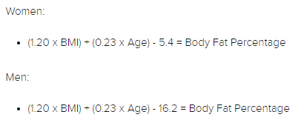

The formula used to calculate LBM is:



*ℓ* = LBM,

m = mass,

*f* = BFP

The formula used to calculate BMR is Katch-McArdle formula:

ref; <https://archive.org/details/exercisephysiolo00mcar>

*BMR = 370 + 21.6(LBM),*

The formula used to calculate RWL is:

$$RWL=\frac{BFP}{100}(\frac{1}{20})×Weight$$

Through a quick research, a small sample of data was taken to acquired the calorific value of food and drinks consumed and also the calorie burned through an amount of exercise done. This data is used to calculate the estiamte total amount of calorie taken or burned by a person in a day. With these data, the estimated calorie deficit can be calculated.

**PROJECT DEPLOYMENT**

This is the flowchart of the program:

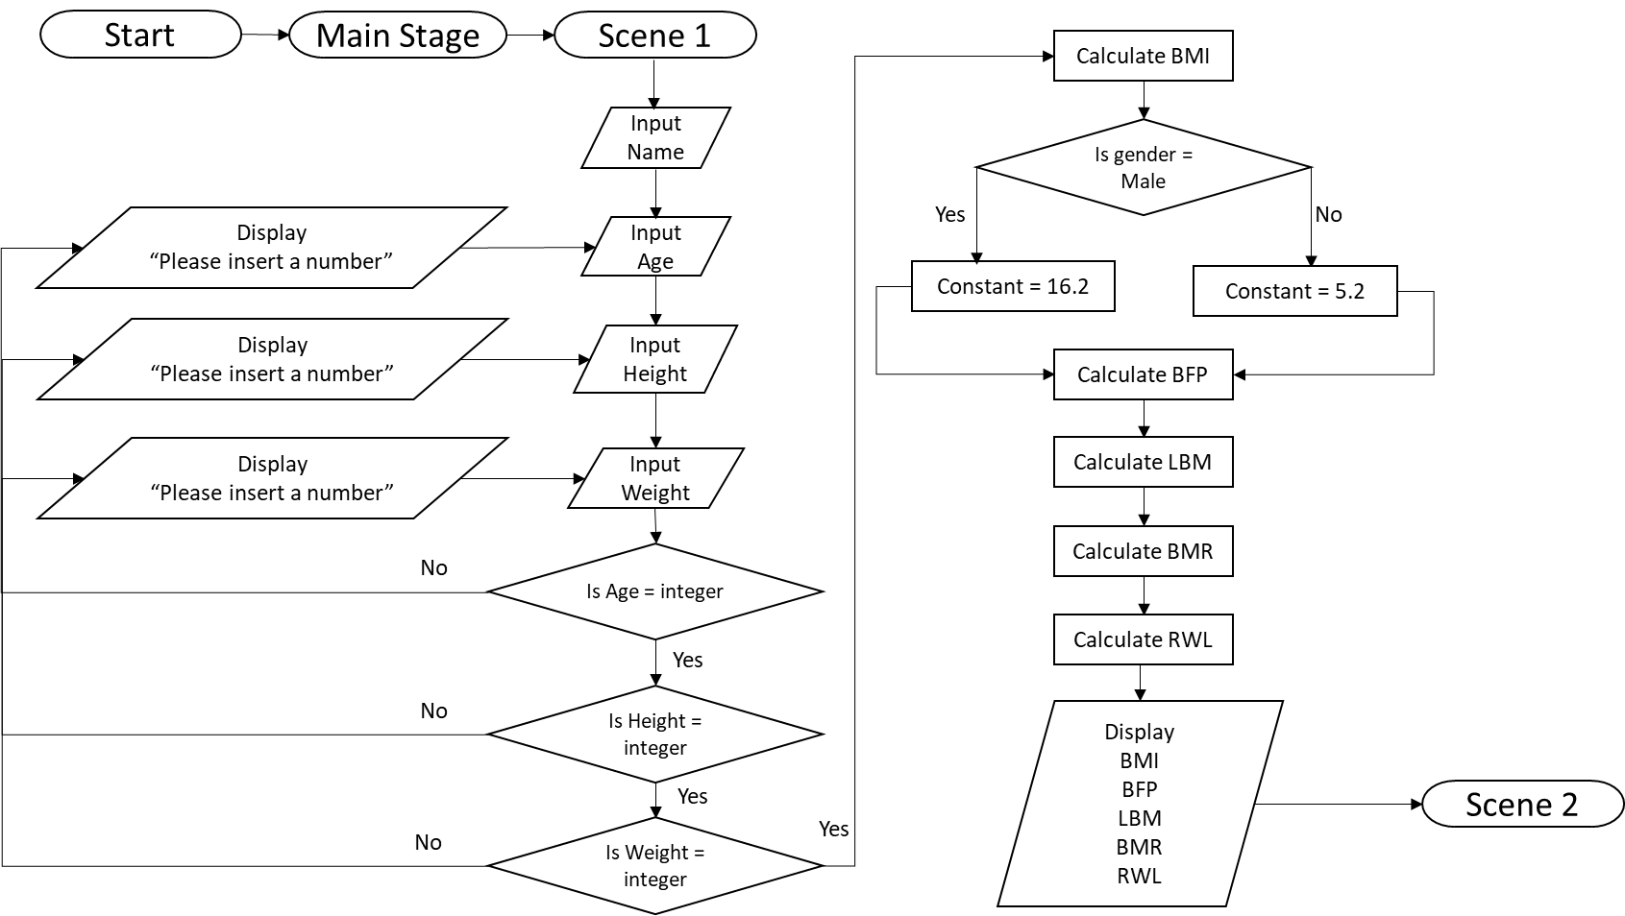

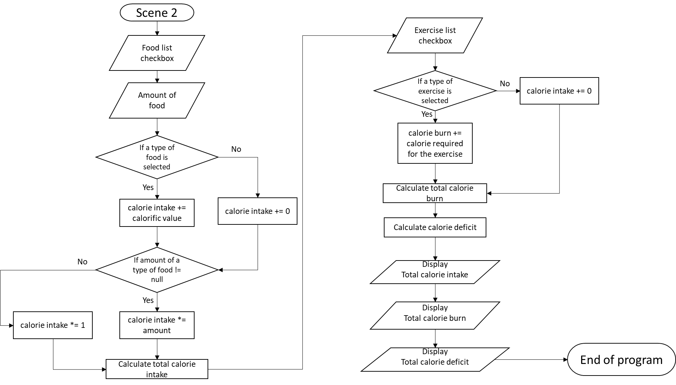

This program is planned to be turned into a mobile application. A mobile application will enable user to access the program easily as user can bring them anywhere. The interface will be improved to be more stylish and more engaging so user can navigate through the app without any complication.

**CONCLUSION**

Calorie calculator is a mobile application that helps user to manage their dietary plan. By inserting several data, the app can calculate the user’s BMI, BFP, and calorie deficit.

In the future, this app will help make a guide for users to start their dietary plan depending on their goal whether it is to loss weight, maintain their fitness or for body building. It will store the user’s data daily and after a period of time for example a week or a month, the app will show a graphical representation of those data to show whether the user is improving or not. It will point out what the user is lacking after it has analyse the user’s data. A big database will be created to store information such as calorific value of food and calorie burned through a certain amount of exercise. This database is important to get a more accurate calculation.