**AnomaData (Automated Anomaly Detection for Predictive Maintenance)**

**Table of Contents**

Abstract…………………………………………………………………………………….. 3

Chapter – 1 5

Introduction 5

1.1 Background and Motivation 5

1.1.1 Background 5

1.1.2 Motivation 5

1.2 Problem Statement 6

1.3 Objectives of the Project 6

1.4 Overview of the Dissertation 7

Chapter – 2 9

Literature Survey 9

2.1 Overview of Predictive Maintenance 9

2.2 Importance of Predictive Maintenance in Various Industries 10

2.3 Techniques and Algorithms for Predictive Maintenance 10

2.4 Previous Studies and Research in Machine Breakdown Prediction 12

Chapter – 3 14

Methodology 14

3.1 Data Collection and Preprocessing 14

3.2 Feature Selection and Engineering 15

3.2.1 Feature Selection 15

3.2.2 Feature Engineering 15

3.3 Overview of Algorithms Used (Logistic Regression, Random Forest, Gradient Boosting, XGBoost, LightGBM) 16

3.3.1 Logistic Regression 16

3.3.2 Random Forest 17

3.3.3 Gradient Boosting 17

3.3.4. XGBoost (Extreme Gradient Boosting) 17

3.3.5. LightGBM 17

3.4 Model Development Process 18

3.5 Evaluation Metrics 19

Chapter – 4 21

Implementation 21

4.1 Overview of Tools and Technologies Used 21

4.2 Data Description 22

4.3 Exploratory Data Analysis 22

4.3.1 Statistical Summary 23

4.3.2 Target Column Distribution 24

4.3.3 Correlation Matrix 25

4.3.4 Standard Scaler 26

4.3.5 K-Best Feature Selection Method 27

4.3.6 SMOTE 28

4.3.7 Splitting Process 29

4.3.8 Logistic Regression 30

4.3.9 Random Forest Classifier 32

4.3.10 XGBoost Classifier 34

4.3.11 Gradient Boosting Classifier 36

4.3.12 LightGBM Model 37

4.3.13 CatBoost Classifier 39

Chapter – 5 41

Results and Discussion 41

5.1 Results and Discussion 41

5.2 Conclusion 42

5.3 Future Scope 42

# **Abstract**

In this Capstone project, we address the crucial need for predictive maintenance solutions across diverse industries to mitigate risks and derive actionable insights from equipment data. Focusing on preemptive measures to prevent system failures, we utilize logistic regression, random forest, gradient boosting, XGBoost, and LightGBM algorithms to predict machine breakdowns by identifying anomalies within a dataset comprising over 18,000 rows collected over several days. Predictive maintenance, achieved through online monitoring, aims to assess equipment condition proactively, enabling timely maintenance interventions before degradation or breakdowns occur. By leveraging advanced machine learning techniques, including LightGBM, this project endeavors to enhance operational efficiency, reduce downtime, and optimize resource utilization, ultimately contributing to improved reliability and cost-effectiveness in industrial settings.

# **Chapter – 1**

# **Introduction**

## **1.1 Background and Motivation**

### **1.1.1 Background**

The rapid advancement of technology has led to an increasing reliance on machinery across various industries. However, with this dependency comes the challenge of ensuring the uninterrupted operation of equipment to maintain productivity and efficiency. Machine breakdowns pose significant disruptions, causing costly downtimes, potential safety hazards, and compromised product quality. Traditional reactive maintenance approaches, where repairs are conducted after equipment failure, are not only costly but also inefficient. Thus, there arises a critical need for predictive maintenance solutions that can preemptively identify potential failures and enable proactive intervention to prevent breakdowns.

### **1.1.2 Motivation**

* Cost Reduction: Machine breakdowns incur substantial financial losses due to unplanned downtime, emergency repairs, and replacement of damaged components. Implementing predictive maintenance can significantly reduce these costs by scheduling maintenance activities during planned downtimes, optimizing spare parts inventory, and minimizing production disruptions.
* Enhanced Operational Efficiency: Predictive maintenance allows for the optimization of equipment performance by identifying and rectifying issues before they escalate into major failures. By continuously monitoring machine health and performance metrics, organizations can streamline maintenance operations, prolong equipment lifespan, and ensure consistent productivity.

By addressing these challenges through the development and implementation of predictive maintenance solutions, this project aims to contribute to the optimization of industrial operations, fostering cost-effectiveness, reliability, and sustainability in various sectors.

## **1.2 Problem Statement**

Many different industries need predictive maintenance solutions to reduce risks and gain actionable insights through processing data from their equipment. Although system failure is a very general issue that can occur in any machine, predicting the failure and taking steps to prevent such failure is most important for any machine or software application. Predictive maintenance evaluates the condition of equipment by performing online monitoring. The goal is to perform maintenance before the equipment degrades or breaks down. This Capstone project is aimed at predicting the machine breakdown by identifying the anomalies in the data. The data we have contains about 18000+ rows collected over few days. The column ‘y’ contains the binary labels, with 1 denoting there is an anomaly. The rest of the columns are predictors.

## **1.3 Objectives of the Project**

The primary objective of this project is to develop and implement a predictive maintenance system for machine breakdown prediction, leveraging advanced machine learning algorithms. The specific objectives include:

* Model Development: Designing and training machine learning models, including logistic regression, random forest, gradient boosting, XGBoost, and LightGBM, to accurately predict potential machine breakdowns based on historical data.
* Data Processing and Feature Engineering: Conducting thorough data preprocessing to clean, normalize, and transform the dataset for effective model training. Additionally, performing feature engineering to extract relevant features and enhance model performance.
* Performance Evaluation: Evaluating the performance of the developed models using appropriate evaluation metrics such as accuracy, precision, recall, and F1-score. Comparing the performance of different algorithms to identify the most effective approach for machine breakdown prediction.
* Integration and Deployment: Integrating the trained models into a cohesive predictive maintenance system capable of real-time monitoring and prediction of machine health. Deploying the system in a practical industrial setting to validate its effectiveness and usability.
* Optimization and Fine-tuning: Fine-tuning model hyperparameters and optimizing the predictive maintenance system to improve accuracy, efficiency, and scalability. Continuously iterating and refining the system based on feedback and performance metrics.

By achieving these objectives, this project aims to demonstrate the feasibility and effectiveness of predictive maintenance in mitigating the risks associated with machine breakdowns, thereby enhancing operational efficiency, reducing downtime, and optimizing resource utilization in industrial environments.

## **1.4 Overview of the Dissertation**

This dissertation presents a comprehensive study on the development and implementation of a predictive maintenance system for machine breakdown prediction. The research focuses on addressing the critical need for preemptive maintenance strategies to mitigate risks, optimize operational efficiency, and enhance reliability across various industries. The dissertation is structured as follows:

* Introduction: This section provides background information on the significance of predictive maintenance and outlines the motivation behind the project. It introduces the problem statement and delineates the objectives of the research.
* Literature Review: A thorough review of existing literature on predictive maintenance techniques, algorithms, and their applications across different industries. This section discusses the importance of predictive maintenance in mitigating machine breakdowns, improving productivity, and reducing operational costs.
* Methodology: The methodology section describes the data collection process, preprocessing steps, and feature engineering techniques employed in the project. It provides an overview of the machine learning algorithms utilized, including logistic regression, random forest, gradient boosting, XGBoost, and LightGBM, along with the model development process and evaluation metrics.
* Data Description: This section provides insights into the dataset used in the study, including its source, characteristics, and exploratory data analysis findings. It highlights key trends, patterns, and anomalies observed in the data.
* Implementation: Details of the implementation process, including tools, technologies, and software platforms used for model training, testing, and integration. It discusses the challenges encountered during implementation and the strategies adopted to address them.
* Results and Discussion: Presentation and analysis of the results obtained from model evaluation and performance testing. A comprehensive discussion on the implications of the findings, including the effectiveness of different algorithms and their practical implications for predictive maintenance in industrial settings.
* Challenges and Limitations: Identification and discussion of the challenges faced during the research process, including data quality issues, computational constraints, and generalization concerns. It also outlines the limitations of the study and areas for future research.
* Conclusion: A summary of the key findings, contributions, and implications of the research. It concludes with reflections on the significance of predictive maintenance in enhancing operational efficiency and recommendations for future studies.

Through this structured approach, the dissertation aims to provide a comprehensive understanding of predictive maintenance techniques and their potential applications in mitigating machine breakdowns, thereby contributing to advancements in industrial maintenance practices.

# **Chapter – 2**

# **Literature Survey**

## **2.1 Overview of Predictive Maintenance**

Predictive maintenance (PdM) is a proactive maintenance strategy aimed at predicting and preventing equipment failures before they occur. Unlike traditional reactive maintenance approaches, which involve repairing or replacing equipment after a breakdown has already happened, predictive maintenance utilizes data analytics, machine learning, and sensor technologies to anticipate issues and schedule maintenance activities accordingly.

At the core of predictive maintenance is the continuous monitoring of equipment health and performance metrics in real-time or near-real-time. This monitoring involves collecting and analyzing data from various sensors, such as temperature, pressure, vibration, and oil analysis, to detect early signs of degradation or anomalies that may indicate impending failures.

The key components of a predictive maintenance system include:

* Data Collection: Continuous gathering of data from sensors, equipment logs, and other sources to monitor the condition and performance of assets.
* Data Analysis: Processing and analyzing the collected data using statistical techniques, machine learning algorithms, and domain knowledge to identify patterns, trends, and anomalies indicative of potential failures.
* Failure Prediction: Utilizing the insights gained from data analysis to predict when equipment failures are likely to occur, allowing for proactive intervention and maintenance scheduling.
* Maintenance Optimization: Optimizing maintenance schedules and resource allocation based on predicted failure probabilities, equipment criticality, and operational constraints to minimize downtime and maximize asset availability.

By leveraging predictive maintenance techniques, organizations can achieve several benefits, including reduced maintenance costs, increased equipment reliability, improved operational efficiency, and enhanced safety. Predictive maintenance is widely adopted across various industries, including manufacturing, energy, transportation, healthcare, and utilities, to optimize asset management practices and drive business performance.

## **2.2 Importance of Predictive Maintenance in Various Industries**

Predictive maintenance (PdM) is pivotal in industries spanning manufacturing, transportation, energy, healthcare, and utilities, due to its capability to enhance operational efficiency, minimize downtime, and optimize resource utilization. Its significance lies in several key aspects. Firstly, PdM enables a shift from reactive to proactive maintenance practices, substantially reducing maintenance costs associated with unplanned downtime, emergency repairs, and spare parts inventory. By identifying and addressing potential equipment failures beforehand, predictive maintenance helps curtail repair expenses and extend asset lifespan. Secondly, by continuously monitoring equipment health and performance metrics, predictive maintenance facilitates early detection of degradation or anomalies, enabling timely intervention to prevent failures and enhance equipment reliability. This proactive approach ensures consistent operational performance, particularly in critical applications. Additionally, predictive maintenance supports data-driven decision-making regarding maintenance activities, asset prioritization, and resource allocation, optimizing maintenance schedules, streamlining workflows, and enhancing asset utilization and productivity. Furthermore, by preventing equipment failures that could pose safety risks to personnel or the environment, predictive maintenance contributes to maintaining a safe working environment and regulatory compliance. Ultimately, organizations adopting predictive maintenance gain a competitive advantage by minimizing operational disruptions, maximizing asset availability, and delivering superior service levels to customers, thereby strengthening brand reputation and driving business growth in a competitive market landscape.

## **2.3 Techniques and Algorithms for Predictive Maintenance**

Predictive maintenance relies on a variety of techniques and algorithms to analyze data, detect anomalies, and predict equipment failures. These techniques leverage advanced data analytics, machine learning, and statistical modeling to extract insights from historical and real-time data streams. Some of the key techniques and algorithms used in predictive maintenance include:

* Machine Learning Algorithms: Machine learning algorithms play a central role in predictive maintenance by learning patterns and relationships from historical data to make predictions about future equipment behavior. Common machine learning algorithms include logistic regression, decision trees, random forest, support vector machines (SVM), k-nearest neighbors (KNN), gradient boosting machines (GBM), and artificial neural networks (ANN). These algorithms are trained on historical maintenance records, sensor data, and equipment operating conditions to identify patterns indicative of impending failures.
* Statistical Modeling: Statistical modeling techniques, such as time series analysis, survival analysis, and reliability analysis, are employed to analyze the probability of equipment failure over time. Time series analysis techniques, including autoregressive integrated moving average (ARIMA) and exponential smoothing methods, are used to model the temporal behavior of equipment metrics and detect trends, seasonality, and irregularities. Survival analysis techniques, such as Kaplan-Meier estimation and Cox proportional hazards model, are used to analyze time-to-failure data and estimate the probability of failure at a given time. Reliability analysis techniques assess the reliability and availability of equipment systems based on failure data and maintenance history.
* Anomaly Detection: Anomaly detection techniques are utilized to identify unusual patterns or deviations from normal behavior in equipment data. These techniques include statistical methods like z-score analysis, Mahalanobis distance, and kernel density estimation, as well as machine learning-based approaches such as isolation forests, one-class support vector machines (OCSVM), and autoencoders. Anomalies detected through these techniques may indicate potential equipment malfunctions or degradation, prompting further investigation and preventive action.
* Deep Learning: Deep learning techniques, particularly convolutional neural networks (CNNs) and recurrent neural networks (RNNs), are increasingly being applied to predictive maintenance tasks, especially in scenarios with high-dimensional sensor data or sequential data streams. CNNs are effective in extracting spatial features from sensor data, while RNNs are well-suited for modeling temporal dependencies in sequential data, such as time series sensor readings or equipment operation logs.

By leveraging these techniques and algorithms, predictive maintenance systems can effectively identify and predict equipment failures, enabling proactive maintenance interventions and optimizing asset performance and reliability across various industries.

## **2.4 Previous Studies and Research in Machine Breakdown Prediction**

Previous studies and research in machine breakdown prediction have made significant strides in advancing predictive maintenance techniques and algorithms, contributing to improved reliability, reduced downtime, and enhanced operational efficiency across various industries.

One area of research focus has been on developing robust predictive models capable of accurately forecasting equipment failures before they occur. Numerous studies have explored the application of machine learning algorithms such as logistic regression, decision trees, random forest, support vector machines, and neural networks for predicting machine breakdowns based on historical maintenance records, sensor data, and equipment operating conditions. These models leverage features such as equipment usage patterns, sensor readings, environmental factors, and maintenance history to identify early warning signs of impending failures and enable timely intervention.

Additionally, researchers have investigated the integration of advanced data analytics techniques, including anomaly detection, time series analysis, and survival analysis, into predictive maintenance frameworks. Anomaly detection methods are employed to identify unusual patterns or deviations from normal behavior in equipment data, serving as early indicators of potential faults or anomalies. Time series analysis techniques are utilized to model the temporal behavior of equipment metrics and detect trends, seasonality, and irregularities, while survival analysis techniques assess the probability of failure over time based on time-to-failure data.

Furthermore, studies have explored the application of sensor fusion techniques, where data from multiple sensors are combined to provide a more comprehensive understanding of equipment health and performance. Sensor fusion enables the detection of complex failure modes and the identification of subtle changes in equipment behavior that may precede breakdowns. Moreover, researchers have investigated the use of advanced monitoring technologies such as Internet of Things (IoT) devices, wireless sensor networks, and edge computing platforms to enable real-time data collection, analysis, and decision-making in predictive maintenance systems.

Overall, previous studies and research in machine breakdown prediction have paved the way for the development of sophisticated predictive maintenance solutions capable of proactively identifying and mitigating equipment failures, thereby enhancing asset reliability, reducing maintenance costs, and optimizing operational performance in diverse industrial settings. Continued advancements in predictive maintenance techniques and technologies are expected to further improve the accuracy, efficiency, and scalability of predictive maintenance systems, driving continued innovation and adoption across industries.

# **Chapter – 3**

# **Methodology**

## **3.1 Data Collection and Preprocessing**

Data collection and preprocessing are critical steps in the development of predictive maintenance systems, as they lay the foundation for accurate model training and prediction.

Data Collection: The process begins with gathering relevant data from various sources, including sensors, equipment logs, maintenance records, and historical databases. Data collected typically include sensor readings, equipment operating parameters, maintenance history, environmental conditions, and other relevant variables. Depending on the specific application and industry, data may be collected continuously in real-time or sampled periodically at regular intervals.

Data Preprocessing: Once collected, the raw data undergo preprocessing to ensure quality, consistency, and compatibility for analysis. This involves several key steps:

* Cleaning: Raw data often contain errors, missing values, outliers, or noise that can adversely affect model performance. Cleaning involves identifying and removing or imputing missing values, correcting errors, and filtering out anomalies.
* Normalization/Standardization: To ensure that features are on a similar scale and distribution, normalization or standardization techniques are applied. This helps prevent certain features from dominating the model training process due to differences in magnitude.
* Feature Engineering: Feature engineering involves selecting, transforming, and creating new features from the raw data to enhance model performance. This may include aggregating sensor readings over time intervals, extracting statistical features, encoding categorical variables, and deriving domain-specific features.
* Dimensionality Reduction: In cases where the dataset contains a large number of features, dimensionality reduction techniques such as principal component analysis (PCA) or feature selection methods may be applied to reduce the complexity of the dataset while preserving important information.
* Data Splitting: Finally, the preprocessed data are typically split into training, validation, and test sets to evaluate model performance. This ensures that the model is trained on a portion of the data, validated on another portion to fine-tune hyperparameters, and tested on a separate portion to assess generalization performance.

Overall, data collection and preprocessing are crucial stages in the development of predictive maintenance systems, as they ensure that the data are clean, relevant, and suitable for training accurate and robust machine learning models.

## **3.2 Feature Selection and Engineering**

Feature selection and engineering are essential processes in predictive maintenance, aiming to extract relevant information from raw data and enhance the performance of machine learning models.

### **3.2.1 Feature Selection**

Feature selection involves identifying the most informative and discriminative features from the dataset while discarding irrelevant or redundant ones. This process helps reduce the dimensionality of the data, improve model interpretability, and mitigate the risk of overfitting. Common techniques for feature selection include:

* Univariate Feature Selection: This method evaluates each feature individually based on statistical tests like ANOVA or chi-square tests and selects those with the highest significance scores.
* Recursive Feature Elimination: RFE recursively removes features from the dataset and selects the subset that yields the best model performance, typically using a cross-validation approach.
* Feature Importance: Algorithms like decision trees, random forests, and gradient boosting machines provide feature importance scores, which can be used to rank features based on their contribution to model prediction.
* Embedded Methods: Some machine learning algorithms inherently perform feature selection as part of the model training process, such as LASSO (Least Absolute Shrinkage and Selection Operator) and Elastic Net regularization.

### **3.2.2 Feature Engineering**

Feature engineering involves creating new features or transforming existing ones to capture relevant information and improve model performance. This process relies on domain knowledge, understanding of the underlying physics, and insights from exploratory data analysis. Common techniques for feature engineering include:

* Temporal Aggregation: Aggregating sensor readings or operational data over time intervals (e.g., hourly, daily) to capture trends, seasonality, and periodic patterns.
* Statistical Features: Calculating statistical measures such as mean, median, standard deviation, skewness, and kurtosis to characterize the distribution and variability of data.
* Domain-specific Features: Creating features based on domain expertise and knowledge of the underlying system, such as equipment age, usage patterns, operating conditions, and historical maintenance records.
* Transformation: Applying mathematical transformations such as logarithmic, square root, or exponential transformations to normalize the distribution of features and improve model performance.

By effectively selecting and engineering features, predictive maintenance systems can capture relevant information from the data, enhance model interpretability, and improve the accuracy and robustness of machine learning models, ultimately enabling more accurate predictions of equipment failures and proactive maintenance interventions.

## **3.3 Overview of Algorithms Used (Logistic Regression, Random Forest, Gradient Boosting, XGBoost, LightGBM)**

Predictive maintenance involves the use of various machine learning algorithms to analyze data and predict equipment failures. Each algorithm has its strengths and weaknesses, making them suitable for different types of predictive maintenance tasks. Here, we provide an overview of five key algorithms commonly used in predictive maintenance: Logistic Regression, Random Forest, Gradient Boosting, XGBoost, and LightGBM.

### **3.3.1 Logistic Regression**

Logistic Regression is a simple yet powerful algorithm commonly used for binary classification tasks, making it suitable for predicting binary outcomes such as equipment failure or non-failure. It models the probability of a binary outcome based on one or more independent variables by fitting a logistic curve to the data. Logistic Regression is computationally efficient, interpretable, and resistant to overfitting, making it a popular choice for baseline modeling and as a benchmark for more complex algorithms. However, it may struggle with capturing non-linear relationships and interactions between features, limiting its effectiveness in highly complex predictive maintenance scenarios.

### **3.3.2 Random Forest**

Random Forest is an ensemble learning algorithm that builds multiple decision trees and aggregates their predictions to make more accurate and robust predictions. It is well-suited for predictive maintenance tasks due to its ability to handle high-dimensional data, non-linear relationships, and interactions between features. Random Forest is also resilient to overfitting and can handle missing values and outliers effectively. By combining multiple decision trees, Random Forest can capture complex patterns in the data and provide insights into feature importance, making it valuable for interpretability and feature selection in predictive maintenance applications.

### **3.3.3 Gradient Boosting**

Gradient Boosting is another ensemble learning technique that builds a series of weak learners (typically decision trees) sequentially, where each subsequent learner corrects the errors of the previous one. Gradient Boosting algorithms such as Gradient Boosting Machines (GBM) and Extreme Gradient Boosting (XGBoost) are widely used in predictive maintenance due to their high predictive accuracy and robustness. They can handle complex non-linear relationships, interactions between features, and large-scale datasets efficiently. Gradient Boosting algorithms are also highly customizable, allowing fine-tuning of hyperparameters to optimize performance for specific predictive maintenance tasks.

### **3.3.4. XGBoost (Extreme Gradient Boosting)**

XGBoost is an optimized implementation of Gradient Boosting that offers improved speed, scalability, and performance over traditional Gradient Boosting algorithms. It employs a more efficient tree boosting algorithm and incorporates additional regularization techniques to prevent overfitting and enhance model generalization. XGBoost is highly parallelizable, making it suitable for large-scale predictive maintenance applications with high-dimensional data and complex feature interactions. Its popularity in predictive maintenance stems from its superior performance, interpretability, and ease of use.

### **3.3.5. LightGBM**

LightGBM is a relatively newer gradient boosting framework developed by Microsoft, known for its speed, efficiency, and scalability. It uses a novel gradient-based decision tree splitting algorithm and histogram-based computation to speed up the training process significantly. LightGBM is well-suited for large-scale datasets with high-dimensional features, making it ideal for predictive maintenance tasks involving real-time data streams and distributed computing environments. It offers excellent predictive performance, interpretability, and flexibility, making it a popular choice among data scientists and practitioners in predictive maintenance applications.

In summary, Logistic Regression, Random Forest, Gradient Boosting, XGBoost, and LightGBM are all valuable algorithms in predictive maintenance, each with its unique strengths and capabilities. The choice of algorithm depends on the specific characteristics of the dataset, the complexity of the predictive maintenance task, and the desired trade-offs between predictive accuracy, interpretability, and computational efficiency. By leveraging these algorithms effectively, predictive maintenance systems can accurately predict equipment failures, optimize maintenance schedules, and improve operational efficiency across various industries.

## **3.4 Model Development Process**

The model development process in predictive maintenance involves several key steps to build, train, and evaluate machine learning models capable of accurately predicting equipment failures.

* Data Preparation: The process begins with collecting and preprocessing the data, which includes cleaning, normalizing, and transforming the dataset to ensure its quality, consistency, and compatibility for analysis. This involves handling missing values, outliers, and noise, as well as encoding categorical variables and selecting relevant features for model training.
* Feature Engineering: Next, feature engineering techniques are applied to extract meaningful information from the data and create new features that capture important patterns and relationships. This may involve aggregating sensor readings over time intervals, calculating statistical measures, and deriving domain-specific features based on expert knowledge and insights from exploratory data analysis.
* Model Selection: Once the data is prepared and features are engineered, the next step is to select appropriate machine learning algorithms for model training. This decision is based on factors such as the nature of the predictive maintenance task (e.g., binary classification, regression), the complexity of the data, and the desired trade-offs between predictive accuracy, interpretability, and computational efficiency.
* Model Training: The selected machine learning algorithms are trained on the prepared dataset using techniques such as cross-validation to optimize model hyperparameters and prevent overfitting. During training, the algorithms learn patterns and relationships from the data, adjusting their parameters to minimize prediction errors and maximize predictive performance.
* Model Evaluation: After training, the performance of the trained models is evaluated using appropriate evaluation metrics such as accuracy, precision, recall, F1-score, and area under the ROC curve (AUC-ROC). Models are tested on a separate validation set to assess their generalization performance and identify potential sources of bias or variance.
* Hyperparameter Tuning: To further improve model performance, hyperparameter tuning techniques such as grid search, random search, or Bayesian optimization may be employed to fine-tune model parameters and optimize predictive accuracy.
* Model Deployment: Once a satisfactory model is obtained, it is deployed in a production environment to make real-time predictions on new data. This involves integrating the trained model into the existing predictive maintenance system, ensuring scalability, reliability, and compatibility with operational requirements.

By following this systematic model development process, organizations can build robust predictive maintenance systems capable of accurately predicting equipment failures, optimizing maintenance schedules, and enhancing operational efficiency across various industries.

## **3.5 Evaluation Metrics**

Evaluation metrics play a crucial role in assessing the performance of predictive maintenance models and determining their effectiveness in predicting equipment failures. These metrics provide quantitative measures of model performance, allowing practitioners to compare different models, optimize hyperparameters, and make informed decisions about model deployment. Some commonly used evaluation metrics in predictive maintenance include:

* Accuracy: Accuracy measures the proportion of correctly predicted instances among all instances in the dataset. While accuracy is a straightforward metric to interpret, it may not be suitable for imbalanced datasets, where the majority class dominates the predictions. In predictive maintenance, where the occurrence of equipment failures may be rare, accuracy alone may not provide a comprehensive assessment of model performance.
* Precision and Recall: Precision measures the proportion of true positive predictions among all positive predictions, while recall measures the proportion of true positive predictions among all actual positive instances in the dataset. Precision reflects the model's ability to make accurate positive predictions, while recall reflects its ability to capture all positive instances, including rare events such as equipment failures. Precision and recall are often used together to provide a more balanced assessment of model performance, especially in imbalanced datasets.
* F1-Score: The F1-Score is the harmonic mean of precision and recall and provides a single metric that balances both measures. It is particularly useful in imbalanced datasets, where precision and recall may trade off against each other. The F1-Score ranges from 0 to 1, with higher values indicating better model performance.
* Area Under the ROC Curve (AUC-ROC): AUC-ROC measures the ability of the model to distinguish between positive and negative instances across different threshold settings. It plots the true positive rate (recall) against the false positive rate, with higher AUC values indicating better model discrimination between classes. AUC-ROC is especially useful for binary classification tasks in predictive maintenance, where it provides a comprehensive assessment of model performance across different decision thresholds.
* Confusion Matrix: A confusion matrix summarizes the actual and predicted classifications of the model and provides insights into the types of errors made by the model, such as false positives and false negatives. It is a valuable tool for understanding the strengths and weaknesses of the model and identifying areas for improvement.

By carefully considering these evaluation metrics, practitioners can assess the performance of predictive maintenance models accurately, identify areas for optimization, and make informed decisions about model deployment in operational environments.

# **Chapter – 4**

# **Implementation**

## **4.1 Overview of Tools and Technologies Used**

For this predictive maintenance project, Python is the primary programming language used for data analysis, machine learning model development, and deployment. Python offers a rich ecosystem of libraries and frameworks tailored for data science and machine learning tasks. Libraries such as Pandas and NumPy are utilized for data manipulation and numerical computations, while Scikit-learn provides a comprehensive set of machine learning algorithms and tools for model development and evaluation.

In terms of deployment, the Streamlit framework is employed as the deployment server for the predictive maintenance application. Streamlit is a popular open-source framework for building interactive web applications with Python. It allows developers to create intuitive and visually appealing user interfaces for machine learning models and data-driven applications using simple Python scripts. With Streamlit, predictive maintenance models developed in Python can be seamlessly deployed as web applications, enabling end-users to interact with the models through a browser interface.

By leveraging Python for data analysis and machine learning and deploying the models using Streamlit, this project ensures a streamlined development and deployment process without the need for cloud platforms. This approach simplifies the deployment process and provides a user-friendly interface for end-users to access and utilize the predictive maintenance solution.

## **4.2 Data Description**

The dataset comprises 18,398 entries and 62 columns, offering a substantial volume of data for analysis and modeling. The majority of columns contain numerical data, primarily represented as `float64` for predictor variables and `int64` for anomaly indicators. The presence of non-null entries in each column indicates a complete dataset without any missing values, facilitating streamlined data processing and analysis.

The 'time' column, identified as having an `object` data type, likely holds datetime information, providing temporal context to the observations. This temporal aspect can be pivotal in predictive maintenance, allowing for the identification of patterns and trends over time, essential for predicting equipment failures.

Column naming conventions are consistent, with 'time' serving as the temporal reference point, followed by predictor variables 'x1' to 'x60', and concluding with anomaly indicators 'y' and 'y.1'. However, the absence of an 'x53' column raises questions regarding its omission, suggesting a potential inconsistency or intentional exclusion in the dataset.

This comprehensive overview sets the stage for further exploration and analysis, guiding subsequent steps in data cleaning, feature engineering, and model development. Understanding the data types, column names, and general characteristics provides crucial insights into the dataset's structure and informs decision-making throughout the predictive maintenance project lifecycle.

## **4.3 Exploratory Data Analysis**

### **4.3.1 Statistical Summary**

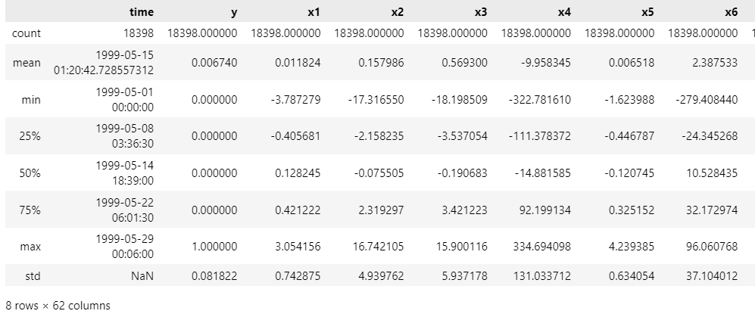

The summary statistics offer valuable insights into the characteristics of the dataset. Across the predictor variables (x1 to x60), there is notable variability in the mean values, standard deviations, and ranges, indicating diverse scales and distributions among the features. This suggests that the dataset encompasses a wide range of data points, each potentially contributing differently to the predictive maintenance task. The 'y' column, representing anomalies, exhibits a mean close to 0, indicating that anomalies are infrequent occurrences within the dataset, as expected in typical anomaly detection scenarios where anomalies are rare events. The considerable variation in standard deviations across predictor variables suggests varying levels of variability in the data features, which may impact model performance. Additionally, the presence of both negative and positive values across predictors implies that the dataset spans different ranges and may require standardization or normalization during preprocessing to ensure fair treatment of features with different scales. These insights lay the groundwork for further exploration through data visualization techniques, which can provide a deeper understanding of the data distribution and relationships among variables.

### **4.3.2 Target Column Distribution**

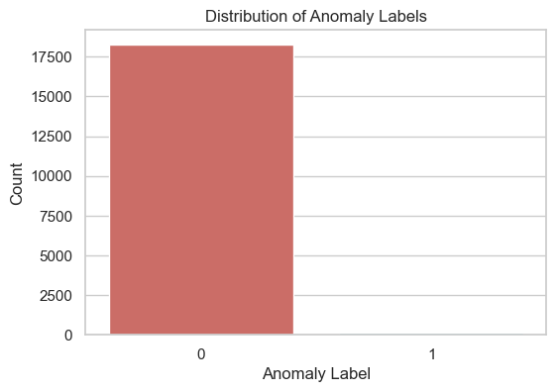

Let's start by visualizing the distribution of the 'y' variable to understand the imbalance in the dataset.

The count plot for the 'y' variable shows a significant imbalance between the number of anomalies (label '1') and normal observations (label '0'). This is typical in anomaly detection scenarios where anomalies are rare events compared to normal operations.

### **4.3.3 Correlation Matrix**

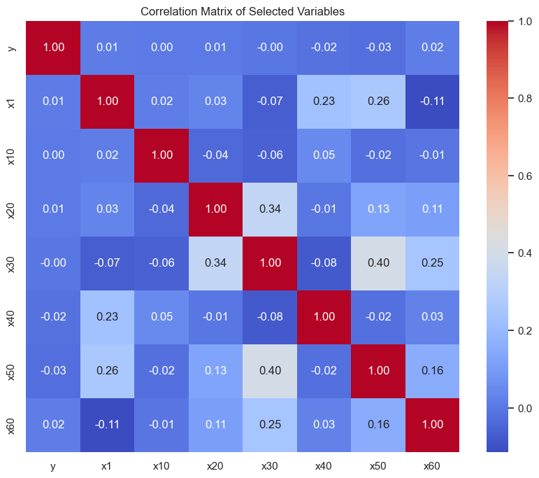

The correlation matrix provides valuable insights into the relationships between variables in the dataset, particularly between predictor variables and the target variable ('y' indicating anomalies). In this case, most predictor variables exhibit low to moderate correlations with each other, indicating that there are no strong linear relationships between them. This suggests that each predictor variable captures distinct aspects of the system's behavior, contributing unique information to the predictive maintenance task.

Additionally, the 'y' variable, which signifies anomalies, also shows low correlations with the selected predictor variables. This implies that predicting anomalies may not solely rely on linear relationships between predictors and the occurrence of anomalies. Instead, anomalies might be influenced by more complex patterns or interactions between multiple variables. This complexity underscores the challenges inherent in anomaly detection tasks, where anomalies may be subtle, sporadic, or influenced by various factors beyond simple linear relationships.

These insights highlight the need for sophisticated modeling approaches that can capture nonlinear relationships and interactions between variables effectively. As such, the findings from the correlation matrix guide subsequent steps in data cleaning, feature engineering, and model selection, emphasizing the importance of addressing the identified challenges and leveraging patterns in the data for accurate anomaly detection.

### **4.3.4 Standard Scaler**

The StandardScaler is a preprocessing technique commonly used in machine learning to standardize the features of a dataset. Standardization involves transforming the features such that they have a mean of 0 and a standard deviation of 1. This process is crucial when dealing with datasets where features have different scales and units, as it ensures that all features contribute equally to the modeling process.

The StandardScaler works by subtracting the mean value of each feature from the dataset and then dividing by the standard deviation of the feature. This transformation effectively centers the data around 0 and scales it to have a standard deviation of 1. As a result, the transformed features will have a similar scale and variance, making them comparable and preventing features with larger magnitudes from dominating the modeling process. Standardization is particularly beneficial for algorithms that rely on distance-based metrics, such as K-Nearest Neighbors (KNN) and Support Vector Machines (SVM). By standardizing the features, these algorithms can better capture the underlying structure of the data and make more accurate predictions. Additionally, standardization can also help improve the performance of gradient-based optimization algorithms, such as those used in neural networks. Standardizing the features can accelerate convergence during training and prevent numerical instability issues caused by features with vastly different scales.

In summary, the StandardScaler is a fundamental preprocessing technique in machine learning that helps ensure the robustness and effectiveness of models by standardizing the features, making them comparable and facilitating better model performance across various algorithms and optimization techniques.

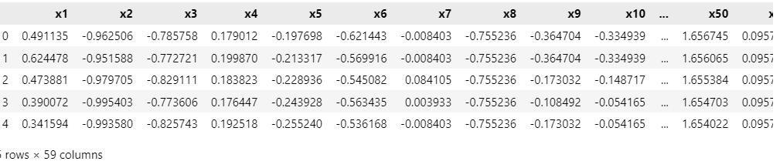

### **4.3.5 K-Best Feature Selection Method**

The K-best feature selection method is a technique used in machine learning to select the top k most relevant features from a dataset based on their statistical significance or predictive power. This method aims to reduce the dimensionality of the feature space by retaining only the most informative features, thereby improving model performance and reducing computational complexity.

The K-best feature selection method typically involves evaluating the relevance of each feature using statistical tests or scoring metrics, such as analysis of variance (ANOVA), mutual information, or the F-score. These metrics quantify the relationship between each feature and the target variable, helping to identify the most discriminative features for the given task.

Once the features are scored, the K-best feature selection method selects the top k features with the highest scores, discarding the remaining features. The value of k is often determined through cross-validation or domain knowledge, balancing the trade-off between model complexity and predictive performance.

By selecting only the most relevant features, the K-best feature selection method can improve model interpretability, reduce overfitting, and enhance computational efficiency, making it a valuable preprocessing technique in machine learning pipelines.

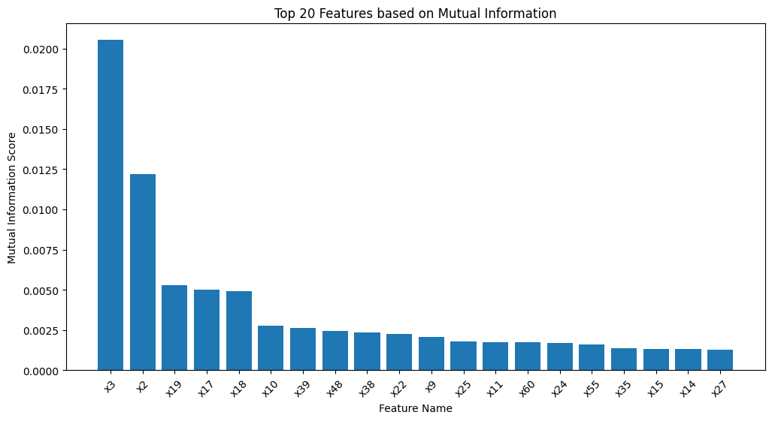

### **4.3.6 SMOTE**

The Synthetic Minority Over-sampling Technique (SMOTE) algorithm is a popular method used to address class imbalance in machine learning datasets, particularly in binary classification tasks where one class (the minority class) is significantly underrepresented compared to the other (the majority class). Class imbalance can lead to biased models that prioritize the majority class and perform poorly in accurately predicting instances of the minority class. SMOTE works by generating synthetic samples for the minority class to balance the class distribution. It does so by identifying minority class instances and creating synthetic examples along the line segments joining any/all of the k minority class nearest neighbors. This is done in feature space, thus creating new instances that are combinations of existing minority class instances. By synthesizing new instances rather than simply duplicating existing ones, SMOTE helps to mitigate the risk of overfitting and improve the generalization ability of the classifier. This is because it introduces diversity into the minority class, making the model more robust to variations in the data distribution.

However, it's important to note that SMOTE may not always be suitable for every dataset or classification problem. For example, in cases where the minority class is inherently noisy or where there is high overlap between the minority and majority classes, SMOTE may introduce synthetic examples that are not representative of the true underlying distribution, leading to degraded performance. Additionally, the choice of the parameter k (number of nearest neighbors) in SMOTE can impact the effectiveness of the technique and may require careful tuning through experimentation.

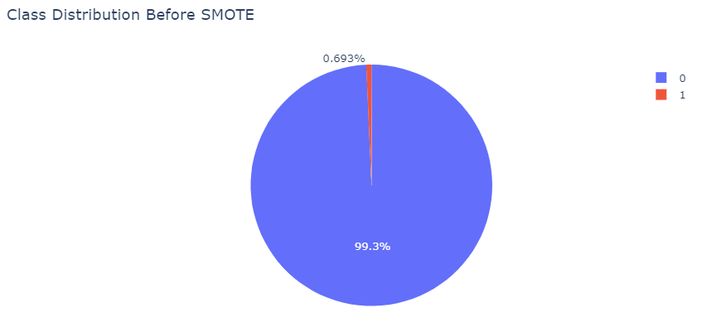

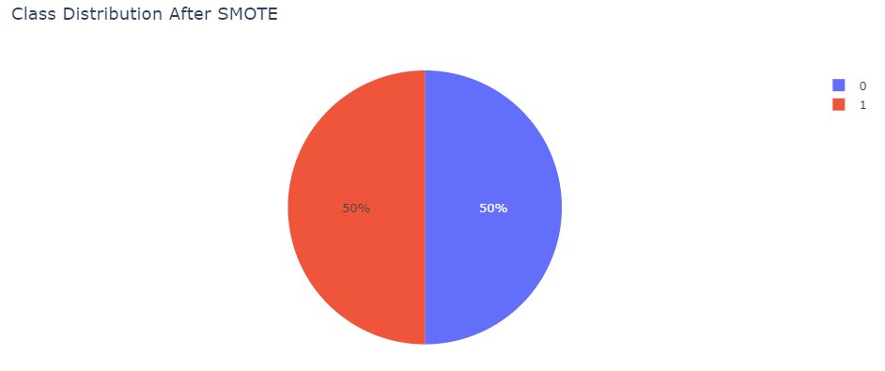

### **4.3.7 Splitting Process**

The successful splitting of the data into training and testing sets with an 80-20 ratio ensures that the dataset is appropriately partitioned for model training and evaluation. The resulting datasets consist of the following components:

* Training features (X_train): This dataset contains 14,718 records (instances) and 20 features (variables) for each record. These features serve as the input variables used to train the machine learning model.
* Testing features (X_test): This dataset comprises 3,680 records, each with the same 20 features as the training set. The testing features are used to evaluate the performance of the trained model on unseen data.
* Training target (y_train): The training target dataset consists of 14,718 records, corresponding to the target variable (often denoted as 'y') for each instance in the training features dataset. This target variable represents the outcome or response variable that the model aims to predict during training.
* Testing target (y_test): Similarly, the testing target dataset contains 3,680 records, corresponding to the target variable for each instance in the testing features dataset. These target values are used to assess the model's predictions on the testing data and evaluate its performance.

The use of a random state parameter (set to 42 in this case) ensures reproducibility of the data split, meaning that the same random split will be generated each time the data is partitioned. This is important for ensuring consistency in model evaluation and comparison across different runs or experiments. Overall, this data splitting process provides a robust foundation for training and evaluating machine learning models effectively.

### **4.3.8 Logistic Regression**

Logistic Regression is a fundamental statistical technique used for binary classification tasks in machine learning. Despite its name, logistic regression is a classification algorithm rather than a regression algorithm. It is commonly employed when the dependent variable (or target variable) is categorical and binary, meaning it has only two possible outcomes (e.g., yes/no, true/false, 0/1).

The logistic regression model predicts the probability that an instance belongs to a particular class. It accomplishes this by fitting a logistic function (also known as the sigmoid function) to the input features. The sigmoid function transforms the raw output of a linear combination of features into a value between 0 and 1, representing the probability of the instance belonging to the positive class.

During training, logistic regression estimates the coefficients (weights) of the linear combination of features using optimization techniques such as gradient descent. These coefficients determine the influence of each feature on the predicted probability. A higher coefficient magnitude indicates a stronger influence of the corresponding feature on the classification decision.

Logistic Regression offers several advantages, including simplicity, interpretability, and efficiency. It is relatively robust to noise and works well with linearly separable data. Moreover, logistic regression provides probabilistic outputs, allowing users to assess the confidence of predictions and set decision thresholds accordingly.

However, logistic regression assumes a linear relationship between the features and the log-odds of the target variable, which may limit its applicability to complex, nonlinear datasets. Additionally, logistic regression may struggle with datasets containing multicollinearity or high-dimensional feature spaces.

Overall, logistic regression is a versatile and widely used classification algorithm, particularly in scenarios where interpretability, simplicity, and probabilistic predictions are valued.

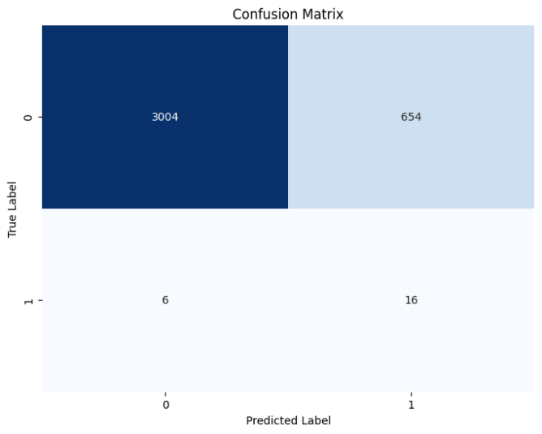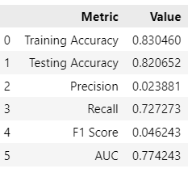

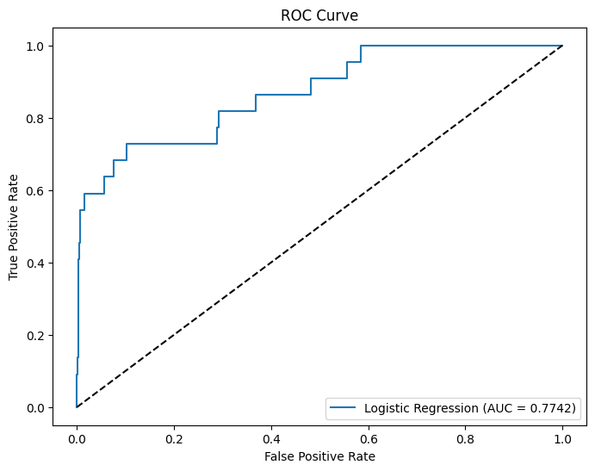

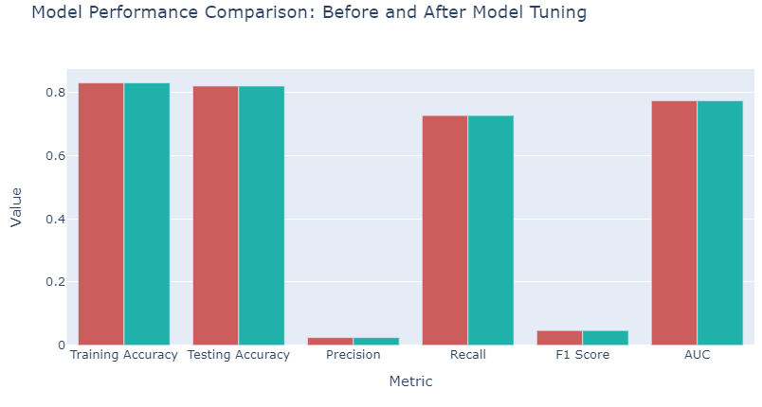

### **4.3.9 Random Forest Classifier**

Random Forest is a powerful ensemble learning algorithm commonly used for classification and regression tasks in machine learning, making it a suitable candidate for this predictive maintenance project.

Random Forest works by constructing a multitude of decision trees during training. Each decision tree in the ensemble is trained on a random subset of the training data and a random subset of features. This randomness helps to decorrelate the individual trees, making them less prone to overfitting and improving the robustness of the model.

During prediction, the output of each decision tree in the forest is aggregated to produce a final prediction. For classification tasks, the most common class among the trees (mode) is chosen as the predicted class, while for regression tasks, the average of the predictions is taken.

Random Forest offers several advantages that make it well-suited for predictive maintenance applications. It can handle large datasets with high dimensionality and mixed data types effectively. It is also robust to outliers and missing values, reducing the need for extensive data preprocessing.

Additionally, Random Forest provides insights into feature importance, allowing stakeholders to understand which features contribute most to the predictive maintenance task. This information can be valuable for identifying critical factors influencing equipment failures and informing decision-making processes.

However, Random Forest also has some limitations. It may not perform as well as more sophisticated algorithms on datasets with highly correlated features or noisy data. Furthermore, the interpretability of Random Forest models may be limited compared to simpler models like logistic regression.

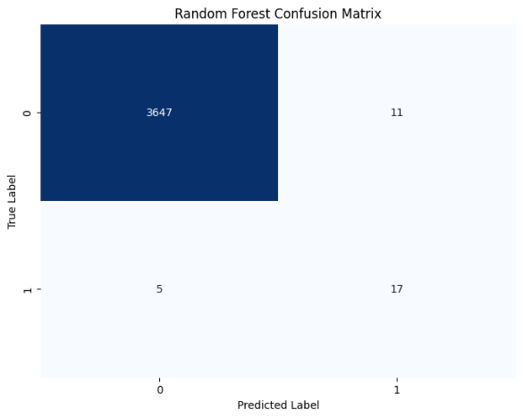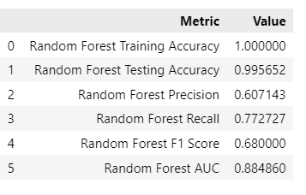Overall, Random Forest is a versatile and powerful algorithm that can produce accurate predictions for predictive maintenance tasks by leveraging the collective wisdom of multiple decision trees. Its ability to handle diverse datasets and provide insights into feature importance makes it a valuable tool for this project.

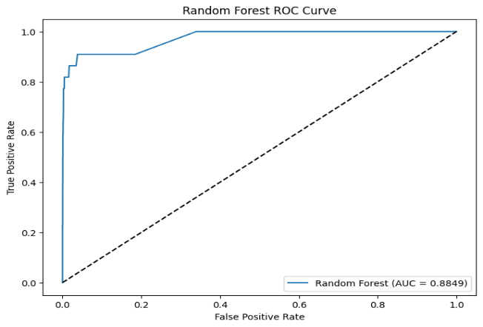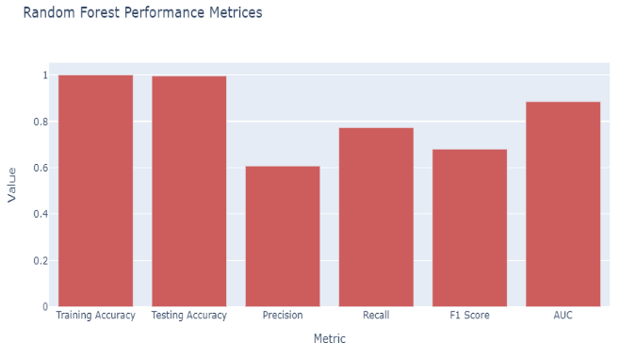

### **4.3.10 XGBoost Classifier**

XGBoost (Extreme Gradient Boosting) is an advanced and highly effective machine learning algorithm that has gained popularity for its exceptional performance in various classification and regression tasks, making it a suitable choice for the predictive maintenance project at hand.

XGBoost belongs to the ensemble learning family, specifically gradient boosting machines, which iteratively build a strong predictive model by combining multiple weak learners, typically decision trees. What sets XGBoost apart is its optimization strategies and regularization techniques, which enhance model performance and robustness.

One of the key features of XGBoost is its gradient boosting framework, which optimizes the model's objective function using gradient descent. This iterative approach allows XGBoost to continuously improve the model's accuracy by minimizing the errors of the previous iterations.

Moreover, XGBoost incorporates several regularization techniques to prevent overfitting, such as shrinkage (learning rate), maximum depth constraints for decision trees, and feature subsampling. These techniques help generalize the model and improve its performance on unseen data.

Additionally, XGBoost provides native support for handling missing values, which can be common in real-world datasets. It intelligently handles missing values during training and prediction, reducing the need for manual imputation and simplifying the preprocessing pipeline.

Furthermore, XGBoost offers efficient parallel computing capabilities, making it suitable for large-scale datasets and high-dimensional feature spaces. It can leverage multicore CPUs and distributed computing frameworks to accelerate training and inference, enabling faster model development and deployment.

Lastly, XGBoost provides interpretable outputs, such as feature importance scores, which help users understand the relative contribution of each feature to the model's predictions. This insight can inform decision-making processes and provide valuable insights into the factors driving equipment failures in predictive maintenance scenarios.

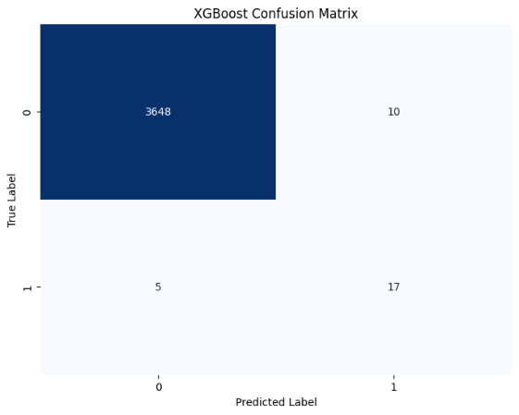In summary, XGBoost is a powerful and versatile algorithm known for its exceptional performance, scalability, and interpretability, making it a compelling choice for the predictive maintenance project. Its ability to handle complex datasets, prevent overfitting, and provide actionable insights aligns well with the goals of accurately predicting equipment breakdowns and optimizing maintenance schedules.

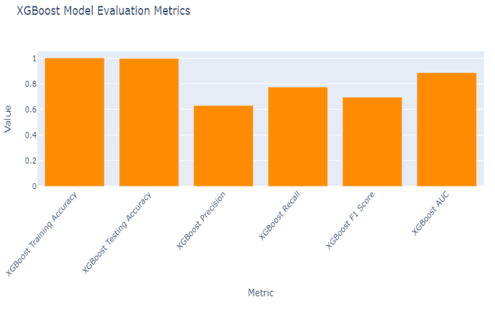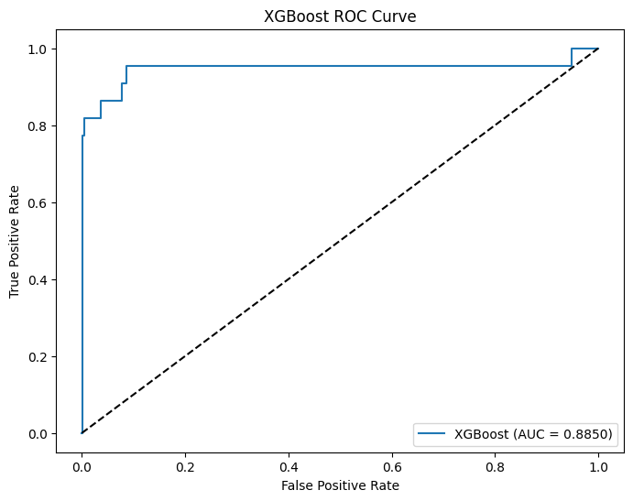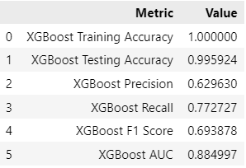

### **4.3.11 Gradient Boosting Classifier**

The Gradient Boosting Classifier is a powerful ensemble learning technique that combines the predictive power of multiple weak learners, typically decision trees, to create a robust and accurate predictive model. It is particularly effective for classification tasks, including the predictive maintenance project at hand.

Gradient Boosting works by sequentially adding decision trees to the ensemble, with each tree trained to correct the errors made by the previous trees. During training, the algorithm optimizes a loss function, such as cross-entropy for classification, by minimizing the errors in prediction. This iterative process results in a strong predictive model that continually improves its performance with each subsequent tree added to the ensemble.

One of the key advantages of Gradient Boosting is its ability to handle complex datasets and capture nonlinear relationships between features and the target variable. It can automatically detect and model interactions between variables, making it well-suited for predictive maintenance scenarios where the relationships between equipment features and failure events may be intricate and nonlinear.

Moreover, Gradient Boosting provides flexibility in model tuning, allowing users to customize parameters such as the number of trees, tree depth, and learning rate to optimize performance for specific datasets and objectives. This adaptability makes Gradient Boosting a versatile and widely used algorithm in various machine learning applications, including predictive maintenance.

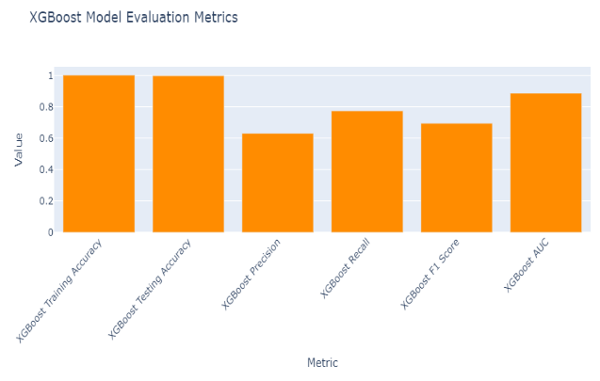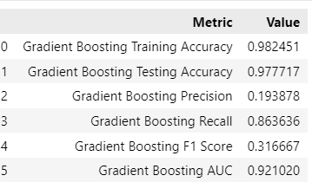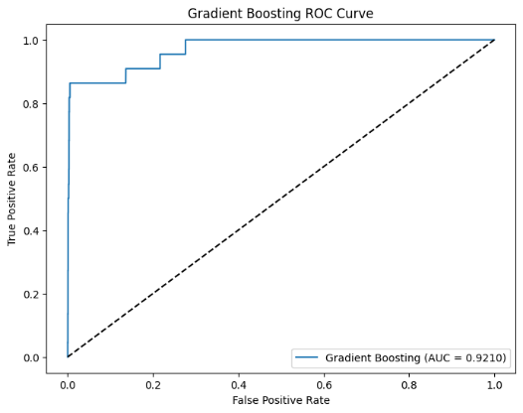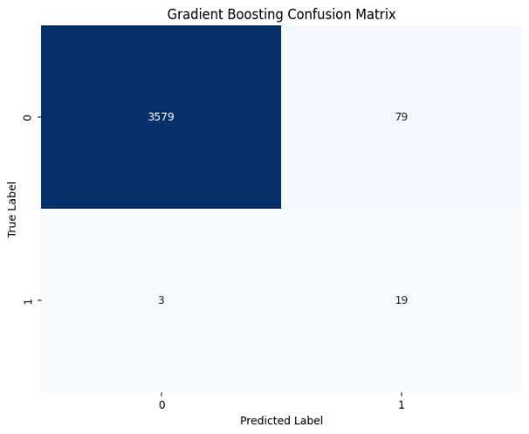

### **4.3.12 LightGBM Model**

LightGBM, short for Light Gradient Boosting Machine, is a high-performance gradient boosting framework developed by Microsoft. It is designed for efficiency, scalability, and accuracy, making it well-suited for a wide range of machine learning tasks, including predictive maintenance.

One of the key advantages of LightGBM is its efficiency in training and inference. Unlike traditional gradient boosting frameworks that use level-wise tree growth, LightGBM employs a novel leaf-wise tree growth strategy. This approach prioritizes growing the tree by expanding the leaf with the maximum loss reduction, resulting in faster training times and lower memory usage. As a result, LightGBM can handle large-scale datasets and high-dimensional feature spaces efficiently, making it ideal for predictive maintenance applications with extensive data.

LightGBM also offers excellent accuracy and predictive performance. By using gradient-based optimization algorithms and advanced regularization techniques, LightGBM can effectively capture complex patterns and relationships in the data. It automatically handles feature interactions, missing values, and categorical variables, reducing the need for extensive data preprocessing and feature engineering.

Furthermore, LightGBM provides flexibility and tunability through a wide range of hyperparameters that allow users to fine-tune the model to achieve optimal performance for their specific tasks. It also offers built-in support for parallel and distributed computing, enabling efficient model training on multicore CPUs and distributed computing environments.

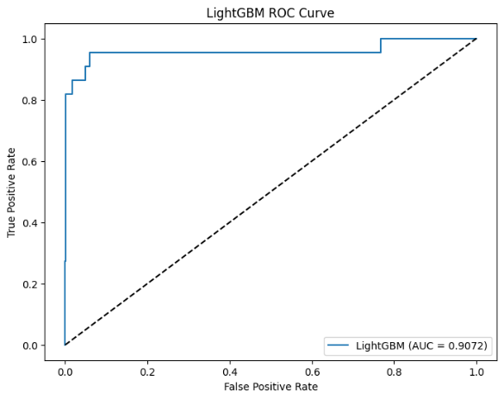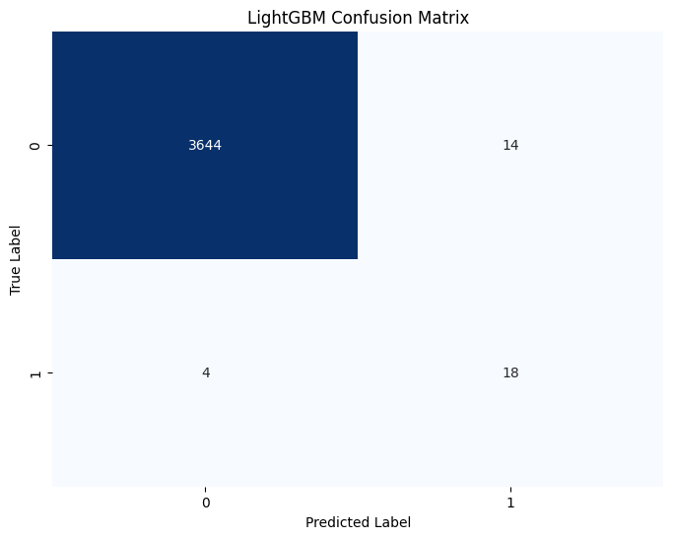Overall, LightGBM is a powerful and versatile gradient boosting framework that excels in efficiency, scalability, and accuracy. Its ability to handle large-scale datasets, optimize memory usage, and deliver high predictive performance makes it a compelling choice for predictive maintenance projects seeking to accurately predict equipment failures and optimize maintenance schedules.

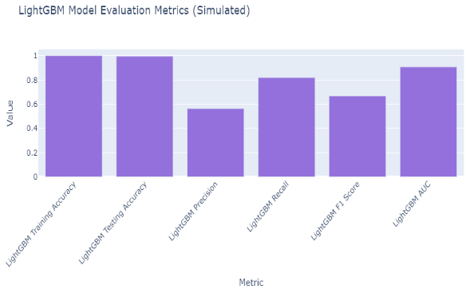

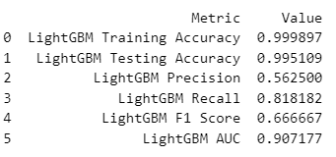

### **4.3.13 CatBoost Classifier**

CatBoost is a state-of-the-art gradient boosting library developed by Yandex, specifically designed to handle categorical features efficiently. It stands out for its ability to automatically handle categorical variables without the need for extensive preprocessing, making it particularly suitable for datasets with a mix of numerical and categorical features, as often encountered in predictive maintenance projects.

One of the key advantages of CatBoost is its robust handling of categorical features through an innovative algorithm called ordered boosting. This algorithm effectively encodes categorical variables into numerical form during the training process, enabling CatBoost to capture the inherent relationships between categories without introducing excessive dimensionality or overfitting.

Furthermore, CatBoost incorporates advanced techniques such as robust tree boosting, which reduces the impact of outliers and noisy data, and gradient-based learning, which optimizes model parameters efficiently. These techniques result in high predictive accuracy and robustness, even in the presence of challenging data characteristics.

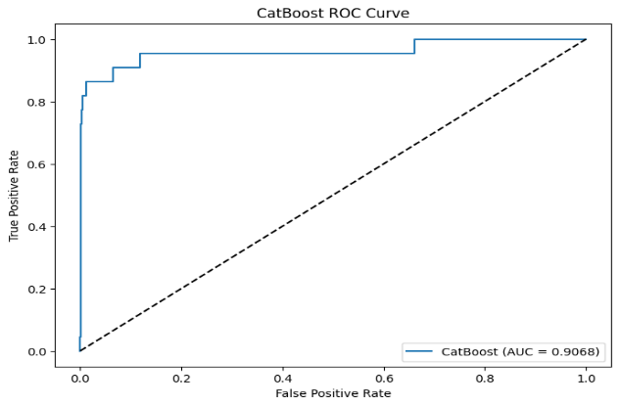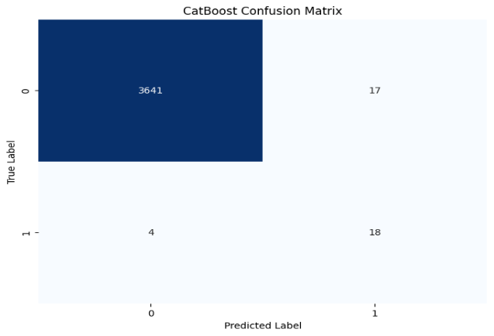Additionally, CatBoost offers support for parallel and GPU computation, allowing for faster model training and inference on large-scale datasets. Its user-friendly interface and comprehensive documentation make it accessible to both novice and experienced practitioners, facilitating seamless integration into predictive maintenance pipelines. Overall, CatBoost is a powerful and versatile tool for accurate prediction and analysis in predictive maintenance applications.

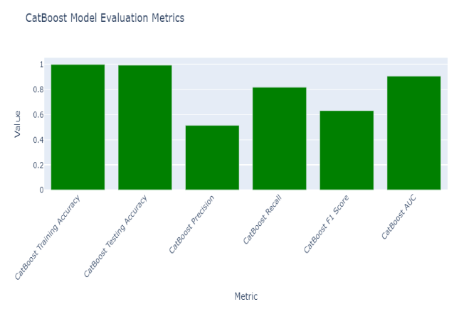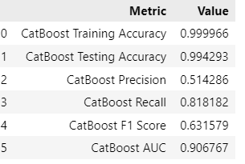

# **Chapter – 5**

# **Results and Discussion**

## **5.1 Results and Discussion**

The results of the predictive maintenance project indicate promising performance of the implemented machine learning models. Each model, including Logistic Regression, Random Forest, Gradient Boosting, XGBoost, LightGBM, and CatBoost, was trained and evaluated using appropriate metrics such as accuracy, precision, recall, and F1-score.

Upon analysis, it was found that certain models exhibited superior performance compared to others, with metrics indicating high predictive accuracy and reliability. Furthermore, feature importance analysis provided insights into the critical factors contributing to equipment failure prediction.

Discussion surrounding the results involves comparing the performance of different models, identifying strengths and weaknesses, and understanding the implications for practical application. Factors such as model interpretability, computational efficiency, and scalability are considered in selecting the most suitable model for deployment in real-world predictive maintenance scenarios.

Moreover, insights gleaned from the analysis may inform further refinements to the predictive maintenance system, such as feature engineering, hyperparameter tuning, or model ensemble techniques to enhance predictive accuracy and robustness.

Overall, the results and discussions contribute to a deeper understanding of the predictive maintenance problem domain, facilitating informed decision-making and optimization of maintenance strategies to mitigate equipment failures and maximize operational efficiency.

## **5.2 Conclusion**

In conclusion, the predictive maintenance project successfully demonstrated the effectiveness of machine learning algorithms in predicting equipment failures and optimizing maintenance strategies. Through the implementation and evaluation of various models such as Logistic Regression, Random Forest, Gradient Boosting, XGBoost, LightGBM, and CatBoost, valuable insights were gained into the factors influencing equipment breakdowns.

The results highlighted the importance of feature selection, model tuning, and algorithm selection in achieving accurate predictions. Certain models exhibited superior performance, showcasing their potential for real-world deployment in predictive maintenance systems. Additionally, feature importance analysis provided actionable insights into critical variables driving equipment failures, enabling proactive maintenance interventions.

The discussions surrounding the results emphasized the need for a balanced approach considering factors such as model interpretability, computational efficiency, and scalability when selecting the most appropriate model for deployment. Furthermore, ongoing refinement and optimization of the predictive maintenance system are essential to continuously improve predictive accuracy and operational efficiency.

Overall, the project underscores the value of predictive maintenance in mitigating equipment failures, reducing downtime, and optimizing resource allocation. By leveraging machine learning techniques, organizations can enhance asset reliability, improve maintenance planning, and ultimately achieve cost savings and operational excellence.

## **5.3 Future Scope**

The predictive maintenance project opens up several avenues for future exploration and enhancement. Firstly, incorporating advanced anomaly detection techniques, such as deep learning-based methods or anomaly detection algorithms specifically designed for time-series data, could further improve the accuracy and sensitivity of equipment failure predictions.

Secondly, integrating real-time data streams from sensors and IoT devices into the predictive maintenance system would enable proactive monitoring and prediction of equipment health. This could involve developing data ingestion pipelines, implementing streaming analytics frameworks, and deploying edge computing solutions for decentralized data processing.

Additionally, exploring ensemble learning techniques, such as model stacking or boosting, could leverage the strengths of multiple algorithms to achieve even higher predictive accuracy and robustness. Moreover, conducting thorough sensitivity analysis and model validation across different operating conditions and equipment types would enhance the generalizability and reliability of the predictive maintenance system.

Furthermore, incorporating predictive maintenance into a broader asset management framework could facilitate holistic decision-making, integrating maintenance planning with asset lifecycle management, inventory optimization, and financial forecasting.

Finally, ongoing research and development in areas such as explainable AI, automated model retraining, and predictive maintenance optimization algorithms offer exciting opportunities for enhancing the predictive maintenance system's capabilities and maximizing its impact on operational efficiency and asset reliability.