**Two-Dimensional Arrays**

To create a 2D array, add each array within its own set of curly braces, and insert a comma (,) inside the square brackets:

### **Example**

int[,] numbers = { {1, 4, 2}, {3, 6, 8} };

numbers is now an array with two arrays as its elements. The first array element contains three elements: 1, 4 and 2, while the second array element contains 3, 6 and 8. To visualize it, think of the array as a table with rows and columns:

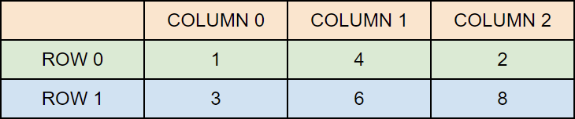

## Access Elements of a 2D Array

To access an element of a two-dimensional array, you must specify two indexes: one for the array, and one for the element inside that array. Or better yet, with the table visualization in mind; one for the row and one for the column (see example below).

This statement accesses the value of the element in the **first row (0)** and **third column (2)** of the numbers array:

int[,] numbers = { {1, 4, 2}, {3, 6, 8} };

Console.WriteLine(numbers[0, 2]); // Outputs 2

# C# | Jagged Arrays

Jagged array is a **array of arrays** such that member arrays can be of different sizes. In other words, the length of each array index can differ. The elements of Jagged Array are reference types and initialized to null by default

In Jagged arrays, user has to provide the number of rows only. If the user is also going to provide the number of columns, then this array will be no more Jagged Array.

**Syntax:**

data_type[][] name_of_array = new data_type[rows][]

**Example:**

int[][] jagged_arr = new int[4][]

#### Initialization

The elements of Jagged Array **must be initialized**before its use. You can separately initialize each array element. There are many ways to initialize the Jagged array’s element.

**Example 1:** Providing the size of each array elements separately. Here each of the elements is a 1-D array of integers where:

* The first row or element is an array of 2 integers.
* The second row or element is an array of 4 integers.
* The third row or element is an array of 6 integers.
* The fourth row or element is an array of 7 integers.

jagged_arr[0] = new int[2];

jagged_arr[1] = new int[4];

jagged_arr[2] = new int[6];

jagged_arr[3] = new int[7];