Here screenshots of the interfaces will be given

1. Login page

We created a responsive login page

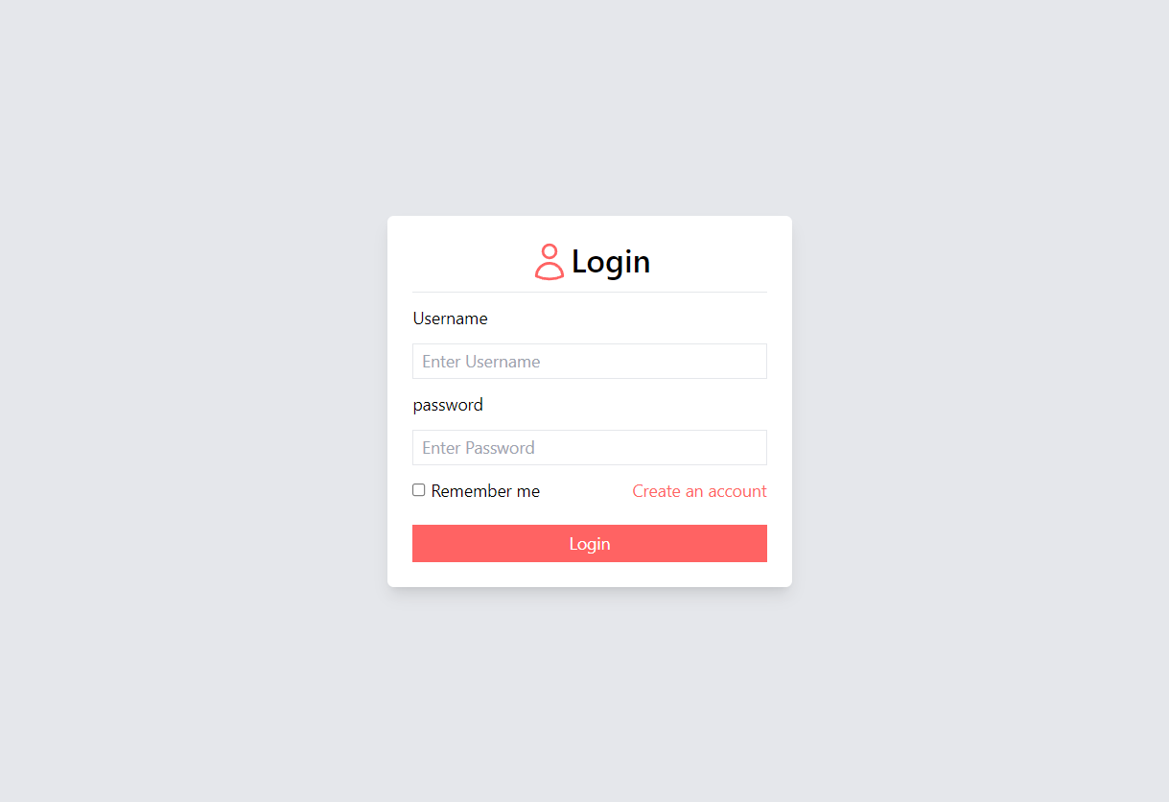

1. Signup page

We created a responsive signup page

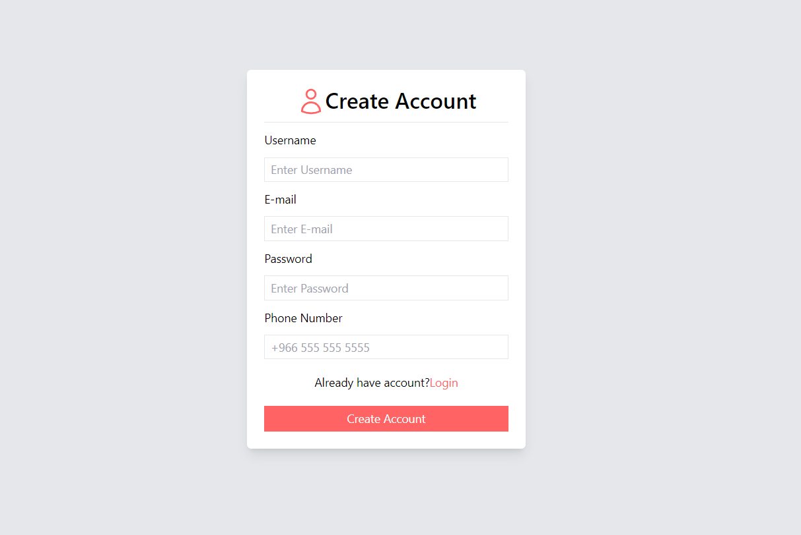

1. Home & Shopping Cart page

We created a responsive Home and shopping cart page.

For large Screens:

For Medium Screens:

For Small Screens(Mobiles):

In mobile screens we changed the nav bar to be a hamburger menu.

Now the Shopping Cart:

It will slide from the right of the screen.

And you can manipulate the quantities and the price will be calculated accordingly. If you reduce the quantity to zero the item will be removed from the cart.