STUDENT MENTAL HEALTH FACTORS & ACADEMIC PERFORMANCE
  - Exploratory Analysis and Machine Learning Classification
Final-Term Project Report

Team Member | Student ID
Masrafi Khan Ornob | 24-58728-2
Junaid Abdin Sakhir | 24-56658-1
Sanjana Sayed Nuha | 23-53087-3
Fairuz Dilshad | 25-61786-1

Project Objective
This project analyzes the relationship between student stress-related factors and academic performance using exploratory data analysis and machine-learning classification. The study focuses on stress level, sleep quality, depression, anxiety, social support, and self-esteem to distinguish High Performance and Low Performance groups.

1. Executive Summary
This project uses student well-being factors to classify High and Low Performance students. It includes data cleaning, visualization, feature engineering, and model evaluation. Logistic Regression and KNN outperform the baseline, with Logistic Regression having a slightly higher F1 Score.

2. Introduction and Project Objectives
The project examines how student well-being factors differ between performance groups using exploratory analysis and classification.

Objectives
- Inspect and clean the student stress dataset.
- Construct useful derived variables for analysis and classification.
- Explore differences in stress, sleep quality, depression, and anxiety between performance groups.
- Train Logistic Regression and KNN classifiers using selected student factors.
- Evaluate the models using Accuracy, Precision, Recall/Sensitivity, F1 Score, and confusion matrices.
- Compare the models with a baseline and identify limitations and future improvements.

Research Questions
RQ1: How do average stress level and sleep quality differ between High Performance and Low Performance students?
RQ2: Do depression and anxiety show different patterns across the two performance groups?
RQ3: Can stress-related and well-being-related variables classify students into High Performance and Low Performance groups?

3. Dataset Description
The project uses the StressLevelDataset.csv dataset. The dataset contains student-related measures including academic performance, stress level, sleep quality, depression, anxiety, social support, self-esteem, blood pressure, and headache-related information. The original dataset contains approximately 1,100 student records, which provides the basis for the exploratory and classification analysis.

Initial Dataset Inspection
The dataset is checked for structure, data types, missing values, duplicates, and summary statistics before cleaning.

4. Data Cleaning and Preparation
The data is cleaned to improve consistency and prepare it for analysis and modeling.
Step | Action | Purpose
1 | Check missing values | Identify incomplete numerical observations before modeling.
2 | Drop blood_pressure and headache | Remove variables not used in the selected analysis.
3 | Fill numerical missing values with the median | Provide a robust replacement for missing numerical entries.
4 | Remove duplicate rows | Prevent repeated observations from being counted more than once.
5 | Reset the index | Create a clean sequential row index after cleaning.
6 | Remove academic_performance after target creation | Prevent the original performance variable from being used directly as a predictor.

5. Feature Engineering and Target Construction
Mental Health Score: A combined score is created as the mean of the depression and anxiety-level variables. This provides a single numerical feature representing the two mental-health-related measurements.
Low Performance Target: Academic performance is converted into a binary classification target. Values less than or equal to 2 are coded as Low Performance (1), while the remaining values are coded as High Performance (0). The original academic_performance column is then removed.

6. Analysis Methodology
The workflow uses Pandas for data handling, NumPy for numerical calculations, and Matplotlib/Seaborn for visualization.

Final Predictors
The final model uses five predictors: stress_level, mental_health_score, sleep_quality, social_support, and self_esteem. The target is low_performance.

Train/Test Preparation
The data is split 75/25 using random state 42 with stratification.

Model Pipelines
Logistic Regression: median imputation → standardization → Logistic Regression (maximum iterations = 1000).
KNN: median imputation → standardization → K-Nearest Neighbors with 7 neighbors.
Pipelines apply imputation and scaling consistently.

Cross-Validation and Model Selection
Five-fold cross-validation using balanced accuracy guides model selection before final testing.

7. NumPy-Based Computation
NumPy is used for median-based replacement and numerical calculation of the mental health score and binary target.

8. Evaluation Measures
Accuracy, Precision, Recall, F1 Score, and confusion matrices are used to evaluate model performance.

9. Student Stress Factors and Academic Performance Analysis
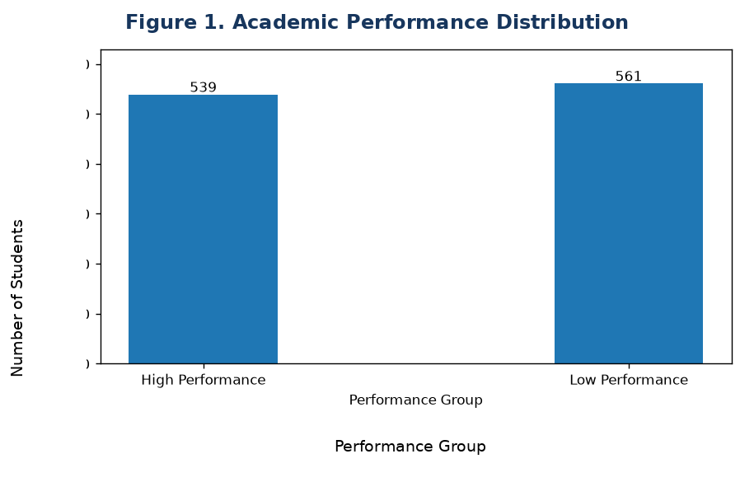
Figure 1. Academic Performance Distribution.
Finding: The two performance groups are relatively balanced, with 539 students in High Performance and 561 in Low Performance. This provides a useful basis for binary classification.
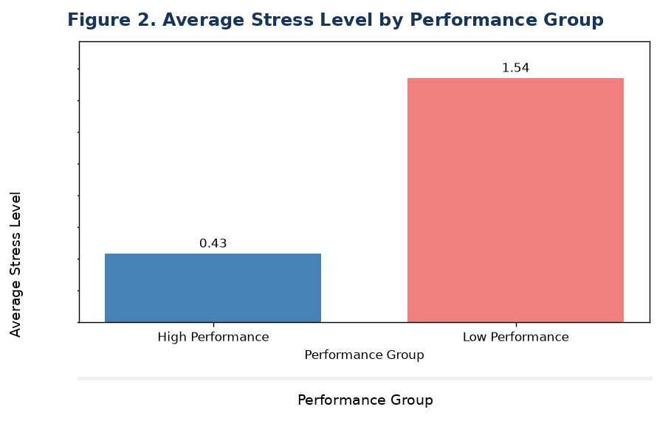
Figure 2. Average Stress Level by Performance Group.
Finding: Low Performance students show a substantially higher average stress level (about 1.54) than High Performance students (about 0.43). The pattern indicates a strong association between stress level and the performance grouping.
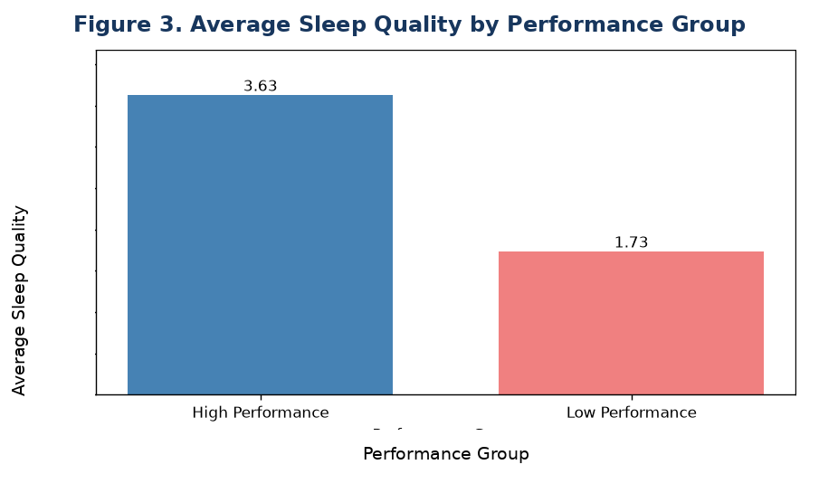
Figure 3. Average Sleep Quality by Performance Group.
Finding: High Performance students have much higher average sleep quality (about 3.63) than Low Performance students (about 1.73). This suggests that sleep quality is an important distinguishing factor in the dataset.
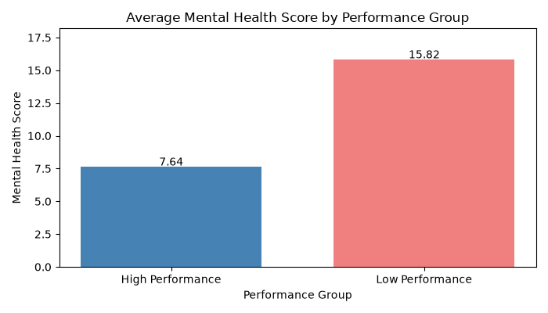
Figure 4. Average Mental Health Score by Performance Group.
Finding: Low Performance students have a higher average mental health score (15.82) than High Performance students (7.64).

Overall Exploratory Interpretation
Overall, Low Performance is linked with higher stress, lower sleep quality, and different depression/anxiety patterns.

10. Model Evaluation and Results

10.1 Classification Performance
Model | Accuracy | Precision | Recall | F1
Baseline | 0.509 | 0.509 | 1.000 | 0.674
Logistic Regression | 0.764 | 0.759 | 0.786 | 0.772
KNN | 0.756 | 0.739 | 0.807 | 0.771
Both trained models perform considerably better than the most-frequent baseline. Logistic Regression records the highest test F1 Score at 0.772, only marginally above KNN at 0.771. KNN has slightly higher recall (0.807 versus 0.786), meaning it identifies more of the positive class, while Logistic Regression provides a slightly better overall balance between precision and recall.
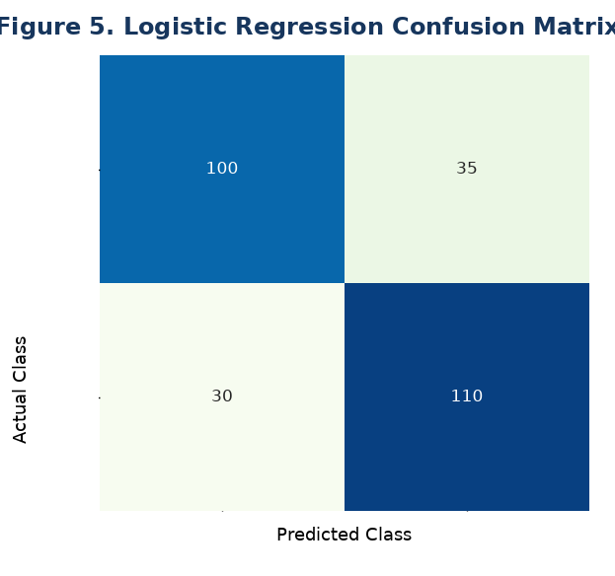
Figure 5. Logistic Regression Confusion Matrix.
Finding: The matrix shows 100 correctly classified High Performance cases and 110 correctly classified Low Performance cases, with 35 and 30 misclassifications respectively.
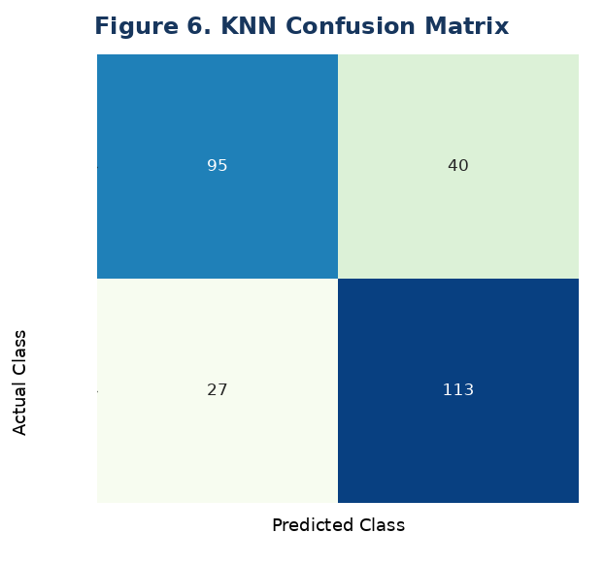
Figure 6. KNN Confusion Matrix.
Finding: KNN correctly classifies 95 High Performance cases and 113 Low Performance cases. It produces 40 and 27 misclassifications for the two classes.

10.2 Model Comparison
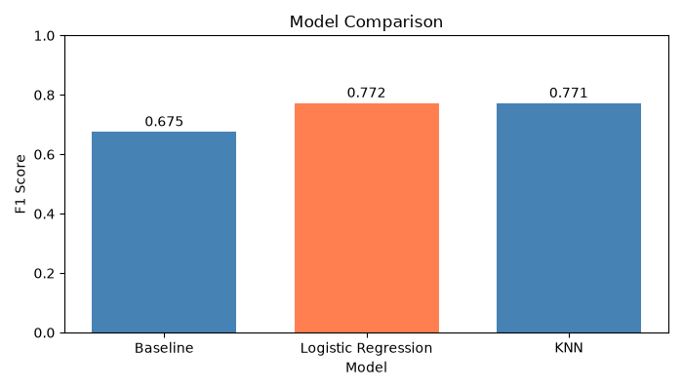
Figure 7. Model Comparison.
Finding: The F1 scores are 0.674 for the baseline, 0.772 for Logistic Regression, and 0.771 for KNN. Logistic Regression has the highest test F1 Score.

11. Key Findings
- The dataset contains two reasonably balanced performance groups, supporting binary classification.
- Low Performance students have substantially higher average stress levels.
- High Performance students have substantially better average sleep quality.
- Depression and anxiety values show a visibly different distribution across performance groups.
- Logistic Regression and KNN both outperform the baseline by a large margin.
- Logistic Regression is the best overall test performer by a very small F1-score margin, while KNN has slightly higher recall.

12. Limitations
- Association does not imply causation: the analysis is observational, so higher stress or lower sleep quality may be associated with performance without proving that one factor causes the other.
- Dataset scope: the findings are limited to the population represented in the dataset and may not generalize to all students, institutions, or countries.
- Self-reported measurements: variables such as stress, depression, anxiety, sleep quality, social support, and self-esteem may contain reporting or measurement bias.
- Derived target definition: converting academic performance into a binary threshold simplifies a potentially more detailed academic outcome and may hide differences within each group.
- Limited predictors: the final model uses five selected variables and does not capture every factor that may influence academic performance, such as workload, attendance, study hours, family circumstances, or financial pressure.

13. Future Work
Future work could improve the study by testing additional classification algorithms, tuning hyperparameters systematically, and evaluating multiple train/test splits or repeated cross-validation. Additional engineered predictors could also be investigated, such as combined stress–sleep indicators or grouped well-being scores, provided they are validated and included consistently in the modeling code. A larger and more diverse dataset would improve generalizability. Longitudinal data could further help study how changes in stress and sleep relate to changes in academic performance over time. Finally, feature-importance or model-explanation methods could be used to better understand which variables contribute most to the predictions.

14. Conclusion
This project demonstrates a complete data-analysis and classification workflow for student stress factors. After systematic data checking and cleaning, derived variables were created and four visualizations were used to examine patterns in performance, stress, sleep, depression, and anxiety. Logistic Regression and KNN both achieved substantially better performance than the baseline. Logistic Regression produced the highest test F1 Score (0.772), making it the preferred model by the selected test metric, although KNN achieved slightly higher recall. Overall, the results show that stress-related and well-being-related measurements contain useful information for distinguishing performance groups, while the limitations mean the findings should be interpreted as associations rather than causal conclusions.

15. References / Dataset and Software
1. Dataset: StressLevelDataset.csv. Raw dataset URL used by the project code: https://raw.githubusercontent.com/mibur1/psy111/main/book/statistics/4_Moderated_Reg/data/StressLevelDataset.csv
2. Alhamed, A. A. (2023). The link among academic stress, sleep disturbances, depressive symptoms, academic performance, and the moderating role of resourcefulness in health professions students during COVID-19 pandemic. Journal of Professional Nursing, 46, 83–91. DOI

16. Team Contributions
The project was divided into four stages: data preparation, exploration, modeling, and evaluation.
Team Member | Student ID | Contribution
Masrafi Khan Ornob | 24-58728-2 | Dataset & Cleaning — dataset loading, inspection, missing-value and duplicate checks, removal of selected columns, median filling, index reset, derived-column creation, and final dataset preparation.
Junaid Abdin Sakhir | 24-56658-1 | Graphs & Exploration — four exploratory graphs, extraction of important values, and interpretation of visual findings.
Sanjana Sayed Nuha | 23-53087-3 | Data Preparation & Models — selection of the five final predictors, X/y creation, stratified train/test split, KNN and Logistic Regression pipelines, training, and 5-fold cross-validation.
Fairuz Dilshad | 25-61786-1 | Evaluation — baseline creation, predictions, Accuracy/Precision/Recall/F1 calculations, confusion matrices, model comparison, and final model selection.
Code Flow
- Person 1: Load → Check → Clean → Create columns
- Person 2: Explore → Create 4 graphs → Findings
- Person 3: X/y → Split → KNN + Logistic Regression
- Person 4: Predictions → Metrics → Confusion Matrices → Comparison
Team statement: The project was organized so that data preparation, exploratory analysis, model development, and evaluation form one reproducible pipeline. The final recommendation is based on the quantitative evidence produced by the analysis.

