UmSELv1 gerber files definitions:
Silk TOP - UmSELv1.gto
Paste TOP - UmSELv1.gtp
Mask TOP - UmSELv1.gts
TOP Layer - UmSELv1.gtl
Negative Plain - UmSELv1.gp1
Internal 1 - UmSELv1.g1
BOTTOM Layer - UmSELv1.gbl
Mask BOTTOM - UmSELv1.gbs
Paste BOTTOM - UmSELv1.gbp
Boarder - UmSELv1.gko
NC drill Top-Bottom plated - UmSELv1-Pl.txt
NC drill Top- Internal1 plated - UmSELv1-Pl.tx1
NC drill Top-Bottom non-plated - UmSELv1-NPl.txt
Assembly/Mechanical TOP - UmSELv1.gm1
Physical PCB Layers structure:
Important to keep 50Ohm impedance (change all lines with the same width if required):
Top-Plane layer pair for all lines width 0.965mm.
Bottom_Internal1-Plane layer pairs for all lines width 0.345mm.
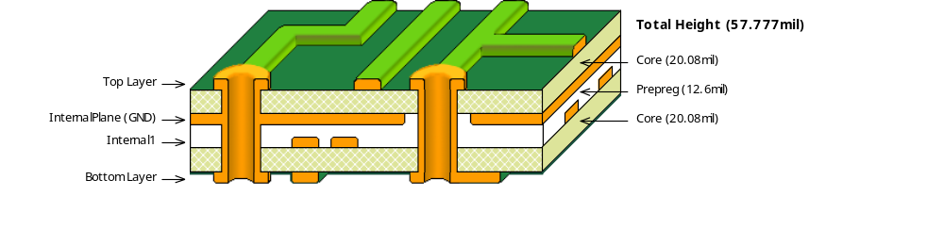
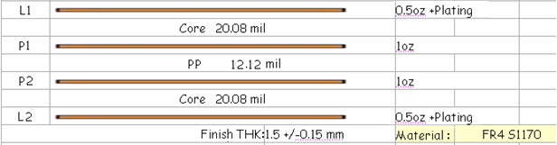
Overall Size - 50 x 99.5 mm ± 0.25 mm.
CC-BY-SA 3.0, “FairWaves”, 2012.

