Lab 4.7.1.6
Use Wireshark to Examine Ethernet Frames
Cisco Networking Academy
Introduction to Networks (ITN)
Student Name: | Assyrzhanova Gaukhar
Group: | IIoT-2401

Objectives
Part 1: Examine the Header Fields in an Ethernet II Frame
Part 2: Use Wireshark to Capture and Analyze Ethernet Frames

Background / Scenario
When upper layer protocols communicate with each other, data flows down the OSI layers and is encapsulated into a Layer 2 frame. The frame composition depends on the media access type. For Ethernet networks using TCP/IP, the Layer 2 encapsulation is Ethernet II. This lab examines Ethernet II frame header fields using Wireshark, first for local traffic (ping to the default gateway) and then for remote traffic (ping to www.cisco.com).

Required Resources
- 1 PC (Windows with Internet access and Wireshark installed)

Part 1: Examine the Header Fields in an Ethernet II Frame

Ethernet II Frame Structure
The Ethernet II frame consists of the following fields:
Preamble | Destination Address | Source Address | Frame Type | Data | FCS
8 Bytes | 6 Bytes | 6 Bytes | 2 Bytes | 46–1500 Bytes | 4 Bytes

Field Descriptions
Preamble (8 Bytes): Contains alternating 1s and 0s used for synchronization between sending and receiving devices. The last byte is the Start Frame Delimiter (SFD) which signals the beginning of the frame.
Destination Address (6 Bytes): The 48-bit (6-octet) MAC address of the intended recipient. This can be a unicast (single device), multicast (group), or broadcast (ff:ff:ff:ff:ff:ff) address.
Source Address (6 Bytes): The 48-bit MAC address of the device that originated the frame. This is always a unicast address.
Frame Type (2 Bytes): Identifies the upper-layer protocol encapsulated in the data field. Common values include 0x0800 for IPv4 and 0x0806 for ARP.
Data (46–1500 Bytes): Contains the encapsulated upper-layer protocol data (the payload). If the data is less than 46 bytes, padding is added to meet the minimum frame size.
FCS (4 Bytes): Frame Check Sequence, a CRC (Cyclic Redundancy Check) value computed by the sender and verified by the receiver to detect transmission errors.

Wireshark Capture: ARP Request Frame
The following screenshot shows the ARP request sent by the PC to discover the MAC address of the default gateway. The Ethernet II header reveals the broadcast destination address and the PC’s source MAC.
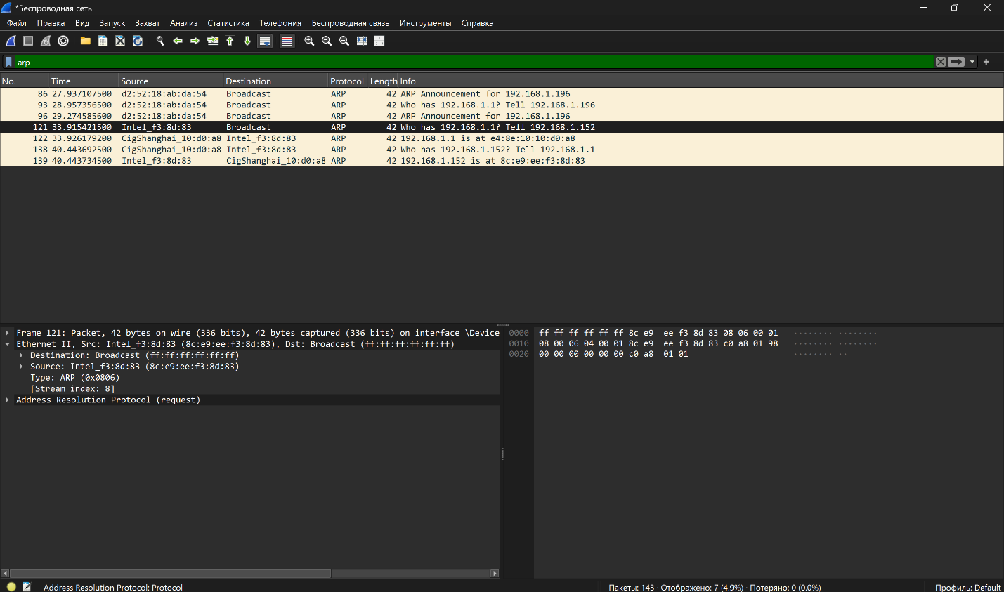

Wireshark Capture: ARP Reply Frame
The following screenshot shows the ARP reply from the default gateway, providing its MAC address back to the PC.
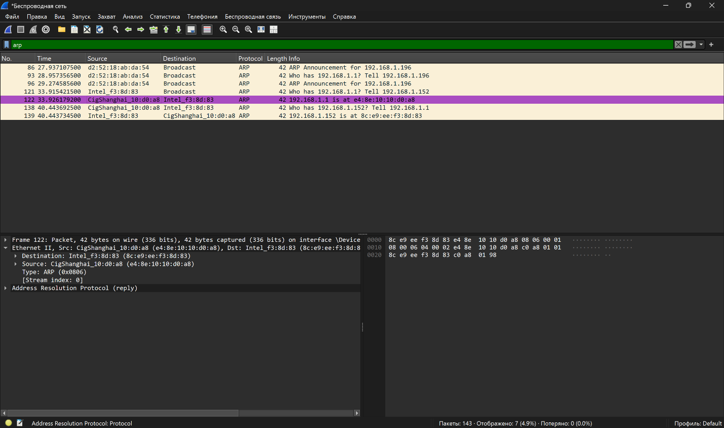

Ethernet II Header Contents – ARP Request Analysis
The following table summarizes the Ethernet II header fields from the ARP request frame (#121):
Field | Value | Description
Preamble | Not shown in capture | Contains synchronizing bits processed by NIC hardware. Wireshark does not capture the preamble.
Destination Address | ff:ff:ff:ff:ff:ff (Broadcast) | A broadcast address, meaning the frame is sent to all devices on the local network segment.
Source Address | 8c:e9:ee:f3:8d:83 (Intel) | The MAC address of the PC’s NIC. The first 3 octets (8c:e9:ee) represent the OUI (Intel Corporation).
Frame Type | 0x0806 | Indicates that the encapsulated upper-layer protocol is ARP (Address Resolution Protocol).
Data | ARP Request | Contains the ARP request payload: “Who has 192.168.1.1? Tell 192.168.1.152.”
FCS | Not shown in capture | CRC value computed by the sending NIC to detect errors during transmission.

Part 1 – Questions and Answers
Question 1: What is significant about the contents of the destination address field?
The destination address in the ARP request frame is ff:ff:ff:ff:ff:ff, which is the Ethernet broadcast address. This is significant because it means the frame is sent to every device on the local network segment. The PC uses a broadcast because it does not yet know the MAC address of the target device (the default gateway at 192.168.1.1) and needs all hosts to receive the request so that the correct device can respond.

Question 2: Why does the PC send out a broadcast ARP prior to sending the first ping request?
The PC must send a broadcast ARP request before pinging because it needs to discover the Layer 2 (MAC) address of the destination. IP addresses operate at Layer 3, but to actually transmit an Ethernet frame on the local network, the PC needs the destination’s MAC address. Since the PC’s ARP cache does not yet contain an entry for 192.168.1.1, it broadcasts an ARP request to resolve the IP address to a MAC address. Once the ARP reply is received (frame #122), the PC populates its ARP cache with the gateway’s MAC (e4:8e:10:10:d0:a8) and can then construct the Ethernet frame for the ICMP ping request.

Question 3: What is the MAC address of the source in the first frame?
The source MAC address in the ARP request (frame #121) is 8c:e9:ee:f3:8d:83. This is the MAC address of the PC’s Intel wireless NIC, as confirmed in the Wireshark Ethernet II header details.

Question 4: What is the Vendor ID (OUI) of the Source NIC in the ARP reply?
In the ARP reply (frame #122), the source is the default gateway with MAC address e4:8e:10:10:d0:a8. The OUI (Organizationally Unique Identifier) is e4:8e:10, which Wireshark identifies as “CigShanghai” (Shanghai CIG Technology Co., Ltd.), the manufacturer of the gateway’s network interface.

Question 5: What portion of the MAC address is the OUI?
The OUI is the first three octets (first 6 hexadecimal digits) of the 48-bit MAC address. For example, in the gateway’s MAC address e4:8e:10:10:d0:a8, the OUI is e4:8e:10. This portion is assigned by the IEEE to uniquely identify the hardware manufacturer.

Question 6: What is the NIC serial number of the source?
The NIC serial number (device identifier) is the last three octets of the MAC address. For the ARP reply source (the default gateway with MAC e4:8e:10:10:d0:a8), the NIC serial number is 10:d0:a8. This portion is assigned by the manufacturer to uniquely identify each individual network interface card.

Part 2: Use Wireshark to Capture and Analyze Ethernet Frames

Step 1: Determine the IP Address of the Default Gateway
The default gateway IP address was determined by running the ping command in the Windows command prompt. The PC successfully communicated with the default gateway at 192.168.1.1 (4 packets sent, 4 received, 0% loss, average RTT = 3 ms).
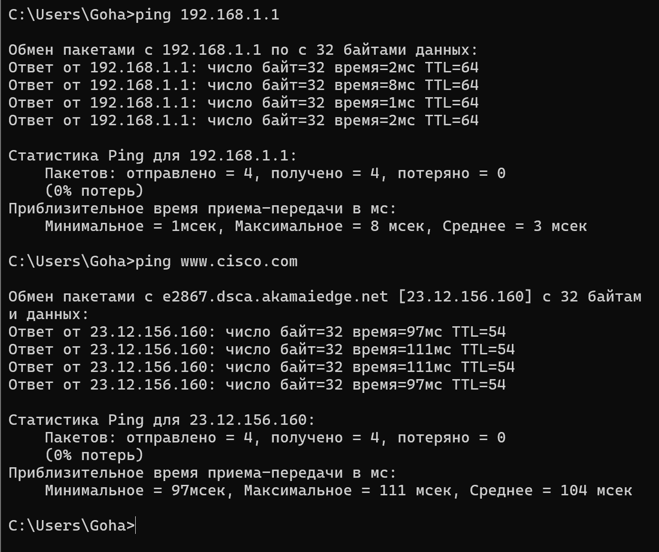
Step 1 – Question: What is the IP address of the PC default gateway?
The IP address of the PC default gateway is 192.168.1.1, as confirmed by the successful ping output showing replies from 192.168.1.1 with TTL=64.

Steps 2–5: Capture and Filter ICMP Traffic
Wireshark was started to capture traffic on the wireless network interface. The display filter was set to “icmp” to isolate only ICMP (ping) packets. Four ping requests were sent to the default gateway (192.168.1.1), generating 4 Echo Request and 4 Echo Reply packets.
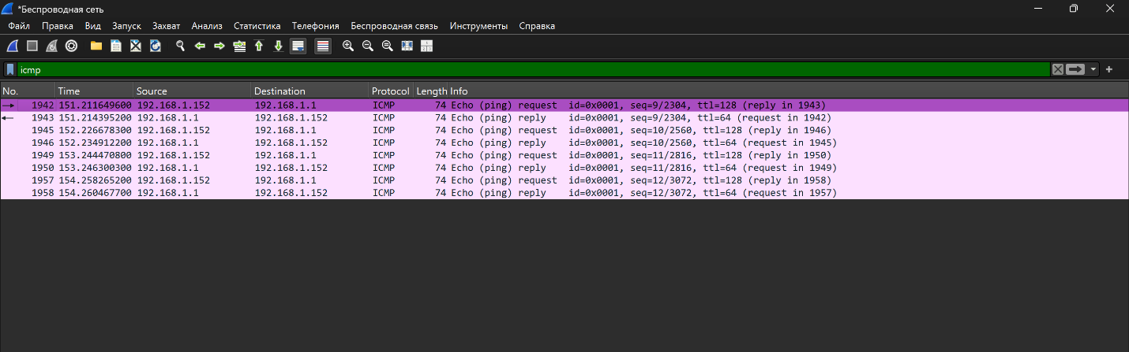

Step 6: Examine the First Echo (Ping) Request
The first Echo (ping) request frame (Packet #1942) was selected in Wireshark. The Packet Details pane reveals the Ethernet II header, IPv4 header, and ICMP payload information.
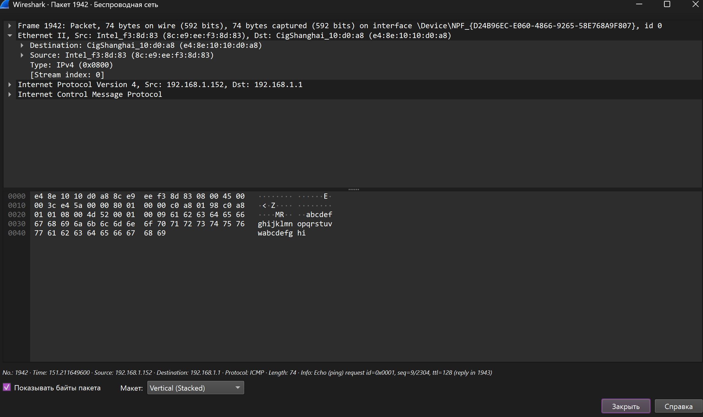
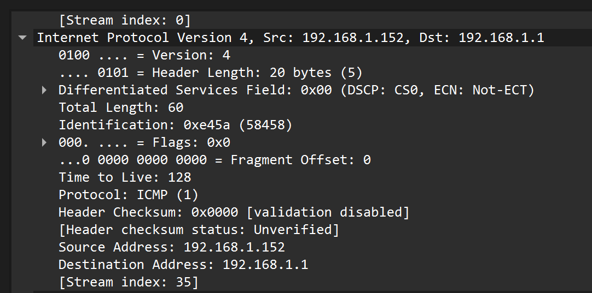

Frame Summary Table – Local Ping (Packet #1942)
Field | Value
Frame Size | 74 bytes on wire (592 bits)
Source MAC Address (PC NIC) | 8c:e9:ee:f3:8d:83 (Intel)
Destination MAC Address (Gateway) | e4:8e:10:10:d0:a8 (CigShanghai)
EtherType / Frame Type | 0x0800 (IPv4)
Source IP Address | 192.168.1.152
Destination IP Address | 192.168.1.1
Protocol | ICMP (1) – Echo (ping) request
Time to Live (TTL) | 128
Total Length | 60 bytes

Step 6 – Questions and Answers

Step 6.1: What is the MAC address of the PC NIC?
The MAC address of the PC NIC is 8c:e9:ee:f3:8d:83. Wireshark identifies the vendor as Intel (OUI: 8c:e9:ee), corresponding to the Intel wireless network adapter installed on the PC.

Step 6.2: What is the default gateway’s MAC address?
The default gateway’s MAC address is e4:8e:10:10:d0:a8. Wireshark identifies the vendor as CigShanghai (Shanghai CIG Technology Co., Ltd.), with OUI e4:8e:10.

Step 6.3: What type of frame is displayed?
The frame type displayed is Ethernet II (also known as DIX Ethernet). The EtherType field value is 0x0800, which indicates that the encapsulated upper-layer protocol is IPv4.

Step 6.4: What is the source IP address?
The source IP address is 192.168.1.152. This is the IPv4 address of the local PC that initiated the ping request.

Step 6.5: What is the destination IP address?
The destination IP address is 192.168.1.1. This is the IPv4 address of the default gateway (router) on the local network.

Step 6.6: What do the last two highlighted octets spell?
The last two octets in the ICMP data payload are 0x68 and 0x69 in hexadecimal, which correspond to the ASCII characters “h” and “i” — spelling “hi”. This is visible in the Packet Bytes pane of the Wireshark capture. It is part of the standard alphabet-based padding pattern (abcdefghijklmnopqrstuvwabcdefghi) used by Windows in ICMP Echo Request packets.

Step 6.7: What device and MAC address is displayed as the destination address?
In the Echo Reply frame, the destination address is the PC itself, with MAC address 8c:e9:ee:f3:8d:83 (Intel_f3:8d:83). This is because the default gateway router sends the reply back to the originating PC, so the source and destination MAC addresses are reversed compared to the request frame.

Step 7: Capture Packets for a Remote Host
A new Wireshark capture session was started, and the command “ping www.cisco.com” was executed from the command prompt. DNS resolved www.cisco.com to e2867.dsca.akamaiedge.net with IP address 23.12.156.160. Four Echo (ping) requests and replies were captured.
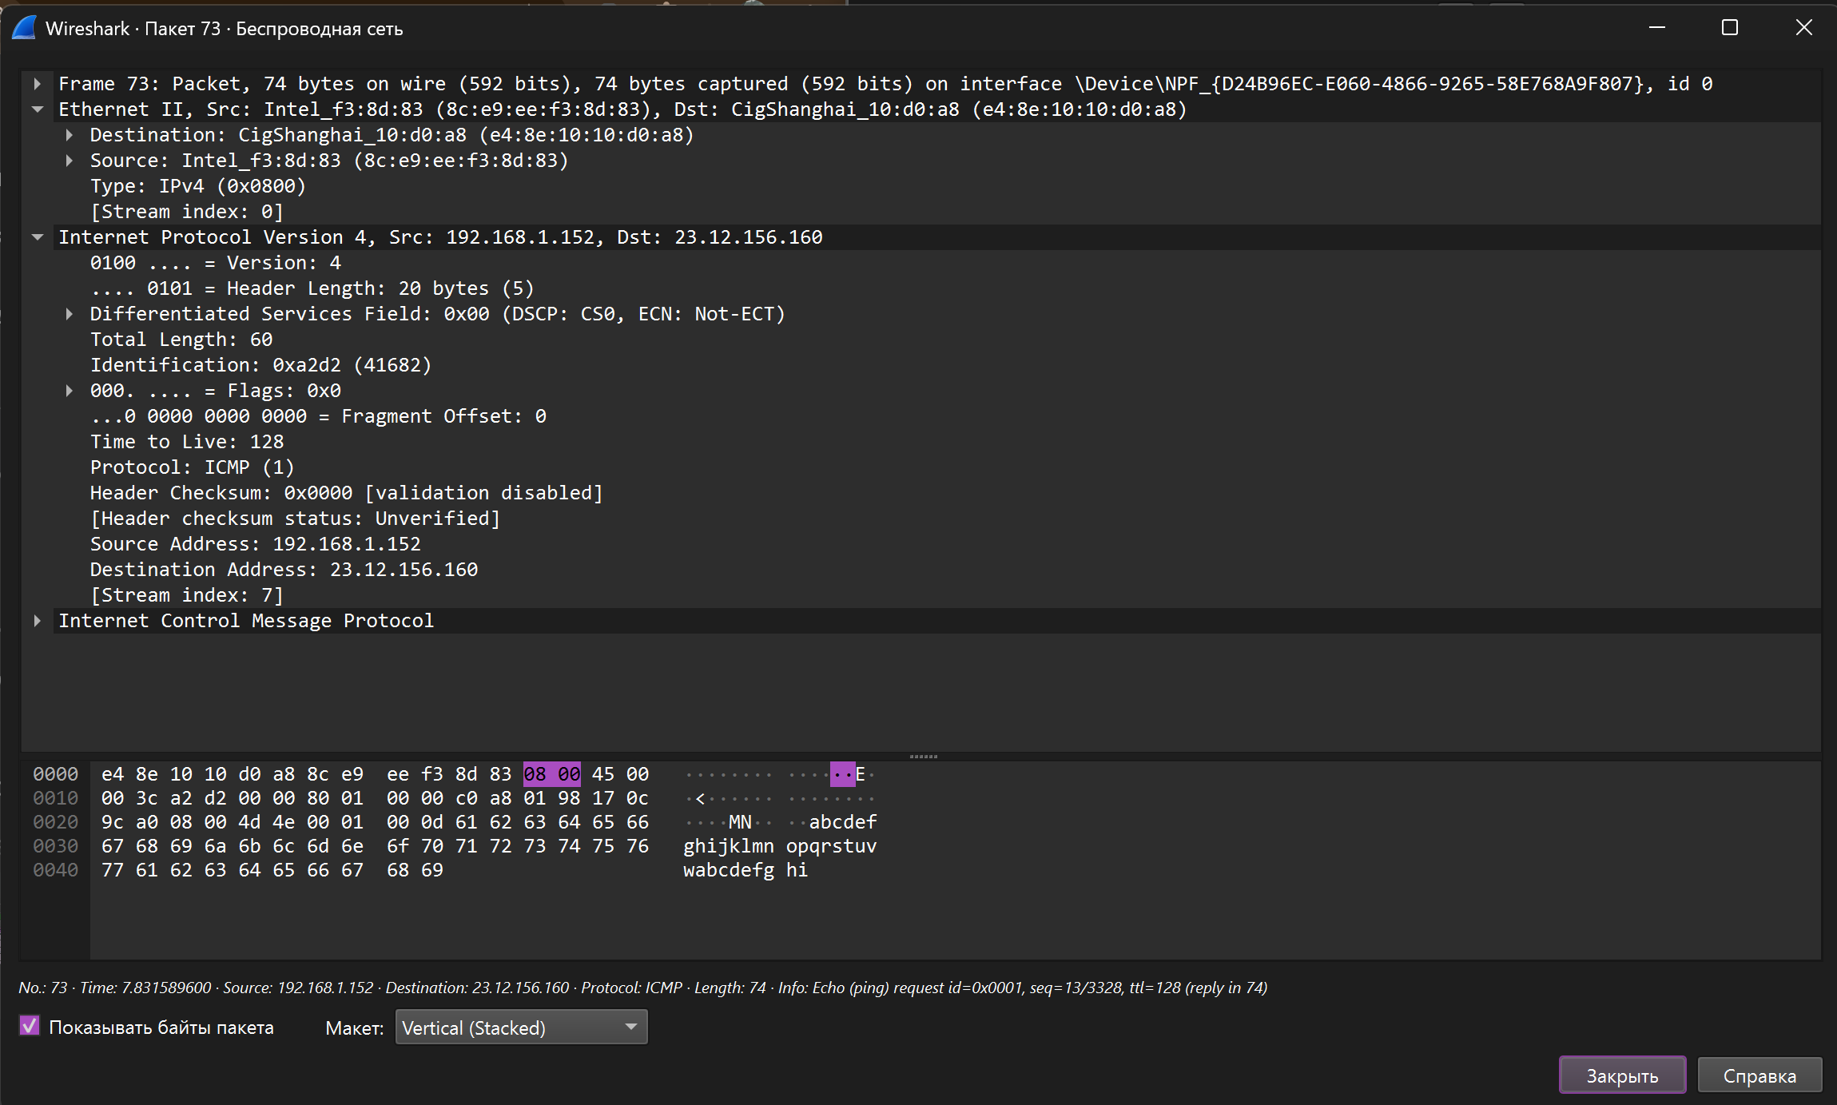
Frame Summary Table – Remote Ping (Packet #73)
Field | Value
Frame Size | 74 bytes on wire (592 bits)
Source MAC Address | 8c:e9:ee:f3:8d:83 (Intel)
Destination MAC Address | e4:8e:10:10:d0:a8 (CigShanghai)
EtherType / Frame Type | 0x0800 (IPv4)
Source IP Address | 192.168.1.152
Destination IP Address | 23.12.156.160 (www.cisco.com)
Protocol | ICMP (1) – Echo (ping) request
Time to Live (TTL) | 128

Step 7 – Questions and Answers
Step 7.1: What is the source MAC address?
The source MAC address is 8c:e9:ee:f3:8d:83 (Intel_f3:8d:83). This is the same PC NIC MAC address used in the local ping — the source MAC does not change because it always represents the originating device’s physical network interface.

Step 7.2: What is the destination MAC address?
The destination MAC address is e4:8e:10:10:d0:a8 (CigShanghai_10:d0:a8). This is the MAC address of the default gateway — the same MAC address used when pinging the local gateway in Step 6.

Step 7.3: What is the source IP address?
The source IP address is 192.168.1.152. This is the PC’s own IPv4 address on the local network.

Step 7.4: What is the destination IP address?
The destination IP address is 23.12.156.160. This is the public IP address of the web server hosting www.cisco.com (resolved via DNS to e2867.dsca.akamaiedge.net, an Akamai CDN edge server).

Step 7.5: Why has the destination IP address changed, while the destination MAC address remained the same?
The destination IP address changed from 192.168.1.1 (local gateway) to 23.12.156.160 (remote Cisco web server) because IP addresses operate at Layer 3 (Network Layer) and represent the final end-to-end logical destination of the packet. However, the destination MAC address remained the same (e4:8e:10:10:d0:a8) because MAC addresses operate at Layer 2 (Data Link Layer) and only have local significance within a single network segment. When a PC sends a packet to a remote host that is not on the local subnet, it forwards the frame to its default gateway (router). Therefore, the destination MAC address is always the MAC of the next-hop device — the default gateway. The router then strips the Ethernet frame, examines the Layer 3 destination IP, and re-encapsulates the packet in a new frame with new MAC addresses for the next hop. This process repeats at every router until the packet reaches 23.12.156.160.

Comparison: Local vs. Remote Ping
Field | Local Ping (192.168.1.1) | Remote Ping (www.cisco.com)
Source MAC | 8c:e9:ee:f3:8d:83 | 8c:e9:ee:f3:8d:83
Destination MAC | e4:8e:10:10:d0:a8 | e4:8e:10:10:d0:a8
Source IP | 192.168.1.152 | 192.168.1.152
Destination IP | 192.168.1.1 | 23.12.156.160
TTL (Request) | 128 | 128
TTL (Reply) | 64 | 54

Reflection Question
Wireshark does not display the preamble field of a frame header. What does the preamble contain?
The preamble contains 7 bytes of alternating 1s and 0s (the pattern 10101010 repeated), followed by 1 byte called the Start Frame Delimiter (SFD) with the pattern 10101011. The purpose of the preamble is to synchronize the clock signals between the sending and receiving NICs. The SFD marks the exact point where the frame content begins. Wireshark does not display the preamble because it is stripped by the NIC hardware before the frame data is passed to the operating system and the packet capture software. The preamble is processed entirely at the physical layer (Layer 1) and is not part of the Ethernet frame header at the data link layer (Layer 2).

Conclusion
This lab provided hands-on experience using Wireshark to examine Ethernet II frame headers. Through capturing and analyzing ARP, local ICMP, and remote ICMP traffic, several key networking concepts were reinforced:
- ARP uses broadcast frames (ff:ff:ff:ff:ff:ff) to resolve Layer 3 IP addresses to Layer 2 MAC addresses before any unicast communication can occur.
- Ethernet II frames contain critical Layer 2 header information including source and destination MAC addresses, the EtherType field, and FCS.
- When communicating with remote hosts, the destination MAC address always points to the next-hop device (default gateway), while the destination IP reflects the actual remote endpoint.
- The distinction between Layer 2 (local, hop-by-hop) and Layer 3 (end-to-end) addressing is fundamental to understanding how data travers’s networks.

