NETWORKING LAB REPORT
IPv6 Addressing & Basic Device Configuration
Student: Assyrzhanova Gaukhar
Course: CCNA: Introduction to Networks
Group: IIoT-2401
Labs: 12.6.6 -Configure IPv6 Addressing | 12.4.5 -Basic Device Configuration

Lab 12.6.6 -Configure IPv6 Addressing

Objectives
The purpose of this lab is to practice configuring IPv6 addresses on a router, servers, and client PCs, and to verify end-to-end IPv6 connectivity across multiple network segments connected through router R1.

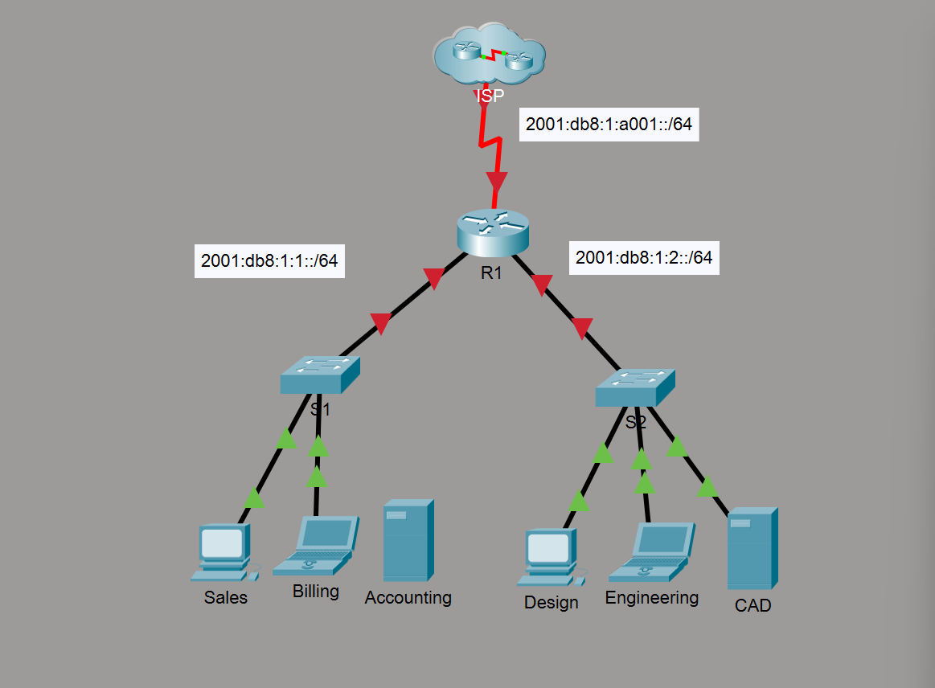

Addressing Table
Device | Interface | IPv6 Address / Prefix | Default Gateway
R1 | G0/0 | 2001:DB8:1:1::1/64 | N/A
R1 | G0/0 | fe80::1 (link-local) | N/A
R1 | G0/1 | 2001:DB8:1:2::1/64 | N/A
R1 | G0/1 | fe80::1 (link-local) | N/A
R1 | S0/0/0 | 2001:DB8:1:A001::2/64 | N/A
R1 | S0/0/0 | fe80::1 (link-local) | N/A
Sales | NIC | 2001:DB8:1:1::2/64 | fe80::1
Billing | NIC | 2001:DB8:1:1::3/64 | fe80::1
Accounting | NIC | 2001:DB8:1:1::4/64 | fe80::1
Design | NIC | 2001:DB8:1:2::2/64 | fe80::1
Engineering | NIC | 2001:DB8:1:2::3/64 | fe80::1
CAD | NIC | 2001:DB8:1:2::4/64 | fe80::1
ISP | S0/0/0 | 2001:DB8:1:A001::1/64 | N/A

Part 1: Configure IPv6 Addressing on the Router
Q: What command enables the router to forward IPv6 packets? Why is it needed?
A: ipv6 unicast-routing. Unlike IPv4 where routing is enabled by default, in IPv6 the router will not forward packets between interfaces until this command is explicitly entered in global configuration mode.
Q: What is the difference between a global unicast address and a link-local address?
A: A global unicast address (e.g., 2001:DB8:1:1::1) is routable across the entire network and internet -it uniquely identifies a device globally. A link-local address (e.g., fe80::1) only works on the directly connected link (cable segment) and cannot be routed. It is used for neighbor discovery and as a default gateway for hosts.
Q: Why does each interface have TWO IPv6 addresses?
A: In IPv6, every interface needs at least two addresses: a global unicast address for network-wide communication, and a link-local address for local operations like neighbor discovery and serving as the default gateway for connected hosts. This is different from IPv4 where each interface typically has only one address.
Q: If you enter a wrong IPv6 address, can you just type the correct one over it?
A: No. In IPv6, entering a new address does not replace the old one -both addresses will remain on the interface. You must first remove the incorrect address using no ipv6 address <wrong-address>, then enter the correct one.
Q: What command verifies IPv6 addressing on the router?
A: show ipv6 interface brief -this displays all interfaces with their IPv6 addresses and up/down status in a concise table format.

R1 Configuration Commands
enable
configure terminal
ipv6 unicast-routing

interface GigabitEthernet 0/0
ipv6 address 2001:db8:1:1::1/64
ipv6 address fe80::1 link-local
no shutdown
exit

interface GigabitEthernet 0/1
ipv6 address 2001:db8:1:2::1/64
ipv6 address fe80::1 link-local
no shutdown
exit

interface Serial 0/0/0
ipv6 address 2001:db8:1:a001::2/64
ipv6 address fe80::1 link-local
no shutdown
exit

end
show ipv6 interface brief
copy running-config startup-config
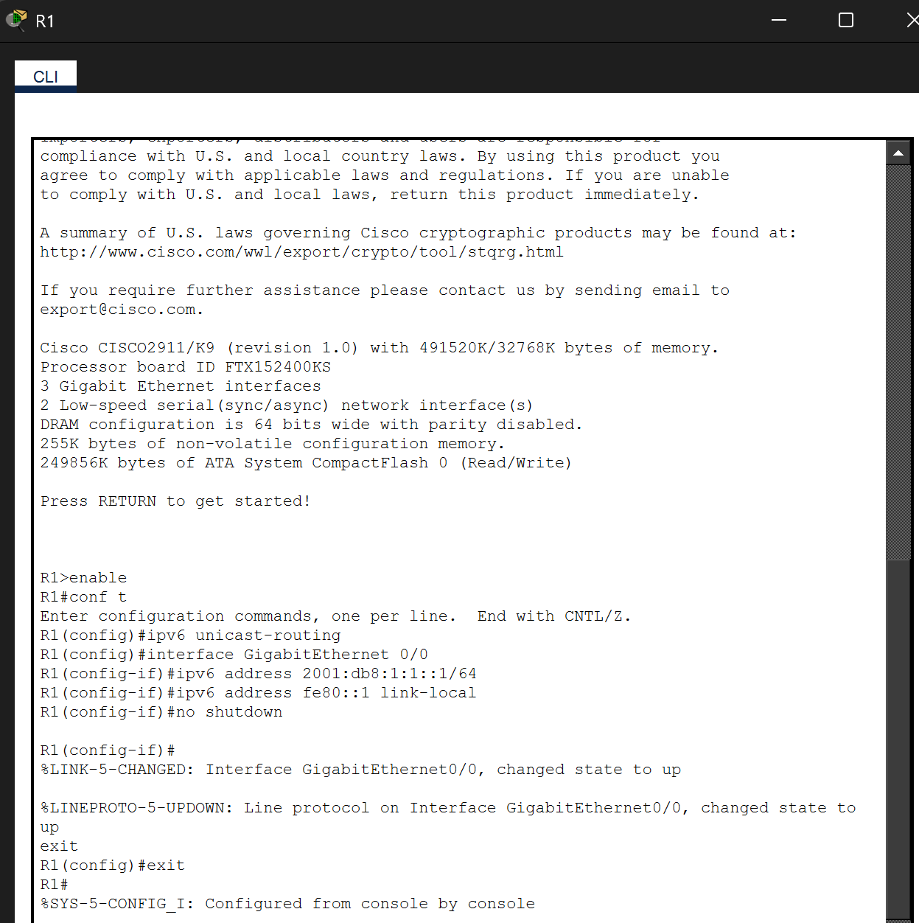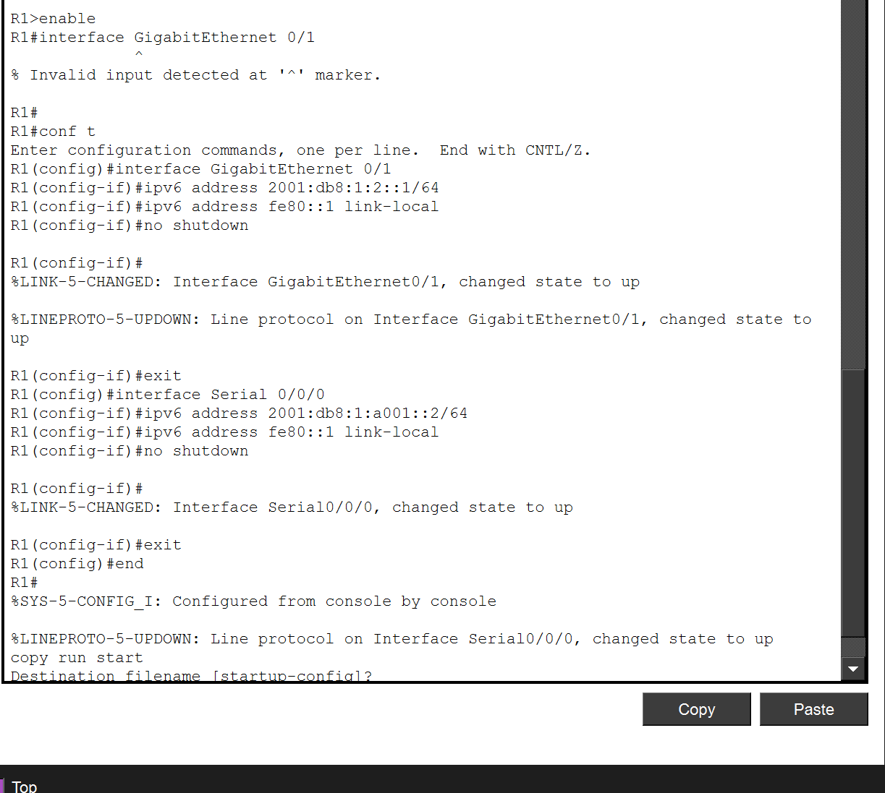

Part 2 & 3: Configure IPv6 on Servers and Clients
Each device was configured via Desktop → IP Configuration with IPv6 set to Static. The IPv6 address, /64 prefix, and fe80::1 gateway were entered manually on all six devices.
Device | IPv6 Address | Prefix | Gateway
Sales | 2001:DB8:1:1::2 | /64 | fe80::1
Billing | 2001:DB8:1:1::3 | /64 | fe80::1
Accounting | 2001:DB8:1:1::4 | /64 | fe80::1
Design | 2001:DB8:1:2::2 | /64 | fe80::1
Engineering | 2001:DB8:1:2::3 | /64 | fe80::1
CAD | 2001:DB8:1:2::4 | /64 | fe80::1

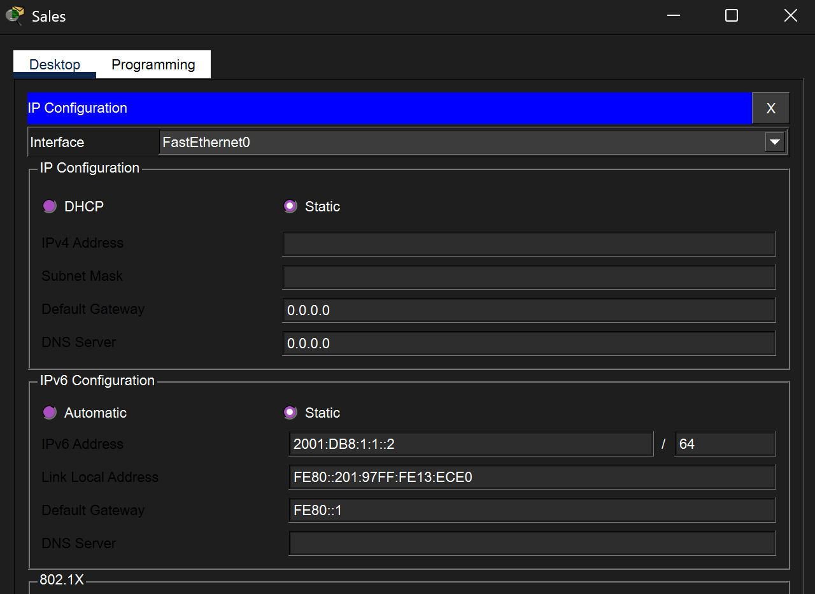

Troubleshooting: Accounting Server
During testing, pings to Accounting (2001:DB8:1:1::4) consistently returned Request timed out. Upon investigation, it was discovered that the Accounting server was not physically connected to switch S1 -the Ethernet cable was missing from the lab file. This is a known issue with the Packet Tracer .pka file, not a configuration error. All other devices (Sales, Billing, Design, Engineering, CAD) were connected and functional.

Part 4: Test and Verify Network Connectivity

Ping Tests
Pings were executed from multiple clients to verify connectivity across both LAN segments and the WAN link to ISP:
From Sales: Ping to R1 (2001:db8:1:1::1) -Success (4/4, 0% loss). Ping to Accounting (::4) -Failed (missing cable).
From Billing: Ping to ISP (2001:db8:1:a001::1) -Success. Ping to Billing (::3) -Success. Ping to CAD (2001:db8:1:2::4) -Success.
From Engineering: Ping to Billing (::3) -Success. Ping to CAD (::4) -Success. Ping to ISP -Success.

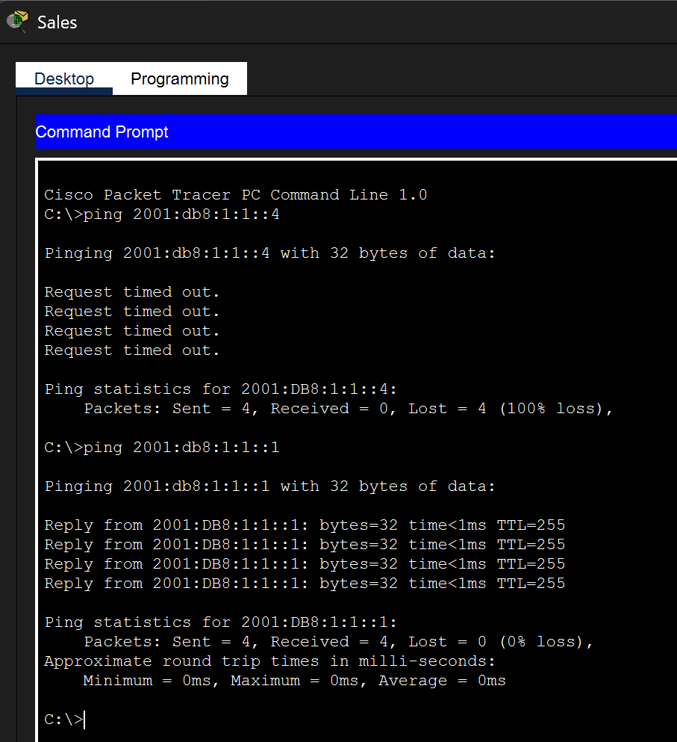

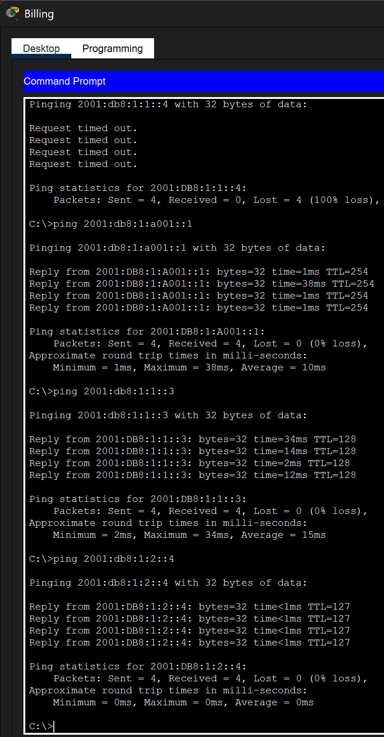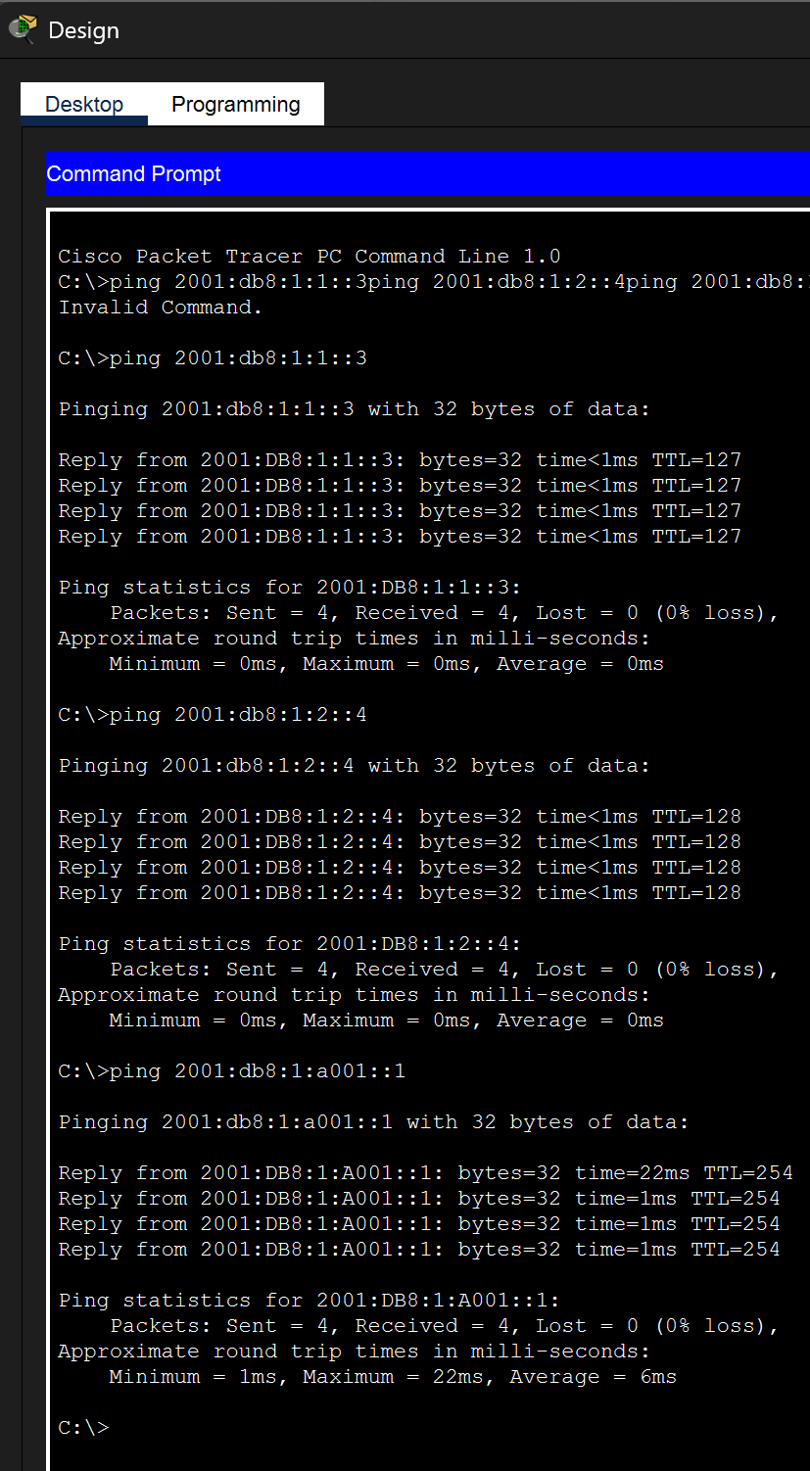

Web Browser Tests
The CAD Server web page was successfully accessed from multiple clients by entering 2001:db8:1:2::4 in the URL bar. The page displayed "Welcome to the CAD server!" confirming HTTP connectivity over IPv6. The Accounting web page could not be accessed due to the missing cable issue.
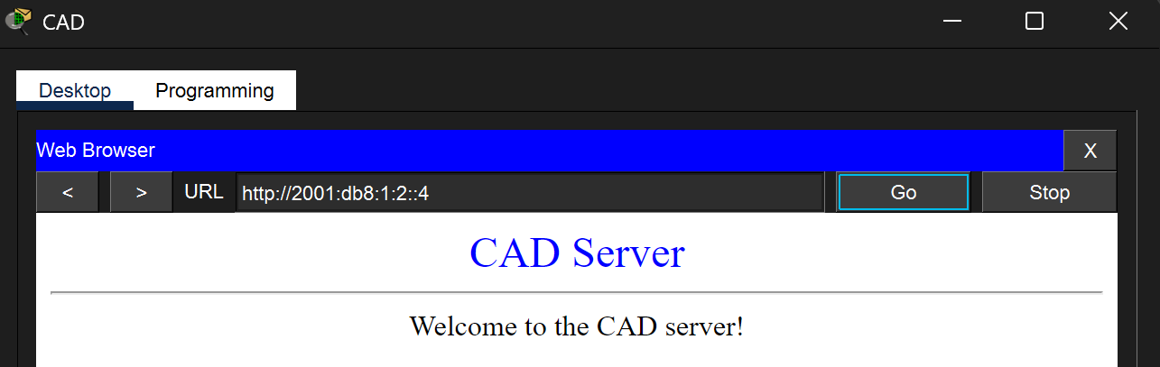
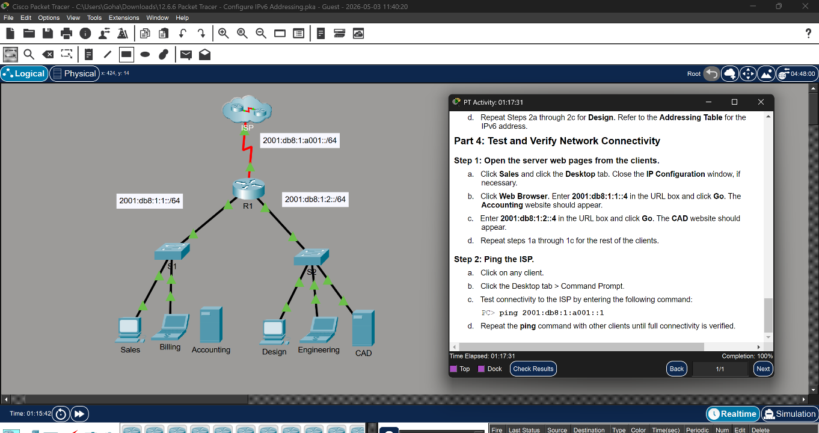

Lab 12.4.5 -Basic Device Configuration

Objectives
This lab demonstrates configuring a dual-stack (IPv4 + IPv6) network with a router, switch, and four PCs. Tasks include setting hostnames, security passwords, MOTD banners, interface addressing with descriptions, and verifying full end-to-end connectivity over both protocols.

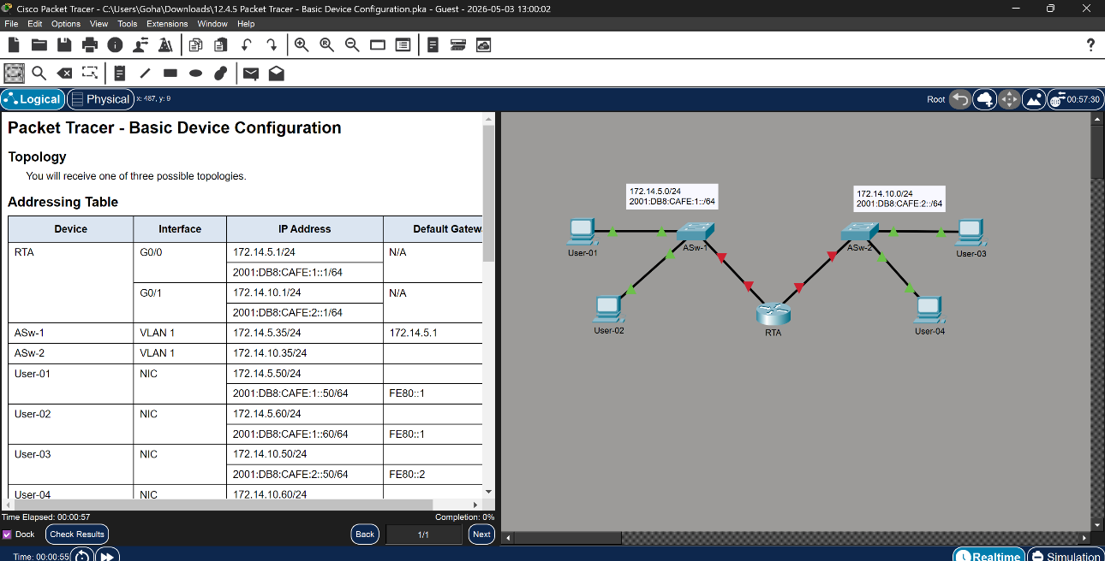

Complete Addressing Table
Device | Interface | IP Address | Default Gateway
RTA | G0/0 | 172.14.5.1/24 | N/A
RTA | G0/0 | 2001:DB8:CAFE:1::1/64 | N/A
RTA | G0/1 | 172.14.10.1/24 | N/A
RTA | G0/1 | 2001:DB8:CAFE:2::1/64 | N/A
ASw-1 | VLAN 1 | 172.14.5.35/24 | 172.14.5.1
ASw-2 | VLAN 1 | 172.14.10.35/24 | 172.14.10.1
User-01 | NIC (IPv4) | 172.14.5.50/24 | 172.14.5.1
User-01 | NIC (IPv6) | 2001:DB8:CAFE:1::50/64 | fe80::1
User-02 | NIC (IPv4) | 172.14.5.60/24 | 172.14.5.1
User-02 | NIC (IPv6) | 2001:DB8:CAFE:1::60/64 | fe80::1
User-03 | NIC (IPv4) | 172.14.10.50/24 | 172.14.10.1
User-03 | NIC (IPv6) | 2001:DB8:CAFE:2::50/64 | fe80::2
User-04 | NIC (IPv4) | 172.14.10.60/24 | 172.14.10.1
User-04 | NIC (IPv6) | 2001:DB8:CAFE:2::60/64 | fe80::2
Q: Why is the IPv6 gateway fe80::1 for User-01/02 but fe80::2 for User-03/04?
A: Because User-01 and User-02 are connected to RTA's G0/0 interface, which has link-local address fe80::1. User-03 and User-04 are connected to G0/1, which has link-local address fe80::2. Each interface has its own link-local address, and hosts use the link-local address of the router interface on their local segment as their gateway.

RTA Router Configuration
enable
configure terminal
hostname RTA
banner motd #Unauthorized access is prohibited.#
enable secret class
line console 0
password cisco
login
exit
line vty 0 4
password cisco
login
exit
service password-encryption
ipv6 unicast-routing

interface GigabitEthernet 0/0
ip address 172.14.5.1 255.255.255.0
ipv6 address 2001:DB8:CAFE:1::1/64
ipv6 address fe80::1 link-local
description LAN connection to ASw-1
no shutdown
exit

interface GigabitEthernet 0/1
ip address 172.14.10.1 255.255.255.0
ipv6 address 2001:DB8:CAFE:2::1/64
ipv6 address fe80::2 link-local
description LAN connection to ASw-2
no shutdown
exit

end
copy running-config startup-config
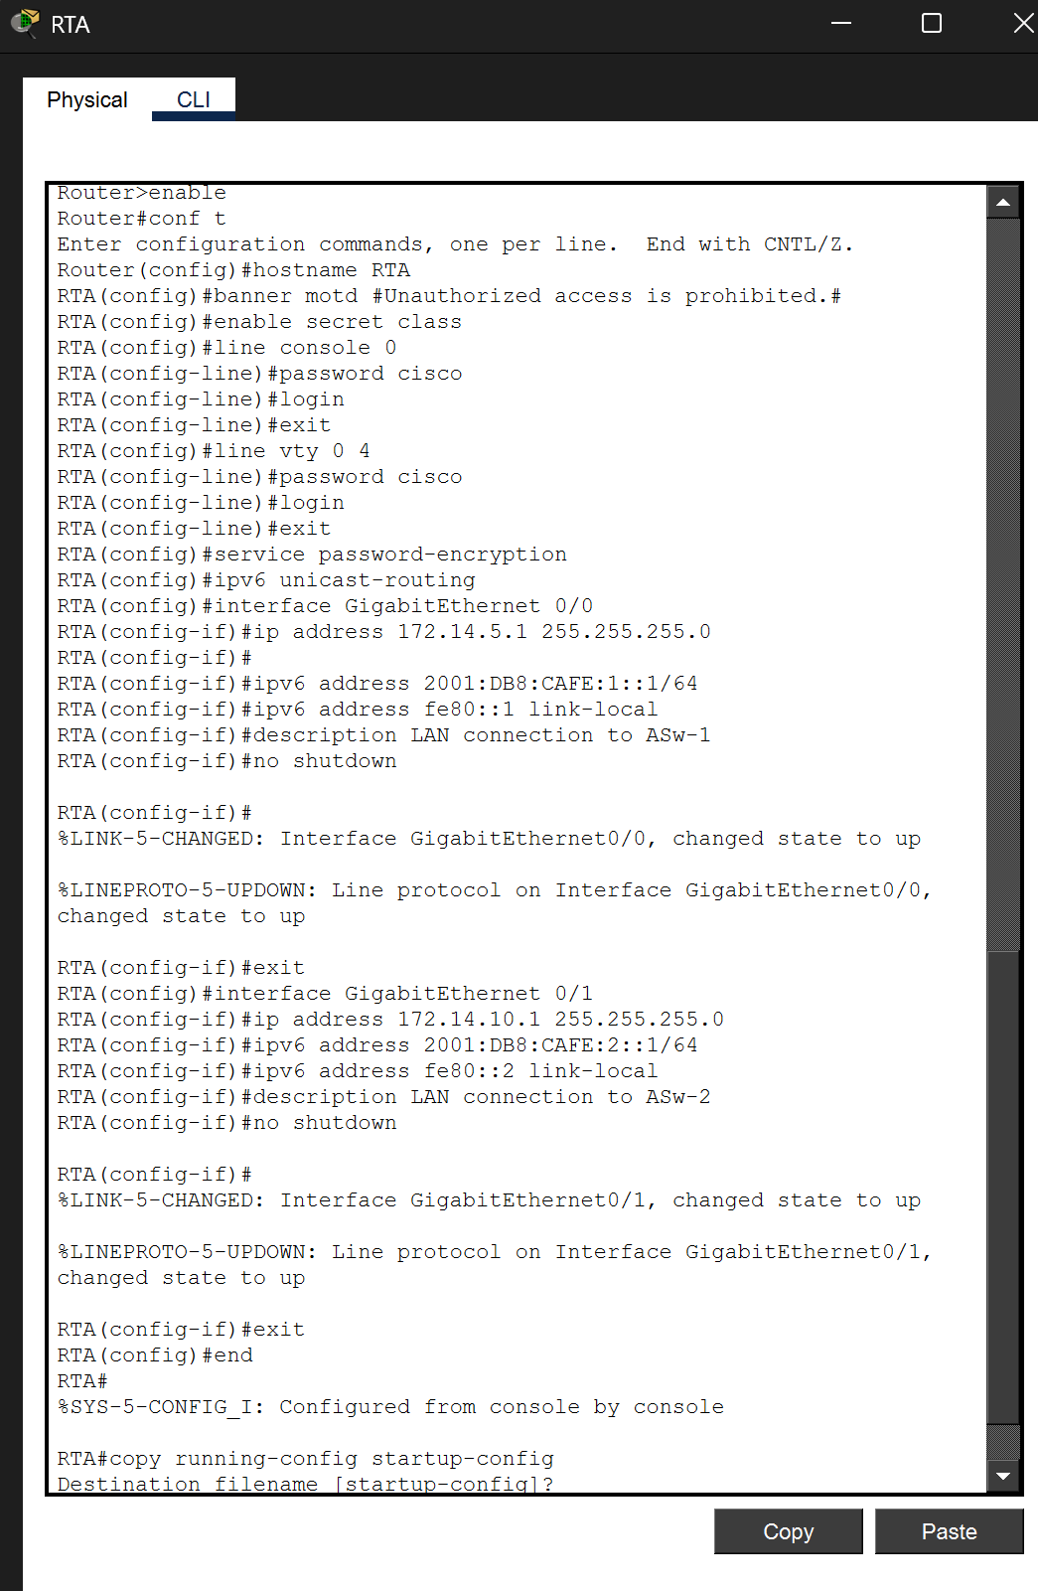

ASw-2 Switch Configuration
enable
configure terminal
hostname ASw-2
banner motd #Unauthorized access is prohibited.#
enable secret class
line console 0
password cisco
login
exit
line vty 0 15
password cisco
login
exit
service password-encryption
interface vlan 1
ip address 172.14.10.35 255.255.255.0
description Management interface
no shutdown
exit
ip default-gateway 172.14.10.1
end
copy running-config startup-config
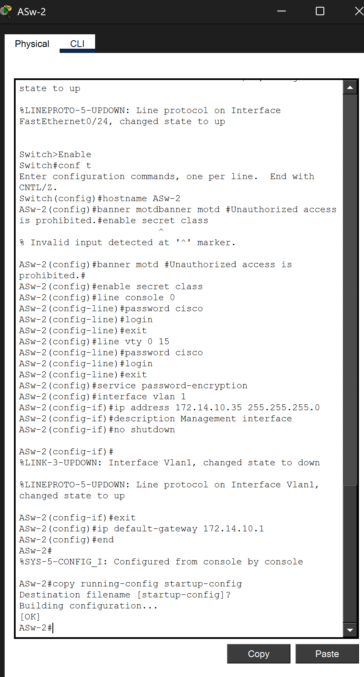

Host Configuration
All four users were configured via Desktop → IP Configuration with both IPv4 (Static) and IPv6 (Static) addresses.

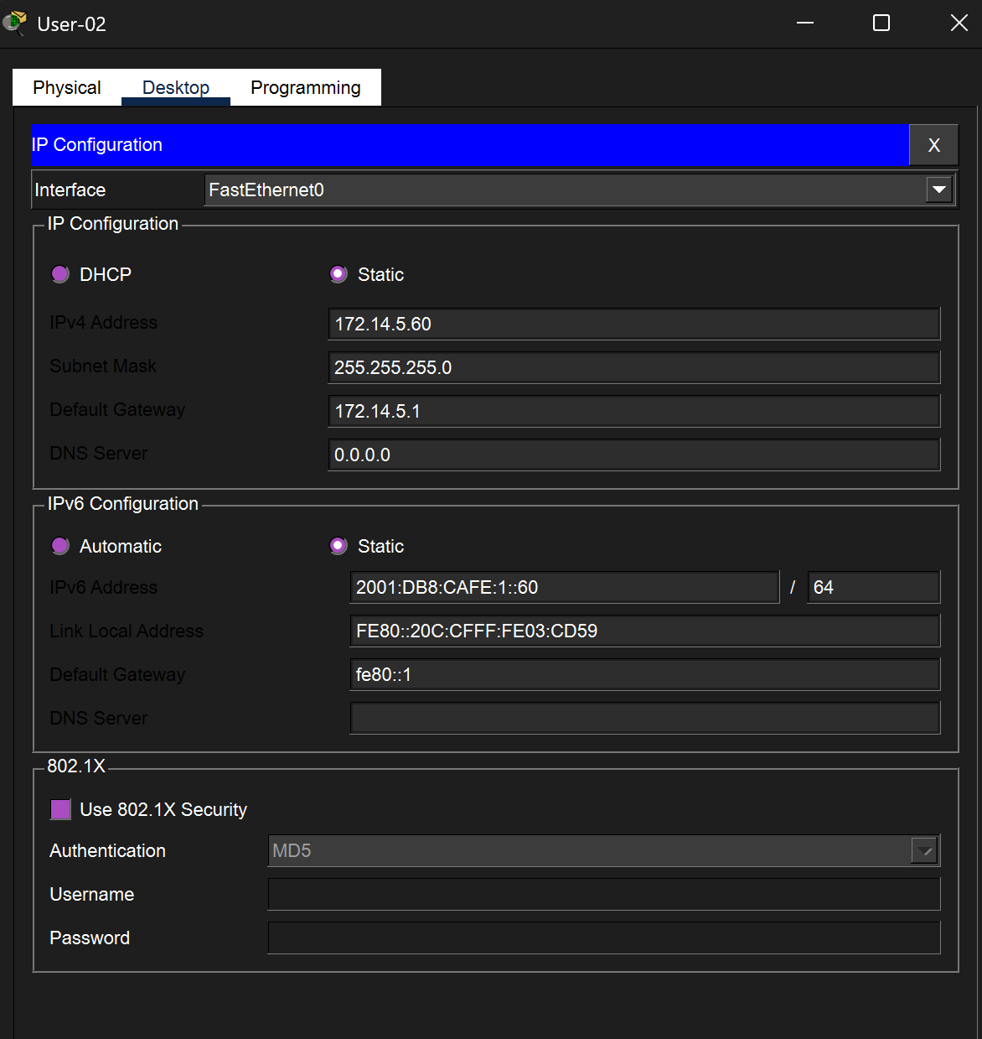

Troubleshooting: User-04 Incorrect IPv4 Address
During verification, User-04 was found to have an incorrect IPv4 address of 128.107.20.30 pre-configured in the lab file. This address belongs to a completely different network (128.107.x.x) and does not match the required 172.14.10.0/24 subnet. The address was corrected to 172.14.10.60 with subnet mask 255.255.255.0 and default gateway 172.14.10.1. After correction, IPv4 connectivity was restored.
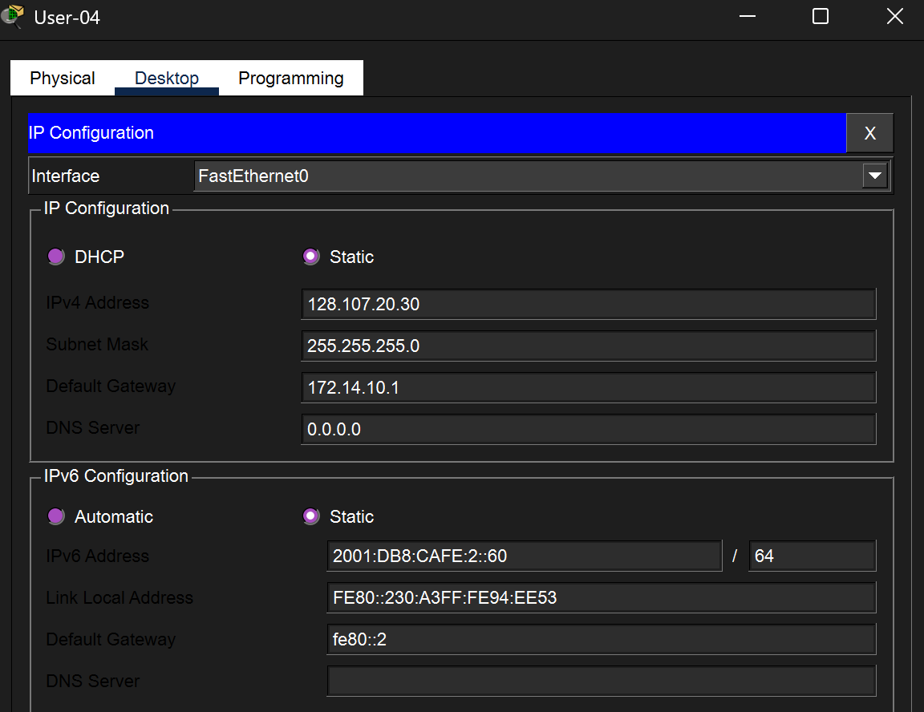

Verification: Connectivity Tests

IPv4 Ping Tests (from User-01)
Ping to 172.14.5.1 (RTA G0/0, local gateway) -Success (4/4, 0% loss).
Ping to 172.14.10.50 (User-03, remote LAN) -Success (4/4 after initial ARP timeout).

IPv6 Ping Tests (from User-01)
Ping to 2001:DB8:CAFE:1::1 (RTA G0/0) -Success (4/4, 0% loss).
Ping to 2001:DB8:CAFE:2::50 (User-03, cross-LAN) -Success, confirming dual-stack routing works correctly.
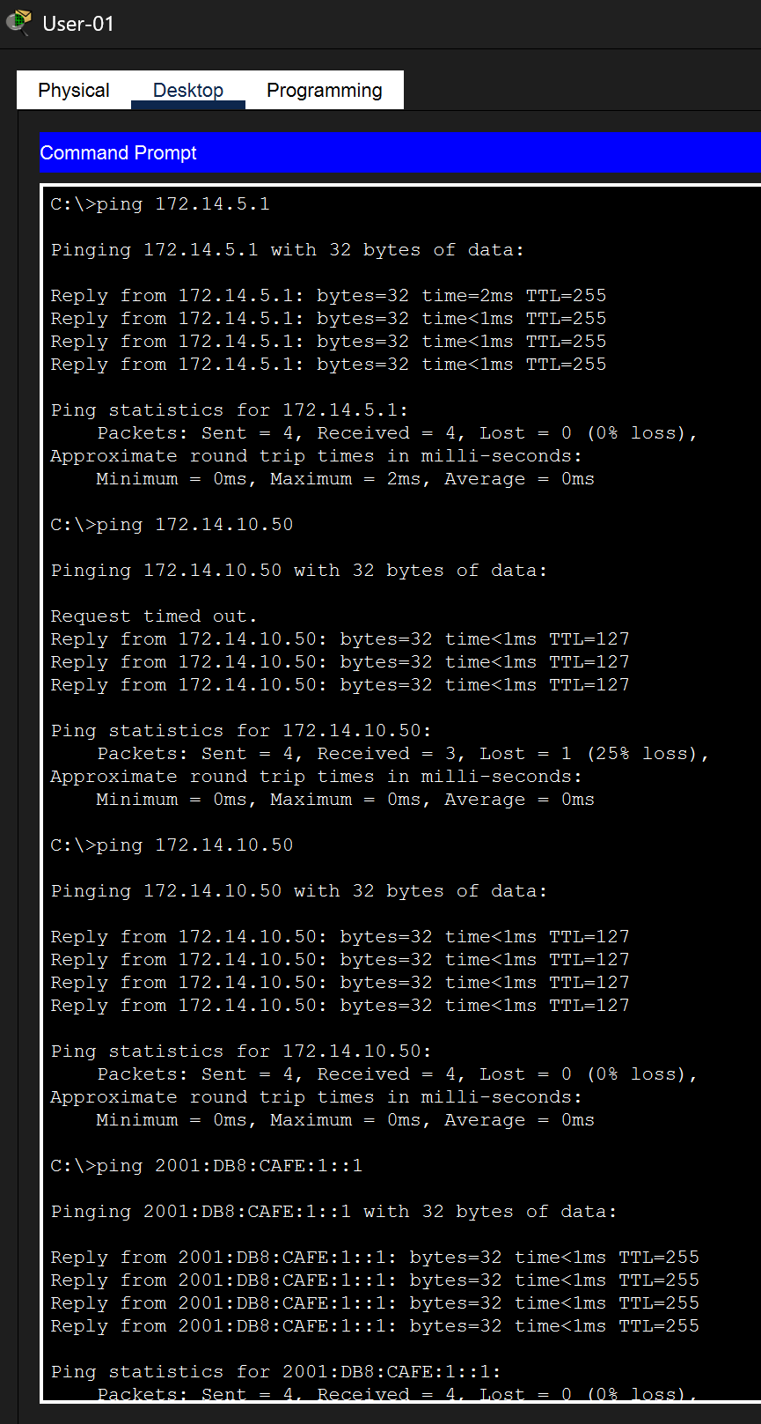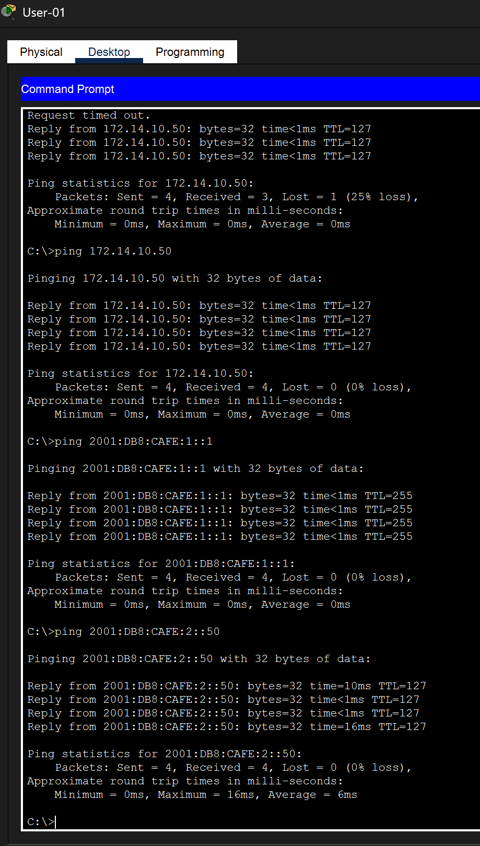
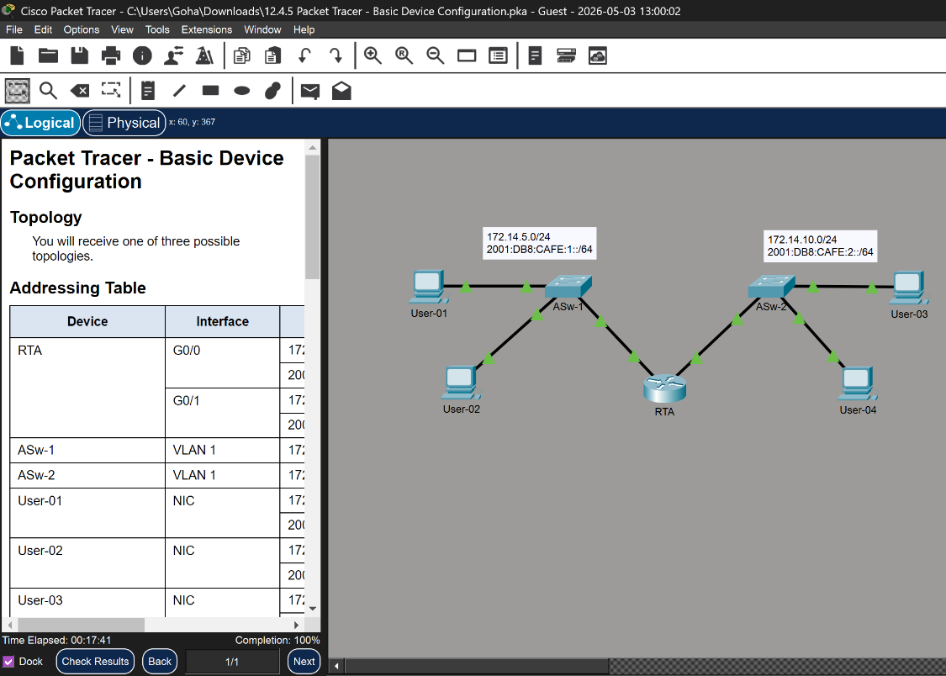

Conclusion
These two labs covered the fundamentals of IPv6 deployment in Cisco networks. In Lab 12.6.6, we configured a pure IPv6 environment: enabling ipv6 unicast-routing on the router, assigning both global unicast and link-local addresses to each interface, and configuring six end devices with static IPv6 addresses. Key takeaways include the requirement for two addresses per interface in IPv6, the use of link-local addresses as default gateways, and the need to explicitly remove incorrect IPv6 addresses rather than overwriting them. In Lab 12.4.5, we implemented a dual-stack configuration supporting both IPv4 and IPv6 simultaneously. This included full router security (passwords, banner, encryption), interface descriptions for documentation, and switch management addressing. Troubleshooting revealed a pre-configured error on User-04 (wrong IPv4 address from a different subnet), which was corrected to restore connectivity. Both labs achieved 100% completion, confirming proper addressing and full end-to-end reachability across all network segments.
-End of Report —

