Combined Lab Report
Basic Router Configuration and LAN Connectivity
Student Name | Assyrzhanova Gaukhar
Group | IIoT-2401
Activities | 1. Configure Initial Router Settings  2. Connect a Router to a LAN

Objectives
- Perform basic router configuration tasks through the CLI.
- Secure access to the router using encrypted and plain-text passwords.
- Configure a Message of the Day (MOTD) banner for security notifications.
- Verify router configuration and save changes to NVRAM.
- Display and interpret router interface, routing, and status information.
- Configure and activate router interfaces for LAN connectivity.
- Verify end-to-end connectivity across a multi-router topology.

Part I: Configure Initial Router Settings

1. Verifying the Default Router Configuration
The router was accessed via a console connection from PCA. After entering privileged EXEC mode with the enable command, the show running-config and show startup-config commands were used to examine the default state of the device.
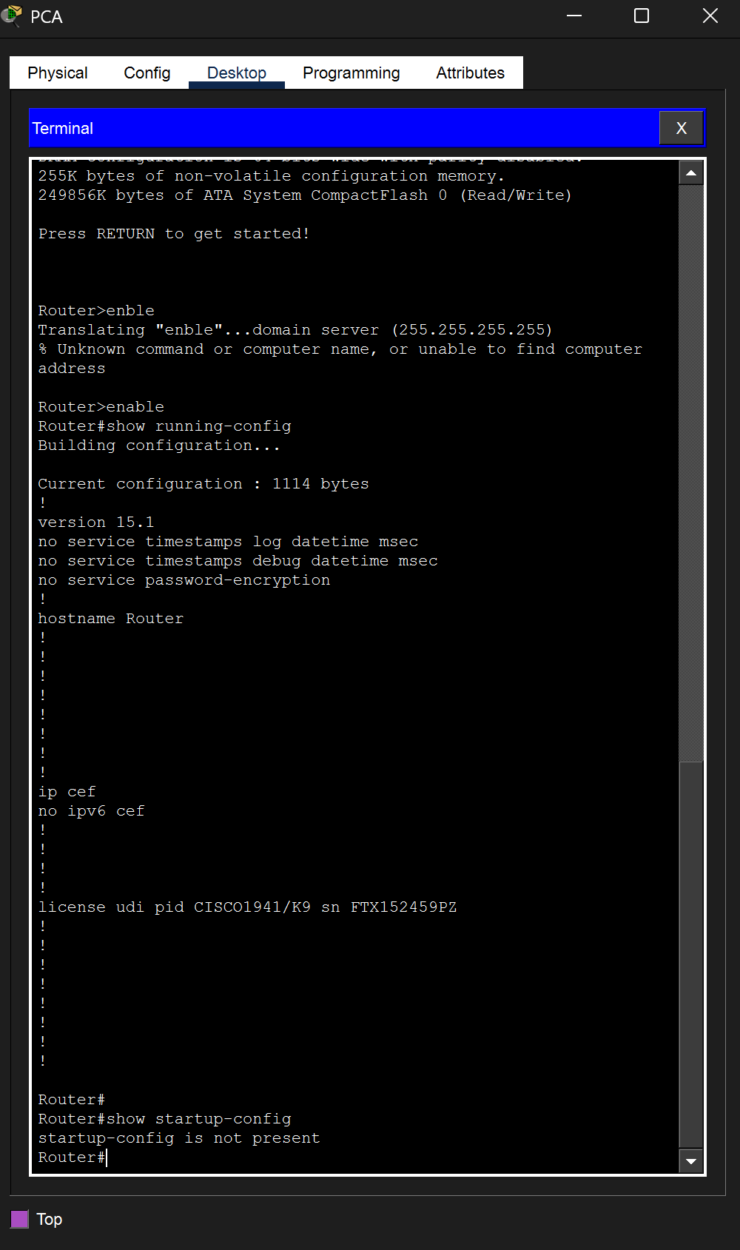
Q: What is the router's hostname?
A: The default hostname is Router, as shown in the running-config output (line: hostname Router).
Q: How many Fast Ethernet interfaces does the Router have?
A: The Cisco 1941 router (CISCO1941/K9) does not have onboard Fast Ethernet interfaces, but it is equipped with a 4-port FastEthernet HWIC module (FastEthernet0/1/0 through 0/1/3), giving a total of 4 Fast Ethernet interfaces.
Q: How many Gigabit Ethernet interfaces does the Router have?
A: 2 Gigabit Ethernet interfaces — GigabitEthernet0/0 and GigabitEthernet0/1.
Q: How many Serial interfaces does the router have?
A: 2 Serial interfaces — Serial0/0/0 and Serial0/0/1.
Q: What is the range of values shown for the vty lines?
A: The default range is vty 0 to 4, which provides 5 simultaneous virtual terminal (Telnet/SSH) sessions.
Q: Why does the router respond with the "startup-config is not present" message?
A: Because the router has not had its running configuration saved to NVRAM yet. Until the administrator executes copy running-config startup-config, the NVRAM remains empty and the router simply reports that no startup configuration file exists.

2. Configuring and Verifying Initial Settings
From global configuration mode, the following parameters were configured on R1: the hostname, an MOTD banner, service password-encryption, the enable password, the enable secret, and a console line password.
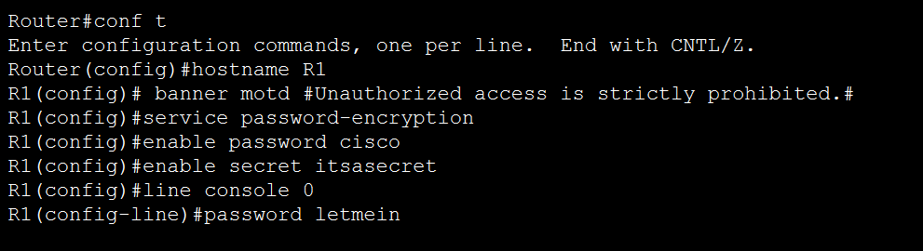
Commands used:
Router(config)# hostname R1
R1(config)# banner motd #Unauthorized access is strictly prohibited.#
R1(config)# service password-encryption
R1(config)# enable password cisco
R1(config)# enable secret itsasecret
R1(config)# line console 0
R1(config-line)# password letmein
R1(config-line)# login
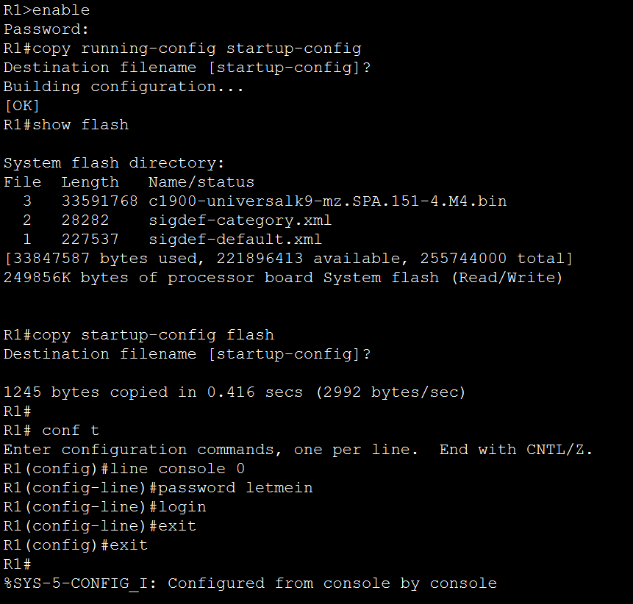
Q: What command do you use to verify the initial settings?
A: show running-config — this displays the active configuration currently running in the router's RAM, confirming that the hostname, banner, and password settings were applied correctly.
Q: Why should every router have a message-of-the-day (MOTD) banner?
A: The MOTD banner serves as a legal warning notifying anyone attempting to access the device that unauthorized use is prohibited. Without such a banner, organizations may have difficulty prosecuting intruders, because the attacker could claim they were unaware that access was restricted.
Q: If you are not prompted for a password before reaching the user EXEC prompt, what console line command did you forget to configure?
A: The login command was omitted under line console 0. The password command alone stores the password, but the login command is required to actually enforce authentication on that line.
Q: Why would the enable secret password allow access to privileged EXEC mode while the enable password no longer does?
A: When both are configured, enable secret takes precedence over enable password. This is because enable secret uses a stronger MD5 hash, and Cisco IOS treats it as the authoritative credential when both are present. The plain enable password is effectively ignored.
Q: If you configure any more passwords on the router, are they displayed in the configuration file as plain text or in encrypted form?
A: They will appear in encrypted form (as Type 7 encrypted strings). This is because the service password-encryption command was enabled earlier, which automatically scrambles all plain-text passwords in the configuration file, including any future ones.

3. Saving the Configuration File
To make the configuration persistent across reboots, the running-config was copied from RAM into NVRAM. An optional backup copy was also stored in flash memory.
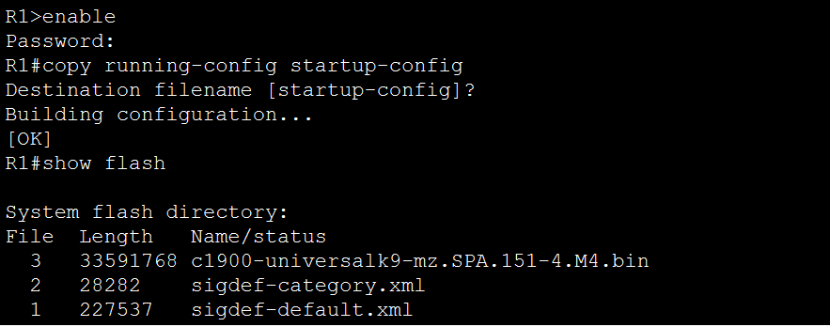
Q: What command did you enter to save the configuration to NVRAM?
A: copy running-config startup-config
Q: What is the shortest, unambiguous version of this command?
A: copy run start
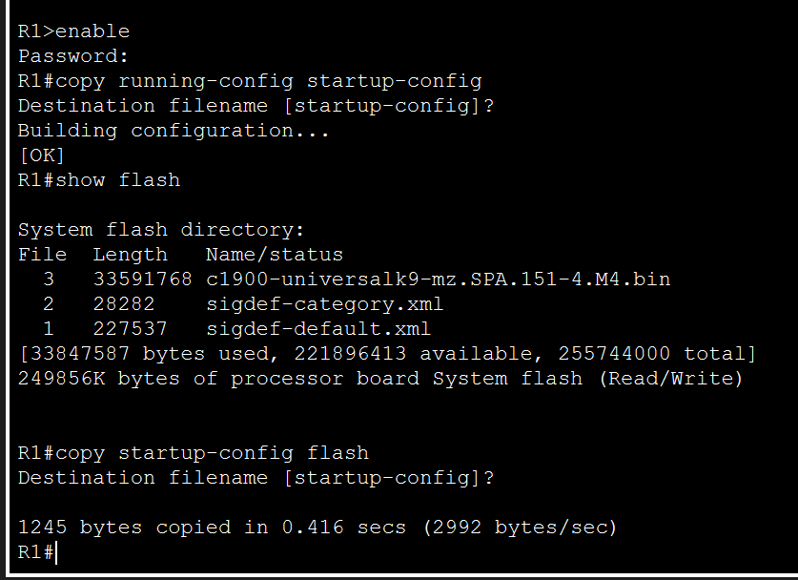
Q: How many files are currently stored in flash?
A: Three files are visible in flash memory:
- c1900-universalk9-mz.SPA.151-4.M4.bin (33,591,768 bytes)
- sigdef-category.xml (28,282 bytes)
- sigdef-default.xml (227,537 bytes)
Q: Which of these files would you guess is the IOS image, and why?
A: The file c1900-universalk9-mz.SPA.151-4.M4.bin is the IOS image. Three strong indicators point to this: (1) it is by far the largest file (~33 MB), which is typical for a full IOS image; (2) the .bin extension indicates an executable binary; and (3) the filename follows the standard Cisco IOS naming convention — platform (c1900), feature set (universalk9), file format (mz = zipped, runs from RAM), and version (151-4.M4).

Part II: Connect a Router to a LAN

Topology Overview
The topology consists of two routers (R1 and R2) connected back-to-back via a Serial WAN link on the 209.165.200.224/30 subnet. Each router has two LANs attached through its Gigabit Ethernet interfaces, with a total of four end-user PCs (PC1–PC4). OSPF is already partially configured between the routers.

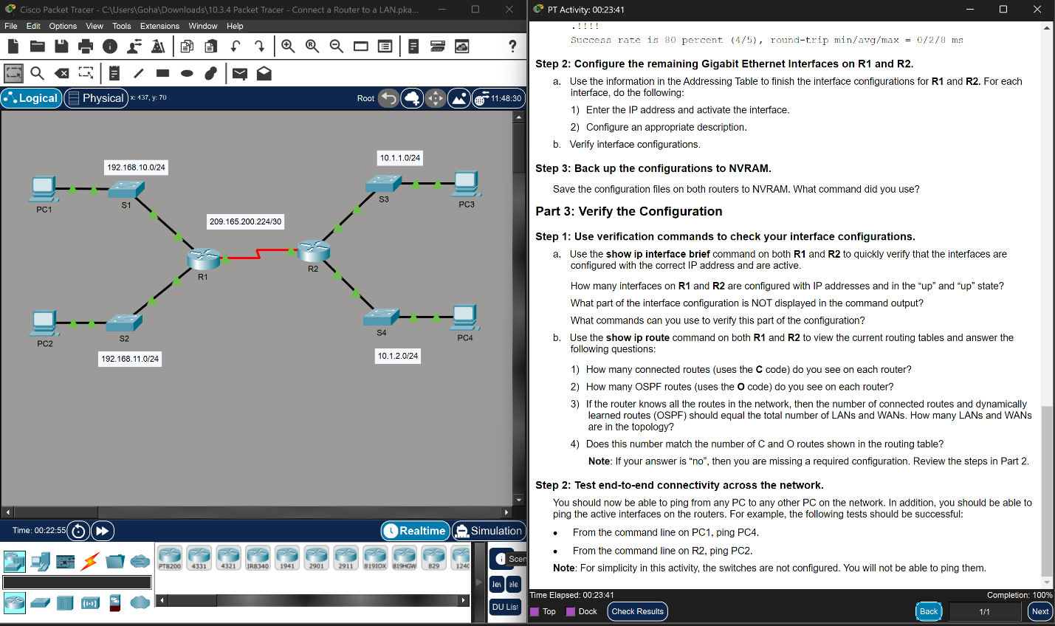1. Displaying Router Information
Q: Which command displays the statistics for all interfaces configured on a router?
A: show interfaces — this displays complete statistics and status for every interface on the router.
Q: Which command displays the information about the Serial 0/0/0 interface only?
A: show interfaces serial 0/0/0

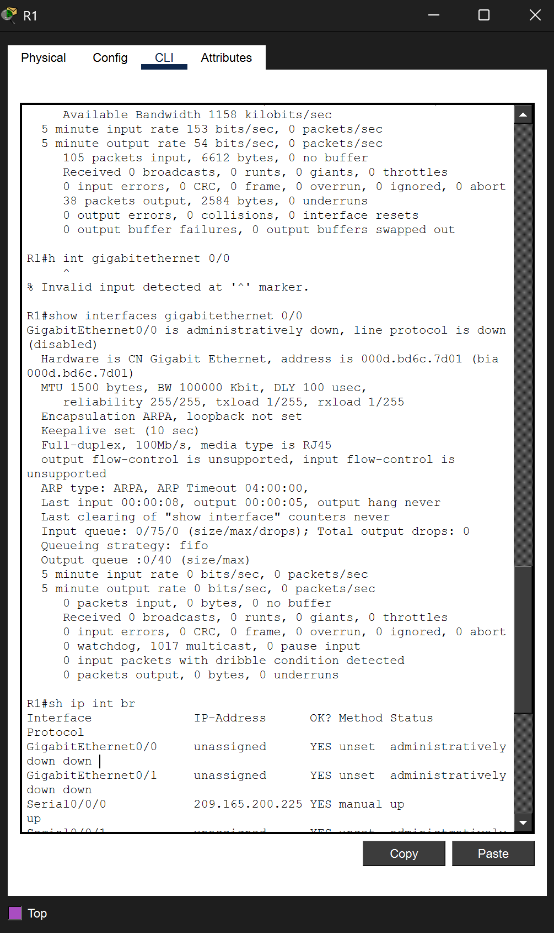

Serial 0/0/0 on R1
- IP address: 209.165.200.225/30
- Bandwidth (BW): 1544 Kbit (T1 default)
- Encapsulation: HDLC
- Status: up, line protocol is up (connected)

GigabitEthernet 0/0 on R1 (before configuration)
- IP address: not configured yet (unassigned) — will be set to 192.168.10.1 in Part 2.
- MAC address: 000d.bd6c.7d01 (both the burned-in address (BIA) and the active hardware address)
- Bandwidth (BW): 100000 Kbit (100 Mbps current operating speed)
Q: Which command displays a brief summary of the current interfaces, their status, and IP addresses?
A: show ip interface brief
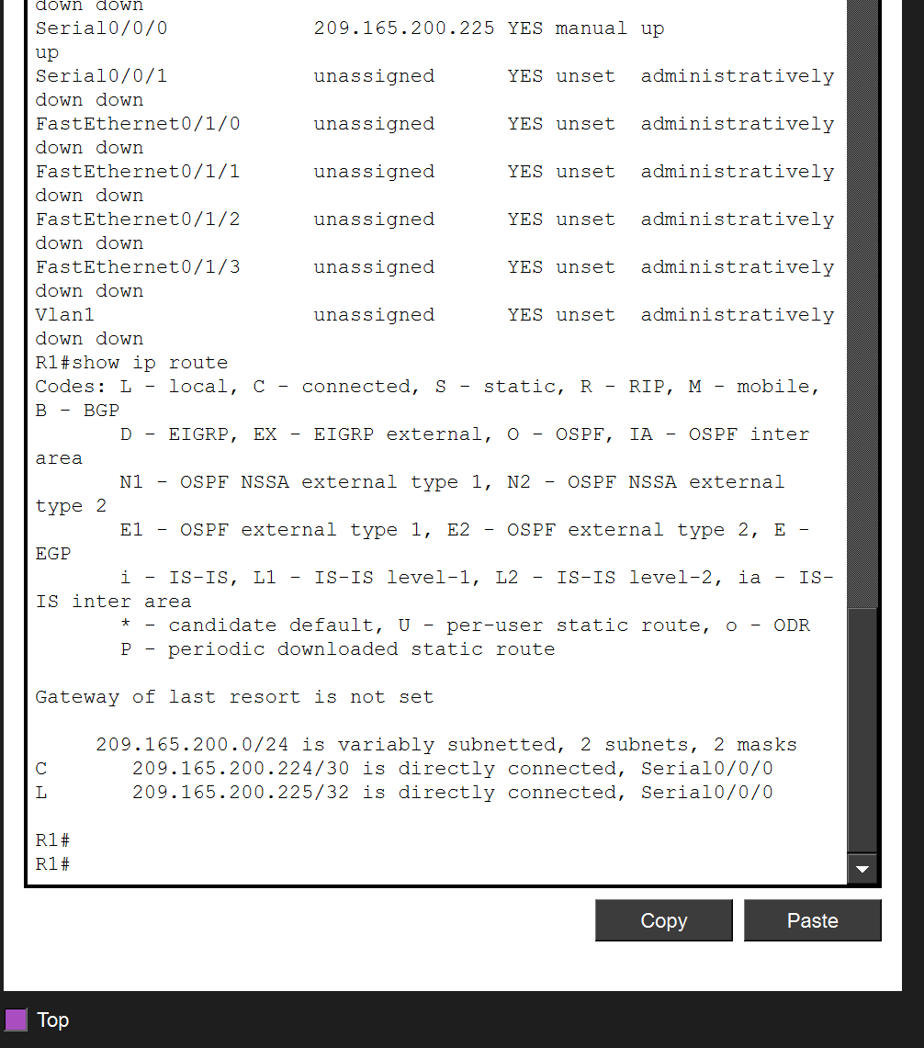
Q: How many serial interfaces are there on R1 and R2?
A: Each router has 2 serial interfaces — Serial0/0/0 and Serial0/0/1.
Q: How many Ethernet interfaces are there on R1 and R2? Are all Ethernet interfaces on R1 the same?
A: R1 has 6 Ethernet interfaces in total: 2 Gigabit Ethernet (Gig0/0, Gig0/1) plus a 4-port FastEthernet module (Fa0/1/0 – Fa0/1/3). R2 has only 2 Ethernet interfaces — both Gigabit Ethernet. No, the Ethernet interfaces on R1 are not identical. The GigabitEthernet ports operate at up to 1000 Mbps (1 Gbps), while the FastEthernet ports are limited to 100 Mbps. Gigabit ports are better for backbone/LAN aggregation, whereas FastEthernet ports are suitable for lower-speed access connections.
Q: What command displays the contents of the routing table?
A: show ip route
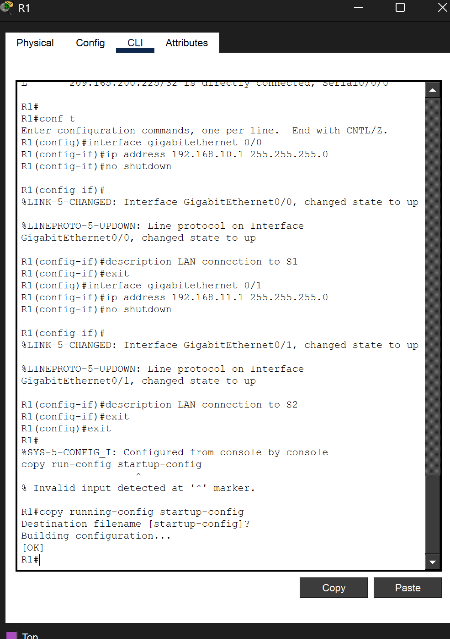
Q: How many connected routes (uses the C code) are there? Which route is listed?
A: Only 1 connected (C) route is present before configuration: 209.165.200.224/30 directly connected on Serial0/0/0. The GigabitEthernet interfaces have no IP addresses yet, so their networks do not appear in the routing table.
Q: How does a router handle a packet destined for a network that is not listed in the routing table?
A: If no matching route — including no default/gateway-of-last-resort route — exists, the router drops the packet and typically sends an ICMP "Destination Unreachable" message back to the source host.

2. Interface Configuration and Saving
R1 configuration:
R1(config)# interface gigabitethernet 0/0
R1(config-if)# ip address 192.168.10.1 255.255.255.0
R1(config-if)# no shutdown
R1(config-if)# description LAN connection to S1
R1(config)# interface gigabitethernet 0/1
R1(config-if)# ip address 192.168.11.1 255.255.255.0
R1(config-if)# no shutdown
R1(config-if)# description LAN connection to S2
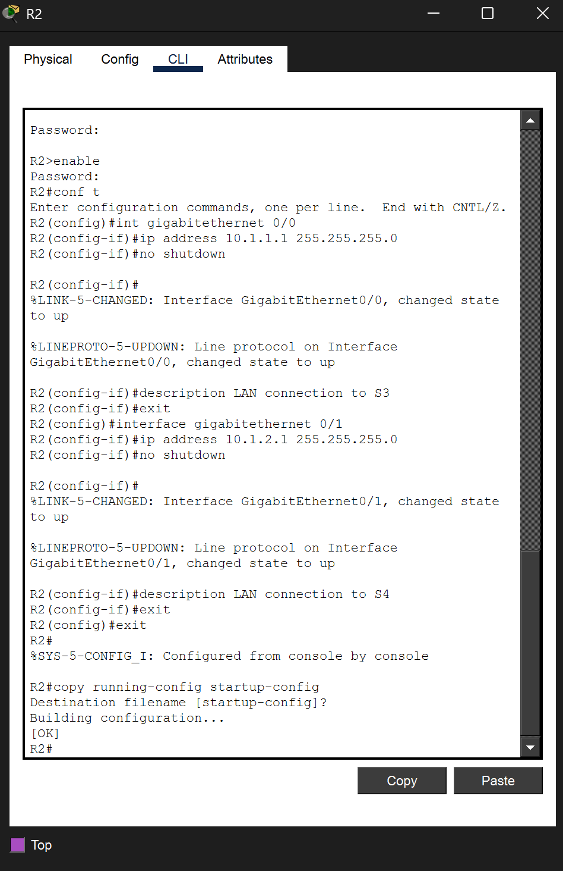
R2 configuration:
R2(config)# interface gigabitethernet 0/0
R2(config-if)# ip address 10.1.1.1 255.255.255.0
R2(config-if)# no shutdown
R2(config-if)# description LAN connection to S3
R2(config)# interface gigabitethernet 0/1
R2(config-if)# ip address 10.1.2.1 255.255.255.0
R2(config-if)# no shutdown
R2(config-if)# description LAN connection to S4
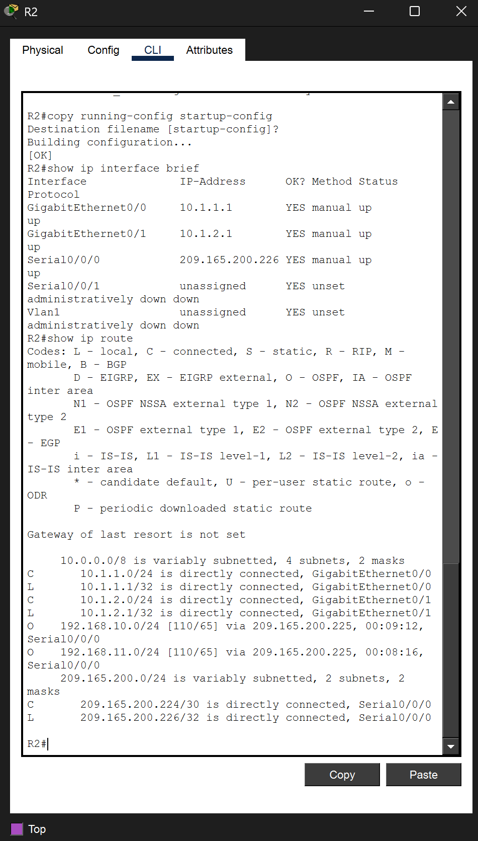
Q: What command did you use to save the configuration files on both routers to NVRAM?
A: copy running-config startup-config (short form: copy run start) executed on both R1 and R2.

3. Verifying the Configuration
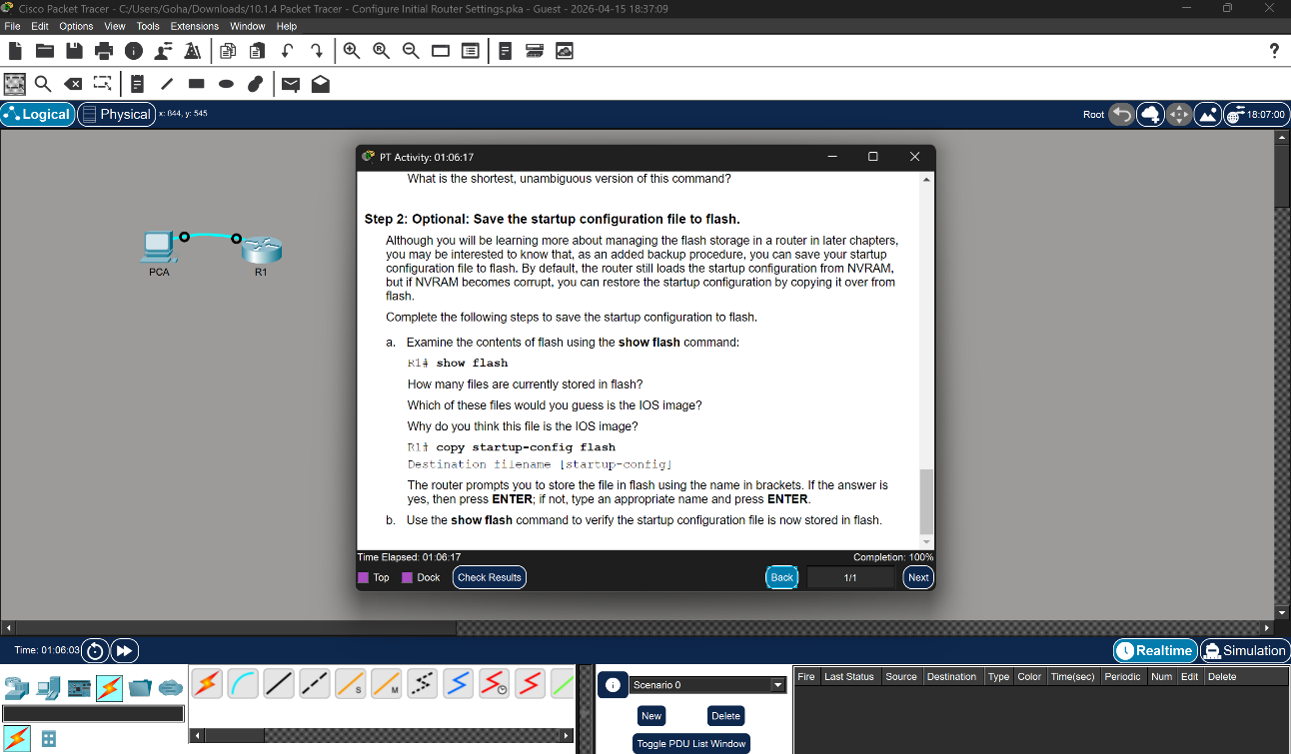
Q: How many interfaces on R1 and R2 are configured with IP addresses and in the "up/up" state?
A: Each router has 3 interfaces in the up/up state: R1 — Gig0/0, Gig0/1, and Serial0/0/0; R2 — Gig0/0, Gig0/1, and Serial0/0/0.
Q: What part of the interface configuration is NOT displayed in the 'show ip interface brief' output, and what commands can you use to verify it?
A: The interface description (along with the subnet mask in /prefix form, bandwidth, duplex, and MAC address) is not shown. To view that information, use:
- show interfaces — full details for every interface
- show interfaces <interface-id> — detailed info for one specific interface
- show running-config — displays the description lines as they were entered
Q: Based on the 'show ip route' command, how many connected (C) routes and how many OSPF (O) routes do you see on each router?
A: On both R1 and R2, there are 3 connected (C) routes and 2 OSPF (O) routes:
- R1 (C): 192.168.10.0/24, 192.168.11.0/24, 209.165.200.224/30
- R1 (O): 10.1.1.0/24, 10.1.2.0/24
- R2 (C): 10.1.1.0/24, 10.1.2.0/24, 209.165.200.224/30
- R2 (O): 192.168.10.0/24, 192.168.11.0/24
Q: How many total LANs and WANs are in the topology? Does this match the C + O total?
A: The topology contains 4 LANs (192.168.10.0/24, 192.168.11.0/24, 10.1.1.0/24, 10.1.2.0/24) and 1 WAN (209.165.200.224/30), for a total of 5 networks. Each router shows 3 C + 2 O = 5 routes, which matches perfectly. This confirms that the routing is complete and every network is reachable.

End-to-end Connectivity Test
Successful pings were executed as required by Step 2: from PC1 to PC4 (192.168.10.10 → 10.1.2.10) and from R2 to PC2 (10.1.1.1 → 192.168.11.10), confirming full reachability across the internetwork.

Conclusion
Across these two activities, the core foundations of Cisco router administration were practiced end-to-end: CLI navigation between user, privileged, global-configuration, line, and interface modes; device security through hostname assignment, MOTD banners, enable secrets, console authentication, and service password-encryption; IP addressing and interface activation on GigabitEthernet links using an addressing table; and verification and connectivity testing using show ip interface brief, show ip route, and ping to confirm that all four LANs and the WAN formed a fully reachable internetwork. Saving the running configuration to NVRAM with copy running-config startup-config ensured the work persisted after reboot, reinforcing the importance of systematic configuration and verification in real-world network deployments.

