COMPUTER NETWORKS LAB REPORT
Student: Gaukhar Assyrzhanova
Group: IIoT-2401
Labs: 11.5.5 Subnet an IPv4 Network | 11.9.3 VLSM Design and Implementation

Lab 11.5.5 Subnet an IPv4 Network

Part 1: Design an IPv4 Subnetting Scheme
Base network: 192.168.0.0/24. Requirements: LAN-A needs minimum 50 hosts, LAN-B needs minimum 40 hosts, plus at least 2 additional unused subnets for future expansion.
Q: How many host addresses are needed in the largest required subnet?
A: 50 this is the LAN-A requirement.
Q: What is the minimum number of subnets required?
A: 4 LAN-A + LAN-B + 2 reserved for future expansion.
Q: What is the /24 subnet mask in binary?
A: 11111111.11111111.11111111.00000000
Q: In the network mask, what do the ones represent?
A: The network portion they identify which part of the address belongs to the network.
Q: In the network mask, what do the zeros represent?
A: The host portion they identify individual devices within that network.

Subnet Mask Analysis Table
Prefix | Decimal Mask | Subnets | Usable Hosts
/25 | 255.255.255.128 | 2 | 126
/26 | 255.255.255.192 | 4 | 62
/27 | 255.255.255.224 | 8 | 30
/28 | 255.255.255.240 | 16 | 14
/29 | 255.255.255.248 | 32 | 6
/30 | 255.255.255.252 | 64 | 2
Q: Which subnet masks meet the required minimum of 50 host addresses?
A: /25 (126 hosts) and /26 (62 hosts).
Q: Which subnet masks meet the minimum number of 4 subnets?
A: /26 (4), /27 (8), /28 (16), /29 (32), /30 (64).
Q: Which subnet mask meets BOTH requirements?
A: /26 (255.255.255.192) 4 subnets with 62 usable hosts each. The most efficient choice.

Resulting Subnet Table
Subnet Address | Prefix | Subnet Mask
192.168.0.0 | /26 | 255.255.255.192
192.168.0.64 | /26 | 255.255.255.192
192.168.0.128 | /26 | 255.255.255.192
192.168.0.192 | /26 | 255.255.255.192

Complete Addressing Table
Device | Interface | IP Address | Subnet Mask | Default Gateway
CustomerRouter | G0/0 | 192.168.0.1 | 255.255.255.192 | N/A
CustomerRouter | G0/1 | 192.168.0.65 | 255.255.255.192 | N/A
CustomerRouter | S0/1/0 | 209.165.201.2 | 255.255.255.252 | N/A
LAN-A Switch | VLAN 1 | 192.168.0.2 | 255.255.255.192 | 192.168.0.1
LAN-B Switch | VLAN 1 | 192.168.0.66 | 255.255.255.192 | 192.168.0.65
PC-A | NIC | 192.168.0.62 | 255.255.255.192 | 192.168.0.1
PC-B | NIC | 192.168.0.126 | 255.255.255.192 | 192.168.0.65
ISPRouter | G0/0 | 209.165.200.225 | 255.255.255.224 | N/A
ISPRouter | S0/1/0 | 209.165.201.1 | 255.255.255.252 | N/A
ISPSwitch | VLAN 1 | 209.165.200.226 | 255.255.255.224 | 209.165.200.225
ISP Workstation | NIC | 209.165.200.235 | 255.255.255.224 | 209.165.200.225
ISP Server | NIC | 209.165.200.240 | 255.255.255.224 | 209.165.200.225

Part 2: Device Configuration

Step 1 CustomerRouter
enable
configure terminal
hostname CustomerRouter
enable secret Class123
line console 0
password Cisco123
login
exit
interface GigabitEthernet 0/0
ip address 192.168.0.1 255.255.255.192
no shutdown
exit
interface GigabitEthernet 0/1
ip address 192.168.0.65 255.255.255.192
no shutdown
exit
end
copy running-config startup-config

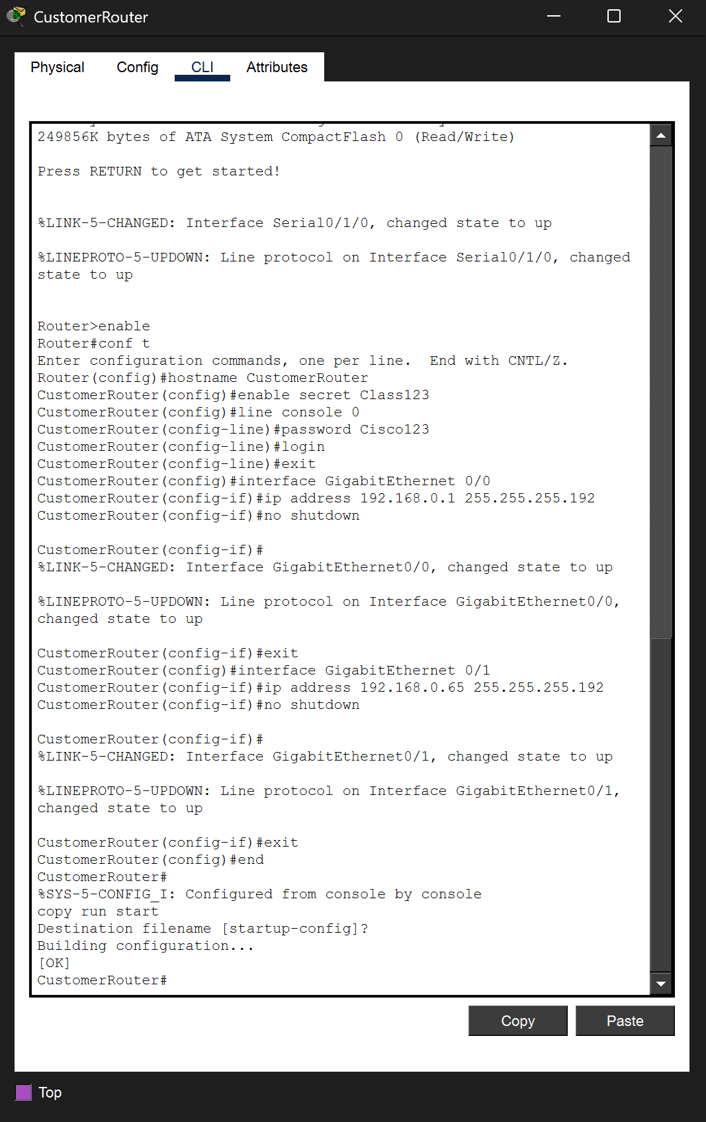

Step 2 LAN-A Switch
enable
configure terminal
interface vlan 1
ip address 192.168.0.2 255.255.255.192
no shutdown
exit
ip default-gateway 192.168.0.1
end
copy running-config startup-config

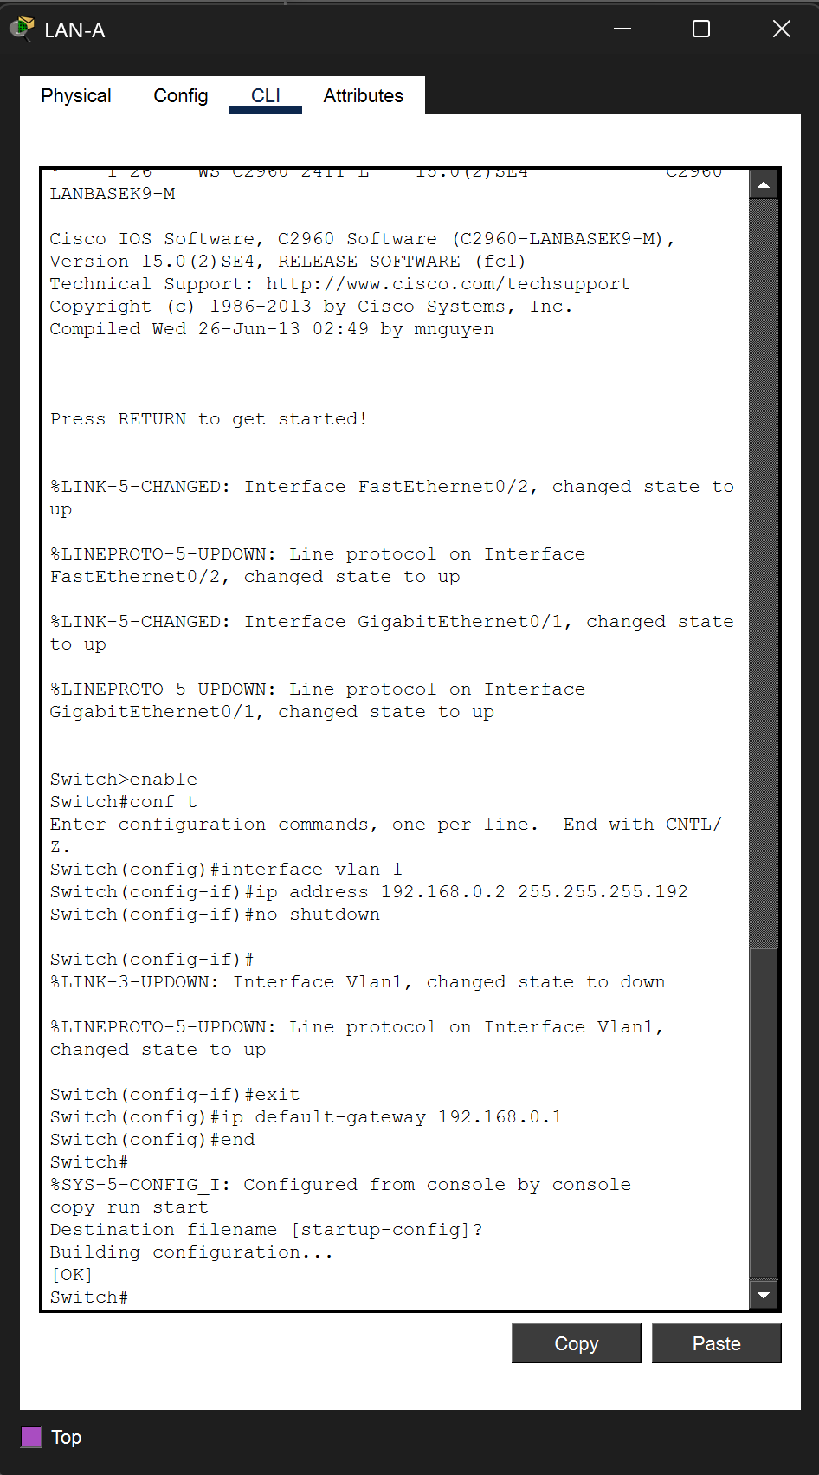

Step 3 LAN-B Switch
enable
configure terminal
interface vlan 1
ip address 192.168.0.66 255.255.255.192
no shutdown
exit
ip default-gateway 192.168.0.65
end
copy running-config startup-config

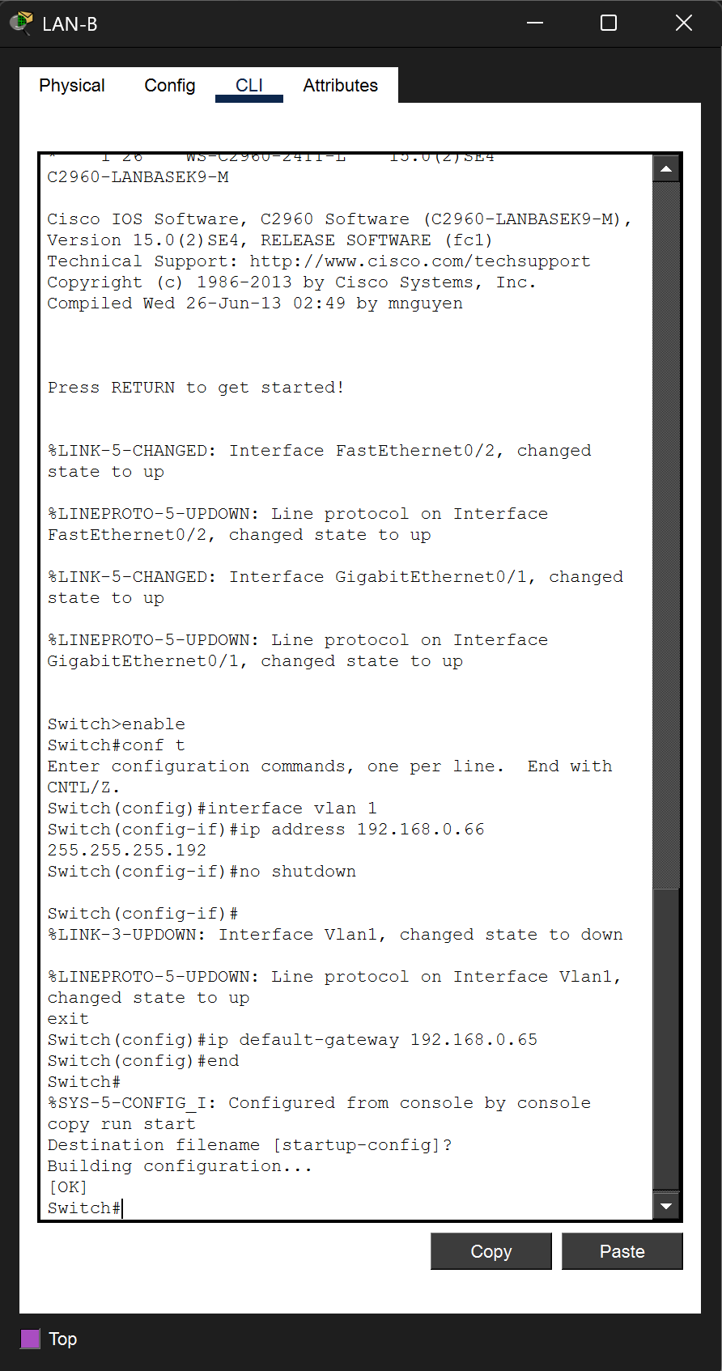

Step 4 PC-A
Field | Value
IP Address | 192.168.0.62
Subnet Mask | 255.255.255.192
Default Gateway | 192.168.0.1

Step 5 PC-B
Field | Value
IP Address | 192.168.0.126
Subnet Mask | 255.255.255.192
Default Gateway | 192.168.0.65

Part 3: Testing and Troubleshooting
Q: Can PC-A communicate with its default gateway?
A: Yes. Ping to 192.168.0.1 returns 4/4 replies, 0% loss.
Q: Can PC-B communicate with its default gateway?
A: Yes. Ping to 192.168.0.65 returns 4/4 replies, 0% loss.
Q: Can PC-A communicate with PC-B?
A: Yes. After initial ARP timeout, second attempt returns 4/4 replies, 0% loss. Full end-to-end connectivity confirmed.
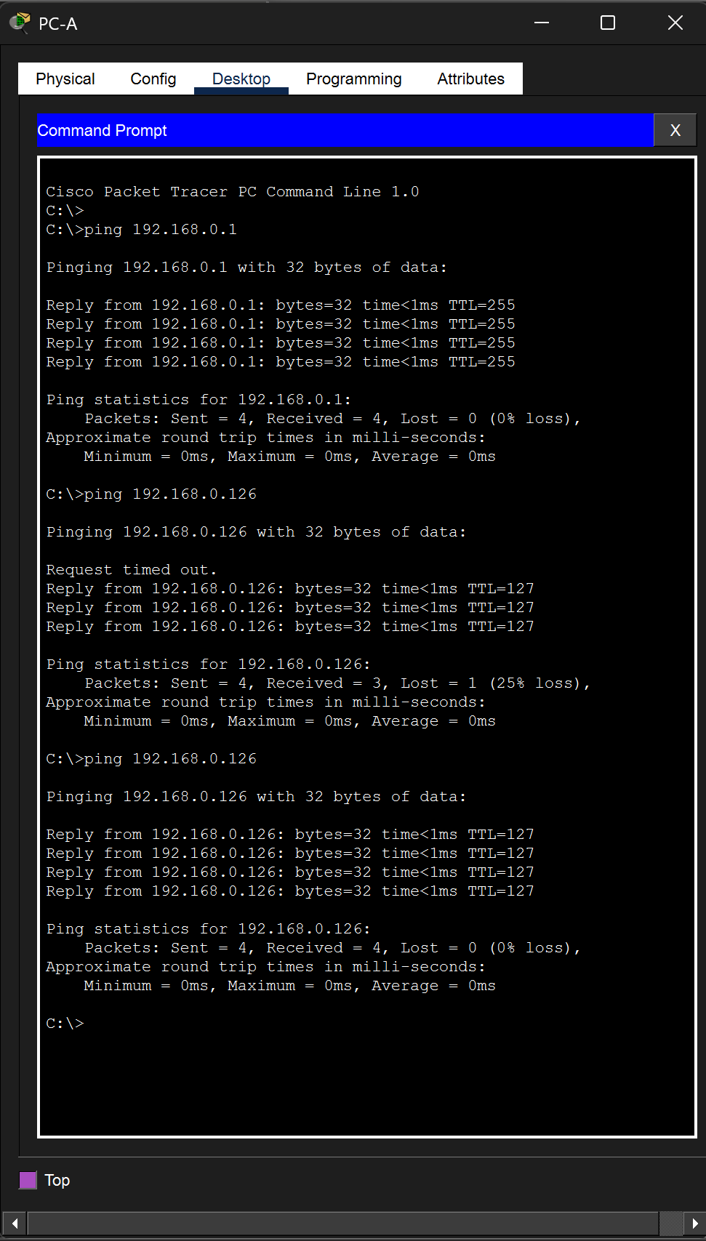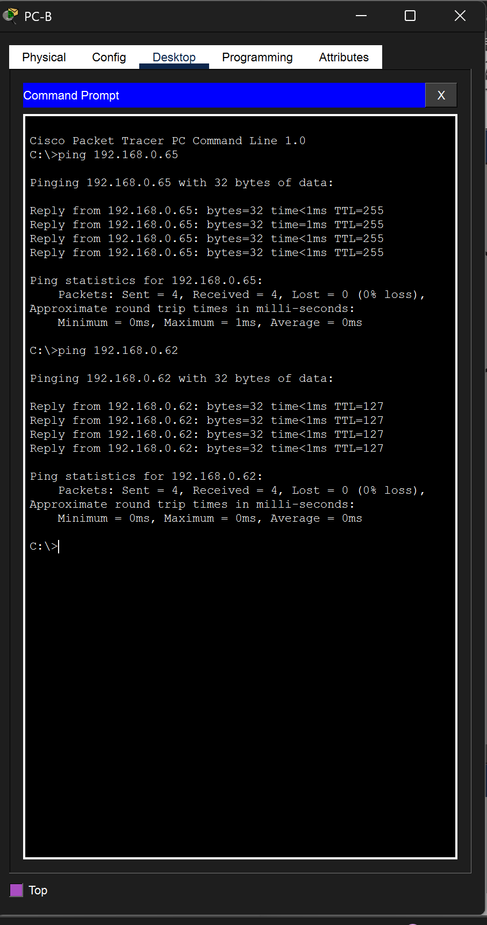

Lab 11.9.3 VLSM Design and Implementation

Part 1: Examine the Network Requirements
Base network: 192.168.72.0/24. Unlike Lab 11.5.5 where all subnets use the same mask, VLSM allows each subnet to have a different size only allocating as much address space as needed.
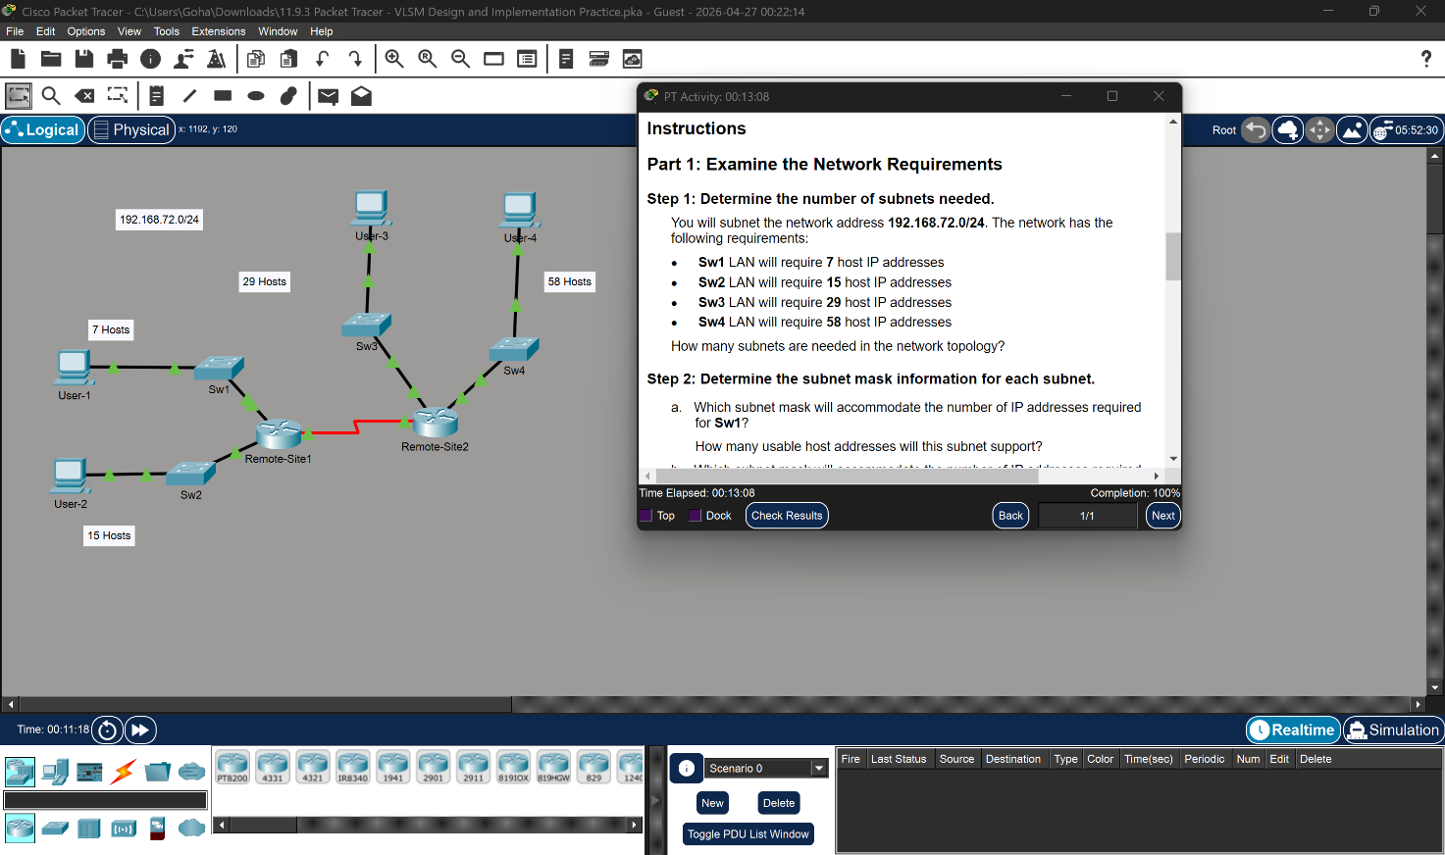Q: How many subnets are needed?
A: 5 subnets four LANs plus one WAN point-to-point link.

Subnet Mask Calculations
Formula: 2^{n} − 2 ≥ required hosts, where n = number of host bits.
LAN | Hosts Needed | Calculation | Mask | Hosts Available
Sw4 | 58 | 2^6 − 2 = 62 ≥ 58 ✓ | /26 (255.255.255.192) | 62
Sw3 | 29 | 2^5 − 2 = 30 ≥ 29 ✓ | /27 (255.255.255.224) | 30
Sw2 | 15 | 2^4 − 2 = 14 < 15 ✗ → /27 | /27 (255.255.255.224) | 30
Sw1 | 7 | 2^4 − 2 = 14 ≥ 7 ✓ | /28 (255.255.255.240) | 14
WAN | 2 | 2^2 − 2 = 2 ≥ 2 ✓ | /30 (255.255.255.252) | 2
Note: Sw2 needs 15 hosts but /28 only provides 14 usable addresses, so /27 (30 hosts) must be used instead.

Part 2: VLSM Addressing Scheme

Subnet Table (Largest to Smallest)
Subnet Description | Hosts | Network/CIDR | First Usable | Broadcast
Sw4 LAN | 58 | 192.168.72.0/26 | 192.168.72.1 | 192.168.72.63
Sw3 LAN | 29 | 192.168.72.64/27 | 192.168.72.65 | 192.168.72.95
Sw2 LAN | 15 | 192.168.72.96/27 | 192.168.72.97 | 192.168.72.127
Sw1 LAN | 7 | 192.168.72.128/28 | 192.168.72.129 | 192.168.72.143
WAN Link | 2 | 192.168.72.144/30 | 192.168.72.145 | 192.168.72.147

Complete Addressing Table
Rules: Router = first usable address, Switch = second usable, PC = last usable. WAN: Remote-Site1 = first, Remote-Site2 = last.
Device | Interface | IP Address | Subnet Mask | Default Gateway
Remote-Site1 | G0/0 | 192.168.72.129 | 255.255.255.240 | N/A
Remote-Site1 | G0/1 | 192.168.72.97 | 255.255.255.224 | N/A
Remote-Site1 | S0/0/0 | 192.168.72.145 | 255.255.255.252 | N/A
Remote-Site2 | G0/0 | 192.168.72.65 | 255.255.255.224 | N/A
Remote-Site2 | G0/1 | 192.168.72.1 | 255.255.255.192 | N/A
Remote-Site2 | S0/0/0 | 192.168.72.146 | 255.255.255.252 | N/A
Sw1 | VLAN 1 | 192.168.72.130 | 255.255.255.240 | 192.168.72.129
Sw2 | VLAN 1 | 192.168.72.98 | 255.255.255.224 | 192.168.72.97
Sw3 | VLAN 1 | 192.168.72.66 | 255.255.255.224 | 192.168.72.65
Sw4 | VLAN 1 | 192.168.72.2 | 255.255.255.192 | 192.168.72.1
User-1 | NIC | 192.168.72.142 | 255.255.255.240 | 192.168.72.129
User-2 | NIC | 192.168.72.126 | 255.255.255.224 | 192.168.72.97
User-3 | NIC | 192.168.72.94 | 255.255.255.224 | 192.168.72.65
User-4 | NIC | 192.168.72.62 | 255.255.255.192 | 192.168.72.1

Part 3: Device Configuration

Step 1 Remote-Site1 Router
enable
configure terminal
interface GigabitEthernet 0/0
ip address 192.168.72.129 255.255.255.240
no shutdown
exit
interface GigabitEthernet 0/1
ip address 192.168.72.97 255.255.255.224
no shutdown
exit
end
copy running-config startup-config

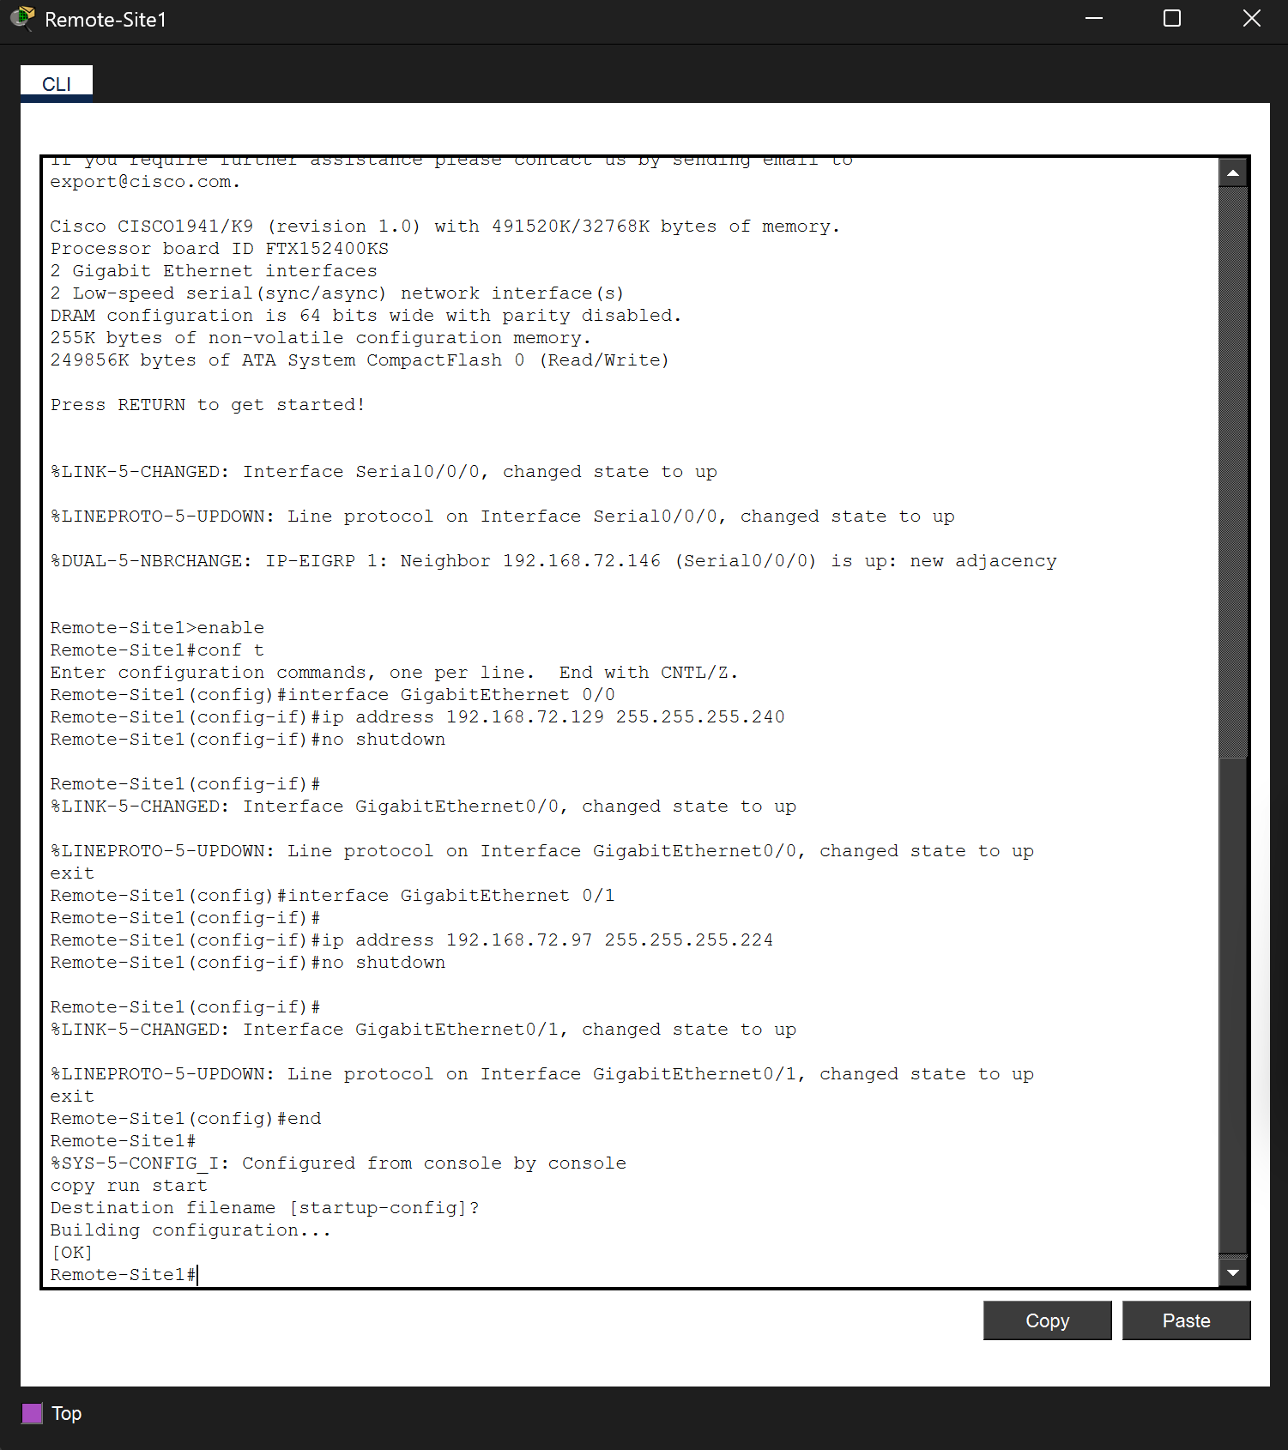

Step 2 Sw3 Switch
enable
configure terminal
interface vlan 1
ip address 192.168.72.66 255.255.255.224
no shutdown
exit
ip default-gateway 192.168.72.65
end
copy running-config startup-config

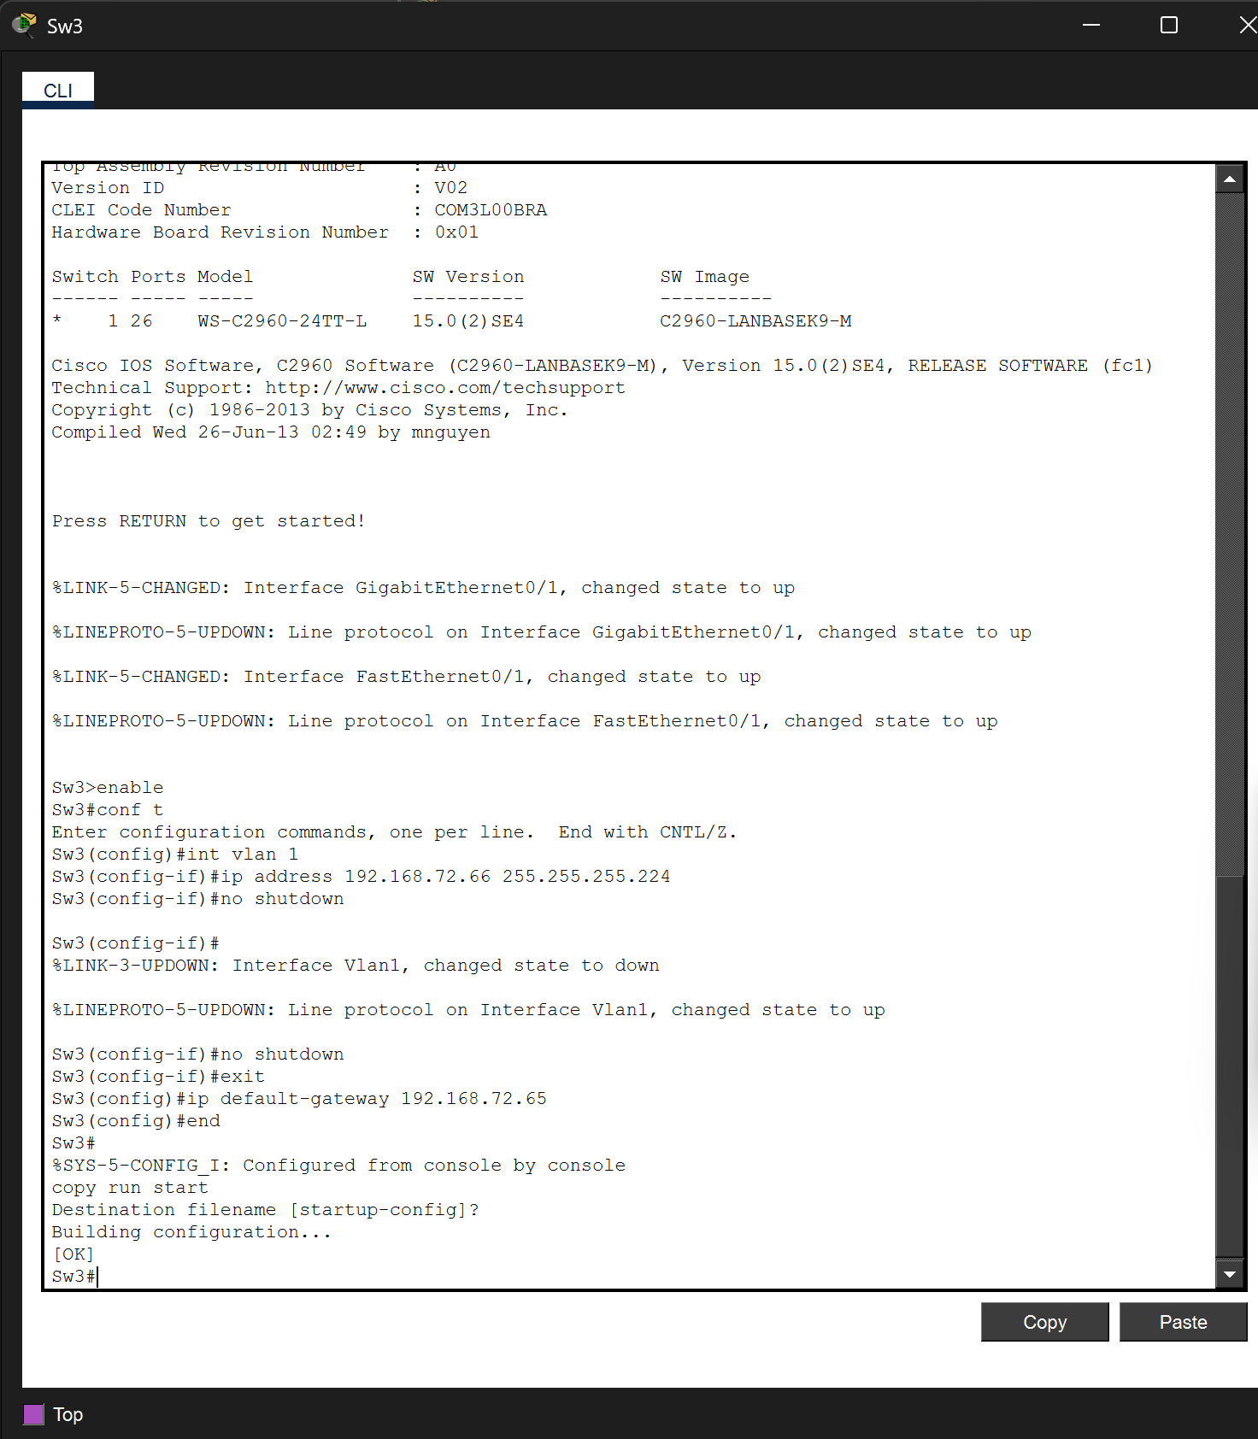

Step 3 User-4 PC
Field | Value
IP Address | 192.168.72.62
Subnet Mask | 255.255.255.192
Default Gateway | 192.168.72.1

Step 4: Connectivity Verification

From Remote-Site1:
ping 192.168.72.62 → Success (User-4)
ping 192.168.72.94 → Success (User-3)
ping 192.168.72.126 → Success (User-2)
ping 192.168.72.142 → Success (User-1)
ping 192.168.72.146 → Success (Remote-Site2 WAN)

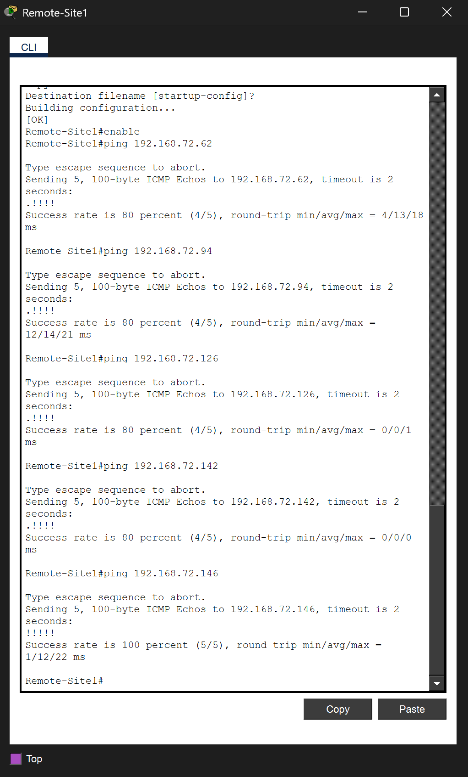

From User-4:
ping 192.168.72.1 → Success (gateway)
ping 192.168.72.65 → Success (Remote-Site2 G0/0)
ping 192.168.72.97 → Success (Remote-Site1 G0/1)
ping 192.168.72.129 → Success (Remote-Site1 G0/0)
ping 192.168.72.145 → Success (Remote-Site1 WAN)
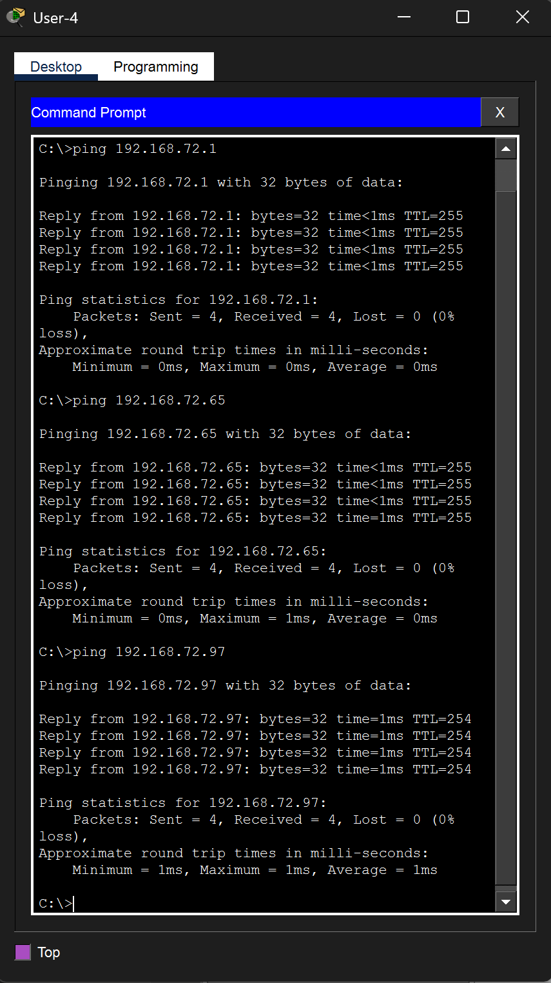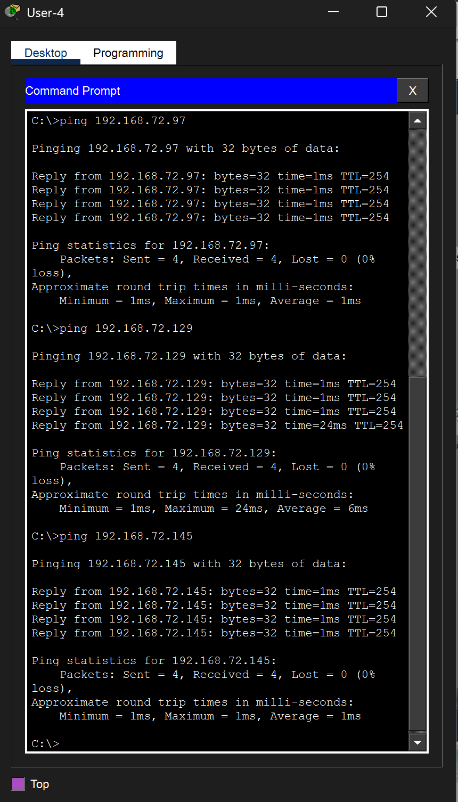

Conclusion
In Lab 11.5.5, we applied fixed-length subnetting dividing 192.168.0.0/24 into four equal /26 subnets (62 hosts each). The /26 mask was the only one that simultaneously satisfies the 50-host minimum and provides 4 subnets (2 active + 2 reserved). In Lab 11.9.3, we applied VLSM, which is more efficient for networks with varying LAN sizes. By ordering subnets largest-to-smallest and assigning /26, /27, /27, /28, and /30 masks, we used only 148 of 256 available addresses leaving 108 for future growth. Both labs reinforced CLI configuration skills, systematic IP address planning, and ping-based connectivity verification.
End of Report —

