Case 6

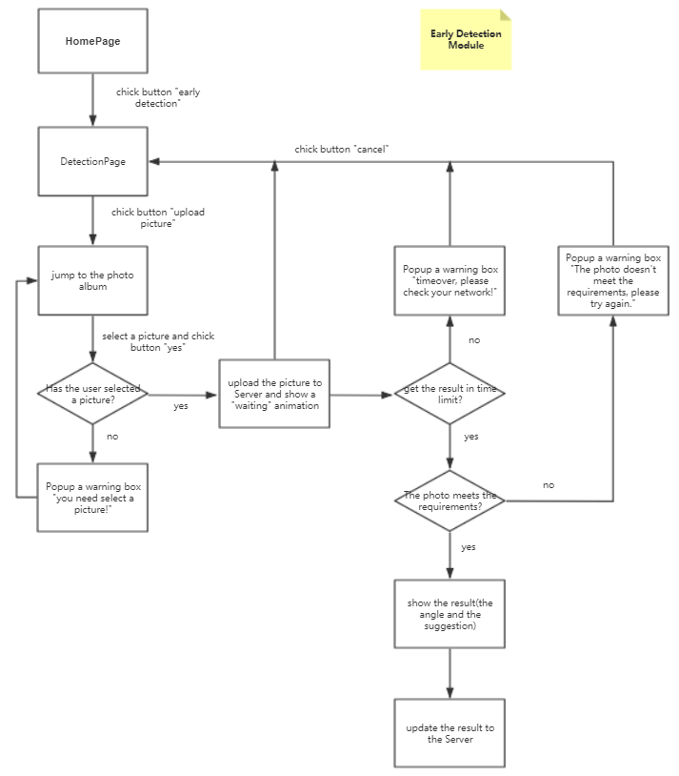

Case 4,7,8

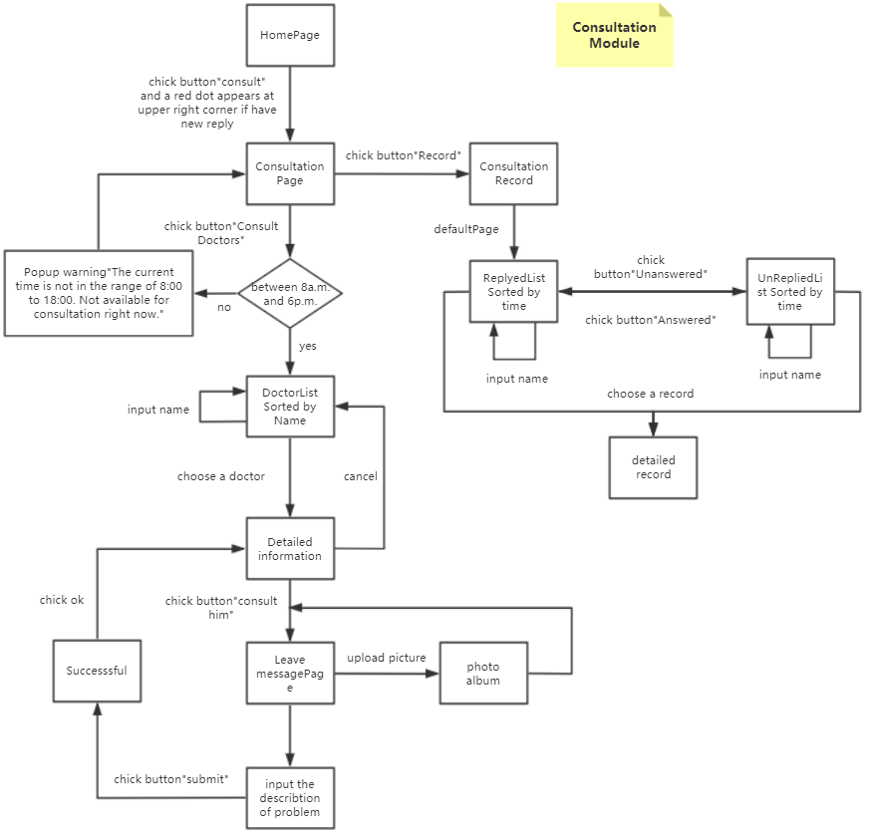

I don’t build flowchart for login module because Teacher Zhang says it’s unnecessary.

The case 1,2(open and close the app),9 are very simple cases and the detail of case 5(chatbot module)still needs to be discussed with chatbot group so i don’t build flowcharts for them.