* 1. 主类别操作

|  |  |
| --- | --- |
| 接口名称 | post /v1/titletype/createmaintype |
| 功能描述 | 分类栏，创建主要类别 |
| 参数形式（传递参数） | {  **"main_title_type_name":”test1”**  } |
| 返回参数(data中存储的是返回数据) | {  "errcode": 200,  "errmsg": "no error",  "data": "data is success"  } |

1.1.1创建主要类别

可以前后端定义统一标识数字，这样就可以议定各自的常量及其意义了。

接口测试结果如下图所示：

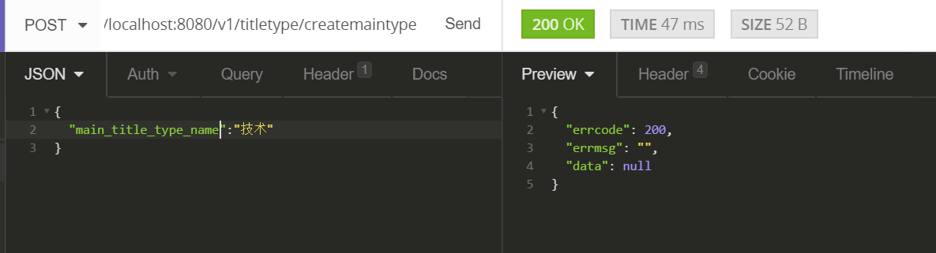

1.1.2获取到maintype的所有信息

|  |  |
| --- | --- |
| 接口名称 | get /v1/titletype */getallmaintype* |
| 功能描述 | 获取到所有主要类别数据 |
| 参数形式（传递参数） |  |
| 返回参数(data中存储的是返回数据) | {  "status": 200,  "msg": "",  "data": [  {  "main_title_type_id": 2,  "main_title_type_name": "技术"  }  ]  } |

1.1.3依据名称删除某个元素

|  |  |
| --- | --- |
| 接口名称 | Post /v1/titletype */delete* |
| 功能描述 | 依据标题删除某个元素 |
| 参数 | {  "main_title_type_name": "技术"  } |
| 返回值 | {  "status": 200,  "msg": "成功"  } |

1.1.4更新列表种类

|  |  |
| --- | --- |
| 接口名称 | Post /v1/titletype */update* |
| 功能描述 | 依据标题更新某个列表元素 |
| 参数 | {  "main_title_type_id": 4,  "main_title_type_name": "生活"  } |
| 返回值 | {  "status": 200,  "data": {  "main_title_type_id": 4,  "main_title_type_name": "生活"  }  } |

1.2用户相关操作

1.2.1创建用户：

|  |  |
| --- | --- |
| 接口名称 | Post /v1/user/register |
| 功能描述 | 创建用户 |
| 参数 | {  "phone":"18258817087",  "nickname":"chen",  "password":"123456"  } |
| 返回值 | {  "status": 200,  "msg": "成功"  } |

1.2.2更新用户相关信息

|  |  |
| --- | --- |
| 接口名称 | Post /v1/user/update |
| 功能描述 | 更新用户信息 |
| 参数 | {  "id":1,  "phone":"18258817097",  "nickname":"chen",  "password":"123456"  } |
| 返回值 | {  "status": 200,  "data": {  "id": 1,  "phone": "18258817097",  "nickname": "chen",  "password": "123456"  }  } |

1.2.3用户登陆

|  |  |
| --- | --- |
| 接口名称 | Post /v1/user/login |
| 功能描述 | 更新用户信息 |
| 参数 | {  "nickname":"chen",  "password":"123456"  } |
| 返回值 | {  "status": 200,  "data": {  "id": 1,  "phone": "18258817097",  "nickname": "chen",  "password": "123456"  }  } |

1.3帖子相关操作

1.3.1 发布帖子

|  |  |
| --- | --- |
| 接口名称 | Post /v1/issue/create |
| 功能描述 | 创建帖子 |
| 参数 | {  "user_id":1,  "issue_content":"hello,world,text me",  "issue_title":"first text",  "type_id":1  } |
| 返回值 | {  "status": 200,  "msg": "插入成功"  } |

1.3.2 获得帖子

|  |  |
| --- | --- |
| 接口名称 | Get /v1/issue/querybasic |
| 功能描述 | 获取帖子信息 |
| 参数 |  |
| 返回值 | {  "status": 200,  "data": [  {  "issue_id": 1,  "user_id": 0,  "issue_content": "",  "issue_title": "first text",  "created": "2018-05-28T15:16:28Z",  "updated": "0001-01-01T00:00:00Z"  },  {  "issue_id": 2,  "user_id": 0,  "issue_content": "",  "issue_title": "first text",  "created": "2018-05-28T15:20:15Z",  "updated": "0001-01-01T00:00:00Z"  },  {  "issue_id": 3,  "user_id": 0,  "issue_content": "",  "issue_title": "first text",  "created": "2018-05-28T15:20:24Z",  "updated": "0001-01-01T00:00:00Z"  },  {  "issue_id": 4,  "user_id": 0,  "issue_content": "",  "issue_title": "first text",  "created": "2018-05-28T15:21:19Z",  "updated": "0001-01-01T00:00:00Z"  },  {  "issue_id": 5,  "user_id": 0,  "issue_content": "",  "issue_title": "first text",  "created": "2018-05-28T15:23:49Z",  "updated": "0001-01-01T00:00:00Z"  }  ]  } |

1.3.3获取帖子详细信息

|  |  |
| --- | --- |
| 接口名称 | Post /v1/issue/*querydetail* |
| 功能描述 | 获取帖子详细信息 |
| 参数 | {    "issue_id":2  } |
| 返回值 | {  "status": 200,  "data": {  "issue_id": 2,  "user_id": 1,  "issue_content": "hello,world,text me",  "issue_title": "first text",  "created": "2018-05-28T15:20:15Z",  "updated": "2018-05-28T15:20:15Z",  "type_id": 1  }  } |

1.3.4删除帖子

|  |  |
| --- | --- |
| 接口名称 | Post /v1/issue/delete |
| 功能描述 | 删除帖子 |
| 参数 | {  "issue_id":2  } |
| 返回值 | {  "status": 200,  "msg": "删除成功"  } |

1.4评论接口

1.4.1 发表评论

|  |  |
| --- | --- |
| 接口名称 | Post /v1/issue_comment/create |
| 功能描述 | 添加评论 |
| 参数 | {  "user_id":1,  "issue_id":1,  "coment_content":"hello,world,my test"  } |
| 返回值 | {  "status": 200,  "msg": "添加成功"  } |

1.4.2更新评论

|  |  |
| --- | --- |
| 接口名称 | Post /v1/issue_comment/create |
| 功能描述 | 更新评论 |
| 参数 | {  "user_id":1,  "issue_id":1,  "coment_content":"hello,world,my test"  } |
| 返回值 | {  "status": 200,  "msg": "更新成功"  } |

1.4.3 依据帖子id查看所有评论

|  |  |
| --- | --- |
| 接口名称 | Post/v1/issue_comment/querybyissue/1 |
| 功能描述 | 查看评论 |
| 参数 |  |
| 返回值 | {  "status": 200,  "data": [  {  "comment_id": 1,  "issue_id": 1,  "user_id": 1,  "coment_content": "hello,world,my test",  "created": "2018-05-28T16:05:03Z",  "updated": "2018-05-28T16:05:03Z"  },  {  "comment_id": 2,  "issue_id": 1,  "user_id": 1,  "coment_content": "hello,world,my test",  "created": "2018-05-28T16:05:05Z",  "updated": "2018-05-28T16:05:05Z"  },  {  "comment_id": 3,  "issue_id": 1,  "user_id": 1,  "coment_content": "hello,world,my test",  "created": "2018-05-28T16:05:05Z",  "updated": "2018-05-28T16:05:05Z"  },  {  "comment_id": 4,  "issue_id": 1,  "user_id": 1,  "coment_content": "hello,world,my test",  "created": "2018-05-28T16:05:06Z",  "updated": "2018-05-28T16:05:06Z"  },  {  "comment_id": 5,  "issue_id": 1,  "user_id": 1,  "coment_content": "hello,world,my test",  "created": "2018-05-28T16:05:07Z",  "updated": "2018-05-28T16:05:07Z"  },  {  "comment_id": 6,  "issue_id": 1,  "user_id": 1,  "coment_content": "hello,world,my test",  "created": "2018-05-28T16:05:09Z",  "updated": "2018-05-28T16:05:09Z"  }  ]  } |

1.4.4删除评论

|  |  |
| --- | --- |
| 接口名称 | Post /v1/issue_comment/delete |
| 功能描述 | 删除评论 |
| 参数 | {  "comment_id": 1  } |
| 返回值 | {  "status": 200,  "msg": "删除成功"  } |