## 一、上传项目源代码（package.json截图上传，项目主文件源代码粘贴在答题框内）

## （1）项目源代码

import { FileOutlined, PieChartOutlined, UserOutlined,DesktopOutlined,TeamOutlined,MenuUnfoldOutlined,HomeOutlined,ReloadOutlined,AudioOutlined,MoreOutlined,DownOutlined,BulbTwoTone,UploadOutlined} from '@ant-design/icons';

import { Breadcrumb, Layout, Menu, theme,Col, Row, Image,Avatar, Space,Input,Button, Dropdown,Tooltip, message,Card,Calendar, QRCode, AutoComplete,Carousel,Progress, Upload} from 'antd';

import type { MenuProps } from 'antd';

import { useState} from 'react';

import React from 'react';

import ReactDOM from 'react-dom';

import { Chart, Line, Point } from 'bizcharts';

import Icon from '@ant-design/icons';

const PandaSvg = () => (

<svg viewBox="0 0 1024 1024" width="1em" height="1em" fill="currentColor">

<path

d="M99.096 315.634s-82.58-64.032-82.58-132.13c0-66.064 33.032-165.162 148.646-148.646 83.37 11.91 99.096 165.162 99.096 165.162l-165.162 115.614zM924.906 315.634s82.58-64.032 82.58-132.13c0-66.064-33.032-165.162-148.646-148.646-83.37 11.91-99.096 165.162-99.096 165.162l165.162 115.614z"

fill="#6B676E"

/>

<path

d="M1024 561.548c0 264.526-229.23 429.42-512.002 429.42S0 826.076 0 561.548 283.96 66.064 512.002 66.064 1024 297.022 1024 561.548z"

fill="#FFEBD2"

/>

<path

d="M330.324 842.126c0 82.096 81.34 148.646 181.678 148.646s181.678-66.55 181.678-148.646H330.324z"

fill="#E9D7C3"

/>

<path

d="M644.13 611.098C594.582 528.516 561.55 512 512.002 512c-49.548 0-82.58 16.516-132.13 99.096-42.488 70.814-78.73 211.264-49.548 247.742 66.064 82.58 165.162 33.032 181.678 33.032 16.516 0 115.614 49.548 181.678-33.032 29.18-36.476-7.064-176.93-49.55-247.74z"

fill="#FFFFFF"

/>

<path

d="M611.098 495.484c0-45.608 36.974-82.58 82.58-82.58 49.548 0 198.194 99.098 198.194 165.162s-79.934 144.904-148.646 99.096c-49.548-33.032-132.128-148.646-132.128-181.678zM412.904 495.484c0-45.608-36.974-82.58-82.58-82.58-49.548 0-198.194 99.098-198.194 165.162s79.934 144.904 148.646 99.096c49.548-33.032 132.128-148.646 132.128-181.678z"

fill="#6B676E"

/>

<path

d="M512.002 726.622c-30.06 0-115.614 5.668-115.614 33.032 0 49.638 105.484 85.24 115.614 82.58 10.128 2.66 115.614-32.944 115.614-82.58-0.002-27.366-85.556-33.032-115.614-33.032z"

fill="#464655"

/>

<path

d="M330.324 495.484m-33.032 0a33.032 33.032 0 1 0 66.064 0 33.032 33.032 0 1 0-66.064 0Z"

fill="#464655"

/>

<path

d="M693.678 495.484m-33.032 0a33.032 33.032 0 1 0 66.064 0 33.032 33.032 0 1 0-66.064 0Z"

fill="#464655"

/>

</svg>

);

const PandaIcon = (props) => <Icon component={PandaSvg} {...props} />;

const fileList = [

{

uid: '0',

name: '回收箱.png',

status: 'uploading',

percent: 33,

},

{

uid: '-1',

name: '杯子.png',

status: 'done',

url: 'https://ts3.cn.mm.bing.net/th?id=OIP-C.oiP4pb-ObrYr-G6rw1kWmQHaFj&w=288&h=216&c=8&rs=1&qlt=90&o=6&dpr=2&pid=3.1&rm=2',

thumbUrl: 'https://ts3.cn.mm.bing.net/th?id=OIP-C.oiP4pb-ObrYr-G6rw1kWmQHaFj&w=288&h=216&c=8&rs=1&qlt=90&o=6&dpr=2&pid=3.1&rm=2',

},

{

uid: '-2',

name: '货车.png',

status: 'error',

},

];

// 数据源

const data = [

{ month: "2023-01-01", acc: 84.0 },

{ month: "2023-02-01", acc: 14.9 },

{ month: "2023-03-01", acc: 17.0 },

{ month: "2023-04-01", acc: 20.2 },

{ month: "2023-05-01", acc: 55.6 },

{ month: "2023-06-01", acc: 56.7 },

{ month: "2023-07-01", acc: 30.6 },

{ month: "2023-08-01", acc: 63.2 },

{ month: "2023-09-01", acc: 24.6 },

{ month: "2023-10-01", acc: 14.0 },

{ month: "2023-11-01", acc: 9.4 },

{ month: "2023-12-01", acc: 7.3 }

];

const contentStyle = {

height: '220px',

color: '#fff',

lineHeight: '220px',

textAlign: 'center',

//background: '#364d79',

};

const downloadQRCode = () => {

const canvas = document.getElementById('myqrcode')?.querySelector('canvas');

if (canvas) {

const url = canvas.toDataURL();

const a = document.createElement('a');

a.download = 'QRCode.png';

a.href = url;

document.body.appendChild(a);

a.click();

document.body.removeChild(a);

}

};

const onPanelChange = (value, mode) => {

console.log(value.format('YYYY-MM-DD'), mode);

};

const { Search } = Input;

const { Header, Content, Footer, Sider } = Layout;

const url = 'https://gw.alipayobjects.com/zos/rmsportal/KDpgvguMpGfqaHPjicRK.svg';

function getItem(label, key, icon, children) {

return {

key,

icon,

children,

label,

};

}

const suffix = (

<AudioOutlined

style={{

fontSize: 16,

color: '#1677ff',

}}

/>

);

//侧边栏信息内容

const onSearch = (value: string) => console.log(value);

const items1 = [

getItem('系统设置', '1', <PieChartOutlined />,[

getItem('用户账号管理', '3'),

getItem('角色管理', '4'),

]),

getItem('商家管理', '2', <DesktopOutlined />, [

getItem('商家账户管理', '6'),

getItem('商家提现管理', '8')

]),

getItem('订单管理', 'sub1', <UserOutlined />, [

getItem('用户订单预约管理', '3'),

getItem('商家收货订单管理', '4'),

getItem('司机取货订单管理', '5'),

]),

getItem('数据统计管理', 'sub2', <TeamOutlined />, [

getItem('商家数据管理', '6'),

getItem('库存管理', '8')

]),

getItem('员工管理', '2', <DesktopOutlined />),

getItem('骑手管理', '1', <PieChartOutlined />),

];

const handleButtonClick = (e) => {

message.info('Click on left button.');

console.log('click left button', e);

};

const handleMenuClick = (e) => {

message.info('Click on menu item.');

console.log('click', e);

};

//账户切换设计

const items = [

{

label: '刘湘勤1号',

key: '1',

icon: <UserOutlined />,

},

{

label: '刘湘勤2号',

key: '2',

icon: <UserOutlined />,

},

{

label: '刘湘勤3号',

key: '3',

icon: <UserOutlined />,

danger: true,

},

{

label: '刘湘勤4号',

key: '4',

icon: <UserOutlined />,

danger: true,

disabled: true,

},

];

const menuProps = {

items,

onClick: handleMenuClick,

};

const App = () => {

const { token } = theme.useToken();

const wrapperStyle = {

width: 300,

border: `1px solid ${token.colorBorderSecondary}`,

borderRadius: token.borderRadiusLG,

};

const [collapsed, setCollapsed] = useState(false);

const {

token: { colorBgContainer },

} = theme.useToken();

return (

// 顶部导航栏设计+侧边栏样式+内容设计

<Layout>

<Header style={{alignItems: 'center',backgroundColor:'#336699'}}>

<Row>

<Col xl={8} xs={24} push={0}>

<div style={{marginLeft:"-43px"}}>

<Space wrap>

<Avatar

style={{

backgroundColor: '#fdeab8',

color: '#55aa00',

fontSize:100,

fontWeight:"900",

}}

size={{sm: 35, md: 40, lg: 55 }}

>

e+

</Avatar>

<span style={{color:'#FFFFFF',fontSize:30,fontFamily:"隶书"}}>再生资源回收门店管理系统</span>

</Space>

</div>

</Col>

<Col xl={3} xs={24} pull={0}>

<div style={{margin:"3px",float:"left"}}><MenuUnfoldOutlined style={{color:'#FFFFFF',fontSize:20}} /></div>

<div style={{margin:"3px 35px",float:"left"}}><HomeOutlined style={{color:'#FFFFFF',fontSize:20}} /></div>

<div style={{margin:"3px",float:"left"}}><ReloadOutlined style={{color:'#FFFFFF',fontSize:19}} /></div>

</Col>

<Col xl={6} xs={24} pull={0}>

<div style={{margin:"18px 20px",float:"right"}}><Search placeholder="请输入搜索内容..." onSearch={onSearch} enterButton /></div>

</Col>

<Col xl={6} xs={0} pull={0}>

<div style={{margin:"4px 60px",float:"left"}}><BulbTwoTone style={{color:'#FFFFFF',fontSize:25}} /></div>

<div style={{margin:"3px -40px",float:"right"}}>

<Space wrap>

<Dropdown.Button menu={menuProps} placement="bottom" icon={<PandaIcon

style={{

fontSize: '22px',

}}

/>}>

<span style={{color:'#a6a6a6',fontSize:14}}>尊敬的刘湘勤用户,欢迎您</span>

</Dropdown.Button>

</Space>

<div style={{margin:"3px -35px",float:"right"}}><MoreOutlined style={{color:'#FFFFFF',fontSize:20}} /></div>

</div>

</Col>

</Row>

</Header>

<Layout>

<Sider collapsible collapsed={collapsed} onCollapse={(value) => setCollapsed(value)} style={{backgroundColor:'#99CCFF'}}>

<div className="demo-logo-vertical" />

<Menu style={{backgroundColor:'#99CCFF'}} defaultSelectedKeys={['1']} mode="inline" items={items1} />

</Sider>

<Layout style={{ padding: '0 24px 24px',backgroundColor:'#CCCCCC'}}>

<Breadcrumb style={{ margin: '5px 0' }}>

<Breadcrumb.Item>主页</Breadcrumb.Item>

<Breadcrumb.Item>列表</Breadcrumb.Item>

<Breadcrumb.Item>应用</Breadcrumb.Item>

</Breadcrumb>

<Content

style={{

padding: 24,

margin: 0,

minHeight: 550,

background: colorBgContainer,

}}

>

<Row gutter={16}>

<Col xl={9} xs={24}>

<Card title="日历" bordered={false} style={{textAlign:"center"}}>

<div style={wrapperStyle}>

<Calendar fullscreen={false} onPanelChange={onPanelChange} style={{margin:"auto"}}/>

</div>

</Card>

</Col>

<Col xl={9} xs={24}>

<Card title="走马灯" bordered={false} style={{textAlign:"center"}}>

<Carousel autoplay>

<div>

<h3 style={contentStyle}><Image width="100%" src="https://tse2-mm.cn.bing.net/th/id/OIP-C.pllqPeARP0s5mU2jSlaPcQHaFe?w=260&h=193&c=7&r=0&o=5&dpr=2&pid=1.7"></Image></h3>

</div>

<div>

<h3 style={contentStyle}><Image width="100%" src="https://tse3-mm.cn.bing.net/th/id/OIP-C.WKFnyTy5EDN1VYDGkjDc5gHaFJ?w=250&h=180&c=7&r=0&o=5&dpr=2&pid=1.7"></Image></h3>

</div>

<div>

<h3 style={contentStyle}><Image width="100%" src="https://tse1-mm.cn.bing.net/th/id/OIP-C.CVVHLEafhCsZ3POVhIfu6wAAAA?w=268&h=180&c=7&r=0&o=5&dpr=2&pid=1.7"></Image></h3>

</div>

<div>

<h3 style={contentStyle}><Image width="100%" src="https://tse2-mm.cn.bing.net/th/id/OIP-C.OtUyFy4XMzg5N1fQUtbbrAHaGB?w=225&h=183&c=7&r=0&o=5&dpr=2&pid=1.7"></Image></h3>

</div>

</Carousel>

</Card>

</Col>

<Col xl={6} xs={24}>

<Card title="二维码" bordered={false} style={{textAlign:"center"}}>

<div id="myqrcode">

<QRCode

value="https://ant.design/"

style={{

marginBottom: 16,

margin:"auto",

}}

/>

<Button type="primary" onClick={downloadQRCode}>

下载客户端

</Button>

</div>

</Card>

</Col>

</Row>

<Row gutter={16}>

<Col xl={12} xs={24}>

<Card title="彩色折线图" bordered={false} style={{textAlign:"center"}}>

<Chart scale={{value: {min: 0}}} padding={[10,20,50,40]} autoFit height={500} data={data} >

<Line

shape="smooth"

position="month\*acc"

color="l (270) 0:rgba(255, 146, 255, 1) .5:rgba(100, 268, 255, 1) 1:rgba(215, 0, 255, 1)"

/>

</Chart>

</Card>

</Col>

<Col xl={6} xs={24}>

<Card title="文件上传" bordered={false} style={{textAlign:"center"}}>

<Upload

action="https://www.mocky.io/v2/5cc8019d300000980a055e76"

listType="picture"

defaultFileList={[...fileList]}

>

<Button icon={<UploadOutlined />}>上传</Button>

</Upload>

</Card>

</Col>

<Col xl={6} xs={24}>

<Card title="进度条" bordered={false} style={{textAlign:"center"}}>

<div

style={{

width: 170,

margin:"auto",

}}

>

<Progress percent={30} size="small" />

<Progress percent={50} size="small" status="active" />

<Progress percent={70} size="small" status="exception" />

<Progress percent={100} size="small" />

</div>

</Card>

</Col>

</Row>

</Content>

</Layout>

</Layout>

</Layout>

);

};

export default App;

## package.json截图

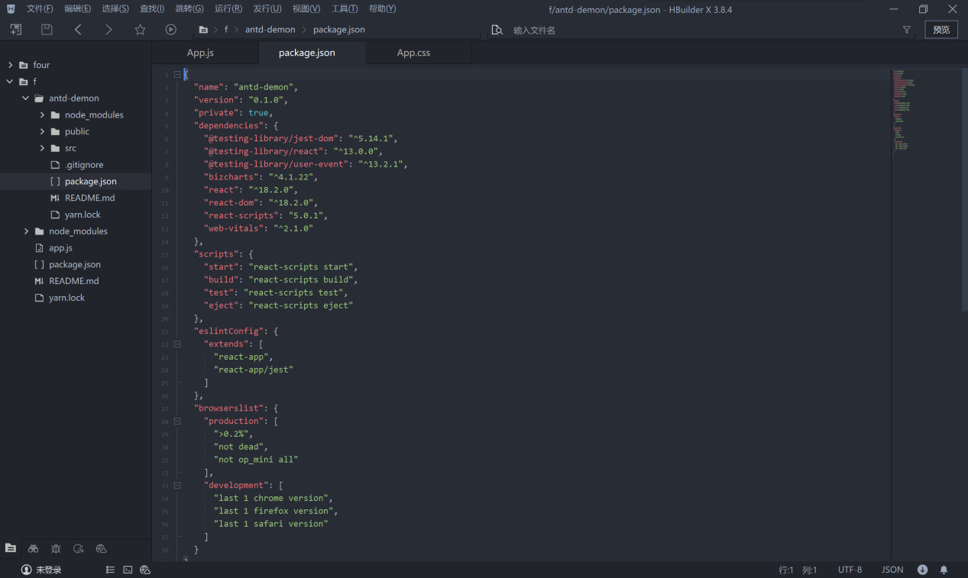

## 上传项目运行截图（至少提供2种屏幕尺寸的效果截图）IMG_256IMG_256

## 在txt文本中写出在实验过程中所遇到的问题及解决办法（截图上传）

