淘宝客API使用方法

申请appkey
登录淘宝联盟（https://pub.alimama.com）
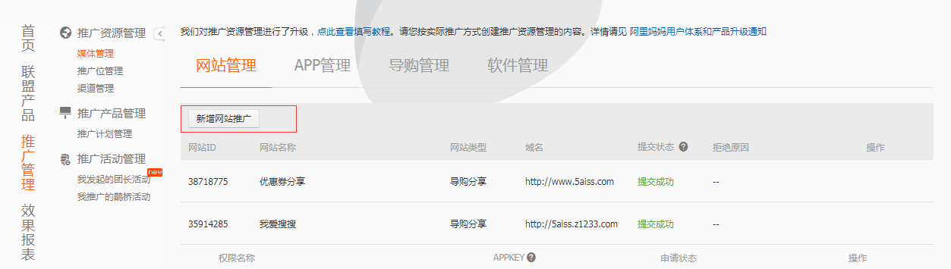
推广管理里面点击新增网站推广
填写网站信息
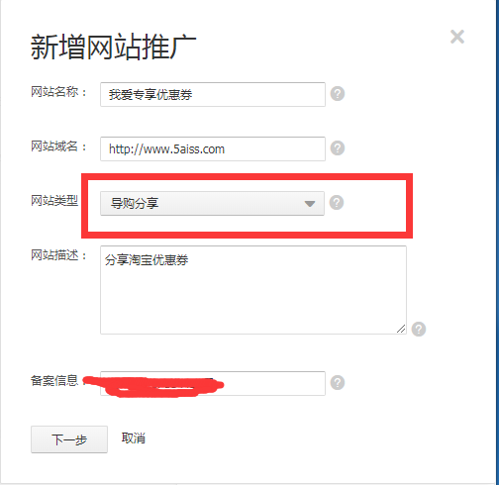
* 网站类型选择导购分享

登记新网站
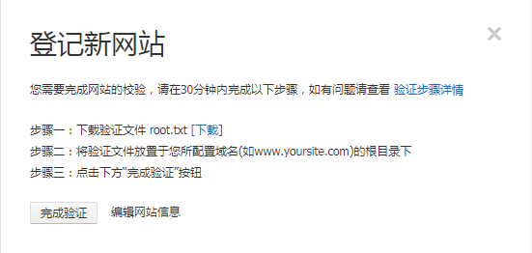
下载root.txt文件上传到你的网站服务器上
上传后可以通过浏览器访问http://www.5aiss.com/root.txt能够查看到root.txt的内容就可了
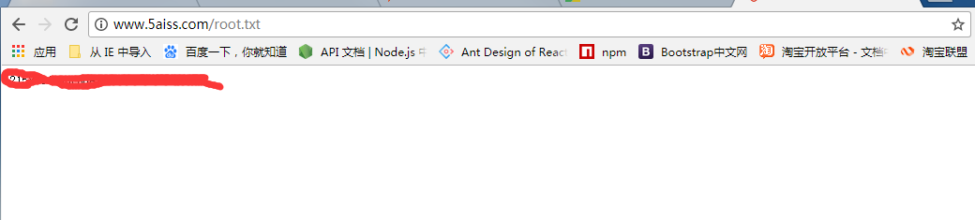
接下来就等待审核通过就可以获取你的appkey和app secret

下载官方sdk到本地
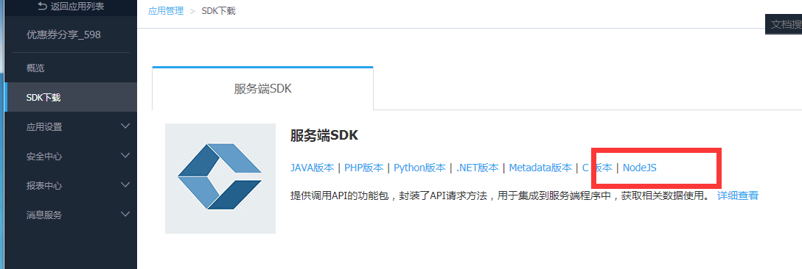

新增网站推广位
复制推广位pid的最后部分
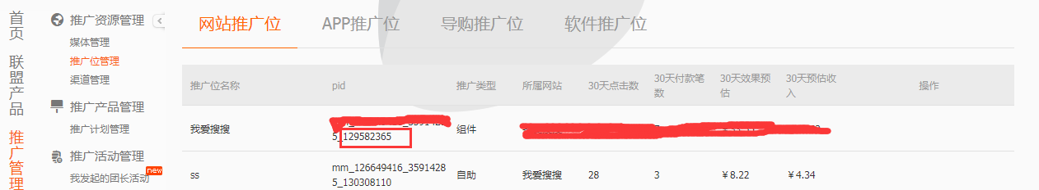

- 代码获取淘宝优惠券数据

Node.js代码

-------------------------------------------------------------------------------------------------------

var TopClient = require('../sdk/lib/api/topClient').TopClient;
var client = new TopClient({
'appkey': '你的appkey',
'appsecret': '你的appsecret',
'REST_URL': 'http://gw.api.tbsandbox.com/router/rest'
});

client.execute(
'taobao.tbk.dg.item.coupon.get',
{
adzone_id: "刚刚拷贝的",
cat: "20",//类别
'q':'女装', //搜索的关键词
platform: "1",
page_size: "10"
},
function(error, response) {
console.log(JSON.stringify(response,null,2));
}
);
-------------------------------------------------------------------------------------------------------
替换代码中的内容

获取到的数据
"tbk_coupon": [
{
"category": 16,
"commission_rate": "5.50",
"coupon_click_url": "https://uland.taobao.com/coupon/edetail?e=SuzMSlxf%2FasGQASttHIRqQHVdu4LdgQPTBmNv2z4kq3B76UlhXoJ9wcL3ei6I3KJ%2F47bCF6Vm6pKSvMi%2F0C%2Fh0IrnPB7t1rlDfqEFBOhTcxBTSXqt0qOvcsPG2qXVezqxRBC7vG5asf%2F6KT%2B%2Bx%2Bu22Pfrr0N2WBetTXi9DHFL9Xk92%2BM7h46c6J7%2BkHL3AEW&traceId=0ab84e8315113361588844214e",
"coupon_end_time": "2017-12-31",
"coupon_info": "满99元减10元",
"coupon_remain_count": 14292,
"coupon_start_time": "2017-09-29",
"coupon_total_count": 100000,
"item_description": "",
"item_url": "http://detail.tmall.com/item.htm?id=557648295779",
"nick": "简港旗舰店",
"num_iid": 557648295779,
"pict_url": "http://img.alicdn.com/tfscom/i1/2269238262/TB1KciBe6uhSKJjSspjXXci8VXa_!!0-item_pic.jpg",
"seller_id": 2269238262,
"shop_title": "简港旗舰店",
"small_images": {
"string": [
"http://img.alicdn.com/tfscom/i2/2269238262/TB2e8TRbYsTMeJjy1zbXXchlVXa_!!2269238262.jpg",
"http://img.alicdn.com/tfscom/i3/2269238262/TB2Ti8PbDZKL1JjSZFIXXX_DFXa_!!2269238262.jpg",
"http://img.alicdn.com/tfscom/i1/2269238262/TB2C4aEXS3PL1JjSZFxXXcBBVXa_!!2269238262.jpg",
"http://img.alicdn.com/tfscom/i3/2269238262/TB2uB2wgH3XS1JjSZFFXXcvupXa_!!2269238262.jpg"
]
},
"title": "中老年女装冬装棉衣棉袄2017新款妈妈装羽绒棉服老年人奶奶衣服女",
"user_type": 1,
"volume": 15575,
"zk_final_price": "119.00"
},

只要通过coupon_click_url这个url点击进去领取购买你的账号就有佣金了。

我做的淘宝客网站www.5aiss.com

