**Filenames**

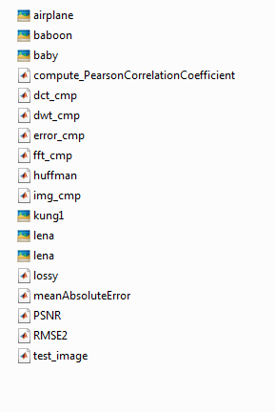**Scripts:**

lossy.m

img_cmp.m

error_cmp.m

test_image.m

**Functions :**

meanAbsouteError.m

PSNR.m

compute_PearsonCorrelationCoefficient.m

RMSE2.m

dct_cmp.m

fft_cmp.m

dwt_cmp.m

**Images:**

lena.png

lena.jpg

airplane.jpg

baboon.jpg

baby.jpg

kung1.jpg

**Working steps**

* First add **Image compression** folder to your MATLAB directory using **Add to Path** command and then run the following files.

**Files to run :**

**lossy.m**

* This file reads an image and compress it using DCT,FFT,DWT
* First it asks for image name, format(ex: image.jpg) and compression rate(1<x<100)
* Then it saves all three compressed images to file as compresseddct.jpg, compressedfft.jpg, compresseddwt.jpg
* Then there is error calculation part where we calculate PSNR,PCC,RMSE,MAE
* Finally it prints these values on command window and plots the image results

**Example Input :**

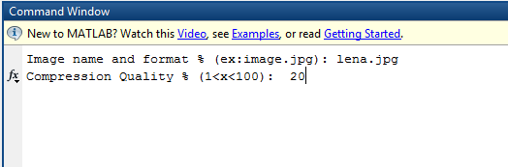

**img_cmp.m**

This file reads the lena.jpg and after running it shows plotted result of compressed images

**Result :**

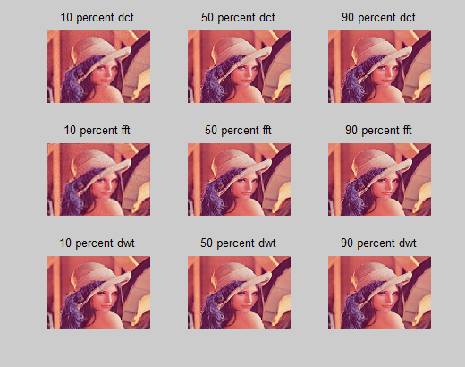

**error_cmp.m**

This file reads an image and do all compression, error calculation ,time calculation for different compression rate 10,20,30,40,50,60,70,80,90 (percent)and plots all result and prints on command window (it might take some times)

**test_image.m**

* This file use three standard test images to compare different transform coding techniques
* Here we used lena.png,airplane.png and baboon.png as standard test image
* Then we compressed these images using DCT,FFT,DWT and recorded each PSNR ratio original and compressed image
* As compression ratio we used 20,40,60 & 80 percent

**Functions and their tasks**

**meanAbsouteError.m**

This function calculates Mean Absolute Error

**PSNR.m**

This function calculates PSNR (Peak Signal to noise ratio)

**compute_PearsonCorrelationCoefficient.m**

This function calculates Pearson Correlation Coefficient

**RMSE2.m**

This function calculates Mean Square Error and Root Mean Square Error

**dct_cmp.m**

This function is used for compression using Discrete Cosine Transform

**fft_cmp.m**

This function is used for compression using Fast Fourier Transform

**dwt_cmp.m**

This function is used for compression using Discrete Wavelet Transform

**General operations**

* I want to compress an image. How can I do this?
* Past your image into Image compression folder. Then, run the **lossy.m** file. It will ask for image name and compression rate. Compressed images will be as compresseddct.jpg, compressedfft.jpg, compresseddwt.jpg
* How can I see the plotted error calculation result of different transform coding techniques?
* Run **error_cmp.m.** It will plot all PSNR, RMSE, MAE and time for different transform coding and different compression rate.
* How I can compare different images at a time?
* Run **test_image.m.** It uses lena.jpg, airplane.jpg, baboon.jpg standard images for comparison and plot their PSNR values in case of DCT, FFT and DWT.
* Which file shows different compression rate result on a specific image?
* **Img_cmp.m**