Git: a website/project to maintain history of project, which person changed what etc and manage them into repositories

ls
mkdir project
cd new_dir

git init (to initialize empty git repository)

ls -a (to see hidden files even)

to know whats in a directory:
ls <foldername>

touch <filename.txt> to create a file

to see what files are modified/added/dltd
or what changes are made to project which are not currently saved and the world is not aware about them
git status

(base) faisal@Faisal-Mohd-Linux:~/Codes/rough/learning/git_rough_dir$ git status
On branch master
Changes not staged for commit:
(use "git add/rm <file>..." to update what will be committed)
(use "git restore <file>..." to discard changes in working directory)
deleted: a.txt

Untracked files:
(use "git add <file>..." to include in what will be committed)
.~t_learn_notes.docm
git_learn_notes.docm

no changes added to commit (use "git add" and/or "git commit -a")
(base) faisal@Faisal-Mohd-Linux:~/Codes/rough/learning/git_rough_dir$

these untracked files: the guests whose picture has not been taken yet/whose history has not been saved yet on stage

to put them on staging area:
git add .

OR
git add <filename>

so, now:

(base) faisal@Faisal-Mohd-Linux:~/Codes/rough/learning/git_rough_dir$ git add .
(base) faisal@Faisal-Mohd-Linux:~/Codes/rough/learning/git_rough_dir$ git status
On branch master
Changes to be committed:
(use "git restore --staged <file>..." to unstage)
new file: .~t_learn_notes.docm
deleted: a.txt
new file: git_learn_notes.docm

ALL GREEN

to permanently save in git history:

git commit -m “messge to save history”

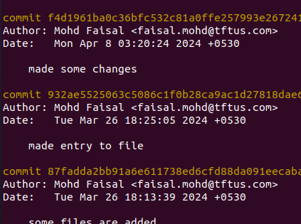

git reset 219cdf07d2cb3c8ef782db0fbe0a1a7555677cca

# to revert the coomit from 219cdf07d2cb3c8ef782db0fbe0a1a7555677cca onwards

and these history before this id, would be removed from git log too

git log # to know the logs

git stash pop # to revert the changes (for ex- if i renamed the file etc. / added content in file etc)

