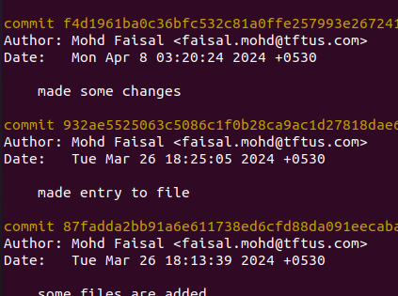

**git reset** 219cdf07d2cb3c8ef782db0fbe0a1a7555677cca

# to revert the coomit from 219cdf07d2cb3c8ef782db0fbe0a1a7555677cca onwards

and these history before this id, would be removed from git log too

**git log** # to know the logs

**git stash pop** # to revert the changes (for ex- if i renamed the file etc. / added content in file etc)