**EXP: 3 Java Servlet Program to Display 'HelloWorld!' in Browser DATE:**

**AIM:**

To write a servlet program that prints **"HelloWorld!"** and displays it in the browser when accessed.

**CODE:**

#HelloWorld.java

package com.faisalSM.servlet;

import java.io.IOException;

import java.io.PrintWriter;

import javax.servlet.ServletException;

import javax.servlet.annotation.WebServlet;

import javax.servlet.http.HttpServlet;

import javax.servlet.http.HttpServletRequest;

import javax.servlet.http.HttpServletResponse;

@WebServlet("/HelloWorld")

public class HelloWorld extends HttpServlet {

private static final long serialVersionUID = 1L;

public HelloWorld() {

super();

}

protected void doGet(HttpServletRequest request, HttpServletResponse response) throws ServletException, IOException {

PrintWriter p = response.getWriter();

p.println("HelloWorld!");

}

protected void doPost(HttpServletRequest request, HttpServletResponse response) throws ServletException, IOException {

doGet(request, response);

}

}

**OUTPUT:**

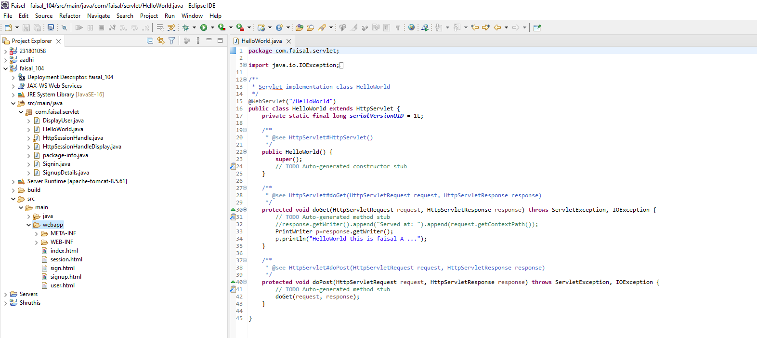

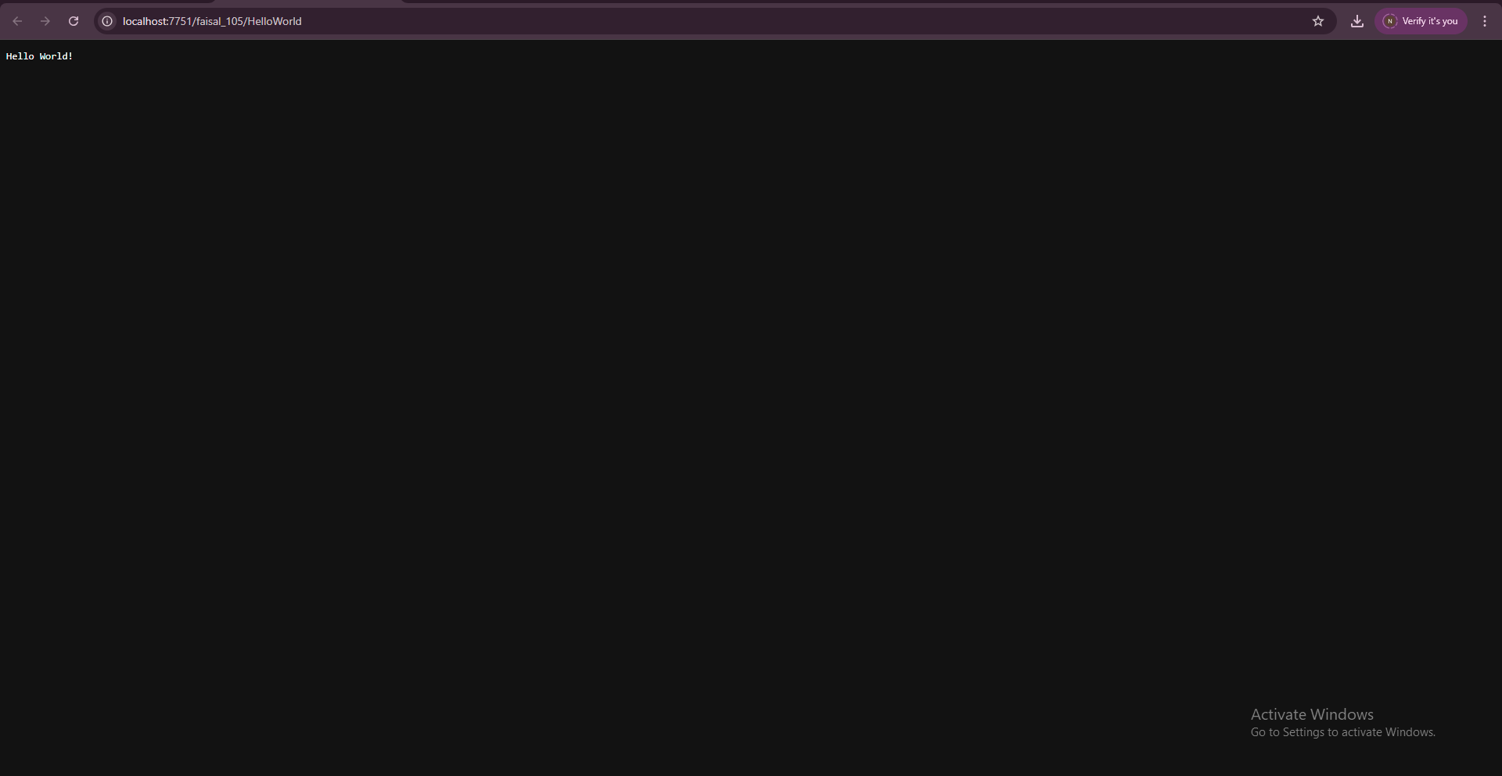

**RESULT:**

The servlet program successfully compiled and executed. It printed **"HelloWorld"** in the browser, demonstrating the use of a basic servlet using the doGet() method.