1. Now we add some data

Graphical user interface, application, Teams

Description generated with very high confidence

1. Now we view name of added data through view button

Graphical user interface, application, Teams

Description generated with very high confidence

1. Now we list the data in list view

Text

Description generated with very high confidenceText

Description generated with very high confidence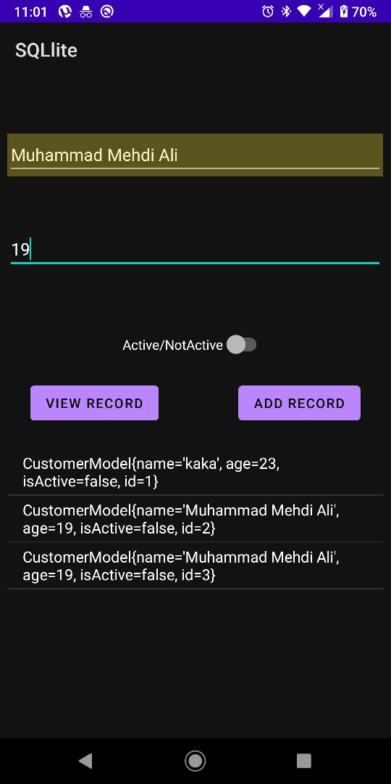

1. Now let’s add a onClick Function on ListItems to delete the clicked Item from database and the list. 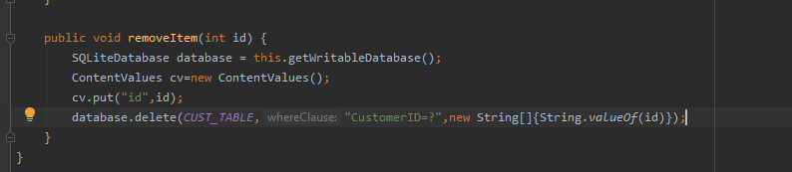Text

   Description generated with very high confidence

Graphical user interface, application

Description generated with very high confidence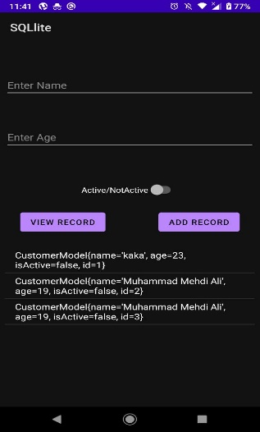

1. Here we removed last 3 entries of list by clicking on them
2. Now we add some data

Graphical user interface, application, Teams

Description generated with very high confidence

1. Now we view name of added data through view button

Graphical user interface, application, Teams

Description generated with very high confidence

1. Now we list the data in list view

Text

Description generated with very high confidenceText

Description generated with very high confidence