**Drawer-Navigation Project**

1. **For headerxml**

**1.1 Code Part**

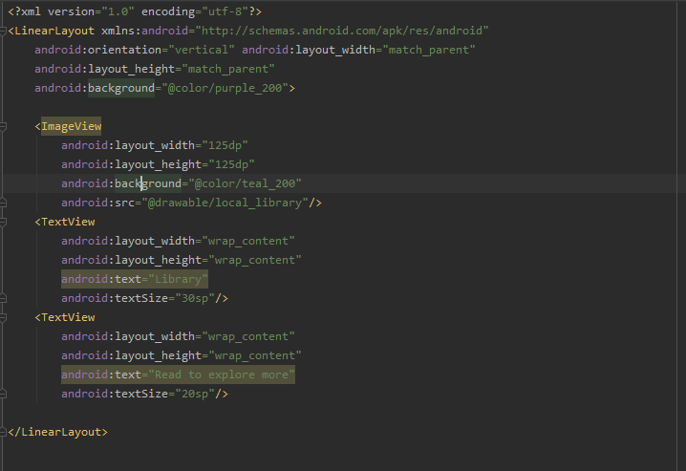

**1.2 design part**

