**VCS-git**

* **Git clone**
  + **git clone** is a **Git** command line utility which is used to target an existing repository and create a **clone**, or copy of the target repository.
  + **Command:**

**git clone https://github.com/Ayman-Shafique/Mobile_Computing_Practice.git** 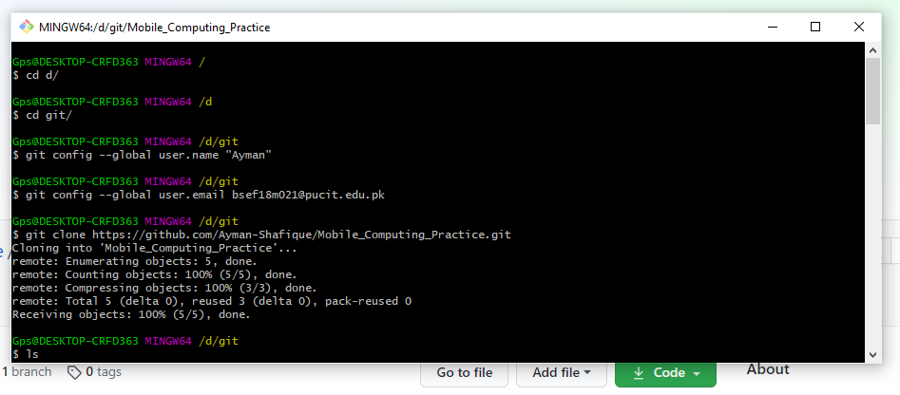

* **Git add**
  + The **git add** command adds a change in the working directory to the staging area.
  + **cd Mobile_Computing_Practice**
  + **Command:** git add text.txt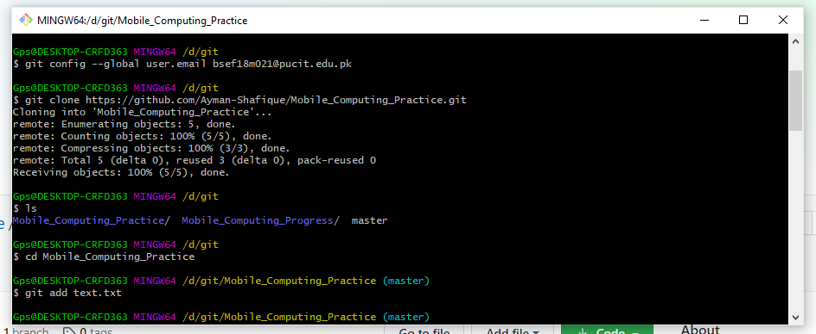
* **Git commit**
  + The **git commit** command captures a snapshot of the project's currently staged changes.
  + **Command:** git commit -m "First Commit"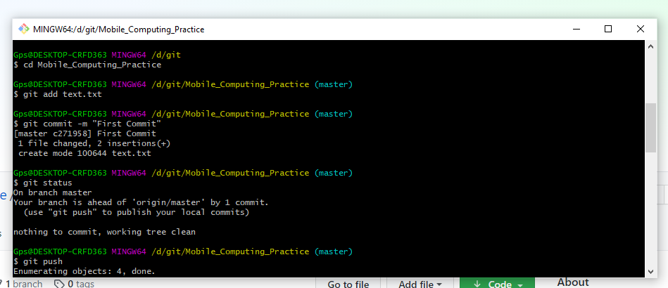
* **Git push**
  + The **git push** command is used to upload local repository content to a remote repository. **Pushing** is how you transfer commits from your local repository to a remote repository.
  + **Command:** git push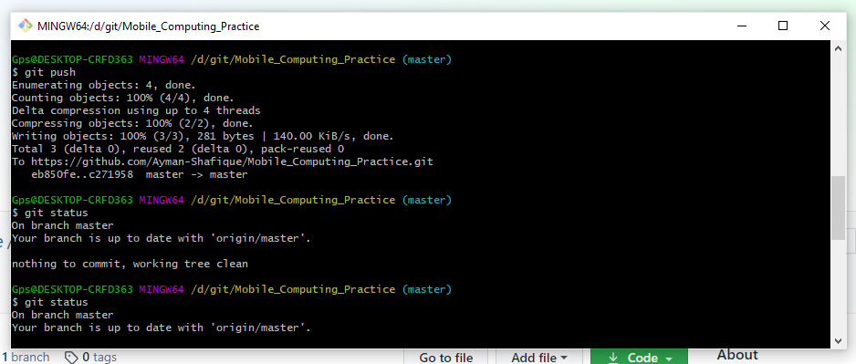
* **Git status**
  + The **git status** command displays the state of the working directory and the staging area. It lets you see which changes have been staged, which haven't, and which files aren't being tracked by **Git**.
  + **Command:** git status