# FastApi

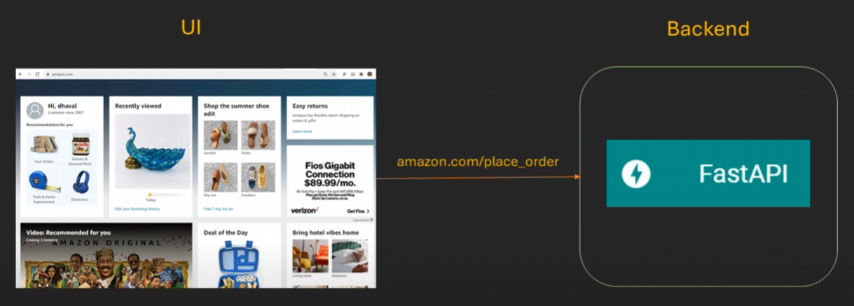

## Commands to install api

Pip install fastap

Pip install uvicorn

Different type of end points

|  |  |  |  |
| --- | --- | --- | --- |
| SQL WORK BENCH | | FAST API | |
| C | CREATE | **P** | POST |
| R | READ | **G** | GET |
| U | UPDATE | **P** | PUT |
| D | DELETE | **D** | DELETE |

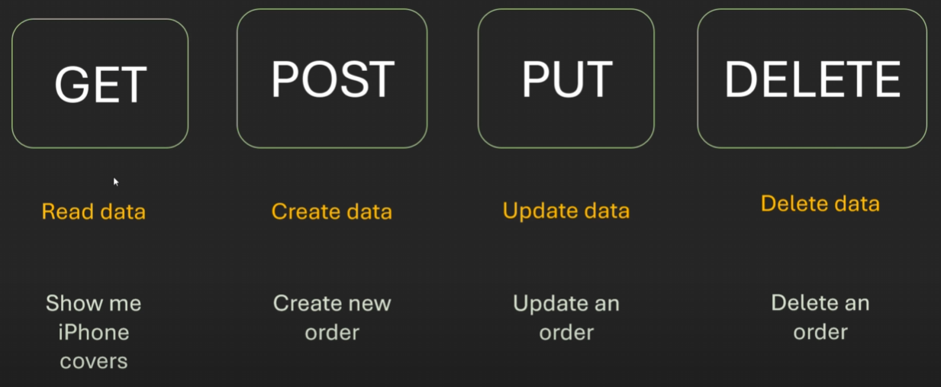

Simple end point

@app.get("/hello/{name}")

async def hello(name):

    return f"welcome to fast api {name}"

#### inbuilt formation then

class Availablecuisines(str,Enum):

    india = 'india'

    america = 'america'

    italy = 'italy'

    japan = 'japan'

food_items= {

    'india' : ['samosa', 'vadapav'],

    'america' : ['pizza', 'burger'],

    'italy' : ['pasta', 'pizza'],

    'japan' : ['sushi', 'ramen'],

}

valid_cusine = food_items.keys()

@app.get("/get_items/{cuisines}")

async def get_cusine(cuisines: Availablecuisines):

    return food_items.get(cuisines)

we run command in terminal as

uvicorn main:app –reload

then we take the fast api server path <http://127.0.0.1:8000/>

paste in google with <http://127.0.0.1:8000/get_items/india>

#### Creation of document / front end automatically

<http://127.0.0.1:8000/docs>

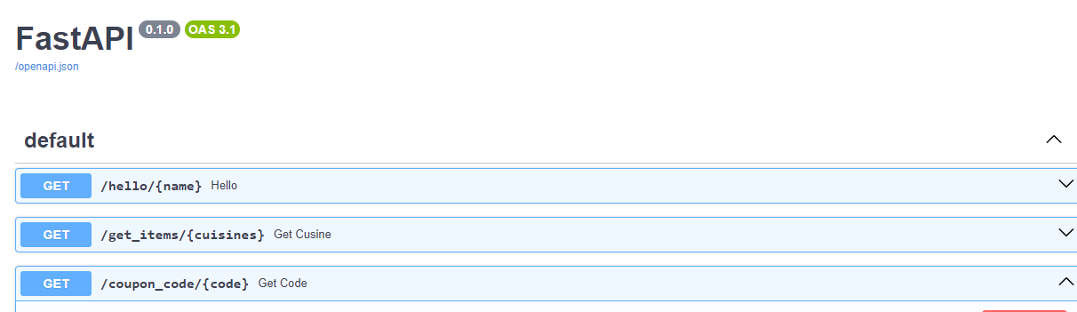

<http://127.0.0.1:8000/redoc>

