**Benzinga** (2 Feeds)

[Premium US Equities Newsfeed](https://www.benzinga.com/apis/cloud-product/stock-news-api/) & [Why is it Moving Feed](https://www.benzinga.com/apis/cloud-product/bz-why-is-it-moving/)

Fields: <https://docs.benzinga.com/benzinga-apis/newsfeed-v2/newsService-get>

(Both feeds have more or less similar fields)

* ID: Unique ID of the output
* Author: Author of the article
* Created/published_date: Created timestamp, in HH:MM:SS format
* Updated:
  + Last updated timestamp, in HH:MM:SS format
  + Last updated timestamp (UNIX)
* Title: Title of the article
* Teaser: Teaser content or short summary
* Body: Timestamp of the conference call, in HH:MM:SS format
* URL: URL to the Benzinga.com website displaying the article
* Image: If images are included, the array will display their URLs
* Channels: List of channel taggings categorized by specific news channels
* Stocks/ tickers
* tags

covers the Wilshire 5000, the TSX, and 1000 other popular tickers.

Benzinga posts between 130-160 full length articles

**Tiingo**

Rules for news:

1. **isLatest**: Check if news is latest (Benzinga: If its not an update, Tiingo: if its crawled less than 60 seconds after being published)
2. **singleSymbolFilter**: checks if the Symbol in the list of Symbols and is the only one in the List
3. **selectCategories**:

* **fundamental_categories** = ["Earnings", "Dividends", "Guidance", "M&A", "Contracts", "Management" ,"Earnings Beats", "Buybacks", "Insider Trades", "Asset Sales", "Regulations", "Press Releases", "Financing", "Earnings Misses", "Stock Split"]
* **analyst_categories** = ["Analyst Ratings", "Price Target", "Trading Ideas", "Initiation", "Upgrades", "Downgrades", "Reiteration", "Analyst Color", "Short Ideas", "Long Ideas", "Previews", "Reviews"]
* **macro_categories** =["Federal Reserve", "Macro Economic Events", "Economics", "Commodities", "FDA"]
* **other_categories** = ["Market-Moving Exclusives", "Exclusives", "Options", "Movers", "Short Sellers", "Intraday Update", "Rumors", "Top Stories", "Equities", "Offerings", "Events", "Hot", "After-Hours Center", "Pre-Market Outlook", "Penny Stocks", "SEC", "Movers & Shakers", "Signals"]

To be Reviewed since in QC was using

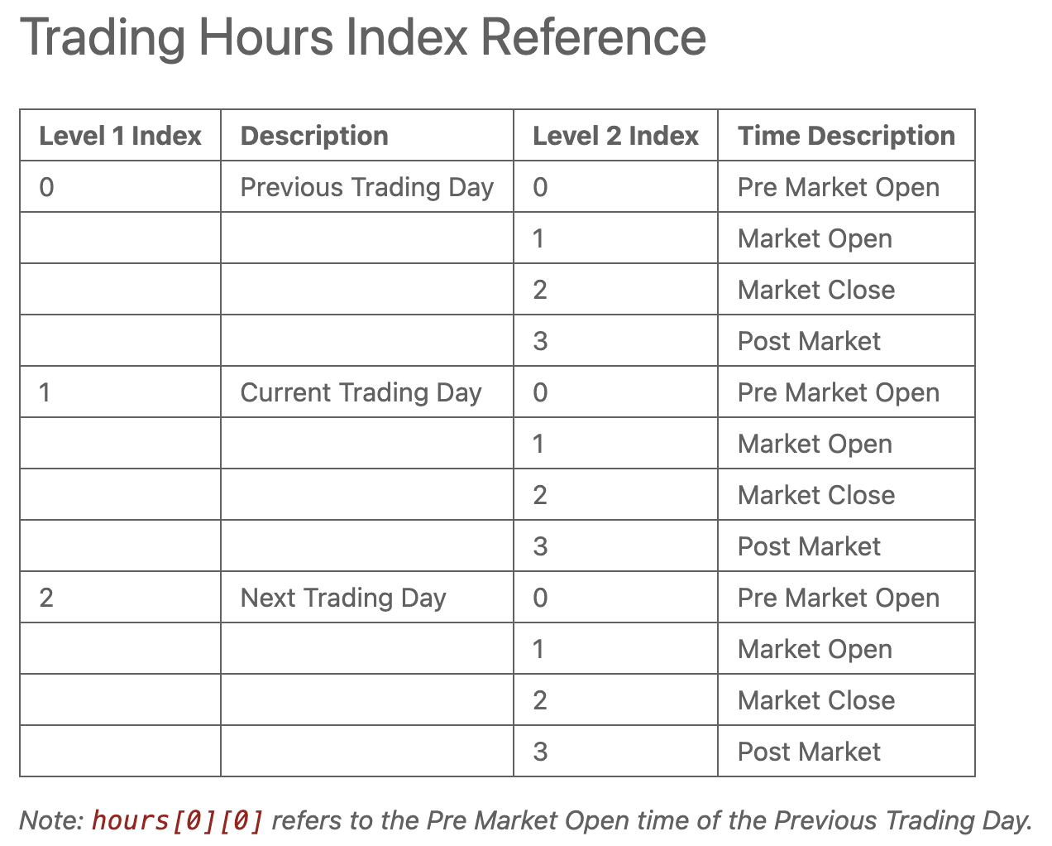

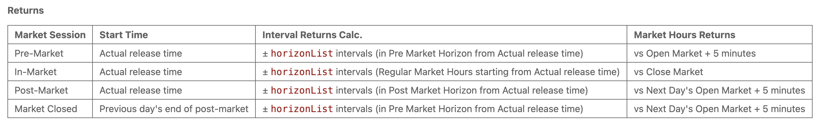

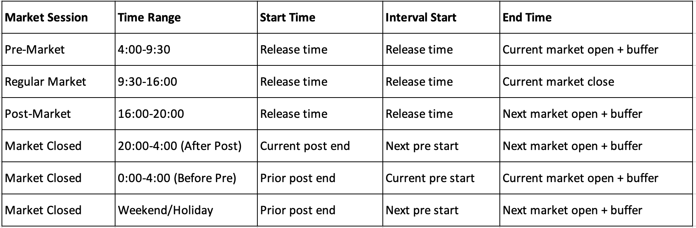

def get_trading_hours(self, timestamp):

"""

Returns trading hours for previous, current, and next sessions, plus market open status.

Args:

timestamp: str or pd.Timestamp - The timestamp to check

Returns:

tuple: ((prev_times), (current_times), (next_times)), is_trading_day

where each *_times tuple contains (pre_start, session_open, session_close, post_end)

all times in US/Eastern

"""

# Ensure proper timezone handling

timestamp = self._ensure_eastern_tz(timestamp)

# Check if it's a trading day

is_trading_day = self.calendar.is_session(timestamp.date())

try:

# Get the relevant sessions

current_session = self.calendar.date_to_session(timestamp.date(), direction='previous')

prev_session = self.calendar.previous_session(current_session)

next_session = self.calendar.next_session(current_session)

trading_hours = []

# Process each session (previous, current, next)

for session in (prev_session, current_session, next_session):

schedule = self.calendar.schedule.loc[session]

# Create fixed time sessions in ET (matching market_hours_cache format)

base_date = pd.Timestamp(session).tz_localize('US/Eastern')

pre_start = base_date.replace(hour=4, minute=0)

session_open = base_date.replace(hour=9, minute=30)

session_close = base_date.replace(hour=16, minute=0)

post_end = base_date.replace(hour=20, minute=0)

trading_hours.append((pre_start, session_open, session_close, post_end))

return tuple(trading_hours), is_trading_day

except (xcals.errors.NotSessionError, ValueError):

return None, False

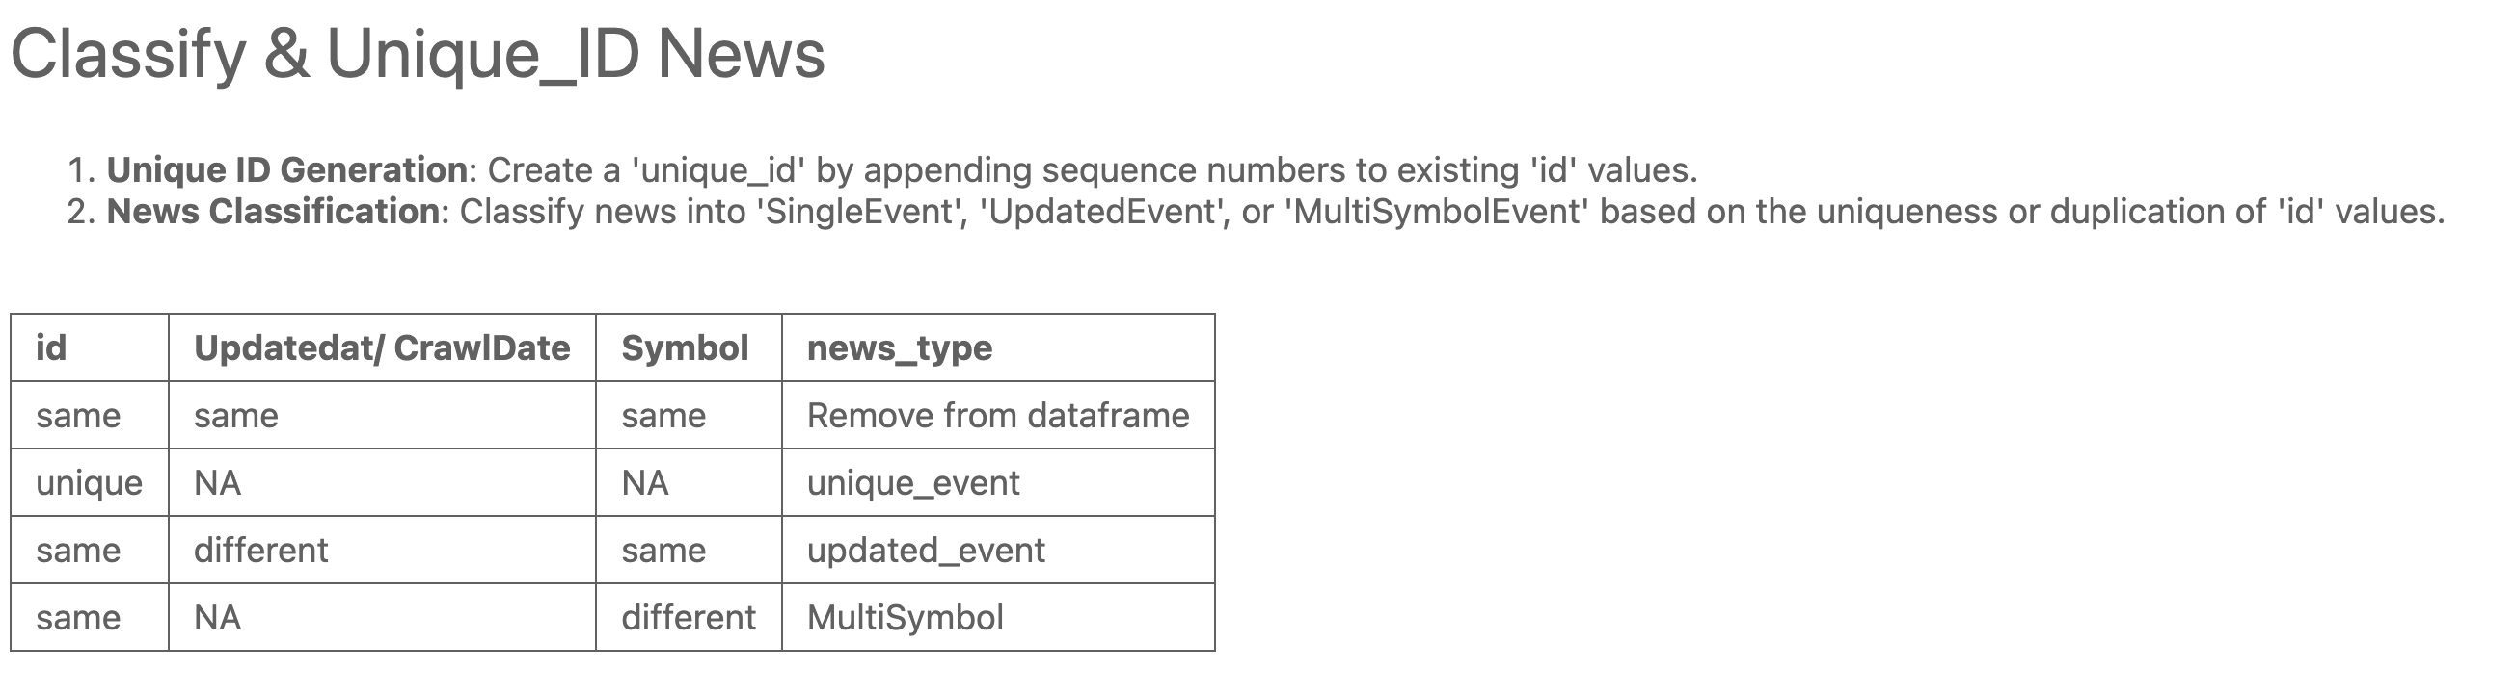

# Ideally this should go to ReturnCalculator or a Seperate Class

Dear Team,

I hope you’re doing well.

I’m interested in the 50% start-up discount for the Stocks Developer plan. While I’m not incorporated, I’m building a trading platform as a one-person start-up. This discount would help me access your data and refine my project while keeping costs manageable.

I’d greatly appreciate your consideration and look forward to your response.

Thank you!  
Faisal