AIR Quality Monitoring System

(AQMS)

**final project report**

**gROUP – 01**

|  |  |
| --- | --- |
| **NAME** | **ID** |
| FAISAL BHUIYAN | 1921298 |
| MAISHA ADITY FARZANA | 1921278 |
| UMME TASNIM | 1921848 |
| FAHAD KABIR | 1921785 |
| FARHAN SAJID | 1931269 |
| MOFAJJEL HOSSAIN CHOWDHURY | 2020549 |

Contents

Chapter 1: Introduction 4

A. Background of the organization 5

B. Background of the PROJECT 5

C. Objectives of the project 5

D. Scope of the project 6

CHApter 2: requirement analysis 7

A. Rich Picture – Existing Business System 7

B. Six Elements Analysis – Existing Business System 9

C. Process Model – Existing Business System 13

D. Problem ANalysis – Existing Business System 16

E. Rich Picture – Proposed System 18

F. Six Elements Analysis – Proposed System 19

G. Process Model – Proposed System 20

Chapter 3 – Logical System Design 22

A. Business Rule 22

B. Entity Relationship Diagram 24

C. Entity RelationShip Diagram to Relational Schema 25

D. Normalization 25

E. DATA Dictionary 27

# Chapter 1: Introduction

Air quality is an important aspect of our daily lives, as we breathe it every day. More and more people have to be aware of exactly how safe or unsafe the air they are breathing is. The purpose of this report is to analyze an existing Air Quality Index project titled CASE (Clean Air & Sustainable Environment) and conduct necessary problem analysis on its existing processes.

After that, we are going to propose a new and improved system with the aim of reducing system errors, conduct the necessary data analysis, report and chart generation easily for all its stakeholders.

The first section will give a brief overview of the organization in issue along with the project. The second section will primarily focus on the existing CASE system and its flaws, as well as an introduction to the proposed system that is going to replace it.

The third and fourth sections will be highly technical, focusing mainly on our implementation of the proposed system.

As per our analysis and investigations of the CASE system, we have identified several places where some important modifications are necessary to make the system more efficient and facilitate communication among stakeholders. In addition to that, the modifications will eliminate the possibility of human mistake and data duplication, and stakeholders will be able to access a vast AQI (Air Quality Index) reports and review valuable information through our system instead of manually reading through documents.

As we progress through the report, we will take a look at how the current Air Quality Monitoring system works, the business processes involved, where there are concerns and difficulties with data management, and how we can create a better system to remedy and enhance these problems.

## Background of the organization

CASE was developed by government with the hopes of creating a clean air and sustainable environment. The main organizations involved in the project are:

* Ministry of Environment and Forest
* Department of Environment
* Dhaka South City Corporation
* Dhaka North City Corporation
* Dhaka Transport Coordination Authority
* The World Bank

The World Bank is an international financial institution that provides loans and grants to the governments of low- and middle-income countries to pursue capital projects. The World Bank was a major contributor to the CASE project.

The Ministry of Environment, Forest and Climate Change is a ministry of the government of the People’s Republic of Bangladesh whose role is ensuring the sustainable environment and optimum forest coverage.

Dhaka South City Corporation (DSCC) and Dhaka North City Corporation are two municipal corporations in Dhaka created on 29 November 2011. DNCC governs 54 northern wards of Dhaka. Both these are responsible for administering and providing basic infrastructure to the city.

Dhaka Transport Coordination Authority is the main government agency responsible for public transport in Dhaka, and it moderates negotiations between transport labor unions and transport owners.

## Background of the PROJECT

The goal of the project is to develop a website for stakeholders and institutional bodies to retrieve Air Quality index and generate appropriate reports and charts as per the user’s requirements.

The system will also allow some stakeholders with administrative rights to converse with other users and make decisions through the system.

## Objectives of the project

To meet the purpose of the project several requirements must be met.

Our system AQMS will provide the users with the requested analysis and allow them to view it on the website in the form of charts directly on the website or request downloadable pdf reports.

The stakeholders of our system will log into the system and select which analysis that

## Scope of the project

We carried out a thorough evaluation of the existing system and identified areas in the business processes that might result in significant delays in time and communication, which we will cover in the following chapter.

Our solution is to build a web application called AQMS (Air Quality Monitoring System) that uses a Relational Database Management System (RDMS) to store, calculate, add and update necessary data for Air Quality Index, as well as to generate the necessary data, reports, charts, and documents and store them in the database.

To ensure that a project is completed, the scope of the project must be defined. We must guarantee that the new system is more effective than the present one because we are modifying an existing system. Because maintaining thorough records of students’ enrollment and documentation is inefficient, an improved and automated Qir Quality Monitoring System is required (AQMS).

So, the goal of this project is to improve the present system by implementing our proposed solution, which will allow us to:

Create a system which takes input with an easy to go interface.

Allow only authorized users to access the system.

Insert, update and delete data from the database in real time.

Calculate the Air Quality Index based on location and region,

Generating table and chart.

## CHApter 2: requirement analysis

We will provide you with information on each stakeholder and their interactions. The Requirement Analysis entails researching and visualizing the present industry tools, methodologies, and standards.

The process of deciding what the database will be used for is referred to as requirements analysis. Interviews with user groups and other stakeholders are conducted to determine what database capabilities they want, the types of data they desire to handle, and the most frequently done activities.

This analysis will provide us with information on each stakeholder and their interactions. We analyze business processes using simple notations and symbols to give everyone an understanding of how they function. First, we’ll run into challenges with the present system’s manual labor related weather data, followed by third-party persons generating faults in the system.

## Rich Picture – Existing Business System

Rich pictures are modelled using diagrams and illustrated graphically which has the main elements and relationship they have between them according to the business system in place. A complete rich picture could be of significance to other stakeholders of the problems in an existing system and permit them to apprehend many different facets of the situation. Both the structure and the processes of a given situation are focused on the Rich Picture. The Rich Picture Analysis also considers the following:

* Structures
* Processes
* Climate
* People
* Issues expressed by people
* Conflict

The following rich picture was created keeping that in mind.

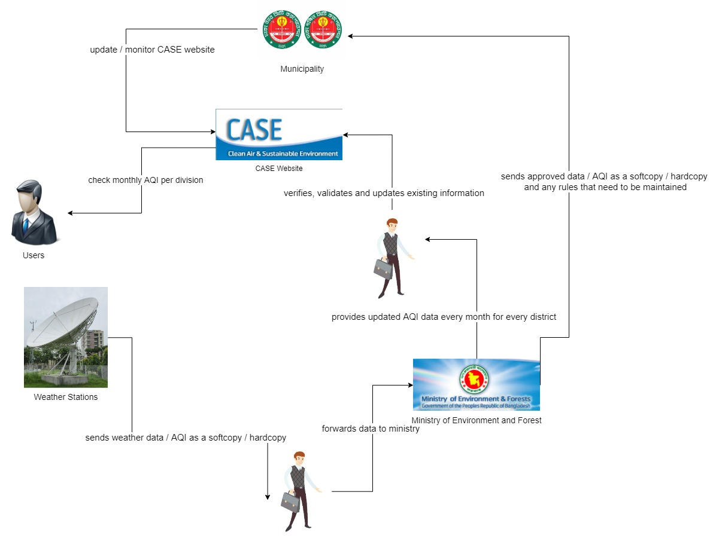

The Rich Picture Analysis shows us that we have the following types of stakeholders:

* Ministry of Environment and Forest
* Weather Station
* Municipality (DNCC and DSCC)
* Users

The only system we can identify here is the CASE website itself.

## Six Elements Analysis – Existing Business System

The Six Elements Analysis provides a detailed description of the role of each element in each process. It is clear from the table below that Human entities dominate all key functions of this system. The existing system, for example, is substantially reliant on manually processed and managed hardcopy databases.

As a result, before the Human parts can fulfil their end of the bargain in the process, there is a large amount of waiting between interdependent operations.

|  |  |  |  |  |  |  |
| --- | --- | --- | --- | --- | --- | --- |
| **Process** | **Human** | **Non-Computing Hardware** | **Computing Hardware** | **Software** | **Database** | **Network and Communication** |
| **Transfer of Weather Data / AQI to Ministry** | **Weather Station Employee:**  1. A weather station employee records the current weather data in a paper.  2. The employee sends the current weather data to a Weather Station representative.  **Weather Station Representative:**  1. Receives the weather data from the weather station employee.  2. Travels to the Ministry Headquarters.  3. Hands the weather data to a Ministry representative. | **Pen and Paper:**  Used to record weather information by weather station. | **Computer / Laptop:**  It is used to make soft copies of the weather information / data for later use.  **Printer:**  It is used to print out hardcopies of the weather data to send to representative. | **Microsoft Excel:**  It is used by Weather Station employee to record the weather data in csv format for later use. | **Hardware Storage:**  It is used for saving the weather information in all the local computers associated with weather station. | **Internet:**  Used by the Weather station employee, representative and Ministry representative to communicate with each other. |
| **Transfer weather data / AQI to CASE website** | **Ministry Employee:**  1. Receives the weather data from Weather Station Representative.  2. Checks if there are any issues with the computer or hardware.  3. If issues present, contact IT Technician.  4. Check if issues present with Internet connection.  5. If present contact External IT Technician.  6. Checks whether the existing information in CASE website is up-to-date.  7. Updates the weather data / AQI in the CASE website.  **Internal IT Technician:**  1. Receive contact from Ministry Employee.  2. Fix the issues.  **External IT Technician:**  1. Receive contact from Ministry.  2. Fix the Issues. | **Pen and Paper:**  1. Used to jot down any information in CASE website that needs to updated.  2. Used to record weather data before inputting to CASE if needed. | **Computer / Laptop:**  1. Used to access the access the CASE website and update the necessary weather data.  **Networking Devices (Router, Switch, Bridge, Hub):**  1. Used to access the Internet. | **Browser:**  1. Needed to update the CASE website and access it. | **Web Storage:**  The AQI data updated on CASE website are stored on a web server / storage. | **Internet:**  Used to access and update the CASE website. |
| **Send Rules and Regulations / AQI data to Municipality** | **Ministry Employee:**  1. Receives the weather data from Weather Station Representative.  2. Gathers the weather data as a softcopy / hardcopy and sends to a Municipality representative.  3. Sends the approved rules and regulations to be maintained to Municipality employee. | N/A | **Computer / Laptop:**  1. Used to input the weather data / AQI to the computer.  2. Used to send the weather data / AQI / rules to Municipality representative via email.  **Printer:**  1. Used to print hardcopy of weather data / AQI to send to Municipality. | **Microsoft Excel:**  1. Used to store weather data as softcopy.  **Browser:**  1. Used to send emails to Municipality. | **Hardware Storage:**  1. Used to store the weather data / AQI data before sending to Municipality. | **Internet & Email:**  1. It is used to by Ministry to send soft copies of weather data and rules and regulations to Municipality. |
| **Update and Monitor CASE website** | **Municipality Employee:**  1. Receive weather data / AQI and rules and regulations from Ministry as hardcopy and softcopy.  2. Check for issues with hardware and computers.  3. If present, contact Internal IT Technician.  4. Check for issues with internet connection.  5. If present, contact External IT Technician.  6. Update CASE website according to data received from Ministry.  **Internal IT Technician:**  1. Receive contact from Municipality Employee.  2. Fix the issues.  **External IT Technician:**  1. Receive contact from Municipality Employee.  2. Fix the issues. | **Pen and Paper:**  1. Used to jot down any issues or problems discovered about CASE website. | **Computer / Laptop:**  1. Used to monitor and update CASE website.  2. Used to send emails to Ministry.  **Networking Devices:**  1. Used to access the Internet. | **Browser:**  1. Used to access CASE website and monitor it.  2. Used to update CASE website. | **Web storage:**  1. Used to store CASE website data. | **Internet / Email:**  1. Used to access CASE website and update it.  2. Used to communicate with Ministry. |
| **Check Monthly AQI per division** | **Users:**  1. Visit the CASE website.  2. Select Air Quality Index on the dashboard and view the latest AQI data. | N/A | **Computer:**  1. Used to access the CASE website.  **Networking Devices:**  1. Used to access the internet. | **Browser:**  1. Used to access CASE website. | N/A | **Internet:**  1. Needed to access CASE website. |

## Process Model – Existing Business System

BPMN stands for Business Process Model and Notation, which is a graphical depiction of business processes in a business process model. Each of the business processes outlined in the preceding section is dissected using business process model diagrams. Each figure depicts the many stakeholders engaged in the process, their interactions, and the decisions that each of them must make.

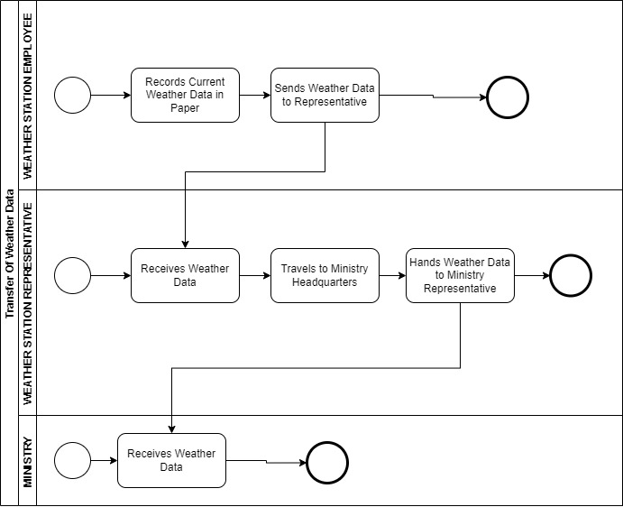

Figure : Transfer of Weather Data to Ministry

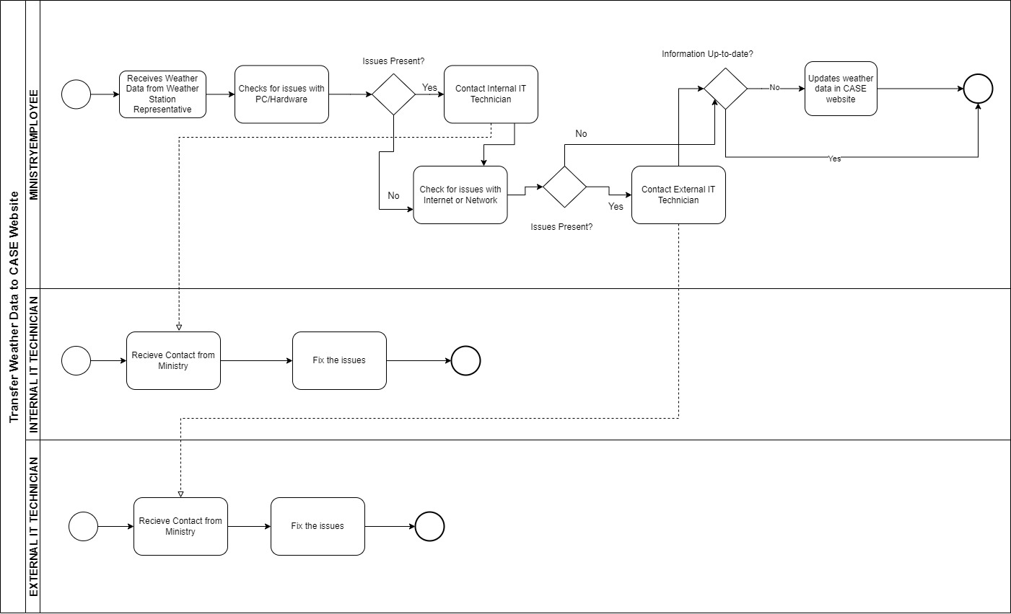

Figure : Transfer of Weather Data to CASE Website

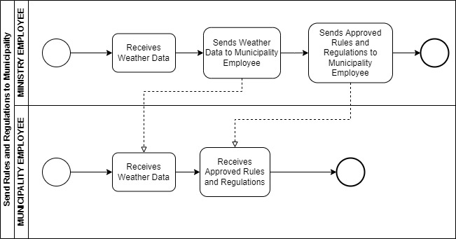

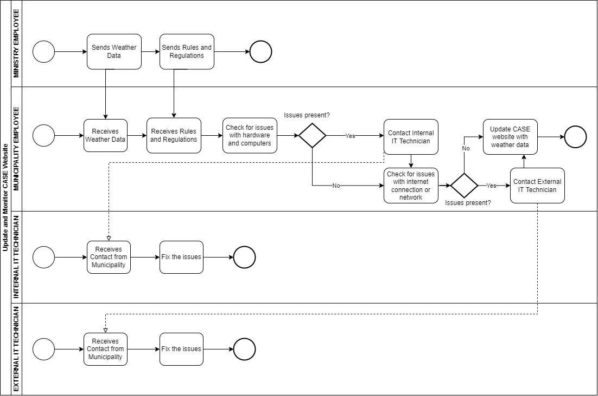Figure : Send Rules and Regulations to ministry

Figure : Update and Monitor CASE Website

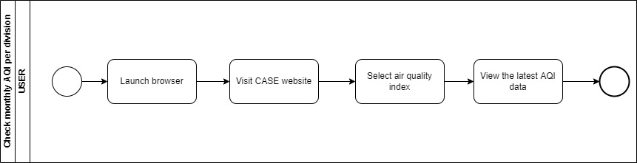

Figure : Check Monthly AQI Per Division

## Problem ANalysis – Existing Business System

The deficiencies in each process were found using the Six Elements Analysis of the existing systems. The analysis column of this table contains a recurring pattern. The facilitation of a private online platform looks to benefit the system in a variety of ways.

|  |  |  |  |  |
| --- | --- | --- | --- | --- |
| **Process Name** | **Stakeholders** | **Concerns (Problems)** | **Analysis (Reason of the Problems)** | **Proposed Solution** |
| Transfer of Weather Data / AQI to CASE website. | 1. Ministry Employee  2. Weather Station Representative | 1. Requires manual distribution of weather data / AQI.  2. Data redundancy and variability.  3. Time Consuming.  4. Human error.  5. Decentralized. | The weather data / AQI gathered by a weather station employee needs to be transferred to a Ministry employee through a weather station representative before sending to the CASE website. This takes up a lot of valuable time. Since the weather station does not contain any database, there is a risk of data variability and redundancy as well. Also, since several different authorities are involved in this one process, it is decentralized. | We proposed a system where there is no need for distribution. The system will work as a central system. The weather data / AQI will be updated to the CASE website directly without any involvement from the Ministry. |
| Send rules and regulations to Municipality | 1. Ministry Employee  2. Municipality Representative | 1. Time Consuming  2. Data redundancy and variability  3. Decentralized | In order for the rules and regulations to be implemented on CASE website, it has to pass through the Municipality manually before they update the website. This takes up unnecessary time. Moreover, since there are three stakeholders (Ministry, Municipality and CASE), it is more prone to data inconsistency. | The Ministry can directly update the rules and regulations on the CASE website, without the municipality, creating a centralized system. |
| Check monthly AQI per division | 1. Users | 1. Disorganized data.  2. Not user-friendly. | Since CASE website only contains raw weather data, the data is presented to the user without any additional calculations. It is not organized into any charts or graphs so the information is not user-friendly. | The proposed system will be able to generate required pdf reports, charts and graphs for the raw weather data. |

## Rich Picture – Proposed System

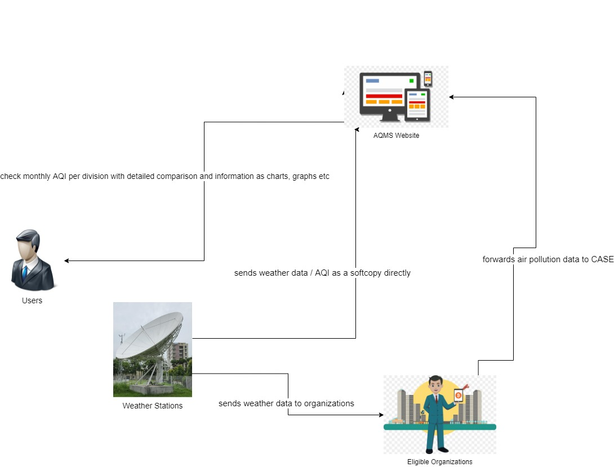

## Six Elements Analysis – Proposed System

|  |  |  |  |  |  |  |
| --- | --- | --- | --- | --- | --- | --- |
| Process | Human | Non-computing hardware | Computing hardware | Software | Database | Network and communication |
| Sends weather data to AQMS website | Weather Station Employee:  1. Prepares updated weather data.  2. Uploads the weather data to AQMS website directly. | Pen and Paper:  1. To note down necessary information if needed. | Computer / Laptop:  1. The weather station employee uses computer to load the weather data into the system.  2. The weather station employee uploads weather data using computer.  Networking Devices (Router, Switch, Bridge, Hub):  1. Needed to access the internet. | MS Excel:  1. To create or edit csv data files of weather data.  CASE:  1. Import the dataset or weather data into the system. | CASE Database:  1. The imported data will be stored into the system’s database. | Internet:  1. Needed to import data and store into the system. |
| Upload Air Pollution Data to AQMS Website | Eligible Organization Employee:  1. Receives weather and pollution data from Weather Stations.  1. Logs onto the AQMS website.  2. Uploads the air pollution data as required. | Pen and Paper:  1. To note down the necessary information if required. | Computer / Laptop:  1. Needed to access the CASE website and upload the air pollution data.  Networking Devices:  1. Needed to access the internet. | CASE:  1. Upload air pollution data. | CASE Database:  1. The uploaded data will be stored in the system’s database. | Internet:  1. Needed to access the CASE website and import air pollution data into the system. |
| Check Monthly AQI per division | User:  1. Request monthly AQI data.  2. Select required graphs, charts or comparison.  3. Receive the required graphs, charts / data.  Ministry Representative:  1. Request necessary AQI Reports.  2. Sends Feedback.  3. View feedback from Municipality.  Municipality Representative:  1. Request necessary AQI Reports.  2. Sends Feedback.  3. View Feedback from Ministry. | N/A | Computer / Laptop:  1. Needed to access CASE website and request data.  Networking Devices:  1. Needed to access the internet. | CASE:  Needed to request monthly AQI data. | CASE Database:  The AQI data is retrieved from the database. | Internet:  Needed to access CASE and request data. |

## Process Model – Proposed System

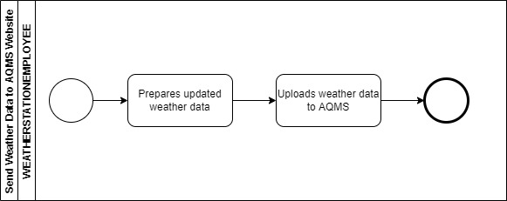

Figure : Sends Weather Data to AQMS Website

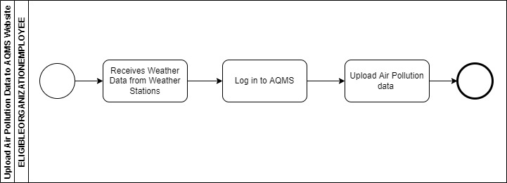

Figure : Upload Air Pollution data to AQMS Website

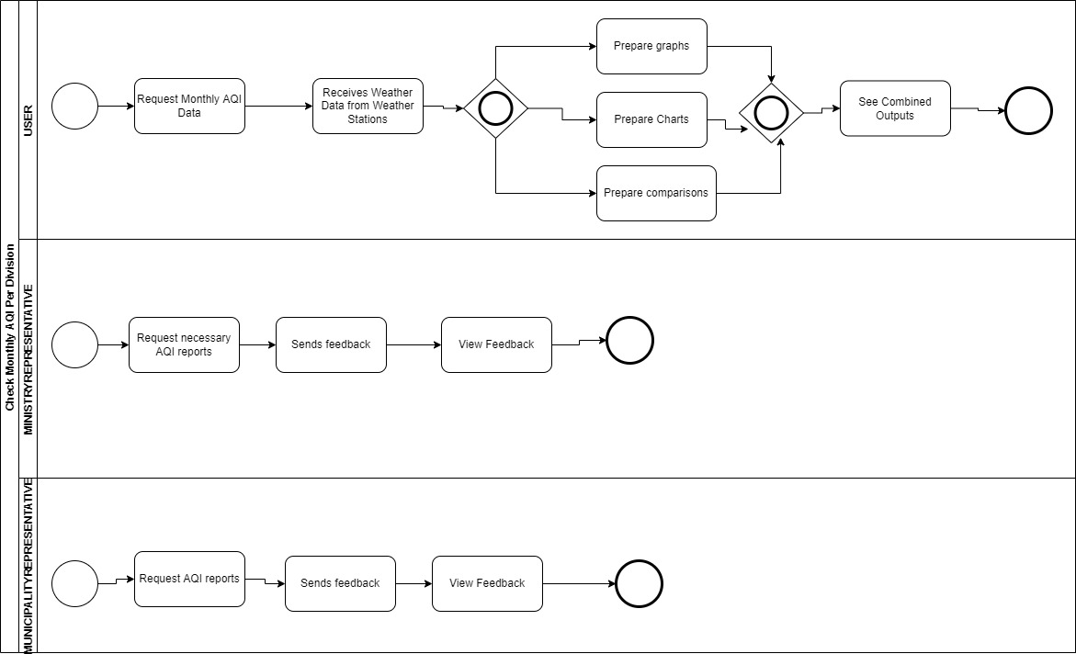

Figure : check monthly AQI Per Division

# Chapter 3 – Logical System Design

## Business Rule

1. A Weather Station Employee has a WSEmpID, WSEmpName and WSEmpEmail.
2. A Ministry Employee has a MinistryEmpID, MinistryEmpName and MinistryEmpEmail.
3. An Organization has OrganizationID, OrganizationName and OrganizationLocation.
4. A User has UserID, UserName and UserEmail.
5. A Municipality Employee has MunicipalityEmpID, MunicipalityEmpName, MunicipalityEmpLocation and MunicipalityEmpEmail.
6. A Weather Station Employee must provide Station Air Quality data. The Station Air Quality data must be provided by a Weather Station Employee.
7. One or more Organization must provide Station Air Quality data and Route Wise Data. The Station Air Quality data or Route Wise data must be provided by an organization.
8. A Municipality Employee or Ministry Employee may post comments to each other.

## Entity Relationship Diagram

## Entity RelationShip Diagram to Relational Schema

## Normalization

|  |
| --- |
| **StationSurrogateKey** → StationId, Division, StationType |
| **StationSurrogateKey** → BMDLocation |
| **StationSurrogateKey** → OrganizationName |
| **AQID** → PM25, AverageTemp, RainPrecipitation, WindSpeed, Visibility, CloudCover, RelativeHumidity, Season, Date, StationSurrogateKey |
| **OrganizationName** → OrganizationID, OrganizationLocation |
| **RouteID** → Latitude, Longitude, Mean, Date, Location, OrganizationName |

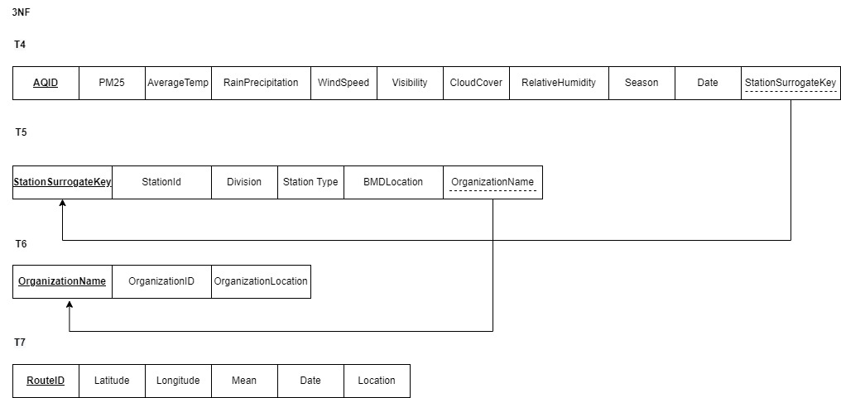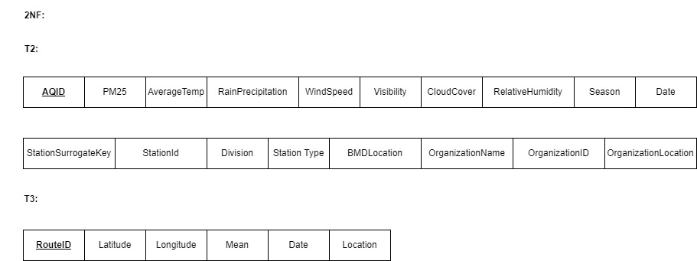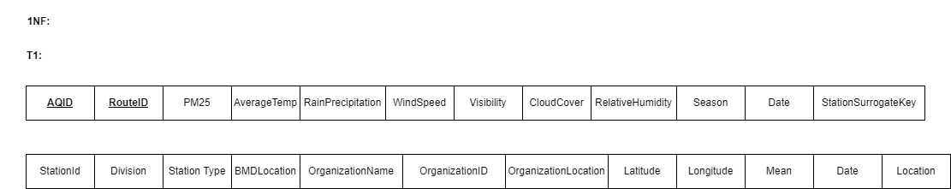

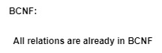

## DATA Dictionary

tblorganization:

|  |  |  |  |
| --- | --- | --- | --- |
| Name | Data Type | Size | Remark |
| cOrganizationName | VARCHAR | 50 | This is the primary key for the name of the organization. This can’t be null. |
| nOrganizationID | INTEGER |  | This is the ID of the organization. This cant be null. |
| cOrganizationLocation | VARCHAR | 25 | This is the location of the organization, eg, Khulna. |

tblstation:

|  |  |  |  |
| --- | --- | --- | --- |
| Name | Data Type | Size | Remark |
| nStationSurrogateKey | NUMBER |  | This is the primary key of station used to identify rainfall, sunrise etc. This can’t be null. |
| nStationID | INTEGER |  | This is the station ID, eg. 112.This cant be null. |
| cDivision | VARCHAR | 16 | This is the name of the division, eg, Khulna. |
| cStationType | CHAR | 1 | This indicates whether the Station is BMD or Organization Station. Eg, o or b |
| cBMDLocation | VARCHAR | 20 | This is the location of BMD, eg. Khulna |
| cOrganizationName | VARCHAR | 50 | This is the name of the organization. It’s a foreign key from the Organization table. |

tblstationairquality:

|  |  |  |  |
| --- | --- | --- | --- |
| Name | Data Type | Size | Remark |
| nAQID | INTEGER |  | This is the primary key used for reporting daily air quality. This cant be null. |
| nPM25 | DOUBLE |  | Fine particulate matter (PM2.5) is an air pollutant that is a concern for people's health when levels in air are high. PM2.5 are tiny particles in the air that reduce visibility and cause the air to appear hazy when levels are elevated. This cant be null. |
| nAverage Temp | DOUBLE |  | This will show the temperature, eg, 39º C. This can’t be null. |
| nRain Precipitation | DOUBLE |  | This will show the probability of rainfall. This cant be null. |
| nWindspeed | DOUBLE |  | Windspeed helps indicate a change in weather patterns, such as an approaching storm. This cant be null. |
| nVisibility | DOUBLE |  | Visibility is a practical index for air quality, as most people directly judge air pollution according to visibility. This cant be null. |
| nCloudCover | DOUBLE |  | Cloud cover refers to the fraction of the sky obscured by clouds on average when observed from a particular location. This cant be null. |
| nRelativeHumidity | DOUBLE |  | This shows how much humidity there is. |
| cSeason | VARCHAR | 6 | This will show the season. |
| dDate | DateTime | “dd/mm/yy” | This will show the date. |
| nStationSurrogateKey | NUMBER |  | This is the foreign key of station used to identify rainfall for the Air quality Station table. This can’t be null. |

tblroutewisedata:

|  |  |  |  |
| --- | --- | --- | --- |
| Name | Data Type | Size | Remark |
| nRouteID | INTEGER |  | This is the primary key for routing the weather stations. This cant be null. |
| nLatitute | DOUBLE |  | It is the measurement of distance north or south of the Equator. |
| nLongitude | DOUBLE |  | Coordinate that specifies the east–west position of a point on the surface of the Earth. |
| nMean | DOUBLE |  | This shows the average distance of the location from the North and the South Pole. |
| cDate | DateTime | “”dd/mm/yyyy” | This will show all the Date of the data. |
| cLocation | VARCHAR | 25 | This is the location, eg , Khulna. |