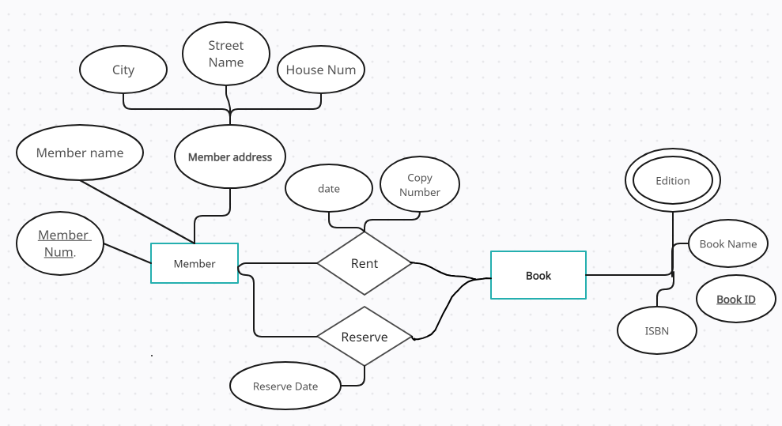 Case Study 1 ( Slide 7)

1…*

1…*

Belongs



**\***

**\***

1

**\***

Category

Author

written

