1/ select * from emp;

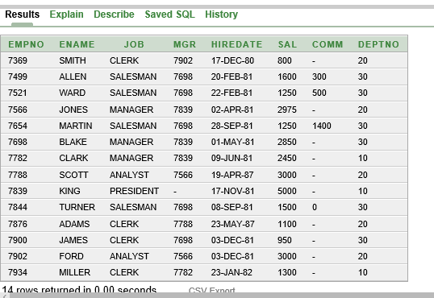

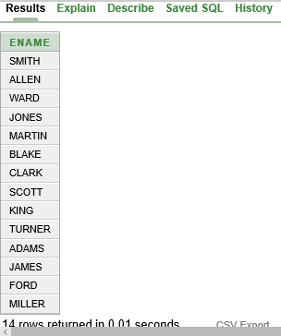2/ Select ename from emp;

3/ Select distinct deptno from emp;

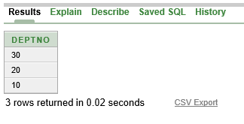

4/

Select empno, ename from emp;

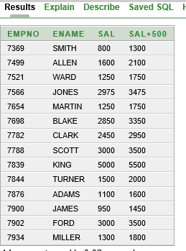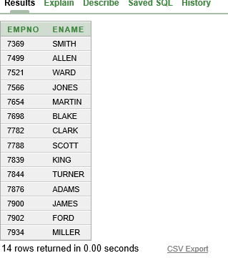

5/

Select empno, ename,sal,sal+500 from emp;

6/Select empno, ename,sal,12*sal+500 from emp;

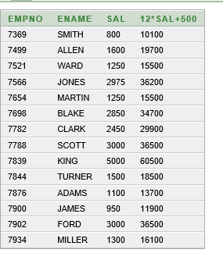

7/Select empno, ename,sal,12*(sal+500) from emp;

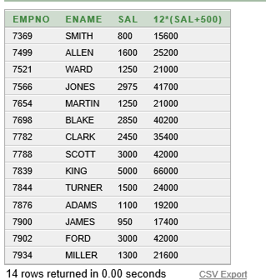

8/Select empno, ename,comm from emp;

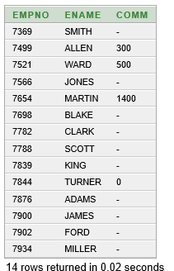

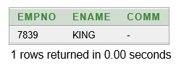9/Select empno, ename,comm

from emp

where ename='KING';

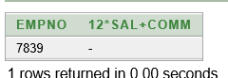10/Select empno, 12*sal+comm

from emp

where ename='KING';

11/SELECT ename AS name, sal salary

FROM emp;

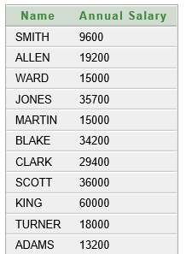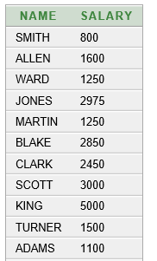

12/SELECT ename "Name",sal*12 "Annual Salary"

FROM emp;

13/

SELECT ename||job AS "Employees"

FROM emp;

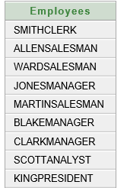

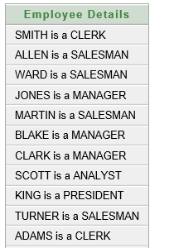14/SELECT ename ||' '||'is a'||' '||job

AS "Employee Details"

FROM emp;

15/

DESCRIBE dept;

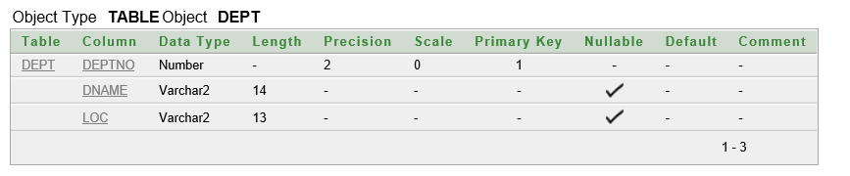

LAB Manual:

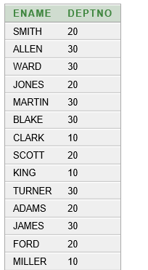1/select ename , deptno

from emp;

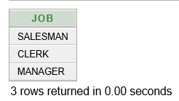2/select distinct job

from emp

where deptno = 30;

3/select loc

from dept

where deptno = 30;

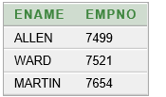4/select ename, empno

from emp

where comm>0;

5/ select ename,deptno

from emp

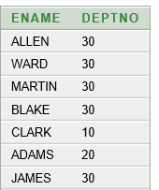where ename like 'A%' or ename like '_A%' or ename like '__A%';