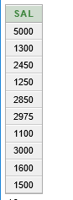1/select distinct sal

from emp

where sal>1000;

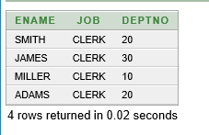2/select ename,job,deptno

from emp

where job='CLERK';

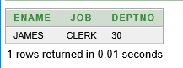3/select ename,job,deptno

from emp

where ename ='JAMES';

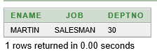4/select ename,job,deptno

from emp

where sal<= comm;

5/select ename,sal

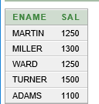from emp

where sal between 1000 and 1500;

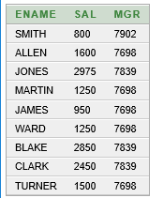6/select ename,sal,mgr

from emp

where mgr in(7902,7698,7839);

7/select ename

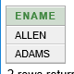from emp

where ename like 'A%';

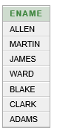8/select ename

from emp

where ename like '%A%';

9/select ename

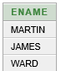from emp

where ename like '_A%';

10/select ename,mgr

from emp

where mgr is null;

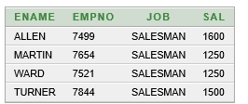11/select ename,empno,job,sal

from emp

where sal >= 1100

and job='SALESMAN';

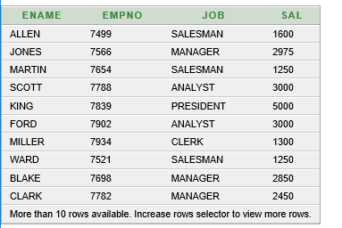12/select ename,empno,job,sal

from emp

where sal >= 1100

or job='SALESMAN';

13/select ename,job

from emp

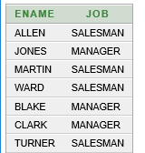where job NOT in ('ANALYST','PRESIDENT','CLERK');

14/SELECT ename, job, sal

FROM emp

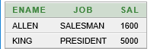WHERE (job='SALESMAN'OR job='PRESIDENT')

AND sal>1500;

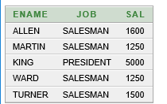15/ SELECT ename, job, sal

FROM emp

WHERE job='SALESMAN'OR job='PRESIDENT'

AND sal>1500;

16/ SELECT ename, job,deptno, HIREDATE

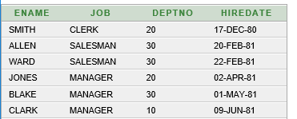 FROM emp

order by HIREDATE;

17/SELECT ename, job,deptno, HIREDATE

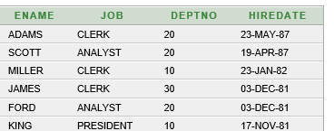 FROM emp

order by HIREDATE DESC;

18/SELECT ename, job, empno, sal * 12 as annsal

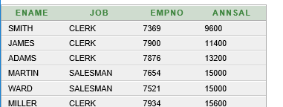 FROM emp

order by annsal;

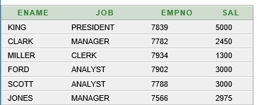19/SELECT ename, job, empno, sal

FROM emp

order by deptno, sal DESC;

20/SELECT empno,ename,deptno

FROM emp

where lower(ename) = 'blake';

21/SELECT empno,CONCAT(ename, job), LENGTH(ename),

INSTR(ename,'A')

FROM emp

where SUBSTR(job,1,5)= 'SALES';

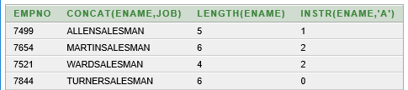

22/

23/

24/SELECT ENAME,SAL, comm, MOD(sal,comm)

FROM emp

where job = 'SALESMAN';

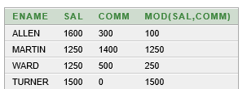

25/SELECT ename,

TO_CHAR(hiredate, 'fmDD Month YYYY') HIREDATE

FROM emp;

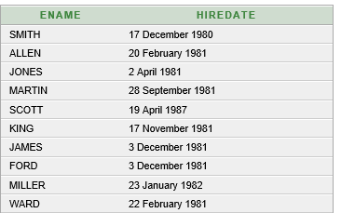

26/SELECT TO_CHAR(sal,'$99,999') SALARY

 FROM emp

WHERE ename = 'SCOTT';

27/SELECT ename, sal, comm, (sal*12)+NVL(comm,0)

FROM emp;

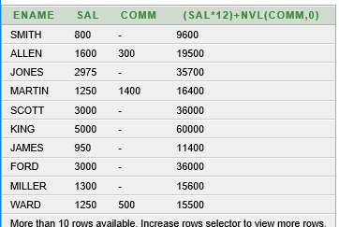

28/SELECT job, sal,

DECODE(job, 'ANALYST', SAL*1.1,

'CLERK', SAL*1.15,

'MANAGER', SAL*1.20, SAL)

REVISED_SALARY

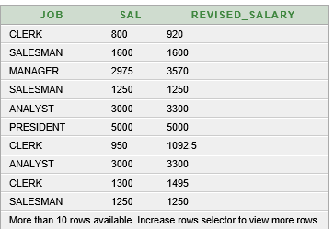 FROM emp;

29/SELECT AVG(sal), MAX(sal),

MIN(sal), SUM(sal)

FROM emp

WHERE job LIKE 'SALES%';



30/SELECT MIN(hiredate), MAX(hiredate)

FROM emp;



31/SELECT COUNT(*)

 FROM emp

WHERE deptno = 30;

32/SELECT COUNT(comm)

 FROM emp

WHERE deptno = 30;

33/SELECT AVG(comm)

FROM emp;

34/SELECT AVG(NVL(comm,0))

FROM emp;

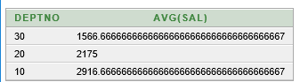35/SELECT deptno, AVG(sal)

FROM emp

GROUP BY deptno;

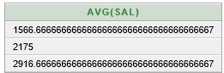36/ SELECT AVG(sal)

FROM emp

GROUP BY deptno;

37/