Procedure for Backup
Table of Contents
1. Purpose 3
2. Scope 3
3. Definitions and Acronyms 3
4. Procedure 3
5. Table of directory Structure 3
6. Table of backup period 3
7. Related Forms 3

- Purpose

This procedure defines how to backup all Projects, Databases and Emails of DigitalSpinners.
- Scope

This procedure applies to all Application Servers, Web Servers, Database Servers and Email Servers of DigitalSpinners. The procedure confirms that all necessary data has backup on two places for web development and two places for application development initially and moved to CD’s or DVD’s finally. For Instance the backup role of thumb is to have a daily backup on the backup hard disk, then after one week the backup will copy to two external hard disks then the backup is taken on optical medium after a month. The backup media is placed to forth place other then the DigitalSpinners premises so that data can be revived on any emergency or need.
- Definitions and Acronyms
1 | DVD-RW, CD-RW | It is a write able compact disk, which can be re written many times.
2 | Working Directories | Application Server: These are the folders, by Projects names, with date identification located on each person’s computer normally in D Drives under Working Folder with user name. All users must work in these folders. These are the directories / folders from which backup is taken of one’s work to backup server. E.g. D:\Working\Employee Name[not required for team project]\Project Name\Date  Web Server: These are folders under wwwroot folder of web Server with project name. All users must work in these folders. These are the folders from which backup is taken of one’s work to backup server. This is the directory from which daily backup of project is taken
3 | Project  Backup  Directory | This is the folder on Backup Server by Project Name. This is the directory where latest copy of project will be stored and from where backup of projects will be written to CD (CD-RW)
4 | ~ | Running Projects
4 | -- | Pending Projects
4 | X | Completed Projects
- Procedure
  - Media of Backup
Backup is taken on Servers, re-writable CD (CD-RW) or re-writable DVD (DVD-RW / DVD+RW).
  - Backup Procedure
    - Application Server

All project members work in their working directory. At the end of the week all project members add their work in the project on server.

Weekly backup of running projects changed till last backup is taken from the working directory to the project backup directory by project members at the end of week. Project Manager will ensure that all backups is placed on Project Backup Directory.
Workstation (D:/Working/Azeem/P1/P101-12-2005) -> Server (E:/Projects Backup/_Application/~/P1.

At the end of the week the network administrator takes backups on two hard disks of all the work done. Then these backups are transfer to CD/DVD(s).
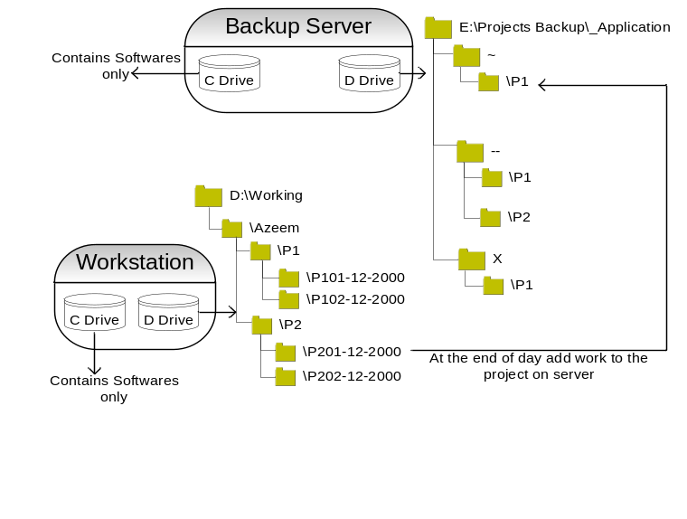
    - Web Server

Weekly backup of project changed till last backup is taken from the server Project directory to the intermediate project Backup directory by project manager. D:/wwwroot/ E:/Date_wise_backup_of_web_projects/ P1/P1_20122005
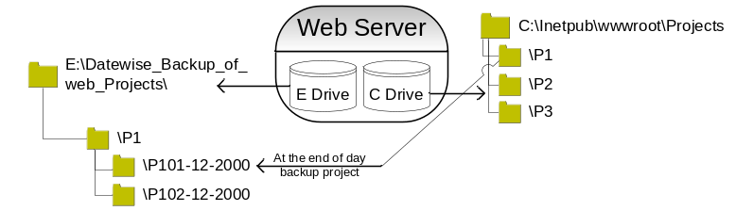

Backup of projects from the working directory to the project backup directory taken by project managers before backup on CD/DVD. Project Manager will ensure that all backups is placed on Project Backup Directory.

The Network Administrator takes backups of all the work done once in months at the end of month. These backups are taken from the server project backup directories to CD/DVD (s).
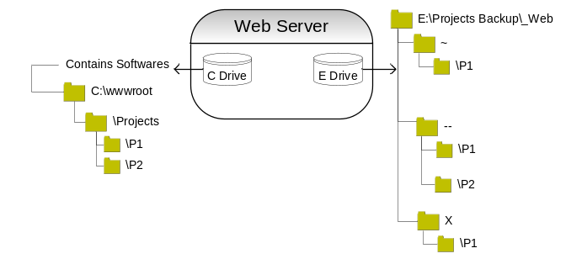
    - Database Servers

The Network Administrator takes backups of all the databases to CD/DVD (s) once in months at the end of month.
    - Email Server

The Network Administrator takes backups of all the emails to CD/DVD (s) once in months at the end of month.

Network Administrator will ensure that all CD/DVD (s) used for DigitalSpinners computerized data backup are labeled with “CD/DVD no Month no Year”. E.g. 010808 means DVD no 01 month 08 (Aug) and year is 2008.

After taking computerized data backup the information is recorded on the following forms.

Computerized Data Backup Form (Server Backup Directory to CD/DVD(s)) NET/4/7/1.00.
- Table of directory Structure

 | Programmer Working Directory | Server Backup Directory
Application Development | D:\Working\EN\PN\PN with date. | H:/Backup/Month/WeekNo/ProjectsBackup/_Application/Proj name.
Web Development | D:\wwwroot\PN On Server | (H:/Backup/Month/WeekNo/ProjectsBackup/_Web/Proj name.

- Table of backup period

 | Programmer Working → Server Backup  Directory Directory | Server → DVD  Backup RW
Application Server | Once in a week | Once in a month (all previous backups of month)
Web Server | Once in a week | Once in a month (all previous backups of month)

- Related Forms

Backup Log Sheet [ADM/4/23/2.00]

