Topic Introduction

The purpose of this topic is to provide learners with some best practices around how to make the most of the Accenture Delivery Methods. This topic also explains differences between how managers, developers, and designers use ADM.

Scenario Background

This section introduces a scenario-based story, starting with the Plan stage.

* During the remainder of this course, you’ll be playing the various roles of Project Manager, Developer, and Designer.
* When determining project scope, the Project Manager starts with the Plan stage, as it is the first activity to initiate the project.
* As we progress through these ADM demonstrations, emphasis is placed on the double perspective of the situation – Project Manager as a planner and as a practitioner.
* This case study demonstrates and simulates the work that needs to be done to accomplish a custom software development project. (This project only involves a Level A Object-Oriented technology software package.)
* The goal of the project is to deliver a single release. The project will cover all ADM stages from Plan to Deploy. (For the purpose of this course, we will emphasize the Analyze-Design-Build-Test stages in particular.)
* The overall project approach is to have several teams split the work over the various stages.
* The Project Manager is experienced and wants to encourage the team to use ADM to the fullest extent possible.
* The team members, from Assistant Manager to Designers and Developers, all have work experience, but this is the first time that they are working with ADM.

At a very early stage in the project, the Project Manager identifies the resources needed for the project. He realizes the team’s lack of experience in using ADM, so he calls for a meeting with the Account Manager and the Team Lead. The purpose of the meeting is to give an overview on the key features of ADM and to provide them with the way to leverage ADM for themselves and their team members. This demonstration helps communicate how it starts by communicating the results of the Plan stage.

Click on the Show Me to watch a guided demonstration.

Making the Most of ADM

ADM can make your job easier, regardless of whether you are involved in planning or implementing work. Understanding the best way to leverage the Methods in each situation enables you to improve the quality, efficiency, and repeatability of your work.

Given different situations, it’s critical to understand how to leverage ADM in the various roles that you may play (e.g., Manager vs. Designer vs. Developer) and:

* Know how to quickly get useful information for your activity or task.
* Understand what information is addressed and to whom.
* Understand how to move from your project’s Plan activities to execution.
* Be able to locate important information at the task and step levels, as those levels of detail will help you to complete your work more efficiently.
* Identify which skills are required for which roles.
* Access and familiarize yourself with key considerations.
* Leverage job aids and templates to accelerate the learning curve (as a new practitioner).
* Confirm completion and repeatability of the approach to fulfill task and quality objectives.

From an activities' perspective, be able to quickly identify the key issues to be considered for planning, managing, staffing, and successfully completing the activity.

Know How to Read Information - Planner vs. Practitioner

A project involves strong and complex interactions among multiple teams, releases, processes, and technology. To address this complexity, ADM is designed to support personnel with differing information needs.

ADM is geared to two key types of users: planners and practitioners. These broad classifications provide a basic guideline for determining which information is most applicable to different types of personnel, based on the type of work for which they are responsible.

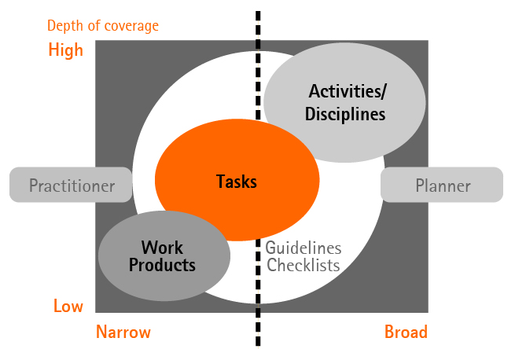

Planners and Practitioners: Role Differences

* The distinction between a practitioner and a planner exists in terms of roles or frames of reference rather than actual personnel.
* In reality, an individual may plan work and do work as appropriate, and hence can be considered both a planner and a practitioner.

ADM uses the concept of a practitioner to identify the methodology information required to execute the Method's processes and to complete the required work products to the desired level of quality.

Planner Use of Methodology

Individuals responsible for structuring, estimating, and managing work on a unit, program or project, or leading a sales effort represent the planner role. A planner's activities occur whenever there is a need to evaluate a potential course of action, create a work plan, or manage a team. Information at the activity level is organized specifically to meet the needs of planners.

This table looks from a planner's perspective at what information is available for each activity and how to best use ADM activities, or Disciplines.

|  |  |  |
| --- | --- | --- |
| Activity or Discipline Level | Purpose for Planner | How it helps the Planner |
| Work Product Flow View | Illustrate the relationships among the tasks of an activity. | The Work Product Flow View can help planners gain an understanding of the overall structure and scope of work within an activity. |
| Purpose | Describe the purpose and intended outcomes of the activity. | This section is used by planners for initial guidance regarding the relevance of the task to the work. This also includes a planning chart that can help planners gain an understanding of the overall structure and scope of work within an activity. |
| Deliverables/Work products | Are produced as a result of the work conducted in the activity. | Planners should review the deliverables listed in this section as they are planning the work to ensure that they understand the desired result of an activity. |
| Roles | Define the responsibilities of a team member. | This information is useful in staffing and balancing the workload of a project. |
| Relationships to Other Workstreams | Explains the dependencies of this activity or workstream on other activities, and in turn what other activities need from the activity. | This information is useful in solutions planning, technical architecture, deploy and Service introduction. |
| Staffing | This includes important considerations for staffing the project. | This information helps in planning resources per task. Planners can staff the requirements team with active, empowered members from the business community. |
| Key Considerations | These explain the dependencies between this activity and other activities or workstreams. These also include the key issues to consider for planning, managing, and successfully completing the activity. | Considerations are used to document key issues, practical advice, and intangible factors related to the activity. This section can be helpful when considering how to structure the work, or how to manage work in progress. |
| More information | Lists any checklists, guidelines and other resources that are related to the activity. | Such guidance materials orient the planner to the nature of the work conducted, when it can be considered complete, and how it is structured. |
| Team allocation | This section lists the roles associated with the activity and details each role’s level of participation with the work products and tasks. | With this section, the planner can quickly view what staff will be involved during this activity, so the planner can ensure resource availability and mobilization. |

Practitioner Use of Methodology

Practitioner is a collective term for the personnel responsible for performing the business capability by executing the processes within the methodology. There are many different types of practitioners, ranging from account team members, application designers, to unit leads to service management experts.

This table looks from a practitioner’s perspective at what information is important and how to best use ADM tasks.

|  |  |  |
| --- | --- | --- |
| Task Level | Purpose for Practitioner | How it helps Practitioner |
| Purpose | Within a task can help define the objectives and intended outcomes of the task. | Planning charts illustrate how work should be conducted, and also point out iteration conditions. The planning chart provides practitioners with a view of the entire scope of work that must be performed at the task level. |
| Input and Output | Information that is generated and captured during the execution of a methodology process. | Work product templates and examples can be used to structure the details of the work contained within a task. Understanding the structure of this information is critical to completing the work successfully. |
| Roles | Define the responsibilities of a team member. | This information is useful in understanding what expertise the practitioner needs to execute, assist, or review the work. |
| Steps | Provide an explanation of each step in a task's planning chart. | They provide the practitioner with additional detail for completing each step of the task. |
| More information section | This lists checklists, guidelines, and other resources that are relevant to the task. | Technique and guideline materials are particularly useful for practitioners, as they include specific detailed explanations of how to conduct the work. |
| Key considerations | Describes the key issues to consider for planning, managing, and successfully completing the task. | Understanding the planning considerations and the advice they contain is just as important for personnel executing the work as it is for those personnel planning the work. |

Checkpoint: Activities and Purposes

Click on the appropriate cell to assign the different activities and their purposes for planners and practitioners to the appropriate column. Click “Submit” when complete.

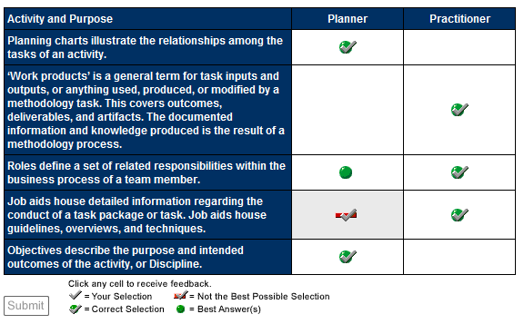

Topic Summary

The principal purpose of this topic was to explain the differences between how practitioners and planners use the activities, or Disciplines, and tasks within ADM. Efficient use of ADM will always have a positive impact on projects, so familiarity with the topic helps users of ADM.

In the next topic, we will provide a walkthrough of the process steps and work products associated with the Plan stage. You will also continue the scenario, which provides more hands-on opportunities to use ADM.v

Topic Introduction

The purpose of this topic is to provide an overview and hands-on walkthrough of the process steps and work products associated with the Plan stage.

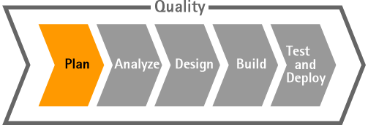

Testimonial: Benefits of ADM in the Plan Stage

This testimonial presents some of the benefits derived from using ADM during the Plan stage of a client project, and provides an example of the positive impact that ADM made on a client.

Scenario Update: Plan Stage

Your Project Manager has already described to you and your team about the different ways to use ADM based on your responsibility. Now your Project Manager wants to show you how to leverage ADM as a Planner or as a Practitioner (or Doer) in the Plan stage.

Overview of Plan Stage from a Planner Perspective

This demonstration focuses on the major items the Project Manager needs to know about the Plan stage. The Project Manager will read through the following sections:

* The work planning schematic helps to understand in one look all tasks to be performed within the discipline/activity.
* The Main Description section helps in understanding the overall goals of the Plan stage. It also discusses and lists key inputs and key outputs.
* The Work Product Flow View links you to a view of all key ADM for Custom Development work products. You can use this view to see how the Plan stage work products fit into the overall flow of work products.
* Key Considerations gives key integration / relationship points to other workstreams, and provides key considerations for planning, staffing, and managing the Plan stage.
* More Information can be obtained from Checklists, Guidelines, and Supporting Materials.

Click on the Show Me below to watch a guided demonstration.

Reminder: At the time this course was developed, the Show Me and Try Me demonstrations were created using ADM version 5.1. ADM has since gone through maintenance updates. Some of the graphics and navigation may be slightly different from the current version of ADM.

Overview of Plan Stage from a Practitioner Perspective

In this demonstration we will read through the 1100 Plan Discipline from a Practitioner, or Doer’s perspective. Reading from this perspective helps identify how to get the work done.

The key purpose of the Plan stage is to:

* Review project scope and understand high-level requirements.
* Review and confirm the current capabilities of the organization in terms of business processes, applications, technology, and change enablement.
* Review and update the solution blueprint, a high-level design, or blueprint, for each area of the solution.
* Review and refine various implementation options. Search for and select Accenture assets and external products that best meet the functional requirements.
* Review and refine the strategies for developing, testing, piloting, and deploying the solution.

Click on the Show Me below to watch a guided demonstration.

Schematic

The work planning schematic describes an activity as a set of tasks. Each task lists the deliverables or work products that should be ready when the particular task gets completed.

Click on the Show Me below to watch a guided demonstration.

Key Outputs Section

The Work Product Flow View lists all key deliverables or work products involved across the lifecycle of ADM for Custom Development. This view takes a high-level look at this Method’s key work products and their lifecycles, and the relationships among the work products.

To get a view of an activity’s specific work products, you can view the Key Inputs and Key Outputs for the activity.

You can also see how these specific inputs and outputs fit within the larger cross-stage view.

Click on the Show Me below to watch a guided demonstration.

Specific Information about Specific Roles

While each work product will be assigned to the appropriate responsible role, it’s easy to get more details about different roles and necessary skills. They are clearly described within the Roles section.

Click on the Show Me below to watch a guided demonstration.

Application Designer Role: Required Skills

As illustrated in the previous demonstration, you can read about a role’s particular skills and responsibilities using the Methods.

Let’s look more closely at the Application Designer role. The Application Designer role can be defined by the list of skills required to be able to complete assigned tasks.

The key responsibilities of Application Designers are to:

* Assist in defining and reviewing requirements and use cases for the application.
* Use the business process requirements to drive out application requirements and metrics.
* Design the application to meet the business process design and application requirements.
* Validate the design with the stakeholders to ensure that the design satisfies the requirements.
* Supervise other designers or developers in completing designs.
* Inform the technical architect and project manager of any issues that may affect other areas of the project.
* Participate in quality management reviews, as outlined in Verification and Validation Overview, ensuring the application design and related work products satisfy the requirements.
* Participate in transitioning the designs to the developers, and ensure a clear and complete understanding of the designs.
* Ensure that other team members, such as the human performance architect, the integration solution designer, and the service introduction lead, have the information they need to successfully complete their work.
* Complete all appropriate documentation required by the developers, testers, deployment team, and application management team that will maintain the application.
* Design the application user interfaces, classes, and components.

On the Application Designer role page in the Methods, the upper graphic illustrates the key tasks (Performs) and work products (Responsible for). For a listing of additional tasks and work products, see the Additional Relationships section.

Click on the Show Me below to watch a guided demonstration.

1121 Refine High-level Requirements: Process Steps

It is important to have a deep understanding of the “how to” for each task by understanding the specific steps for the task. Having a comprehensive, step-by-step approach for a task makes sure that all outcomes will be complete and consistent over all projects.

In this demonstration we’ll take a look at how an ADM user can review the tasks he or she is responsible for in his or her role. In this instance, we’ll look at the 1121 Refine High-level Requirements task, which is performed by the Business Architect.

Click on the Show Me below to watch a guided demonstration.

Scenario Update: Transition to Other Project Management Team

By completing tasks as defined within an activity process flow, the Project Manager provides an update to the team that they were able to achieve all tasks quickly and in a comprehensive way.

Therefore, leveraging ADM enables the use of a comprehensive approach for the Plan stage, supporting quality and leveraging Accenture experience. For instance, a New Joiner Manager at Accenture must be able to follow ADM to complete a project, following the same standard processes that our experienced Project Managers follow.

* Solution Planning happens during the Opportunity phase, with the intent to produce planning deliverables at the level sufficient for estimating and selling the work. It is typically done in a short timeframe during the proposal development period. If the solution planning deliverables are produced at the level sufficient for the team to proceed to the Analyze stage, then most Plan stage tasks can be condensed. Otherwise, the planning work started as part of the Solution Planning effort should be continued in the Delivery (Plan) phase.
* Depending on your project, you may transition to Plan execution, and this may be the role of the next Project Manager. Or, it may be your role, as your project moves to the next stage. Regardless of which project manager assumes responsibility, the Plan and Mobilize task guides the Project Manager in this next step.
* As the Project Manager did for the Plan Stage, so too the Project Manager for the next stage, Analyze, will leverage the activities / disciplines and tasks in ADM to perform their work.

The Project Manager, along with other leads, is responsible for developing, implementing, and maintaining the Project Plan, including the configuration management, risk management, project measurement, and quality management plans.

Topic Summary

You've just completed a walkthrough of the ADM Plan stage. To this point, we have examined:

* How ADM is organized overall and how you use it differently according to your Planner or Practitioner (Doer) role.
* How activity / discipline pages are organized in ADM.
* How to interpret and leverage ADM activity sections, such as:
  + Work planning schematic
  + Descriptions
  + Relationships with other workstreams
  + Key Planning, Staffing, and Managing considerations
* How to get more information about role definitions, skills required, job aids, and accessing work products, templates and/or samples

The next topic will continue the practical overview by working through the Analyze stage.

Topic Introduction

The purpose of this topic is to provide a practical overview and hands-on walkthrough of the process steps and work products associated with the Analyze stage.

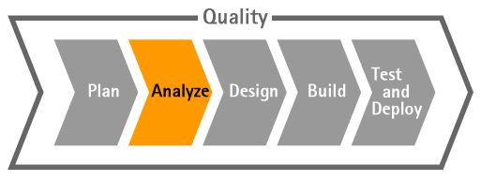

Testimonial: Benefits of ADM in the Analyze Stage

This testimonial presents some of the benefits derived from using ADM during the Analyze stage of a project, and provides a client example of challenges encountered when ADM was not followed.

The purpose for performing Analysis is to:

* Produce a requirements pack for the solution consisting of the application requirements, use cases, business rules, and other requirements-related deliverables.
* Define an inventory of work items that will be designed in the next stage from a clearly defined set of requirements.
* Ensure that requirements are complete, clear, and specific. Use the Requirements Development Guidelines for guidance.
* Analyze the product requirements and use cases to create a starting point or first iteration for the application design.
* Establish the approach, technique, and tools to enable and support the requirements traceability throughout the project lifecycle.
* Understand and document the technical architecture requirements.
* Translate the solution blueprint into a series of architectures.
* Identify the technical architecture components required to support the application requirements.
* Define application development guidelines and standards.
* Develop an understanding of the technical security needs and considerations.
* Validate the analysis with the stakeholders to make sure the analysis satisfies the requirements.

Obtain sign-off for requirements from business owners to manage scope.

Scenario Update: Analyze Stage

Our project scenario is based on delivering a new application to a customer. This application is designed to provide users with a new interface system, so that they can consult a centralized data system and generate specific reports. This reporting system is designed to answer different needs for different departments. Given the limited size of business supported by the client’s company, available packaged systems were not suitable. The customer could not afford to make the investment needed for a packaged system.

The Solution Architect, in consultation with the Project Manager, has to clearly define the Architecture required and then choose a Method accordingly (SAP, Oracle, Siebel, PeopleSoft, Packaged Development, etc.). Detailed process flows and specific technical work products are defined and available within the selected Method.

Notes:

* The Architecture (User Interface/Component/Data) is chosen for this training because it does not require any special technical background. In this training, we will cover only the Application workstream. Other workstreams, including Technical Architecture, Change Enablement, and Service Introduction are mentioned but not covered.

The main outcome of the Analyze stage for this scenario is an approved work plan for the project. The Project Manager involves each Associate Manager responsible for a project team, and they help with estimating the work and organizing the work plan per team per stage.

Business Analyst Activity: Flow Chart and Objectives

The Analyze Application Activity is led by the Associate Manager in charge of the Business Analyst Team.

The key responsibilities of a Business Analyst are to:

* Analyze and design the “to-be” business processes.
* Work with the Business Architect and other Planners to assess current capabilities and identify high-level customer requirements.
* Identify and define detailed product requirements and use cases.
* Set up and maintain the Requirements and Traceability deliverable.
* Work with the Project Manager, Architects, and other team members to define metrics and performance goals for the application.
* Participate in transitioning the requirements and use cases to the designers, and ensure a clear and complete understanding of the requirements.
* Assist in translating requirements and use cases into test conditions and expected results for product, performance, user acceptance, and operational acceptance testing.
* Participate in quality management reviews as outlined in the Verification and Validation Overview, in particular reviews of the designs, prototypes and other requirements work products to ensure they fulfill the requirements.
* Serve as a liaison to the business community. Participate in a user and task analysis to maintain the business community's perspective.
* Serve as a resource for the change enablement team as they evaluate training and performance support needs and design the training and performance support products.
* Understand that client team members often fill this role. This role includes the business process experts involved in defining the business processes and performing any business process re-engineering required before the application is designed from a technical perspective.

First, let’s look at the flow chart and the objectives to provide the main direction for this activity.

Click on the Show Me below to watch a guided demonstration.

https://mylearning-products.accenture.com/SEF_ADMv3/ADF_ADM/cImages/showme_button_n.gif

Reminder: At the time this course was developed, the Show Me and Try Me demonstrations were created using ADM version 5.1. ADM has since gone through maintenance updates. Some of the graphics and navigation may be slightly different from the current version of ADM.

Business Analyst Activity: Workstream Relationship

From a Planner’s perspective, this section is meant to increase your understanding of dependencies with other activities.

For instance, a Business Analyst can use the transition point of the Plan stage as a milestone before entering the Analyze Application stage. Using that transition point helps to make sure the project scope was clearly defined in the Plan stage and the appropriate ADM work products are included.

Click on the Show Me below to watch a guided demonstration.

https://mylearning-products.accenture.com/SEF_ADMv3/ADF_ADM/cImages/showme_button_n.gif

Business Analyst Activity: Other Considerations

There are several other considerations that need to be taken into account during this activity.

**Planning Considerations**

* Execute the application analysis tasks iteratively.
  + Logically, the business process design drives out the product requirements, which in turn drive out use cases. It is not always realistic to fully complete a task before starting the next task.
  + Iterative development can also go across activity boundaries. You do not have to complete all the analysis deliverables before starting the design deliverables.
* Prioritize the use cases to help plan and manage project iterations.
  + Plan and scope project iterations/releases around the prioritized list of use cases.
  + Plan use cases that represent essential and high-risk functionality into earlier iterations and those with nice-to-have features to be implemented in later iterations.

**Staffing Considerations**

* Staff the requirements team with active, empowered members from the business community.
  + Identify one lead person per business area, who:
    - Owns the requirements and is capable of signing off on the requirements and the analysis model.
    - Is an active participant who thoroughly understands high-level and product requirements, rather than someone who only provides a sign-off.
* Based on our project scenario, the application must be accessible by different departments, each of which will have a dedicated user interface and different reporting systems. Therefore each Business Analyst will be assigned to a specific department and a specific part of the application. They are responsible for getting a strong understanding of the business processes supported by the interface and getting sign off from stakeholders.

**Managing Considerations**

* Properly manage requirements and scope in distributed development projects.
  + Scope and requirements management is needed for all projects, but it is critically important in distributed development projects.
    - The increased possibility of miscommunication can create misunderstandings of project scope and requirements.
    - Ensure clearly defined communication procedures and scope control processes exist.
* Consider using an additional transition point to transition requirements and use cases.
  + If your project uses multiple teams in the Analyze stage, conduct additional transition points to transition the requirements and use cases from the Requirements team to the Analysis teams.

Click on the Show Me below to watch a guided demonstration.

https://mylearning-products.accenture.com/SEF_ADMv3/ADF_ADM/cImages/showme_button_n.gif

Business Analyst Activity: Inputs, Outcomes, and Players

The Key Outputs section lists documents that the Team Lead will need to review and use to ensure the team delivers within the planned schedule.

Work products are produced as a result of the work conducted in the activity. Planners should review the work products listed in the Key Output section (as they are planning the work) to ensure that they understand the desired result of an activity.

In ADM, the Roles section of a particular work product lists the primary role responsible for creating that work product. This information is useful in staffing and balancing the workload of a project, and it helps to understand the profile of the requested resource.

Click on the Show Me below to watch a guided demonstration.

https://mylearning-products.accenture.com/SEF_ADMv3/ADF_ADM/cImages/showme_button_n.gif

Scenario Reminder

Reminder: This project is based on ADM for Custom Development. Therefore, what we see here is an application for ADM for Custom Development. In the case that our project requires another technology, the Project Manager would need to identify a different Accenture Delivery Method, such as SAP, Oracle, Retek, etc.

If we do need to use a different Method, the stages remain the same; however, tasks and work products are adjusted according to technology specificities. The bottom line is that whatever the technology, the same approach is used with all Accenture Delivery Methods.

The next part of this topic illustrates how a Business Analyst will execute tasks and leverage the information available in ADM.

2115: Define Business Processes

We have learned how Associate Managers read Activities from the Planner perspective, and now we will go through several activity tasks and get the Practitioner’s perspective of the Analyze stage.

Let’s look at the 2115 Define Business Processes task. The flow chart illustrates the steps to be followed:

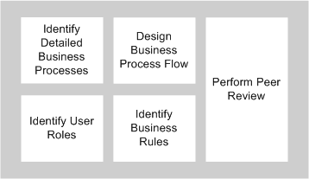

For this task, the Business Analyst will:

* Create the “to-be” business process design.
* The current business design may have been created during Solution Planning. If not, start by assessing the current business processes and understand the impact by the new system to the current organization, roles, and applications.
* Define how the new business processes interact with the business roles and applications.
* Define the business process flows and dependencies.
* Define the business rules applicable to the organization with which the system must comply.

The business process flow is a major outcome and it should be documented in BP310 Business Process Design.

Another key step for this task is performing peer review and any additional reviews by subject matter experts and stakeholders as according to the schedule and standards defined in MG132 Quality Management Plan.

Click on the Show Me below to watch a guided demonstration.

https://mylearning-products.accenture.com/SEF_ADMv3/ADF_ADM/cImages/showme_button_n.gif

2115: Work Products

The Outputs section lists the work products that are outcomes for this task. Each relevant work product (or outcome of the task) is listed in this section.

Click on the Show Me below to watch a guided demonstration.

https://mylearning-products.accenture.com/SEF_ADMv3/ADF_ADM/cImages/showme_button_n.gif

2115: Responsible Role

The responsible role for achieving the 2115 Define Business Process task is the Business Analyst. When assigning a task to a team member, it is important to ensure that the resource has the appropriate skills needed to complete that task.

Reminder: In this example, the person filling the Business Analyst role could also be the Designer. There will be project specific staffing needs, and the Associate Manager must be sure to get the skill sets required to fulfill both roles.

Click on the Show Me below to watch a guided demonstration.

https://mylearning-products.accenture.com/SEF_ADMv3/ADF_ADM/cImages/showme_button_n.gif

2115: Key Considerations

The Key Considerations section is intended to help all Practitioners initiate projects using our existing ADM best practices. This can be seen as advice coming from an experienced resource to someone less experienced. The Team Lead should emphasize this information to team members before starting each task, addressing key issues, practical advice, and intangible factors related to the activity.

2115: Job Aids/Guidelines

The More Information section provides Practitioners with references to best practice techniques, job aids, and guidelines, which contain detailed information related to specific tasks within the methodology. Technique and guideline job aids are particularly useful for Practitioners, as they include specific detailed explanations of how to conduct the work.

Scenario Next Steps

The Team Lead assigned work to the Business Analysts on the team to confirm the quality, completeness, consistency, and traceability of work products during this activity. The Team Lead is already developing a comprehensive approach for the work that still needs to be completed, and is therefore already looking ahead to the 2191 Review Application Analysis Deliverables task.

2191: Review Application Analysis Deliverables

As indicated in the Scenario next steps on the preceding page, the next step is to Review Application Analysis Deliverables.

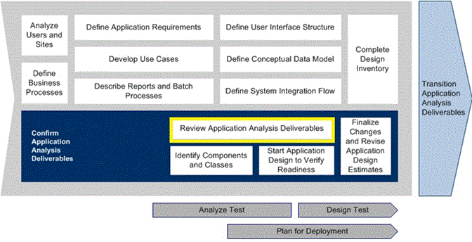

The purpose of this task is to:

* Confirm the completeness, consistency, and traceability of the analysis deliverables within the analysis team.
* Review the deliverables with the various stakeholder groups (e.g., sponsors, application users, design team, etc.) to balance the stakeholders’ needs and the project constraints and to obtain formal approval and sign-off.

Click on the Show Me below to watch a guided demonstration.

https://mylearning-products.accenture.com/SEF_ADMv3/ADF_ADM/cImages/showme_button_n.gif

Analyze Try Me

Click on the Try Me below to work through a hands-on simulation.

https://mylearning-products.accenture.com/SEF_ADMv3/ADF_ADM/cImages/Tryme_button_n.gif

Topic Summary

You’ve just completed a working walkthrough of the Analyze stage, continuing your trip through the step-by-step guided tours of the specific activities required. We have examined:

* Activity/discipline pages.
* Detailed tasks.
* How to read through ADM pages and access information for activities/disciplines, tasks, and work products.
* How to apply (from a Planner's role) Planning, Staffing, and Managing Considerations within the Analyze activity.
* How to get more information about role definitions, skills required, job aids, and templates or samples.
* From a task level, how to consider and put in practice process steps, key considerations, and job aids.

The next topic will continue the practical overview by working through the Design stage.

Topic Introduction

The purpose of this topic is to provide an overview and hands-on walkthrough of the process steps and work products associated with the Design stage.

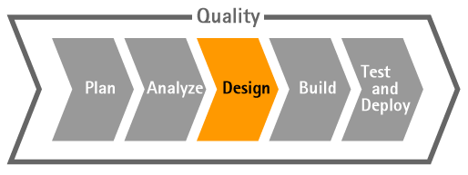

Testimonial: Benefits of ADM in the Design Stage

This testimonial presents some of the benefits derived from using ADM during the Design stage of a client project, and explains that using the templates and samples in conjunction with ADS Tools and Architectures improves the quality of application designs and the speed of delivery.

Scenario Note: Design Stage

Note: As we enter the Design stage, the content of this section should particularly interest Designers.

Resuming our storyline, at this step in the process the Analyze Team has successfully performed their tasks, and all deliverables defined in 2100 Analyze Application have been reviewed, signed off by stakeholders, and baselined. Also, all changes in requirements due to the analysis have been handled according to our project change control process.

Our impact analysis suggests approval (given the fact that impact was minor and all changes have been approved), and project planning was adjusted accordingly. In our case, the changes only impacted user interface requirements, and did not have an impact in terms of development time (which means no extra work at this stage of the project). Finally, all deliverables that have been created are up-to-date regarding the very latest requirements.

Therefore the Analyze Team has transferred all deliverables to the Design Team according to T2199 Transition Application Analysis Deliverables transition point. (Note: More information about this transition point will be provided later within the course.)

3100: Design Application

As a first step for every project reaching this stage, the Designer/Team Lead must consider the activities he or she will supervise. The Team Lead may look at the following points:

* Description of design phase activities
* List of tasks to perform in the design phase
* Deliverables to be produced
* Roles that will perform the work to complete the tasks
* Additional support material for completing the tasks

This information will help the Team Lead to organize and assign tasks to the Design Team.

Click on the Show Me below to watch a guided demonstration.

https://mylearning-products.accenture.com/SEF_ADMv3/ADF_ADM/cImages/showme_button_n.gif

Reminder: At the time this course was developed, the Show Me and Try Me demonstrations were created using ADM version 5.1. ADM has since gone through maintenance updates. Some of the graphics and navigation may be slightly different from the current version of ADM.

3100: Key Considerations

The following are key considerations outlining how the Design Application Activity relates to the other workstreams:

* **Technical Architecture:** Work closely with the Technical Architecture Team to gain a good understanding of the capabilities, as well as the constraints, of the development and technical architecture.
* **Deploy:** Involve the Deployment Team in the review of the design to ensure that deployment-related concerns, such as infrastructure constraints, distributed locations, etc., are properly addressed.
* **Service Introduction:** Involve the Service Introduction Lead in the review of the design to ensure that operation-related concerns, such as quality of service, stability, maintainability, etc., are properly addressed.

Click on the Show Me below to watch a guided demonstration.

https://mylearning-products.accenture.com/SEF_ADMv3/ADF_ADM/cImages/showme_button_n.gif

3100: Staffing Considerations Activity Team Q&A

Your Team Lead has called a meeting to make sure that your team understands the progress of the project, and how best to use ADM in the Design stage. Roll your mouse over the team members that are tagged with question marks to participate in the Q&A.

3100: Guidelines and Checklists

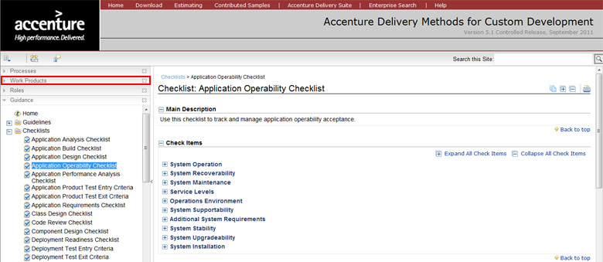

There are guidelines and checklists available for your use, and these assets can help to:

* Verify the consistency and completeness of the application design deliverables at the end of the Design Application activity.
* Track and manage application operability acceptance.

These are just a few of the assets available to help you:

* Application Design Checklist
* Application Operability Checklist

Team Leads have support material available in the Guidance section of the left navigation panel. This material helps you complete your work according to standard guidelines and checklists to monitor the completeness of your work.

Focus on One Task

Let's focus on one task in the Design stage, task 3143 Refine User Interface Standards.

As you walk through the task, it is important to get a clear understanding of the purpose of the task. The purpose is displayed directly underneath the schematic diagram of the task. The purpose of task 3143 is to:

* Review the interface standards passed from the Technical Architecture Team.
* Document user interface design decisions.
* Provide guidelines for future application development.

It is critical to take the time to read through Process steps before starting any task. ADM provides you with an explanation of each step in a task. Steps provide Practitioners with additional details for completing the task. For task 3143 the detailed steps include:

* Gather Existing Standards
* Define Global Standards
* Create Wireframes
* Conduct Usability Evaluation
* Define Page-level Standards
* Prototype User Interface
* Perform Peer Review

Obtain Stakeholder Agreement

PM294 Peer Review Feedback Form

The Peer Review Feedback Form is a simple but important tool for quality control throughout the project.

Click on the Show Me below to watch a guided demonstration.

https://mylearning-products.accenture.com/SEF_ADMv3/ADF_ADM/cImages/showme_button_n.gif

Topic Summary

In this topic we have examined:

* The additional guidance and support materials available to the Design Team.
* The importance of peer reviews in the Design stage.
* The importance of blending skill and experience to ensure the design accounts for more than the basic functional requirements.

The next topic will continue the practical overview by working through the Build stage

Topic Introduction

The purpose of this topic is to provide a practical overview and hands-on walkthrough of the process steps and deliverables associated with the Build stage.

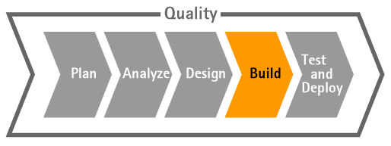

Testimonial: Benefits of ADM in the Build Stage

This testimonial presents some of the benefits derived from using ADM during the Build stage of a client project, specifically the value added by ADM's configuration process.

Scenario Note: Build Stage

At this stage, the Design Team has executed all tasks as described in the 3100 Design Application Activity. The Team Lead:

* Ensured the completeness, consistency, and traceability of design deliverables.
* Reviewed all deliverables with stakeholders and got sign off.
* Baselined and placed the approved deliverables under configuration management according to the Configuration Management Plan, as appropriate.

Therefore, the next step is to transition the work to the Build Team and follow procedures as defined within T3199 Transition Application Design Deliverables task.

Note: The transition points will be addressed in further detail later in this course.

Best Practices in the Build Stage

Starting at the Build stage, the Team Lead needs to plan and arrange work for his/her team. However, based on previous experiences, ADM will help you understand your work’s relationship with others workstreams.

**Technical Architecture**

* It is important to get the Technical Team involved early to gain a good understanding of the capabilities, as well as the constraints, of the development and technical architectures.

**Deploy**

* Involve the Deployment Team in the review of the design to ensure that deployment-related concerns, such as infrastructure constraints, distributed locations, etc., are properly addressed.

**Service Introduction**

* Involve the Service Introduction Lead in the review of the design to ensure that operation-related concerns, such as quality of service, stability, maintainability, etc., are properly addressed.

In addition to understanding your work’s relationship with other workstreams/teams, there are some important considerations that will help to organize your team, including ensuring that technology and tool training exists for developers. The skills and experience of your team members will have a big impact on their learning curves for working with component technology. Therefore if your team lacks experience regarding tools and technology it is important for Team Lead and Project Manager to:

* Include time in the Build stage schedule for training resources, and ensure that the appropriate tools and training are available.

Estimate and consider the learning curve of the team on a new tool or technology component in your project schedule, including intermediate milestones. Also, it is important for the Team Lead to keep track of the team’s productivity improvement.

4100: Build Application

The 4100 Build Application Activity describes tasks and outcomes of the stage. However, it is important to understand that the ADM Build stage is very dependent on the technology in use. Therefore, using the right Method will provide you an appropriate and detailed approach relevant with the technology in use.

Click on the Show Me below to watch a guided demonstration.

https://mylearning-products.accenture.com/SEF_ADMv3/ADF_ADM/cImages/showme_button_n.gif

Reminder: At the time this course was developed, the Show Me and Try Me demonstrations were created using ADM version 5.1. ADM has since gone through maintenance updates. Some of the graphics and navigation may be slightly different from the current version of ADM.

Key Considerations

Rather than telling you what to do, the Key Considerations section simply provides you with some extra considerations about how to proceed with your work. These considerations are based on Accenture’s best practices and previous experiences. Reading through this considerations section helps you to strengthen your approach to what needs to be considered before and during task execution.

Click on the Show Me below to watch a guided demonstration.

https://mylearning-products.accenture.com/SEF_ADMv3/ADF_ADM/cImages/showme_button_n.gif

Perform Peer Review

Perform Peer Review is a critical step in the 4183 Create Unit Tests task. Peer review is the cornerstone of quality control in application development. As a reminder, it is commonly recognized in the software industry that each hour spent on peer review is saving 10 hours of rework

Click on the Show Me below to watch a guided demonstration.

https://mylearning-products.accenture.com/SEF_ADMv3/ADF_ADM/cImages/showme_button_n.gif

Scenario Update

The Build stage has been completed. All unit and component testing has been executed and all necessary corrections to the code have been reported and resolved accordingly. All reviews and tests have been performed successfully. The work products are signed off by all necessary stakeholders. The deliverables to be passed on to the Testing Team are baselined and ready for transition. We are now ready to move on and conduct the next phase: Test Application.

Build Stage Try Me

Click on the Try Me below to work through a hands-on simulation.

https://mylearning-products.accenture.com/SEF_ADMv3/ADF_ADM/cImages/Tryme_button_n.gif

Topic Summary

In this topic, you learned:

* How to leverage ADS Practices available through the Workstream relationship.
* The importance of thoroughly planning unit testing.
* The importance of Building and Testing application components.
* How to plan and perform peer review.
* How to access (at task level) detailed information, including job aids, checklists and guidelines.

The next topic will continue the practical walkthrough of the Test and Deploy stages of a project.

Topic Introduction

The purpose of this topic is to provide a practical overview and hands-on walkthrough of the process steps and deliverables associated with the Test and Deploy stages.

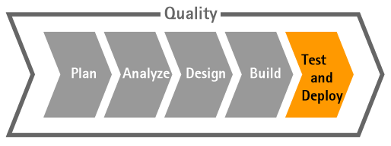

Testimonial: Benefits of ADM in the Test and Deploy Stages

This testimonial presents some of the benefits derived from using ADM during the Test stage of a client project, and how ADM's simple, standard and comprehensive processes for testing applications is one of the most powerful aspects of ADM.

Test Stage Introduction

First, let’s take a closer look at the Test stage.

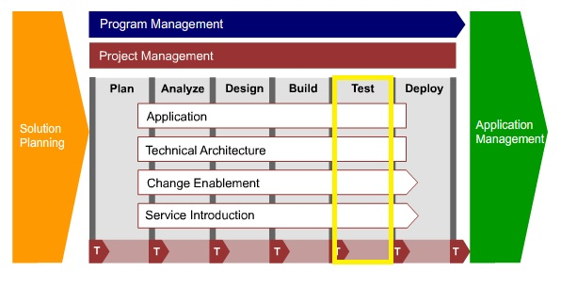

Testing Framework Overview

The Testing Framework Overview page provides a standard framework to help software development project teams plan and execute testing tasks.

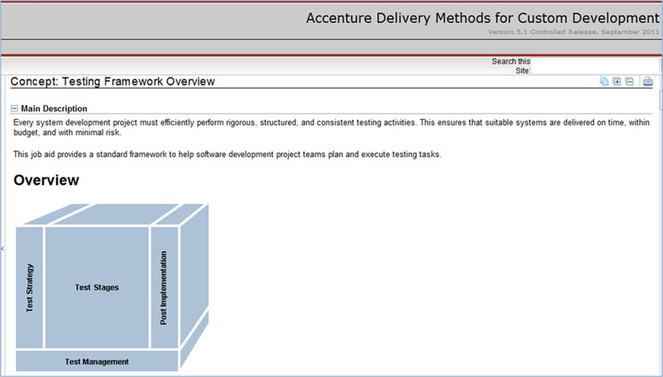

**Test Strategy**

The test strategy defines the major aspects of the test effort and outlines the coverage to key sponsors. This ensures that testing is considered from the outset of a project, reducing the risk of failure. The test strategy is captured in the PL178 Testing Strategy within the Solution Delivery Strategy composite created during Solution Planning. Use the testing strategy throughout the Analysis, Design, and Build stages as a starting point for creating the Test Approach documents for specific test stages.

**Test Stages**

* Testing a system is a complex undertaking. To manage the complexity, testing is divided into a number of standard stages, based on the V-Model concept.
* Standard test stages are organized into functional and technical testing:
  + Functional testing consists of unit test, assembly test, product test, and user acceptance test. Completing the functional test stages ensures that the final solution is tested end-to-end, proven to be stable, works as originally specified, and is satisfactory to the project sponsors.
  + Technical testing ensures the smooth transition of systems to production and complete the testing lifecycle. Technical testing is comprised of performance test, deployment test, and operational acceptance test.

**Test Tasks** Every standard test stage contains specific testing tasks. In brief:

* + Define approach
  + Plan the test
  + Prepare the test
  + Execute the test
  + Close the test

**Post Implementation**

You may need to complete a test post-implementation report (TPIR) to finalize all testing activity. A TPIR is similar to a Test Closure Memo, but it covers all major areas of the test effort (that is, all test stages), draws conclusions, and makes recommendations to suggest ways to improve testing methods and processes. The TPIR also performs a quantitative analysis of the test effort to aid future test project planning.

**Test Management**

To ensure that each area of the Testing Framework is effectively managed, apply the following structure to the test management process:

* Testing deliverables
* Testing review process

Testing metrics

5000: Test Application Stages

After the Build stage, the application that was developed will go through a series of tests. It is important to understand the purpose of each type of testing. To better understand the intent of each test, you may refer to the stage during which the test plan and test cases are written. For example, the test plan and test cases for a Product Test and/or an Acceptance Test are developed during the Analyze stage. That means those tests will be testing functionality, user interfaces, and integration with the external system - in short, the outcomes of the Analyze stage. The same mechanisms apply for Acceptance Testing, which will prove that the design has been properly implemented within the code.

**Stage Containment**

The process described above is illustrative of stage containment. The goal of stage containment is to identify problems in the system during development before they are passed to the next stage. This helps build quality into the system. Finding problems or errors in the stage they occur in is important because problems become more expensive and difficult to fix later in the project lifecycle.

**V-Model**

The V-Model, contained in ADM, explains in detail the connection of testing and Functional/Technical and Design Requirements. The V-Model will be discussed more later in this training.

**Identifying & Fixing Defects**

What is important to understand is that in ADM “testing” means checking that the “Right things are working right.” This is done by checking that all specifications:

* Have been properly implemented.
* Are performed by executing the code.

Finally, given that during testing, defects are likely to be found, it is critical that you follow predefined procedures and use the correct tools to keep records of the defects that are discovered. This process should create confidence for the project that any defects have been documented, fixed, and successfully tested.

Click on the Show Me below to watch a guided demonstration. This demonstration will:

* Emphasize the terminology and sequence of the various testing stages.
* Explain the purpose of each of the testing stages.

https://mylearning-products.accenture.com/SEF_ADMv3/ADF_ADM/cImages/showme_button_n.gif

Reminder: At the time this course was developed, the Show Me and Try Me demonstrations were created using ADM version 5.1. ADM has since gone through maintenance updates. Some of the graphics and navigation may be slightly different from the current version of ADM

Plan the Test

For each Analyze Test task – from application product testing through to operational acceptance testing – you perform several key steps repeatedly. In brief you will be:

* Refining the scope and strategy.
* Defining the test approach.
* Defining the product test cycles.
* Reviewing assets according to the schedule and standards defined in the Quality Management Plan.

It is also important to:

* Define the test environment requirements and set-up plans.
* Manage all testing.
* Periodically measure and report the test progress.
* Document this with test progress metrics and weekly progress reports (issues, actions, risks, change requests, etc., as appropriate).

For example, if we look more closely at the assembly test, we see that one of our main goals is to make sure that related application components function properly when assembled. The purpose of the 2730 Plan Assembly Test task is to:

* Review the testing scope and strategy from solution planning.
* Create the test approach for the application assembly test.
* Define the initial set of test cycles for assembly test.
* Conduct peer reviews. All stakeholders (e.g., application designers, technical designer, etc.) must sign off on the assembly test approaches.

Click on the Show Me below to watch a guided demonstration.

https://mylearning-products.accenture.com/SEF_ADMv3/ADF_ADM/cImages/showme_button_n.gif

On the next page, we’ll look a little closer at the Test Approach.

TE582 Test Approach

The first step in any test stage is to develop a test approach. The testing strategy, created in Solution Planning, defines the overall strategy for all test stages: unit test, assembly test, application product test, integration product test, performance test, etc. Use this testing strategy deliverable to create a more detailed test approach for a specific test stage.

A test approach addresses all major aspects of the Test stage that affect the success of testing. The template for the test approach includes the following sections:

* Test Overview
* Stage Containment/Test Model
* Testing Control
* And many others sections that you can explore leveraging ADM

Click on the Show Me below to watch a guided demonstration.

https://mylearning-products.accenture.com/SEF_ADMv3/ADF_ADM/cImages/showme_button_n.gif

TE583 Test Scenarios

After you have identified the test approach, the next step is to identify and document test scenarios.

Test scenarios are high-level descriptions of functional and technical areas to be tested. Scenarios can be further broken down into sub-scenarios as required, until detailed, testable conditions and expected results can be determined. As a result, each test scenario (or sub-scenario) is described by a number of associated test conditions. Together, a set of test conditions makes up a list of items to be used to fully test the associated test scenario.

Note that test conditions and expected results can be directly derived from requirements and use cases so you may not have to create the test scenarios. Even when the test scenarios are needed, they may not have to be created as separate deliverables. Document them as part of the test approach deliverable or as part of the test conditions and expected results deliverable.

Test scenarios are usually required only for performance, product, and user acceptance tests as they are inherently process and business requirements based, although they can sometimes be applied to complex assembly tests as well. You do not have to create test scenarios for unit/component test.

The next page provides more information on the TE584 Test Conditions and Expected Results Work Product.

TE584 Test Conditions and Expected Results

The TE584 Test Conditions and Expected Results work product defines the tests to be performed and should always match the development stages they relate to. In our Assembly Test, we intend to prove and test the design.

In addition to normal positive conditions, the test conditions address the following:

* Limit values: Values that are not within the normal range but are acceptable.
* Negative values: Unacceptable values.
* Exception values: Values that are not normal but can occur; they need special processing (e.g., receiving an empty file as the input).

Click on the Show Me below to watch a guided demonstration.

https://mylearning-products.accenture.com/SEF_ADMv3/ADF_ADM/cImages/showme_button_n.gif

TE585 Test Cycle Control Sheet

**Test Cycles**

Test cycles are logical groupings of test scenarios and conditions created to facilitate efficient test execution. A control sheet is an efficient and simple tool used to plan, monitor and follow up on testing execution.

Define a high-level set of test cycles based on the anticipated test scenarios from the application requirements and use cases. Application requirements include both functional and non-functional requirements. Test cycles that test the functional requirements are derived from the use cases. The non-functional requirements would cover such testing areas as performance, load, reliability, availability, recovery and security.

Let's turn again to our assembly test cycle. ADM groups assembly test conditions into two cycles:

* Normal conditions
* Error conditions

**Test Cycle Control Sheet (TCCS)**

The Test Cycle Control Sheet (TCCS) deliverable defines when, and by whom, test cycles are executed. Together, the TCCS and the associated test scripts form the part of the test plan to be used by the test execution team. The TCCS is used to manage the execution schedule, since this lists every cycle that is executed, along with the associated start and stop dates and resources. The test scripts are followed by the testers and used to document actual results.

For each test cycle, you will specify in the TCCS:

* Name and description of the cycle
* Business relevance
* Type of the cycle, such as online, batch, etc.
* Execution dependency; some cycles cannot be executed until some others are executed

Approximate time span needed to execute the cycle.

TE586 Test Scripts

A test script details the exact steps a tester follows when executing a test (i.e., to test all the conditions), usually covering a test scenario. Each step of a test script has an associated test condition that can be traced back to a requirement item to provide traceability. This traceability allows the Tester to record the actual against the expected test result and provide commentary where appropriate. Test scripts also include the data that is used for testing or the scripts can reference external data files to be used.

Test scripts are typically documented using a table/spreadsheet format. However, if a test management tool is in use (e.g., Requisite Pro or Rational Requirements Composer), test scripts are stored in the tool so that they can be automatically associated with test conditions. When appropriate, use templates to capture test conditions, scenarios, scripts, test cycle control sheets, etc., or create them directly within the test tools being used by the project.

The test script template, applicable for all types of testing, contains the following sections:

* Test Stage: The overarching test stage the script relates to (e.g., application product test).
* Test Script Name: The name of the test script typically associated to the test scenario being tested.
* Pre-Requisite Scripts: Details of other test scripts that must be completed prior to commencing this test script.
* Pre-Requisite Steps: Details of steps that must be completed prior to commencing this test script, including:
  + Action to be undertaken (e.g., Execute overnight reporting batch).
  + Expected result after undertaking the action (e.g., Overnight reporting batch has successfully completed).
* Script Execution: Details of the steps to be tested, including
  + Step Number.
  + Test Condition ID.
  + Action/Description: Description of what actions must be undertaken to satisfy the step (e.g., access the reporting menu screen).
  + Input Data: Details of input data required for the test step.
  + Expected Result: The expected outcome of the test (e.g., Reporting menu screen will be displayed to the user showing all active reports).
  + Actual Result: The actual outcome of the test (e.g., Reporting menu screen is displayed but not all active reports are available).
  + Pass/Fail: Indicator as to whether the test step passed (i.e., whether or not the expected result was achieved).
  + Comments: Commentary to support the outcome of the test step (e.g., provide additional details if the test step failed).

Requirement: Identifier for the associated requirement(s) to ensure traceability.

V-Model

The V-Model explains the importance of the differences between Validation, Verification, and Testing. Understanding these differences will help you to create a better test plan and focus on the right objective when executing validation, verification, and testing tasks.

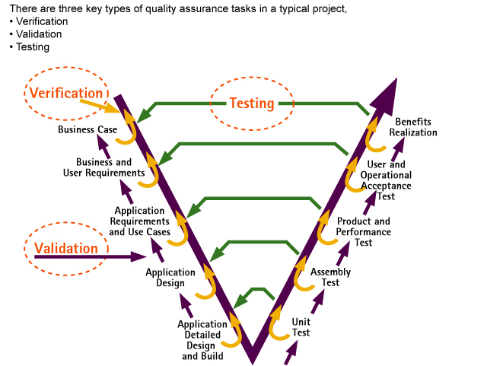

Acceptance Test: Definition and Purpose

The Acceptance Test verifies the assembly and combined operation of components (i.e., individual modules, interface modules, etc.) to ensure that the interactions between the components function correctly before building the overall solution.

The Acceptance Test progressively increases in complexity. First, it verifies the low-level functionality of several small sets of related components. Next, acceptance testing verifies the functionality of inter-related assemblies by assembling them into larger sets of related components until progressive acceptance testing verifies the low-level functionality across the system. Acceptance Tests do not test complex functionality of the final product– that is the role of the Product Test.

Tailor the Acceptance Test level to suit the custom software, packages, and enhancement projects. For example, the Acceptance Test for an Enterprise Resource Planning system (e.g., Oracle®, SAP, Baan, etc.) tests the assembly of large pre-built and customizable modules for effects on data flow and expected functionality due to configuration. The Acceptance Test for a custom Visual Basic® application would verify that small custom modules delivered the correct data flow and functionality together.

The boundaries between the Component Test and Acceptance Test may overlap. A single Test Team often manages both stages. If so, fully explain and document this in the testing strategy and the specific test approach documents.

Deploy Stage Introduction

Next, we’ll focus specifically on the Deploy stage.

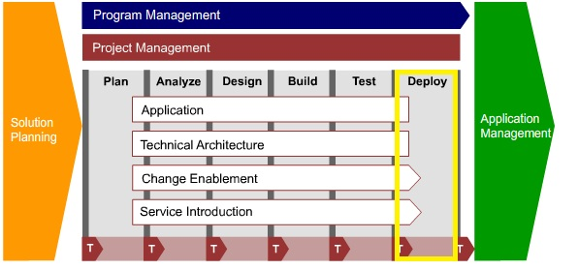

6100: Deploy Application

Once the project has passed through the Testing stage, the Deploy stage has to be worked through. If we look carefully, the process flows for the Build/Design/Test activities contain information about all tasks related to deployment. This means that deployment has to be prepared ahead of time and many tasks have to be completed even before the project passes the UAT Stage. This screenshot illustrates the 6100 Deploy Activity.

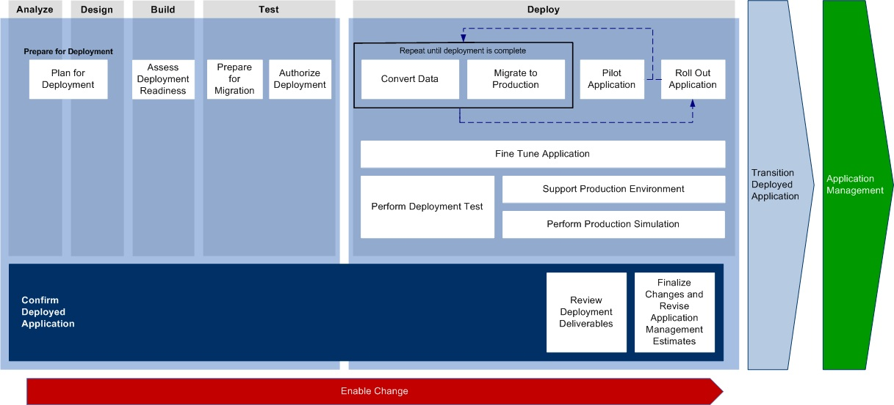

Let’s take a closer look at the objectives of the Deploy stage:

* Prepare the production and operating environments for application roll-out to the users and other application stakeholders.
* Enable users and other application stakeholders to use or support the new application.
* Roll out the new application to the deployment groups.
* Transfer the responsibility for operating and maintaining the application to the operating group.

It is important to understand the criticality of this stage, and the need to be prepared. The Deploy stage provides enough considerations and detailed task information to be followed closely to maximize deployment success.

Task 6188 Roll-Out Application

The purpose of the Roll-Out Application task within 6100 Deploy is to:

* Communicate dates and details about application roll-out to involved parties.
* Deploy application and attend user installation.
* Monitor delivery, deployment, and operation of application, and collect user feedback report.
* Analyze findings and feedback about deployment, and distribute results to the users.

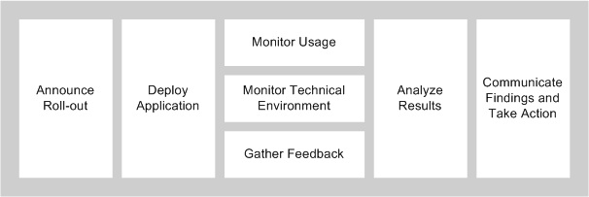

Scenario Update

At the 6100 Deploy stage, the project rolls out the application to the client environment on the appropriate production system.

After the application has been rolled out, the project should:

* Monitor the usage of the application by the users – evaluating the activities and identifying any issues that may arise.
* Monitor the development and performance of the application within the technical environment.
* Gather feedback on the application deployment from all parties involved in the process.
* Analyze the results of the feedback gathered and create action items as necessary.
* Communicate findings and take action.

At the end of the Deploy stage, the Project Manager should do the following:

* Identify the key artifacts that can be shared. This could include the estimation model, project plans, development strategy, Best Practices, checklists, work products, Metrics, etc.
* Review these artifacts for suitability.
* If the organization has a Process Improvement team or a Software Engineering Process Group (SEPG), submit the artifacts to this group.

If the project uses Accenture Delivery Metrics Repository, make sure the latest data is posted.

Test and Deploy Stages Try Me

Click on the Try Me below to work through a hands-on simulation.

https://mylearning-products.accenture.com/SEF_ADMv3/ADF_ADM/cImages/Tryme_button_n.gif

Topic Summary

In this topic, we have covered:

* The 5000 Test Application discipline grouping of ADM for Custom Development.
* Accenture’s Testing Framework.
* The different test streams and activities within those streams.
* The work products that are created to plan the test, including:
  + TE582 Test Approach
  + TE583 Test Scenarios
  + TE584 Test Conditions and Expected Results
  + TE585 Test Cycle Control Sheet
  + TE586 Test Scripts
* The V-Model.
* The Deploy stage and how to prepare the production and operating environments for application roll out.

The next topic will continue the practical overview by exploring several of the ways that ADM helps Accenture ensure quality in all of our products.

Topic Introduction

The purpose of this topic is to explain how ADM helps maintain quality. This methodology can make your job easier regardless of whether you are involved in selling, planning, or implementing work. Understanding the best way to leverage the methodology in each of these situations will enable you to improve the quality, efficiency, and repeatability of your work.

Specifically, we will examine:

* How does ADM ensure Quality?
* How is quality built into ADM?

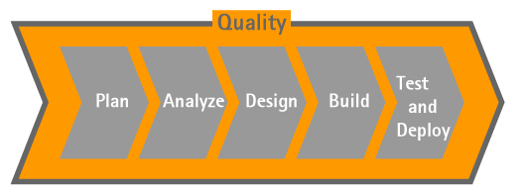

Testimonial: Benefits of Planning for Quality

This testimonial discusses how ADM ensures quality on all client projects.

Planning for Quality

Planning for quality upfront helps a project create better deliverables and a better system. There are several management techniques across ADM that ensure successful gathering, understanding, and delivery of stakeholder expectations. A key way to make sure we have quality embedded in what we do every day is to follow our standard methodology, processes, and tools.

* ADM should be used at all times (with a few exceptions).
* Use ADM to help guide you and provide best practice. There’s a wealth of information and experience that you should be leveraging.
* The tools are there to make things easier and to provide more consistent output, but you need to understand how to get value out of them and use them to truly manage your work.
* Ultimately, having the discipline and instilling it from the top down has proven to make a big difference in our successful projects.

**ADM for Custom Development**

* **MG132 Quality Management Plan:** This deliverable documents the processes and techniques the project follows to build quality into the project deliverables.
* **Quality Management Guidelines:** This job aid supports the creation and implementation of the Quality Management Plan.
* **Requirements Development Guidelines:** This job aid outlines the different types of requirements.
* **Application Quality Requirements Guidelines:** This job aid describes testing the quality requirements.

Click on the Show Me below to watch a guided demonstration.

https://mylearning-products.accenture.com/SEF_ADMv3/ADF_ADM/cImages/showme_button_n.gif

Reminder: At the time this course was developed, the Show Me and Try Me demonstrations were created using ADM version 5.1. ADM has since gone through maintenance updates. Some of the graphics and navigation may be slightly different from the current version of ADM.

Content View: Planning for Quality

Reviews that improve the predictability of delivery reduce the cost of poor quality and improve client satisfaction. An experienced Quality Assurance director who is external and objective to the project conducts the review. The review’s primary purpose is to reasonably assure the project’s ability to deliver on the client’s and our company’s expectations.

Click on the Show Me below to watch a guided demonstration.

https://mylearning-products.accenture.com/SEF_ADMv3/ADF_ADM/cImages/showme_button_n.gif

Content View: Quality in Testing

Testing is an essential part of the software development lifecycle. It is a structured way of validating that requirements and technical specifications are properly implemented in a solution, and provides a definitive answer to whether the solution meets the customer’s functional, technical, operational, and maintenance expectations. Testing is critical to reducing software delivery risks.

Therefore, it is important to read and follow existing:

* ADM Guidelines
* Testing Processes

Click on the Show Me below to watch a guided demonstration.

https://mylearning-products.accenture.com/SEF_ADMv3/ADF_ADM/cImages/showme_button_n.gif

Content View: Verification and Validation

Verification and validation are part of the quality assurance process found at key points in the solution development process. Verification and validation tasks ensure that:

* Output deliverables satisfy the requirements specified in input deliverables of a previous stage.
* The work product is within scope, contributes to the intended benefits, and does not have undesired side effects.

Verification and validation tasks serve as the primary quality assurance gate before you transition the deliverables to another team.

Note: Quality checklists, process-level checklists, and transition points are tools available in ADM.

Click on the Show Me below to watch a guided demonstration.

https://mylearning-products.accenture.com/SEF_ADMv3/ADF_ADM/cImages/showme_button_n.gif

Content View: Quality Guidelines

The Quality Guidelines provide a set of approaches, techniques, considerations, and guidelines for planning, managing, and executing projects. This demonstration illustrates an index of guidelines, providing a definition of what each document refers to and the document’s scope.

Click on the Show Me below to watch a guided demonstration.

https://mylearning-products.accenture.com/SEF_ADMv3/ADF_ADM/cImages/showme_button_n.gif

Content View: Certification and Quality Levels

A methodology is one of many components that are assessed when an organization aspires to operate at a particular certification or quality level. ADM is designed to help organizations satisfy the requirements associated with CMMI® (SM) Levels 2 and 3.

Click on the Show Me below to watch a guided demonstration.

https://mylearning-products.accenture.com/SEF_ADMv3/ADF_ADM/cImages/showme_button_n.gif

1235 Manage Quality Task

The Project Management activity includes the Quality Management processes highlighted below:

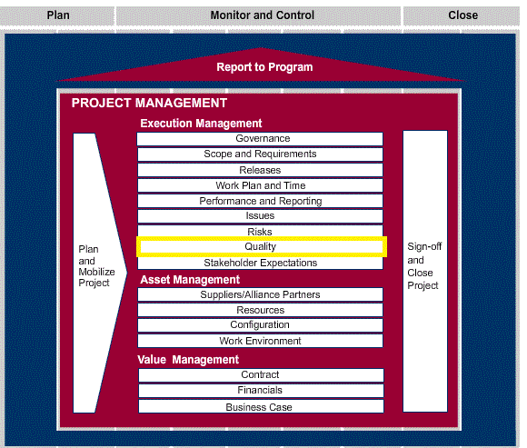

Please note: The Project Management content is hosted in a separate methodology and can be viewed at<https://methodology.accenture.com/core_prog_proj_mgt/#publish.port_prog_proj_mgt/customcategories/proj%20mgt%20processes_3775EFAB.html>

Quality Management is the process of defining stakeholder expectations, quality metrics and plan, implementing, and overseeing the execution of quality reviews and improvement activities in order to meet expectations and quality objectives. The quality management component includes client expectations management, quality assurance, and continuous improvement activities.

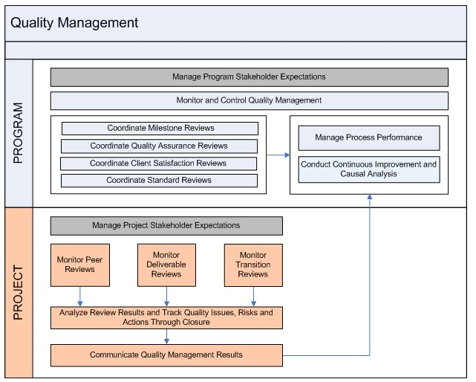

A Practice flow is designed to support the program and project management scenario and depicts the interplay between program-level and project-level processes. The flow diagram above shows how steps or tasks between a program and project relate to one another.

Click on the Show Me below to watch a guided demonstration.

https://mylearning-products.accenture.com/SEF_ADMv3/ADF_ADM/cImages/showme_button_n.gif

MG132 Quality Management Plan: Deliverable Purpose and Content

The MG132 Quality Management Plan deliverable is part of the Project Management Activity. We create this document at the start of the program or project, in the Plan and Mobilize stage. It documents the processes and techniques that the program or project follows to build quality into the work products and help ensure they enable the effort to deliver business value, and meet or exceed client expectations.

The Quality Management Plan document addresses verification and validation activities and QA reviews.

**Verification** ensures that the project “built it right,” i.e., that the deliverable conforms to the project standards for architecture, design, coding, and testing. It also ensures that the right processes were followed for project execution.

**Validation** ensures that the project “built the right thing.” Validate specifications to ensure that the development process is still on track to provide a solution that meets the requirements and the business case.

Quality reviews are used to verify and/or validate that:

* Stakeholder expectations are being met or exceeded.
* Processes and deliverables/work products comply with program standards and procedures.
* Defects in deliverables/work products are identified and removed early and efficiently.
* CMMI requirements are adhered to (if applicable).

The Stakeholder Expectations Management plan can also be documented separately.

Quality management is one of the key management areas, and it must be addressed in the Management Plan or a separate Quality Management Plan per Global Policy 0011 – Use of Accenture Delivery Methods.

It is recommended to produce a Management Plan along with a Risk Management Plan, Quality Management Plan, Configuration Management Plan, and Measurement Plan that stand on their own.

The Quality Management Plan should reflect Accenture's quality vision.

To better understand the importance of this document, here are some examples of how the Quality Management Plan will be leveraged on projects by different resources (various roles) along the project's stages:

* The Project Manager and Quality Manager use this deliverable to support the management and control of the overall project. The Quality processes are defined and then the team can execute as planned.
* Architects and Team Leads follow the quality management processes identified for day-to-day management of quality within the application, technical architecture, and training and performance support.
* New team members can refer to this document as a reference for “Quality Assurance” definition on the project.

Quality Management Guidelines

Quality management is a systematic approach consisting of processes, procedures, techniques, and standards for ensuring the:

* Quality of project deliverables created by the project team.
* Application of best practices and techniques that minimize risks to project quality, schedule, and budget.
* Delivery of consistent results in terms of quality, schedule, and budget across multiple projects.
* Comprehension of stakeholder expectations, with a clearly outlined approach to meet those expectations.

You can use the Quality Management Guidelines document to plan and implement the quality management effort for your project.

**Purpose of Quality**  
The purpose of quality activities (e.g., quality reviews, testing, and validation) is to ensure that projects provide business value, meet client expectations, and that quality deliverables are delivered to the client. Quality, validation, and verification activities verify that the project will deliver on the following items:

* Business goals: Provide high client satisfaction by understanding how clients define success.
* Team goals: Provide the team with a clear sense of direction by clarifying goals and expectations.
* Financial goals: Manage costs by implementing efficient, effective, and repeatable procedures, processes, and standards.
* Quality goals: Minimize problems (e.g., errors, defects, and faults) and re-work by carefully verifying and validating the work at each stage.
* Delivery goals: Improve speed, quality, and cost of delivery by continuously improving the project.

Follow best practices to avoid common root causes. Everyone involved in delivering our contracts should:

* Avoid “Out of Sight, Out of Mind.” Operating as an **end-to-end** team is essential to success.
* **Raise your hand** and escalate issues.
* Understand and **continually monitor client expectations** and know what you can do personally to meet them.
* Understand your **contract and commercial construct** and what Accenture has committed to deliver.
* Embrace the use of Accenture’s **standard methodology** (ADM), processes, and tools for all aspects of our work.

**Individual Call to Action:** What can you do based on your role?

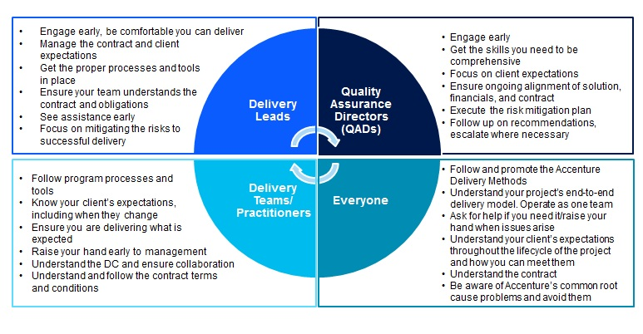

Checklists and Transition Points

* **Quality checklist:** The Accenture Delivery Methods Quality Checklists for Custom Development (Knowledge Exchange) are designed to verify that projects are focused on overall quality and solution delivery excellence. Each checklist asks questions about the primary deliverables within a specific Method to ensure the deliverable has achieved its objectives. Project Managers should use the checklists during quality reviews to ensure the correct actions are taken to make the project successful.
* **Process level checklist:** Process level checklists are used after completing an activity or task to confirm the activity or task have been completed correctly.
* **Transition point:** Transition points define the point in the process for transitioning product deliverables from one team to another, especially when the teams are distributed across multiple sites. (This will be more explicitly explained later.)

Click on the Show Me below to watch a guided demonstration.

https://mylearning-products.accenture.com/SEF_ADMv3/ADF_ADM/cImages/showme_button_n.gif

Verification and Validation

Verification and validation are important parts of the quality assurance process, and occur at key points in the solution development process. Verification and validation tasks ensure the following:

* Output deliverables satisfy the requirements specified in input deliverables of a previous stage.
* The work product is within scope, contributes to the intended benefits, and does not have undesired side effects.
* They serve as the primary quality assurance gate before you transition the deliverables to another team.

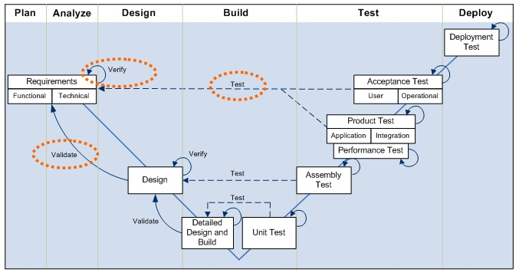

**Verification**

Verification finds faults or errors. It checks the following:

* A deliverable derives correctly from inputs and is internally consistent.
* The output and process conform to the standards outlined in the project’s Quality Management Plan.

Perform verification as the final step of key tasks. Verify deliverable quality through inspection and peer review.

Verification ensures that the project was built correctly and that the deliverable conforms to the project standards for architecture, design, coding, and testing. Verification attempts to catch problems as early as possible in the development lifecycle and ensures the specifications are complete, correct, and adhere to standards. Verification includes most testing efforts (excluding user acceptance testing, which is a validation activity). It also includes most quality reviews, although QA reviews may contain a validation and a verification purpose.

This V-Model-based graphic illustrates the relationship between Verification and Validation.

**Validation**

Validation ensures the following:

* The business case, requirements, and user expectations are met.
* Output deliverables satisfy the requirements specified in a previous stage’s input deliverables.
* The work product is within scope, contributes to the intended benefits, and has no undesired side effects.

An integrated validation of all the deliverables created in an activity is the final task of analysis and design activities, before obtaining sign-off of the deliverables. Additionally, validation validates deliverable quality and integration through inspection, review, simulation, or prototyping.

**Guidelines:**

* Define the verification and validation approach early.
* Select the most appropriate verification and validation technique.
* Involve the right people.
* Execute the confirmation tasks iteratively.

Click on the Show Me below to watch a guided demonstration.

https://mylearning-products.accenture.com/SEF_ADMv3/ADF_ADM/cImages/showme_button_n.gif

Scenario Update

If we consider our scenario at different project stages, we can see that each role on the project is using different sets of tools to plan and monitor for quality.

For example:

* PM/SQA is planning and monitoring for quality.
* SQA is monitoring the project all along ensuring quality processes and tools are properly followed.
* The Analyze/Design/Build/Testing Teams are applying the tools and assets (peer review/checklist/etc.) ensuring quality.
* The Practitioner Designer/Developer is applying appropriate tools and checklists.

Topic Summary

In this topic you learned:

* That ADM has been built in a way that demands projects will build in quality from the earliest stages of the project.
* How to apply a rigorous approach to verification, validation, and testing.
* That ADM is based on the V-Model.
* That adhering to ADM substantially decreases the number of errors found in production after each release.
* That quality is designed into the system rather than tested into the system.

The next topic will continue the practical overview by providing an ADM Transition Point overview.

Topic Introduction

This topic is introducing the concept of a "transition point" as defined in ADM.

Transition points provide the opportunity to review the present status of units of work, assessing whether the objectives defined for each individual stage are fulfilled before the work is relocated to another team or before it is moved from one stage to the next. In a multi-site environment, when reaching a transition point, the project will move from one stage to the next and also potentially to a different site.

A transition point also represents an interface between two teams on a project. At a transition point, project deliverables, such as requirements, design documents, and code transfer from one team to another. The main purposes of the transition points are to:

* Confirm the quality of deliverables being transitioned.
* Foster effective communication between the sending and receiving teams.

All projects use the transition point process. Geographic separation or time zone differences can increase chances of miscommunication among teams. Also, a multi-site project may involve multiple workforces and cultures, making the transition point process even more critical.

Transition points make sure that teams communicate effectively at key points during the project's development lifecycle. However, do not overlook traditional communication channels, such as status reporting and periodical issue resolution meetings, as the foundation for a solid communication program between the teams.

Distributed Work: Introduction

As mentioned previously, all projects use the transition point process. In some situations, teams will be geographically separated. The Distributed Work View in ADM provides more details about the Distributed Work model and various scenarios that the project team may encounter. The Distributed Work View also provides details on a recommended Delivery Center teaming approach. The Distributed Work View provides a set of approaches, techniques, considerations, and guidelines for planning, managing, and executing multi-site projects.

Click on the Show Me below to watch a guided demonstration.

https://mylearning-products.accenture.com/SEF_ADMv3/ADF_ADM/cImages/showme_button_n.gif

Reminder: At the time this course was developed, the Show Me and Try Me demonstrations were created using ADM version 5.1. ADM has since gone through maintenance updates. Some of the graphics and navigation may be slightly different from the current version of ADM.

Multiple Distribution Center Scenario

This graphic is meant to:

* Introduce the concept of multiple teams working together from different locations.
* Reinforce the importance of transition points when working with multiple locations.

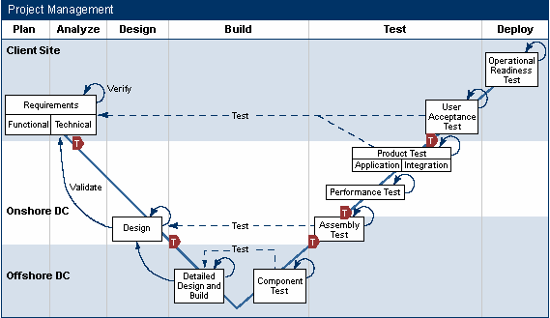

Important Note: In many of our engagements, we employ multiple locations/distribution centers, placing work most effectively per skills, cost, and personnel. You are likely to see this in your engagement work.

Transition points are important when working in a distributed work environments. Clearly define transition points to transition the work at relevant transition points.

Before the transition takes place, define and standardize the escalation procedures; the risk, issue, and scope change management tool, guidelines, and procedures; and the configuration management guidelines across each site.

Make sure that the set of transition points fits into the work distribution pattern between the distributed sites. To understand how to distribute the work, see the Distributed Work Model.

Click on the Show Me below to watch a guided demonstration.

https://mylearning-products.accenture.com/SEF_ADMv3/ADF_ADM/cImages/showme_button_n.gif

Transition Point: Introduction

A transition point occurs each time two teams exchange project deliverables. These transition points mostly occur between activities and at the completion of any key project deliverables.

In an Application Development project, there can be many team-interfacing points where project deliverables change hands. ADM defines the following transition points, which represent a standard set of such key interfaces for a typical project.

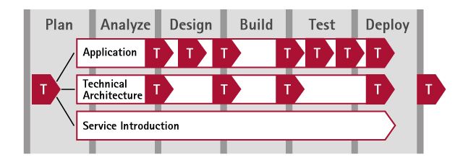

Click on the Show Me below to watch a guided demonstration.

https://mylearning-products.accenture.com/SEF_ADMv3/ADF_ADM/cImages/showme_button_n.gif

Testimonial: Importance of Transition Point Processes

This testimonial provides an example of a mishandled transition point, and explains some of the resulting challenges.

Entry and Exit Criteria

Documents required to start the next stage or complete a stage have to meet entry and exit criteria. The entry and exit criteria document what is required to start a stage and when a stage is considered complete.

* Entry criteria: The set of conditions that must be met for a project to enter a particular development or test stage. These criteria include:
  + Required tasks and the steps to complete them.
  + Required deliverables to complete, update, and review for which a sign-off is required.
* Exit criteria: The set of conditions for a project to exit from a particular development or test stage. Exit criteria are statements to confirm if the required tasks and steps are satisfactorily completed. Exit criteria confirm if the required deliverables are complete, reviewed, and have received sign-off before the stage is considered complete and ready for transition.

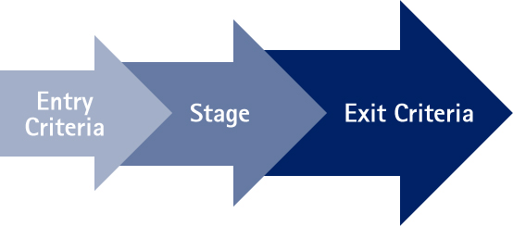

Major Transition Points

As you may have noticed by reading through the various activities, transition points are at the end of each activity in ADM. In this demonstration, you will review the major transition points as if you were working on a project with multiple-site work distribution.

Click on the Show Me below to watch a guided demonstration.

https://mylearning-products.accenture.com/SEF_ADMv3/ADF_ADM/cImages/showme_button_n.gif

Transition Point: General Information

With this demonstration, you will read through the general information of a transition point.

Click on the Show Me below to watch a guided demonstration.

https://mylearning-products.accenture.com/SEF_ADMv3/ADF_ADM/cImages/showme_button_n.gif

Scenario: Transition Point

As you consider the project scenario, you need to understand how two teams are managing the transition of deliverables.

Click on the Show Me below to watch a guided demonstration.

https://mylearning-products.accenture.com/SEF_ADMv3/ADF_ADM/cImages/showme_button_n.gif

Transition Benefit: Multi-Center Scenario

Transition points are important when working in a Distributed Work Environment. Clearly define transition points to transition work at the relevant time.

Transition points provide the opportunity to review the present status of units of work, assessing whether the objectives defined for each individual activity and/or stage are reached before the work is relocated. In a multi-site environment, when reaching a transition point, the project will move from one activity and/or stage to the next and also potentially to a different site.

Before the transition takes place, define and standardize the escalation procedures, issue management guidelines, and configuration management guidelines across each site.

Make sure the transition points fit into the work distribution pattern between the distributed sites and/or teams. Relevant distributed work guidelines for defining and supporting transition points are available in ADM.

A transition prior to the Acceptance Test may mean a change in team and ownership. Such a transition may be required due to technical testing constraints. An example of this would be testing carried out in cross-platform environments or testing that complies to specific contractual obligations, such as delivering only one part of the application.

However, where possible, Acceptance Testing is more effectively performed by the development team prior to any significant handover or transition to another organization (e.g., the formal onshore test team).

Tailor Transition Points

At the start of a project, all involved parties agree to the set of transition points to use. This may require tailoring the standard set of transition points provided within ADM to the project’s specific needs and constraints.

The standard set of transition points introduced above from within ADM is drawn from experiences from many past projects. However, taking full advantage of these transition points may require emphasizing some transition points while de-emphasizing others, creating additional transition points specific to the project and/or engagement.

Several factors may influence the tailoring process:

* Site distribution pattern: Transition points are more crucial between distributed teams. Face-to-face communication between co-located teams reduces the need for formal conduct of some transition points.
* Key project deliverables: Design transition points around key project milestones when transitioning significant deliverables, such as requirements, designs, etc.
* Development environment setup: Transition points are more crucial when teams do not share a common development environment/repository and deliverables are migrated across multiple technical environments.
* Quality requirements: Project quality requirements also determine how rigorously project teams must conduct the transition points.

While projects may differ in the exact number of transition points used and how to formally conduct them, all projects, regardless of distribution pattern, size, etc., use transition points as a standard practice.

Transition Point: Other Guidelines

**Execute Transition Points Iteratively**  
Transition points do not promote a waterfall model or encourage throwing deliverables over the wall. Break the set of deliverables into smaller, more manageable work units/packages. Transition the deliverables from one work unit at a time. This incremental transition of deliverables is especially effective for projects that use an iterative development approach.

**Use Transition Point Progress as a Key Project Status Indicator**

* Integrate the transition point execution status into the standard project status tracking and reporting.
* Reference transition point names explicitly in the weekly project status report to highlight where the project is in terms of progress and milestones.
* Define and track transition point-related metrics, such as the number of transition points completed, percentage of work unit transitions completed at a particular transition point, etc.

**Integrate with Other Quality Management Processes**  
Transition points are not just another task for a project to complete. Integrate the transition point process into the standard project Quality Management process and other quality control and management activities. For example, add transition point-related metrics into the Quality Management Plan (for example, 90% of work units go through a transition point on the first pass), as appropriate.

**Enhance the Standard Review Processes**  
Use transition points to enhance the standard deliverable review and testing processes. Transition points enhance the project deliverable review, verification, and testing processes, but do not replace them.  
Key differences include the following:

* Conduct a transition point between two or more teams, and focus on transferring responsibility for the next stage of work on a particular set of deliverables.
  + For example: A project team conducts a review or test for the team. For instance, the project team conducts a requirements review within the Requirements Analysis Team. In this case, the responsibility for the reviewed deliverables remains within the project team.
* A transition point process checks the full receipt of the deliverables, confirms understanding of the deliverables, and confirms that the deliverables continue to work in the receiving team's technical environment. In general, do not repeat the content verification of the transitioned deliverables already performed by the sending team. However, some overlap is necessary between transition points and the standard reviews and tests.
  + For example: A reduced set of regression tests may have to be rerun at a transition point once the application build is transitioned to a new technical environment.

Transition Point Try Me

Click on the Try Me below to work through a hands-on simulation.

https://mylearning-products.accenture.com/SEF_ADMv3/ADF_ADM/cImages/Tryme_button_n.gif

Topic Summary

In this topic you learned:

* About the concept of transition points and the related ADM processes.
* How to access detailed information and guidelines to understand, plan, and execute efficient transitions between teams or stages within a project.
* How to obtain more information within ADM regarding Distributed Work or a multi-location work scenario.

Topic Introduction

The purpose of this topic is to help you develop the background to know when to leverage ADM, and the exceptions to when you have to use it. There is a policy requirement that states all Accenture engagements should use ADM. However, there are certain notable exceptions that we will address in detail in this topic.

When to use this Methodology

On February 1, 2006, Accenture introduced [Policy 0011 - Use of Accenture Delivery Methods](https://publishing.accenture.com/Policies/ClientsEngagements/0011.htm). There have been several updates since its inception, but the focus of Global Policy 0011 remains the same. That is, Global Policy 0011 mandates that all Accenture engagements, regardless of the type of work, size, or duration, use Accenture Delivery Methods and Estimators, or in the event of certain defined and acceptable exceptions, follow the ADM Tailor Process.

‘Engagements’ as defined in the Policy is work where the Company has contracted with a client for Consulting or Outsourcing work, or the work is an internal effort.

Accenture Delivery Methods provide support across the lifecycle for engagements, covering Strategy & Planning, Management, Implementation and Operations. The components of the Accenture Delivery Methods covered under this Policy include:

|  |  |
| --- | --- |
| **ADM Component** | **Component Description** |
| [ADM Content](https://sites.accenture.com/groups/ADS/TopicPages/Methods.aspx) | Set of tasks, deliverables and roles that describe ‘what’ needs to be done, the deliverables to be produced and the roles necessary to accomplish the work. |
| [ADM Estimators](https://sites.accenture.com/groups/ADS/TopicPages/Estimators.aspx) | Accenture Delivery Methods estimating models that help drive accuracy in level of effort and pricing. |
| [ADS Practices](https://sites.accenture.com/groups/ADSPractices/default.aspx) | Accenture Delivery Suite (ADS) Practices are common management and development processes used across all types of work. They are essential for the Company to perform consistently across all workforces to ensure the integrated management of multi-service, multi-location deals. |

**Note:** Although Policy 0011 does not apply to the use of other components of the Accenture Delivery Suite at this time, standard [Accenture Delivery Tools (ADT)](https://sites.accenture.com/groups/ADS/TopicPages/Tools.aspx)automate and simplify the processes, tasks, and activities prescribed by Accenture Delivery Methods. The use of these standard tools simplifies configuration and reduces the time and cost to deploy, manage and maintain tools on Company projects.

Requirements for Using ADM

Engagements can be compliant with Policy 0011 by choosing one of the following options:

* Fully utilize an Accenture Delivery Method on the project.
* Tailor their use of an Accenture Delivery Method, if they meet the valid exceptions defined on the next page.

The following three questions must be answered “Yes” following these validation steps:

|  |  |
| --- | --- |
| **ADM Usage Compliance Question** | **Steps to Validate** |
| 1. **Does the work breakdown structure in the work plan reflect ADM activities, tasks, and transition points?** | 1. Identify that the appropriate Accenture Delivery Methods are used for the engagement scope. 2. Verify that the work breakdown structure utilizes the stages, activities, tasks, and deliverables as defined within the associated Accenture Delivery Methods. |
| 1. **Are both the high-level work plan and estimates based on the ADM Estimators?** | 1. Create estimates using the appropriate Accenture Delivery Methods Estimator(s). 2. Verify that the delivery cost estimates and initial work schedule, work plan, and resource/sourcing plan for the engagement were created using the ADM Estimators. Ensure these were reviewed and approved by qualified subject matter experts (e.g., Solution Architects and Delivery Leads).   **Note:** BPO does not use Estimators, so this is not applicable to BPO deals. |
| 1. **Do the required ‘management plan’ deliverables exist and were they created using ADM templates?** | Consulting Type of Work: Create and use the [Management Plan](https://methodology.accenture.com/core_prog_proj_mgt/#meth.port_prog_proj_mgt/workproducts/Management%20Plan_BFCB2DCF.html) (formerly known as the Project Plan) using the ADM template.   The following areas should be addressed in the Management Plan. If necessary, these could be created as separate plan documents using the ADM templates:   1. [Risk Management Plan](https://methodology.accenture.com/core_prog_proj_mgt/#meth.port_prog_proj_mgt/workproducts/Risk%20Management%20Plan_6BCD08A3.html) 2. [Quality Management Plan](https://methodology.accenture.com/core_prog_proj_mgt/#meth.port_prog_proj_mgt/workproducts/Quality%20Management%20Plan_7D33F48D.html) 3. [Configuration Management Plan](https://methodology.accenture.com/core_prog_proj_mgt/#meth.port_prog_proj_mgt/workproducts/Configuration%20Management%20Plan_2CD0B51D.html) 4. [Measurement Plan](https://methodology.accenture.com/core_prog_proj_mgt/#meth.port_prog_proj_mgt/workproducts/Measurement%20Plan_DEA5EA0B.html)   **All of the plans listed above are required to meet this criterion.**  **ITO Outsourcing Delivery Type of Work:** Create and use the six (6) management plans listed below using ADM templates. These plans provide guidance for all work performed within the ITO engagement as a whole:   1. [Measurement Plan](https://methodology.accenture.com/core_outsrc_ops/#base.outsourcing/workproducts/Operating%20Model_4562D0.html) 2. [Operating Model](https://methodology.accenture.com/core_outsrc_ops/#base.outsourcing/workproducts/Operating%20Model_4562D0.html) 3. [Risk Management Plan](https://methodology.accenture.com/core_prog_proj_mgt/#meth.port_prog_proj_mgt/workproducts/Risk%20Management%20Plan_6BCD08A3.html) 4. [Stakeholder Goals and Expectations](https://methodology.accenture.com/core_outsrc_ops/#base.outsourcing/workproducts/Stakeholder%20Goals%20and%20Expectations_5442C3A0.html) 5. [Quality Management Plan](https://methodology.accenture.com/core_outsrc_ops/#base.outsourcing/workproducts/Quality%20Management%20Plan_ED10132B.html) 6. [Business Continuity Plan](https://methodology.accenture.com/core_outsrc_ops/#base.outsourcing/workproducts/Business%20Continuity%20Plan_E7AF54E6.html)   **All of the plans listed above are required to meet this criterion.**  For additional details on these required management plans, refer to the Accenture Delivery Methods.  **BPO Outsourcing Delivery Type of Work** All deals within BPO must adhere to the standard processes defined in the [BPO Delivery Navigator](https://sites.accenture.com/publishing/navigatoronline/Pages/default.aspx). In addition, the specific services delivered on a deal must adhere to the standards defined through the [Standard Delivery Solutions (SDS)](https://sites.accenture.com/publishing/navigatoronline/Pages/default.aspx). |

Exceptions to Using ADM

There are certain exceptions to the general ADM requirement, in such situations it may be necessary to comply with Policy0011 by executing the ADM Tailor Process. For Policy 0011, there are currently four (4) exceptions where the ADM Tailor Process can be used to tailor ADM.

The table below outlines the specific exceptions and their required actions. In most cases, for a tailoring to be approved, you must perform a gap analysis against ADM.

|  |  |
| --- | --- |
| **Exception** | **Actions To Be Taken** |
| 1. **An Accenture Delivery Method does not exist for the scope of the engagement** | * Review the current master list of Accenture Delivery Methods found on the Accenture Delivery Suite portal. * Where a specific Accenture Delivery Method may not exist, Program, Project, and/or Service Management Methods in the ADM should be reviewed, and at a minimum, the key management plans as listed in Option 1 for ADM compliance must be created. * Execute the Tailor Process to document the tailoring and get approval for the tailoring and this exception. |
| 1. **The client contract requires an alternative methodology for time and materials engagements**   **Note:** only valid for time and materials engagements | * Perform a gap analysis against the appropriate Accenture Delivery Methods to ensure that the alternative methodology is ADM compliant. * Validate that the key management plans exist or will be created and managed. * Use an ADM Estimator to validate the engagement estimate created with any non-ADM Estimator to identify gaps or discrepancies in the estimates. * Execute the Tailor Process to document the tailoring and get approval for the tailoring and this exception. * Address any gaps identified in the previous steps. |
| 1. **Engagements are using an extended or customized version of ADM** | * Execute the Tailor Process to document the tailoring of the ADM extension being used and get approval for the tailoring and this exception. |
| 1. **Staff Augmentation type of work** | * Execute the Tailor Process and document the reason ADM is not being used on the engagement and get approval for the tailoring and this exception. |

Testimonial: Exceptions to Using ADM

This testimonial describes scenarios where projects were exempted from using ADM, and how those waivers were received.

|  |  |  |  |  |  |  |  |  |  |
| --- | --- | --- | --- | --- | --- | --- | --- | --- | --- |
| Checkpoint: Integration with Other Methods  Top of Form   |  |  |  | | --- | --- | --- | | **To approve tailoring ADM, the leadership of the project must perform a gap analysis between the alternative and ADM. True or false?** | | | |  | https://mylearning-products.accenture.com/SEF_ADMv3/ADF_ADM/cImages/sg_checkc.gif | True | |  |  | False |   Bottom of Form  **This is the correct choice.** |

Topic Summary

In this topic, you learned:

* Accenture has a policy requirement (Policy 0011) that states that all engagements should use ADM and Estimators.
* There are certain notable exceptions to Policy 0011, including scope  considerations, certain client contract requirements for time and materials engagements, usage of extended or customized versions of ADM, and staff augmentation work.
* ADM is rigorous enough to be able to work smoothly with other proven methodologies.

Now, you will take a look at how to use ADM in your work. In the next topic, you will also get to spend more time in hands-on explorations of specific processes, which you will be using on a day-to-day basis.

Topic Introduction

The purpose of topic is to provide some high-level information about how to practically integrate ADM processes and best practices on any type of project, and how ADM helps standardize the estimating and execution of our work. You will also learn how to determine which method to use.

Proposal Development

During an engagement’s proposal stage, the team usually creates a presentation for the client that describes:

* The solution that we believe will address a client’s value proposition.
* The broad approach that we would use to deliver the solution (supported by ADM).
* A rough estimate of the time/effort/cost required to deliver the solution.
* Credentials that demonstrate our organization’s expertise in delivering such solutions.

Methodology assets can assist in the development of each of these components as follows:

* Methodology helps in the solution definition and planning process:
  + ADM for Solution Planning – Outsourcing supports the selling process for an outsourcing opportunity. This Method defines and documents an approach to realize a client’s business performance objectives. It provides a structure for the activities necessary to define and document the Solution Plan.
  + ADM for Solution Planning – SI&TC supports the selling for an SI and/or TC opportunity. This Method defines and documents the solution planning process, which is a core activity, performed by certified Systems Integration and Technology (SI&T) Solution Architects, during the sales process for SI&T opportunities.
* The process-driven structure of a methodology provides an excellent way to communicate the proposed work approach.
* Methodology assets help estimate models that support the creation of high-level estimates, even when little detail is available.

ADS credentials and selling/proposal materials are also available to support sales opportunities. The [Sell Finder](https://kxsites.accenture.com/groups/ADS/Pages/TopicPages/Selling.aspx?lftTitle=Selling) on ADS.Accenture.com provides you the most relevant Success Stories, Credentials and Marketing Collateral for discussions with Accenture clients.

Tailoring the Engagement Scope and Approach

Methodologies provide a common starting point for a team's plans. Engagement teams rarely apply methodologies as-is, but instead customize them to the specific context of their situation.

The Estimator supplied with a Method can facilitate this localization by helping you create a work plan and estimate for your project.

The following is an approach for using an ADM Estimator:

* Initial process filtering: The Engagement Team reviews the list of methodology processes to determine which, if any, are obviously outside the scope of the engagement. In some cases, an Engagement Team may need to remove broad areas (activities); other times, they may choose to eliminate individual tasks.
* Assessing deliverables: You need to confirm what deliverables you can expect from each process. The Estimator lists the key deliverables of each task. Review the task description for more detail as necessary, and determine whether any of the deliverables can be removed from the engagement’s scope.
* Adding a new process or deliverable: The client may require extra documentation with more details about a particular aspect of the engagement. For example, the client may have specific testing processes and/or deliverable outcomes that they require, which are outside the scope of the Method being used. Whether or not there are new processes or deliverables depends on the specifics of the actual project situation. In such a case, the scope must account for these extra tasks and/or deliverables.

As you can see, during this stage, ADM serves as the starting point to build a work plan.

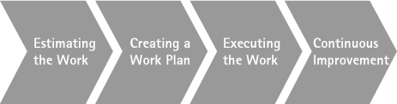

Testimonial: Tailoring the Engagement Scope and Approach

This testimonial describes a scenario of when ADM was tailored to meet a client's needs.

Estimating the Work

After setting the scope of the work, the Project Manager needs to estimate the required work effort and create a resource plan.

The methodology’s Estimator and staffing guidelines are tools based on data and experience from actual projects. You can use these tools to create a high-level estimate during the early stages of a project, and a detailed estimate later on, when more details about the project are available.

Estimators are a critical component of ADM. You will learn more about Estimators later in the course.

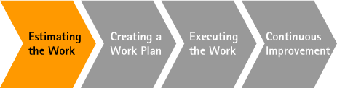

Creating a Work Plan

Create a work plan to show the duration and relative timing of the different activities and specific assignments of the work. Use the Method’s associated ADM Estimator to estimate the work effort and thereby create a basis for the work plan.

Note: There are additional training courses on myLearning that provide detailed, step-by-step instructions for creating an MSPS 2010 work plan, as well as modules to maintain a team’s work plan and to close it upon completion.

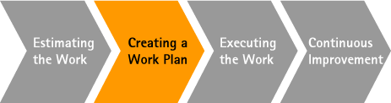

Executing the Work

Once the project is underway, ADM serves as a useful reference in a number of contexts, including:

* Team members will refer to process and deliverable documents to understand their own assignments.
* Project leaders can refer to methodology reference documents to describe the project status to new team members.
* The estimate and work plan are based on ADM, and they have been adjusted to fit with the scope of the project requirements.

NOTE: From the Plan stage onward, most of the team’s effort will focus on delivering the project.

ADM should provide the framework for all team members during every stage of the project. Explore ADM further so you can better understand how it helps you:

* Identify the critical aspects of each activity.
* Track details, tasks, and related deliverables (and their inputs).
* Define roles and responsibilities for those who will have to work on the tasks. (This point will also be included within a project’s work plan.)
* Provide step-by-step information, key considerations, and best practices for how to complete each task.
* Identify Key Considerations for planning activities for projects and teams.
* Access templates, samples, job aids, guidelines, and references that you can reuse for your task, work product, or team.

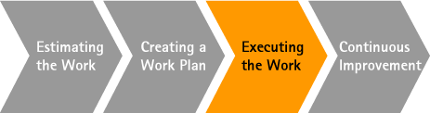

Continuous Improvement

This methodology reflects our collective best practices and should evolve over time. To help other engagements benefit from the work that your team has accomplished, consider “harvesting” key deliverables from your engagement. Certain documents are very valuable in improving our Methods and ADM Estimators, including:

* Work plans with estimates and actuals
* Proposals, scope definitions, and business cases
* Work product and deliverable samples
* Management processes
* Standards and templates

Teams should share the results of their work with their knowledge management representatives, who can help package the project deliverables for reuse and route them to the appropriate teams for possible Methods integration.

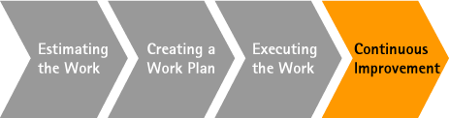

 Checkpoint: ADM Stage Detail

**Match the ADM Stage with the appropriate description.**

Click and drag each of the detailed descriptions to its corresponding stage. Correct choices will remain; incorrect items will snap back into place.

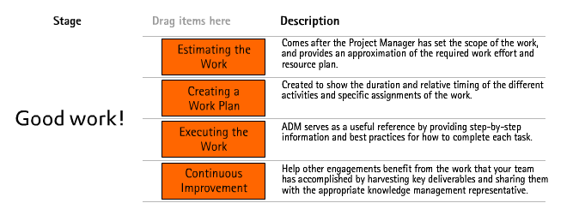

Determining Which Method to Use

Methods are classified at a high level into the following groups:

* Management
* Strategy and Planning
* Operations (used when providing support)
* Implementation (used for development)

Each group contains different Methods. Implementation, for instance, contains:

* Custom Development
* SAP
* And others

This screenshot illustrates the ADM page at ADS.Accenture.com > Methods, Tools and More > Methods, where you can find information on all the different Methods.

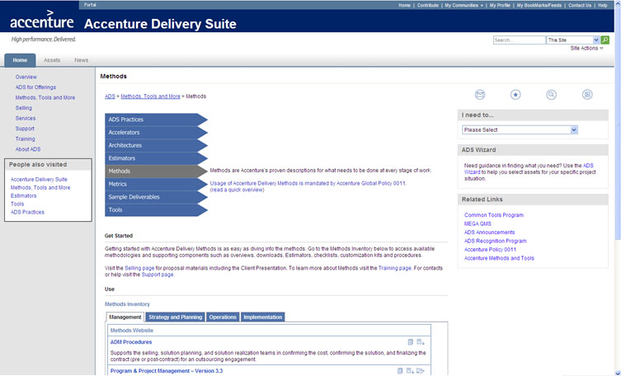

Another useful tool to help you determine the Methods you should employ is the ADS Wizard. You can use the wizard to recommend relevant ADS assets, such as Methods, Estimators, Tools, Training, etc., for your project based on project information you input.

Implementation Methods Available Today and In Progress

To illustrate the breadth of ADM, review the following list, which details the Implementation Methods available at the time of this training’s publication. The Methods evolve to address changing engagement needs. Continuous Improvement efforts may also mean that there are Methods being decertified or retired. For this reason, refer to ADS.Accenture.com > Methods, Tools and More > Methods for a current listing:

* Accenture Insurance Solution - Retiring
* Agile Development
* ALIIP EA - Decertified
* Alnova - Decertified
* Application Renewal - Retiring
* Asset Engineering
* Business Intelligence
* Computer Telephony Integration
* Change Enablement
* Custom Development
* Custom Java Development
* Custom Portal Development
* Custom Development – SOA/BPM
* Custom Development with SOA Extension - Retiring
* Custom – Enterprise Content Management
* Data Migration EA
* Distributed Agile Development
* Distributed Agile – Mobility
* Distributed Agile – RIA
* Enterprise Integration - Retiring
* Infrastructure
* Interactive Voice Response
* Oracle
* Oracle – Value Chain Planning (VCP)
* Packaged Development
* Packaged Development with SOA Extension - Retiring
* Packaged – Accenture Policy Components
* Packaged – Bank in a Box
* Packaged Development - Curam
* Packaged – Maximo
* Packaged – Murex MXpress
* Packaged – SaaS
* PeopleSoft
* Performance Engineering EA
* Predictive Analytics EA
* Retek
* SAP – Core
* SAP – Roll-Out
* SAP – Business Intelligence
* SAP – Core Banking
* Service Introduction
* Service Transition
* Siebel
* Small Project Development EA
* Solution Realization - Retiring
* Testing

ADM Website Overview

For any of the Methods listed on the ADS website, you can find the following information:

* Method overview
* Estimator
* Download
* Quality checklist
* Staffing guidelines

The following demonstration will show you how to find, access, and use this information for a specific Method, using ADM for Custom Development as an example.

Click on the Show Me below to watch a guided demonstration.

https://mylearning-products.accenture.com/SEF_ADMv3/ADF_ADM/cImages/showme_button_n.gif

Estimators

Accenture Delivery Methods (ADM) Estimators encapsulate Accenture’s project experience with delivery and maintenance projects. ADM Estimators help projects estimate the level of effort and drive out cost estimates. They create estimates that completely align with the Accenture Delivery Methods. The ADM Estimators focus on realistic, accurate estimates, since Accenture estimating experts have developed and calibrated them against numerous Accenture historical project data. An inventory of the ADM Estimators is available on the ADS website.

The Estimator inventory is classified into the following groups:

* Management
* Strategy and Planning
* Operations (used when providing support)
* Implementation (used for development)

There are multiple add-ons available for ADM Estimators, including:

* The **Merge Add-on** allows you to merge multiple estimating models and then later slice and dice the data for client review.
* The **Staffing Add-on** enables you to create staffing plans, which you can use to cost and price estimates.
* The **Planner Add-on** enables you to create deliverable-based work plans, which you can later import into Microsoft Project.
* The **Reporter Add-on** gives you access to advanced reporting capabilities.

ADM Estimators will be covered in much greater depth in the next topic.

Downloads

The Accenture Delivery Methods Downloads is an executable that enables you to browse the Methods without a network connection.

Some functionality will differ while using the download, including:

* Links to external references will only work if you are online.
* The Feedback function displays a page giving you an option to go to the website or access the Methodology Support site.
* The Download button will not be available.
* Search functionality will be limited.

Once you have downloaded a Method, you will be notified each time an updated offline version of that Method is available. Please note that the offline Methods are not directly customizable.

Customization Kit

While you can use the ADM methodology as-is from the central web site, sometimes project teams may need to tailor the methodology content to meet their unique project situation. See Global Policy 0011 - Use of Accenture Delivery Methods for the conditions required to execute the Tailor Process.

For more information on how to set up and configure a project-specific methodology, refer to the resources listed below. In this instance, we are looking at tailoring ADM for Custom Development, used throughout this training.

* [ADM Customization Kit for Custom Development v5.3](https://methodology.accenture.com/cr_core_custom/meth.customv5/guidances/supportingmaterials/ADM%20Customization%20Kit%20for%20Custom%20Development%20v5.3_F35A53C5.html) includes the source files necessary to start a customization project. The starter kit specifically includes:
  + Source files to enable updates to the methodology content.
  + Zip file of customizable source graphics for all process pages.
* [Accenture Delivery Methods - Customization Kits](https://methodology.accenture.com/cr_core_custom/base.common/guidances/supportingmaterials/Accenture%20Delivery%20Methods%20-%20Customization%20Kits_CB553062.html) gives you instructions on how to set up and tailor the methodology.
* [Methodology Structure](https://methodology.accenture.com/cr_core_custom/meth.customv5/guidances/supportingmaterials/Methodology%20Structure_30140CDD.html) provides an overview of this methodology's structure, including the types of documents it includes and how they are related. This can help you understand how the methodology is put together prior to launching a customization effort.
* [Using the Methodology](https://methodology.accenture.com/cr_core_custom/meth.customv5/guidances/supportingmaterials/Using%20the%20Methodology_DB19EDB9.html) provides basic information on how a methodology may be used during a typical engagement.

|  |  |  |  |  |  |  |  |  |  |  |  |  |  |  |  |  |  |  |  |  |  |
| --- | --- | --- | --- | --- | --- | --- | --- | --- | --- | --- | --- | --- | --- | --- | --- | --- | --- | --- | --- | --- | --- |
| Checkpoint: Applying ADM  Top of Form   |  |  |  | | --- | --- | --- | | **Identify the classifications used to group ADM Estimators.** | | | |  |  | Quality | |  |  | Management | |  | https://mylearning-products.accenture.com/SEF_ADMv3/ADF_ADM/cImages/sg_checkc.gif | Strategy and Planning | |  |  | Operations | |  |  | Implementation | |  |  | Contracts |   Bottom of Form  **You have not selected all the correct answers.** Management, Strategy and Planning, Operations, and  Implementation are the classifications used to group ADM Estimators. |

Topic Summary

In this topic, you learned to:

* Start using ADM.
* Tailor ADM to suit your project’s needs.
* Recognize how ADM supports the consistent estimating and execution of work.
* Determine which Method to use, and how to download it, if desired.

Now we will take some time to study Accenture’s different ADM Estimators, and to examine how crucial it is to select the right ADM Estimator. There are different needs at different stages of any given project, and Accenture has an ADM Estimator ready for almost every circumstance.

Topic Introduction

The purpose of this topic is to provide an overview of the ADM Estimators.

The ADM Estimators create estimates that are fully aligned with ADM. The ADM Estimators focus on realistic, accurate estimates because Accenture estimating experts have developed and calibrated the Estimators against numerous Accenture historical project data.

Accenture Global Policy 0011 mandates the use of ADM Estimators.

Accuracy: Different Needs at Different Stages

The primary objective of each ADM Estimator is to accurately predict the effort and resources required to complete the work. There are multiple types of Estimators to correspond to different estimating needs at different stages of an engagement’s lifecycle.

This graphic below illustrates how the ADM Estimator is organized around physical deliverables that have been measured and observed.

* These deliverables can be quantified and production time measured.
* These components cover all aspects of work:
  + Application development
  + Architecture/infrastructure development
  + Performance support
  + Project/program management

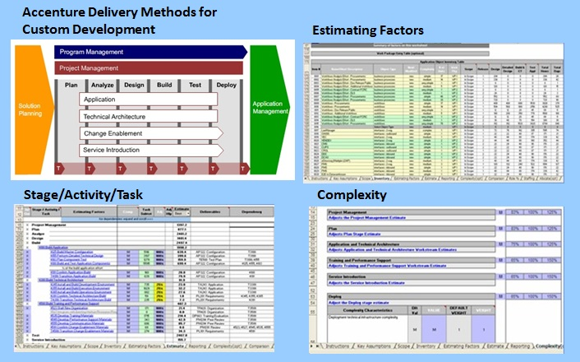

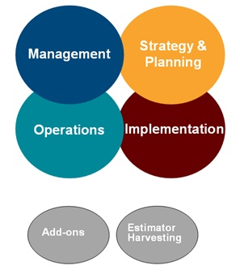The ADM Estimators cover four major areas:

* **Management Methods**  
  Drive discipline and broad-based oversight to ensure identified value is delivered.
* **Strategy and Planning Methods**  
  Identify value creation opportunities, formulate business strategies, and plan solutions.
* **Operations Methods**  
  Deliver ongoing services across application management, technology infrastructure, and business processes.
* **Implementation Methods**  
  Design and build solutions and all of their elements, including business processes, systems, and organizations.

**Additionally, ADM Estimators include:**

* **Add-ons:** Merge, Work Planner, Reporter, Resource, Staffing, Workspace Manager.
* **Estimator Harvesting:**Data harvesting to make sure that ADM Estimators continually produce accurate and relevant estimates of our work.

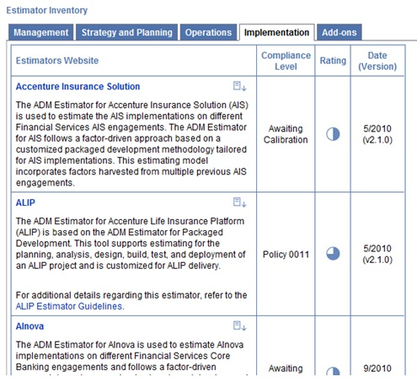

*Illustrative screen shot – not an entire inventory.*

ADM Estimators: Benefits

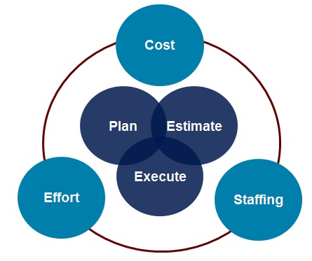The Accenture Delivery Methods Estimators enhance Accenture‘s ability to plan, estimate, and execute our solutions and services. Using ADM Estimators will:

* Increase the overall rigor of creating estimates.
* Provide tools with a rich set of features, yet are intuitive and easy to use.
* Deliver more accurate estimates based on experience and project historical data.
* Allow estimation of work of various types and scale.
* Integrate with a variety of supporting tools to assist with staffing, costing, and planning projects.

Accenture’s estimating capability assists projects to determine the level of effort, appropriate staffing mix, and delivery costs.

Selecting the Right Estimator

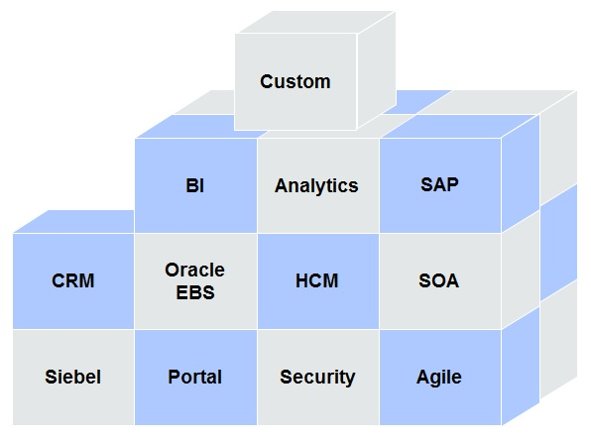The different types of ADM Estimators allow users to select the ADM Estimator most suitable for their needs.

* They cover a broad range of capabilities and market offerings.
* The unique drivers support estimation of different types of work.
* They provide a mechanism for integrating the results and analysis from multiple areas.
* They are aligned with the development process and Methods.
* The ADM Estimators are organized into product lines to reduce the development, roll-out, and maintenance efforts.

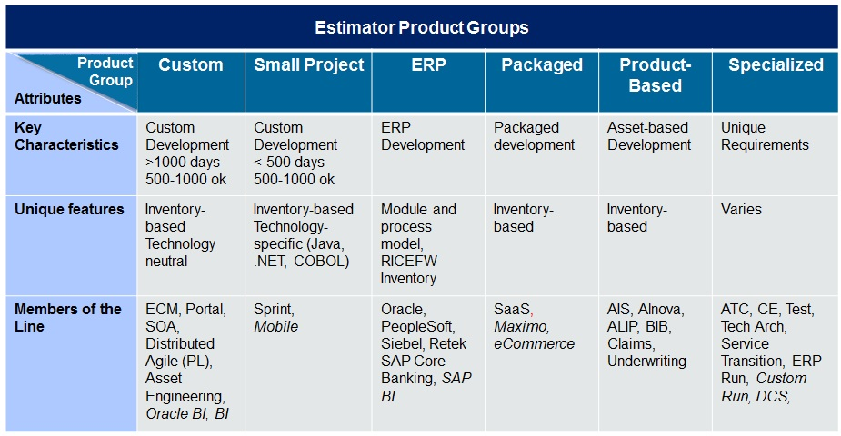

Testimonial: Selecting the Right Estimator

This testimonial describes why it is critical to select the appropriate ADM Estimator. If you are ever in doubt, you should start with the ADM Estimator for Custom Development.

Repeatable Processes

At the macro level, each project team prepares to create a credible estimate by following this general process.

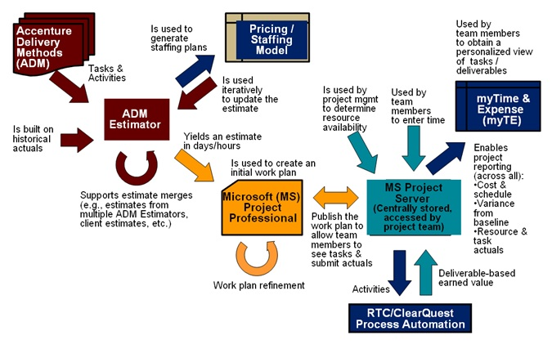

Usability

ADM Estimators have features and functionality to estimate a wide and diverse range of scenarios.

* Default parameters – to create a first-cut estimate quickly.
* Scope control and adjustment – to align the scope of the estimate to the project.
* Collapsible fields - for extensive documentation of assumptions.
* Links to methods – to review details of tasks being estimated.
* Help – to guide you via extensive online help, process guides, factor definitions, glossaries, and estimating factor guidelines.
* Combined top-down/bottom-up support - quick high-level estimate can be gradually refined into a detailed bottom-up estimate.
* Multi-site support - available to adjust for the work done at Accenture Delivery Centres on and off shore.
* Multi-release support - ability to distribute estimate total among multiple releases.
* Estimate partitioning/grouping - ability to segment the estimate by work packages and associate them with teams, functional areas, and change requests.
* Benchmarking and comparison - ability to compare an estimate with estimates and actuals from other projects.

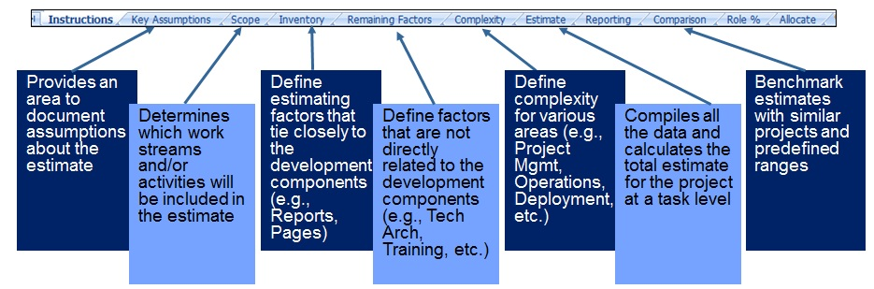

Customizing the Estimator

* The ADM Estimator is based on historical project data and aims to provide realistic and accurate estimates.
* Project specifics will determine how you "fine tune" the Estimator.
* The individual components of the Estimator Tool Suite are adjustable through the configuration files by an Estimator Expert. The Estimators can be tailored by specially trained Estimator teams.

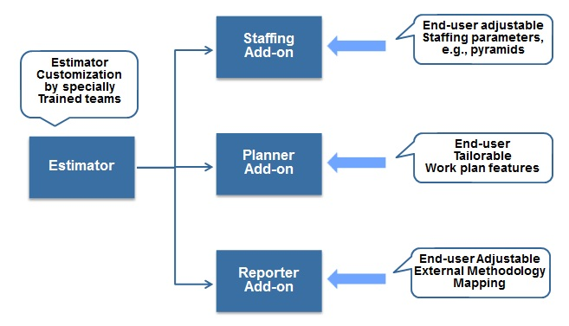

Staffing Guidelines

* The Staffing Guidelines were created across the Management Consulting, Systems Integration & Technology, and AO growth platforms with the support of leaders in each area and represent Accenture's best thinking on how to effectively plan our resource needs. Widespread and consistent use of ADM Methods and Estimators, and the appropriate staffing guidelines leads to optimized labor costs, providing a crucial lever for increased competitiveness and/or margin improvements.
* It is recognized that every engagement has its own idiosyncrasies. Staffing plans need to reflect that, and Solution Architects must be able to substantiate differences between their plans and the staffing guidelines

Available Estimator Training

The following is a partial list of training courses about ADM Estimators available on the Accenture Portal:

* Accent on ADM Estimator Overview
* Accent on ADM Sample Estimators
* ADM Estimator Deep Dive Part 1: Creating & Fine Tuning an Estimate using an ADM Estimator
* ADM Estimator Deep Dive Part 2: Staffing & Costing an ADM Estimate, Exporting the Estimate to MSPS, & Harvesting Estimate Data
* ADM Estimator for SAP - Deep-Dive

For more details on Estimator-specific training, please go to https://ads.accenture.com > Training > ADS Learning Finder, or visit myLearning.

Topic Summary

In this topic, you learned:

* ADM Estimators enhance Accenture’s ability to plan, estimate, and execute project work.
* ADM Estimators:
  + Share a common, proven approach to estimating.
  + Serve different needs based on the stage and type of work.
  + Share common features and support.

In the next topic, you will examine some of Accenture's best practices concerning harvesting and continuous improvement.

Topic Introduction

Continuous improvement is more of a philosophy than a process or system. It is based on the concept that you can bring about continuous improvement with a never-ending series of small changes. In fact, a compelling advantage of continuous improvement is that it can eliminate the need for large-scale shifts, because it is evolutionary, rather than revolutionary. It requires everyone in the company to adopt, as part of their normal jobs, a mindset of continuously looking for ways to improve processes and systems, and committing to the different tools we use to capture this information.

Continuous Improvement

Methodology reflects our collective best practices and should evolve over time. To help other engagements benefit from the work that your team has accomplished, consider “harvesting” key deliverables from your engagement so that other teams can reuse them. This is also important to keep the methodology up-to-date and relevant to the work Accenture does. Teams should share the results of their work with their Knowledge Management representatives, who can help package the project deliverables for reuse and route them to the appropriate teams for possible Methods’ integration.

You can also provide your feedback and inputs on the Methods and recommend new samples and guidelines to benefit other methodology users by using Feedback and Support. The ADM planning and development groups will use your feedback as input to improving the Methods.

The following project documents are extremely valuable in improving the quality of the Accenture Delivery Methods and ADM Estimators:

* Work plan estimates and actuals
* Proposals, scope definitions, and business cases
* Work product and deliverable samples and templates
* Management processes
* Standards and guidelines

Contributed Samples and Templates

As stated in ADM, we encourage you to submit your work product and deliverable samples and templates. An expert will review your submissions and will consider including them in the next release of ADM or in the ADM Repository to make them widely available.

Let's take a moment to review how to reach this repository in ADM.

Click on the Show Me below to watch a guided demonstration.

https://mylearning-products.accenture.com/SEF_ADMv3/ADF_ADM/cImages/showme_button_n.gif

 Topic Summary

To help other engagements benefit from the work that your team has accomplished, it is important to harvest key work products and deliverables samples and templates from your engagement so they can be reused by other teams.

Work with your Knowledge Management representative to provide feedback and inputs on the Methods and Estimators directly, and make recommendations for improvements.

Topic Introduction

The purpose of this topic is to introduce Accenture Delivery Methods (ADM) for Application Management for Application Outsourcing engagements.

At the end of this topic, you will be able to:

* Navigate through ADM for Application Management.
* Identify and describe the different discipline groupings and processes within ADM for Application Management.

What is Application Management?

Application Management is the set of activities undertaken to make sure managed applications continue to meet the needs of the client’s business in the most efficient manner possible. This includes both strategic and tactical activities, including six common functions (outer boxes) and six AO-specific inner functions (inner boxes).

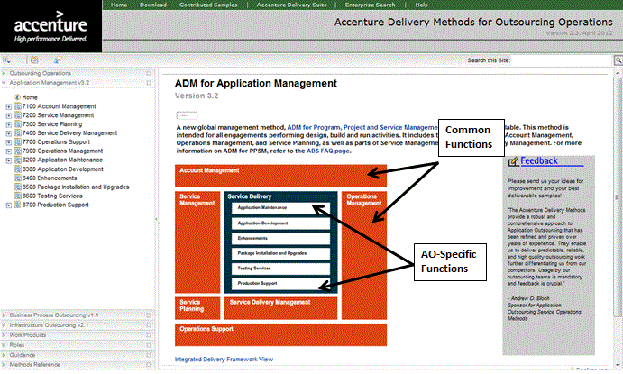

Testimonial: The Importance of ADM for Application Management

This testimonial from Rajeev Vijayan explains the importance of ADM for Application Management.

Engagement Types

Accenture caters to different types of engagements, such as technology, consulting, and outsourcing. Some engagements may focus exclusively on one type of work, such as only application development, while some may consist of multiple work types, such as application development and application maintenance.

Let’s go through two examples to see the role of Accenture Delivery Methods on these engagements:

* **Application Development Engagements:** These engagements start with the requirements definition and end with deploying the new application in accordance with the requirements. Such engagements dramatically change the customer application landscape as they initiate the application installation at the customer’s end. These engagements usually follow the V-Model system development process.
* **Application Maintenance Engagements:** These engagements manage, maintain, and update (develop) applications for one or more clients. The intent is to make sure that applications work properly and are available to end users, within the agreed availability norms.

AO Engagement Overview

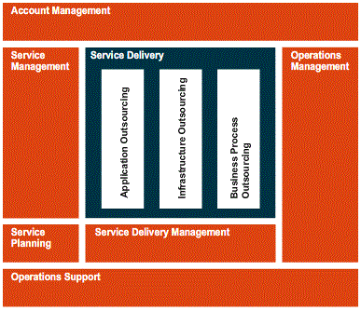The scope of the Accenture Delivery Methods for Outsourcing Operations covers the management and operation of an operating unit.

Each large box on the framework represents a key business area (also referred to as a workstream) needed to operate an outsourcing unit.

AO Service Delivery consists of services delivered to clients, such as:

* **Application Maintenance:** This provides the processes necessary to resolve or fulfill incidents, problems, or service requests assigned through Service Management.
* **Application Development:**This provides links to full application development methodologies for planning, designing, building, and testing new applications for the client.
* **Enhancements:** These provide links to processes for developing enhancements to existing client applications.
* **Packaged Installation and Upgrade:** This provides links to methods for configuring and installing packaged software or software upgrades for the client.
* **Testing Services:** These provide links to methods for testing the applications developed by other groups.
* **Production Support:** This provides processes for managing application performance and application environment.

While it is true that application development work can form a major chunk of AO engagement work, it is equally important to note the critical role application management services play in ensuring sucess of the outsourcing model. It is important for Accenture to maximize the outsourcing productivity of its Application Management engagements.

Looking on the ADS website, you can see numerous application development Methods, within the Implementation tab, each addressing a dedicated technology or package.

Regarding Application Management, ADM provides a single Method, covering various types of applications and technologies (AO, IO, and BPO).

To access ADM for Application Management from the ADS website, click on the Methods, Tools and More links from the navigation tree on the left, and then click on the Methods tab. If you navigate to the Operations tab, you will find the link to ADM for Application Management.

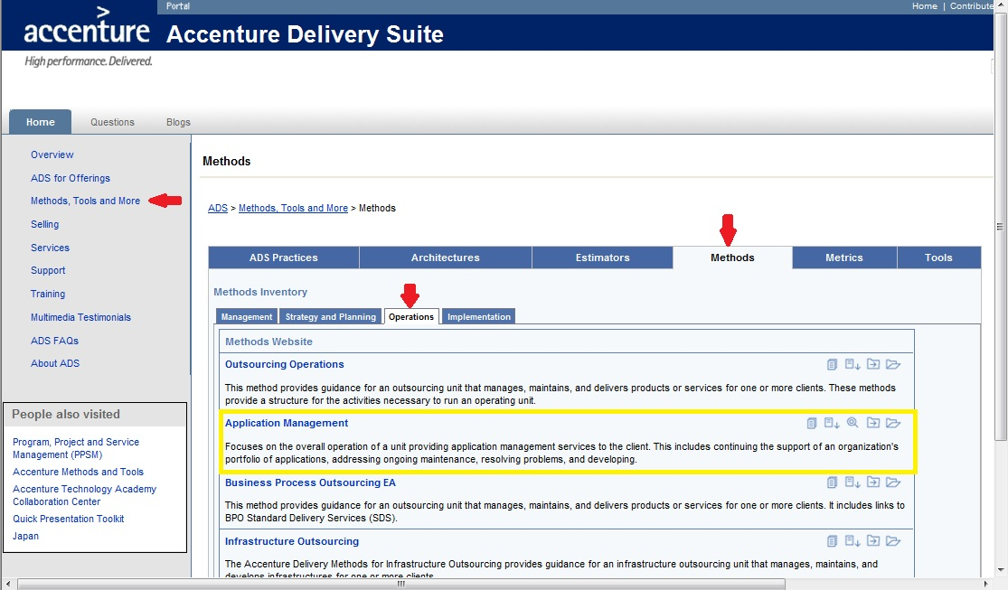

Benefits of ADM for Application Management

What is the value or benefit of leveraging ADM for Application Management?

An effective Application Management solution delivers value to the client in a number of ways. Leveraging ADM for Application Management makes the following possible:

* Improved service delivery, predictability, and scalability for the same reasons seen previously with other Accenture Delivery Methods. Improved speed to market with new client business capabilities by re-using the Accenture standard model and practices.
* Reduced cost and risk through demand management and process improvements.
* A shift in investment from low-value maintenance efforts to value-added application development, as the maintenance team will be responsible for monitoring and fixing problems as well as developing and delivering new application enhancements requested by business.
* Access to leading Accenture Delivery Methods, Tools, and Processes.

Application Management Service Definition

Before you are introduced to the specifics of ADM for Application Management, it's important to take a minute and define the concept of "service" from an Application Management or Support Team perspective. Be careful not to confuse the service that Customer Support is proving to the client (e.g., Customer Relationship Management (CRM)) with the support delivered by a Support Team. A Support Team is in charge of keeping an application up and running according to a service definition (for instance keeping a CRM system accessible and running properly according to the agreement).

Based on this example, it is easy to understand that the idea of Service will directly depend upon the client’s needs. The major keys for defining what the service will be:

* What the Support Team will be in charge of in terms of application
* What the Service support level and availability will be:
  + From Level 1 (i.e., a front desk answering client’s calls) up to a Level 4 (i.e., a technical team investigating bugs and delivering a fix into the production system)
  + From support only during business hours, up to 24/7 support
* What the scope of the support activity will be:
  + New Developments
  + Upgrades
  + Break Fix/Support
  + Enhancements

These items typically define the nature of work performed:

* What the operating model will be
* The communication model (customer/support)
* The escalation process
* Who will be responsible for what within the customer operations organization

ADM for Application Management Methodology Structure

ADM for Application Management follows the same principles, core method, and structure as the other application development Methods, for example, ADM for Custom Development.

ADM for Application Management is organized by:

* Activity: A large unit of work with a single major outcome
* Tasks: Smaller units of work performed by one individual or team to create a single primary outcome.
* Steps: Tasks are further broken down into steps

Following the same principles, this Method also contains:

* Processes: What needs to be done
* Work Products: What needs to be produced (artifacts)
* Roles: Who needs to do it

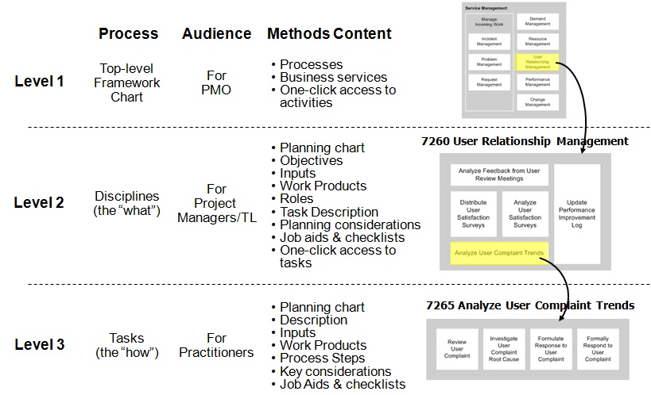

ADM for Application Management Methodology Organization

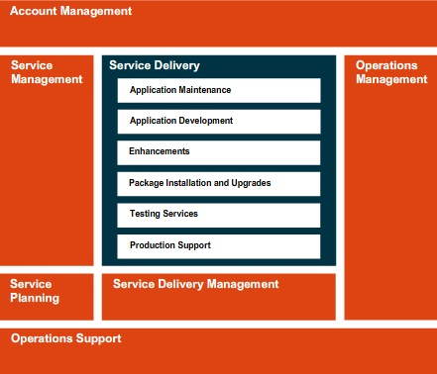Application Development Methods, for example ADM for Custom Development, follow the V-Model. In the case of ADM for Application Management, the model is no longer organized by stages. Instead, ADM for Application Management has been divided into the following business areas:

* Account Management
* Service Management
* Service Planning
* Service Delivery Management
* Operations Support
* Operations Management
* Application Maintenance
* Application Development
* Enhancements
* Package Installation and Upgrades
* Testing Services
* Production Support

Each business area contains activities that you can access by a single click. Also, please note that activities do not represent a linear progression; rather, each business area performs its activities continuously or cyclically.

ADM for Application Management Methodology: Functions

ADM for Application Management has the same six common functions (outer boxes) and six AO-specific inner functions (inner boxes).

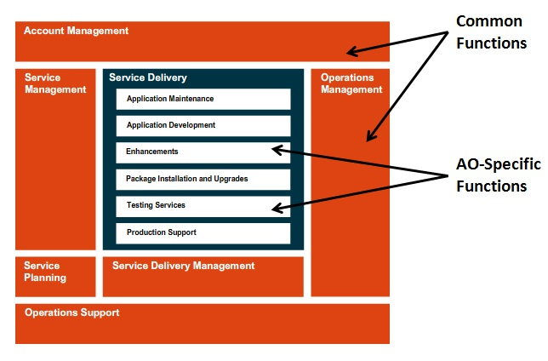

The Application Outsourcing services that Accenture provides may require you to use multiple processes, which are defined in different parts of the Methodology.

In ADM for Application Management, these processes are primarily represented in:

* Service Management
* AO Service Delivery
* Service Delivery Management

All disciplines in the Methodology contain detailed process descriptions, work products, templates, samples, guidance, and references to procedures, including SDO Procedures used by AO.

We’ll take a closer look at each of these business areas, but first we’ll provide an overview of each of the six Common Functions, starting with Account Management.

Common Function: 7100 Account Management

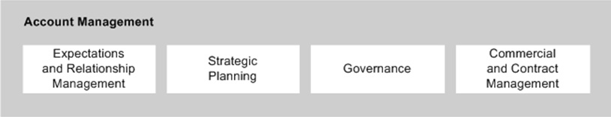

7100 Account Management involves the key business and leadership functions that are strategic and involve client interaction at the contract level. Click on each function below for more information.

* [7110 Expectation and Relationship Management](javascript:crse_showMultiPop('c181101_pop1.htm',%20500,%20290);)
* [7120 Strategic Planning](javascript:crse_showMultiPop('c181101_pop2.htm',%20500,%20240);)
* [7130 Governance](javascript:crse_showMultiPop('c181101_pop3.htm',%20500,%20250);)
* [7160 Commercial and Contract Management](javascript:crse_showMultiPop('c181101_pop4.htm',%20500,%20360);)

Common Function: 7200 Service Management

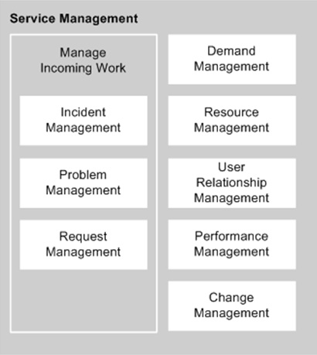Once the level of service is defined, it is important to introduce how the service will be managed within the guidelines of ADM for Application Management.

Service Management is one of the six common discipline groupings (that is, the orange boxes) in ADM for Application Management. It is the single point of entry for all workcoming into an outsourcing unit.

Service Management includes activities that define the interface between the client and the delivery organization and governs all aspects of service delivery. It works with Service Delivery Management and Account Management services to make sure that the account meets the service commitments made to the customer.

Specifically, Service Management comprises the following functions:

* [7201 Manage Incoming Work](javascript:crse_showMultiPop('c181201_pop1.htm',%20480,%20340);)
  + [7210 Incident Management](javascript:crse_showMultiPop('c181201_pop2.htm',%20480,%20340);)
  + [7220 Problem Management](javascript:crse_showMultiPop('c181201_pop3.htm',%20480,%20340);)
  + [7230 Request Management](javascript:crse_showMultiPop('c181201_pop4.htm',%20480,%20340);)
* [7240 Demand Management](javascript:crse_showMultiPop('c181201_pop5.htm',%20480,%20340);)
* [7250 Resource Management](javascript:crse_showMultiPop('c181201_pop6.htm',%20480,%20340);)
* [7260 User Relationship Management](javascript:crse_showMultiPop('c181201_pop7.htm',%20480,%20340);)
* [7270 Performance Management](javascript:crse_showMultiPop('c181201_pop8.htm',%20480,%20340);)
* [7280 Change Management (production)](javascript:crse_showMultiPop('c181201_pop9.htm',%20480,%20340);)

For more information on each of these activities, refer to the detailed descriptions in ADM for Application Management.

Common Function: 7300 Service Planning

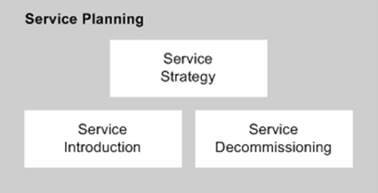7300 Service Planning includes activities that define and involve the introduction of new services. It also includes decommissioning, determined as part of Service Portfolio Strategy and Planning during service operations. This business area includes the following functions. Click on each function below for more information:

* [7310 Service Strategy](javascript:crse_showMultiPop('c181301_pop1.htm',%20480,%20340);)
* [7350 Service Introduction](javascript:crse_showMultiPop('c181301_pop2.htm',%20480,%20340);)
* [7360 Service Decommissioning](javascript:crse_showMultiPop('c181301_pop3.htm',%20480,%20340);)

For more information on each of these activities, refer to the detailed descriptions in ADM for Application Management.

Common Function: 7400 Service Delivery Management

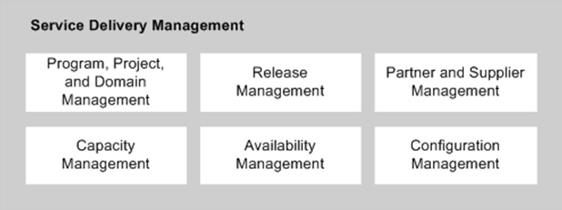

7400 Service Delivery Management describes the activities and processes that need to be managed for Service Delivery, including the following functions. Click on each function below for more information.

* [7410 Program, Project, and Domain Management](javascript:crse_showMultiPop('c181401_pop1.htm',%20480,%20340);)
* [7430 Capacity Management](javascript:crse_showMultiPop('c181401_pop3.htm',%20480,%20340);)
* [7450 Release Management](javascript:crse_showMultiPop('c181401_pop4.htm',%20480,%20340);)
* [7460 Availability Management](javascript:crse_showMultiPop('c181401_pop5.htm',%20480,%20340);)
* [7470 Partner/Supplier Management](javascript:crse_showMultiPop('c181401_pop6.htm',%20480,%20340);)
* [7480 Configuration Management](javascript:crse_showMultiPop('c181401_pop7.htm',%20480,%20340);)

For more information on each of these activities, refer to the detailed descriptions in ADM for Application Management.

Common Function: 7700 Operations Support

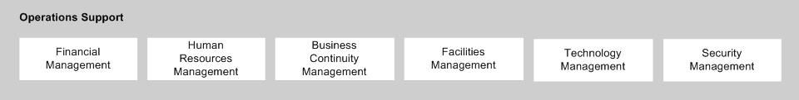

7700 Operations Support supplies tangible resource support for the delivery of contracted services.

It consists of the following functions. Click on each function below for more information:

* [7710 Financial Management](javascript:crse_showMultiPop('c181501_pop1.htm',%20480,%20340);)
* [7720 Human Resources Management](javascript:crse_showMultiPop('c181501_pop2.htm',%20480,%20340);)
* [7740 Business Continuity Management](javascript:crse_showMultiPop('c181501_pop3.htm',%20480,%20340);)
* [7760 Facilities Management](javascript:crse_showMultiPop('c181501_pop4.htm',%20480,%20340);)
* [7770 Technology Management](javascript:crse_showMultiPop('c181501_pop5.htm',%20480,%20340);)
* [7780 Security Management](javascript:crse_showMultiPop('c181501_pop6.htm',%20480,%20340);)

For more information on each of these activities, refer to the detailed descriptions in ADM for Application Management.

Common Function: 7900 Operations Management

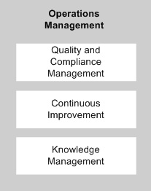

7900 Operations Management consists of the following functions. Click on each function below for more information.

* [7910 Quality and Compliance Management](javascript:crse_showMultiPop('c181601_pop1.htm',%20480,%20340);)
* [7930 Continuous Improvement](javascript:crse_showMultiPop('c181601_pop2.htm',%20480,%20340);)
* [7970 Knowledge Management](javascript:crse_showMultiPop('c181601_pop3.htm',%20480,%20340);)

For more information on each of these activities, refer to the detailed descriptions in ADM for Application Management.

Service Delivery: AO-Specific Functions

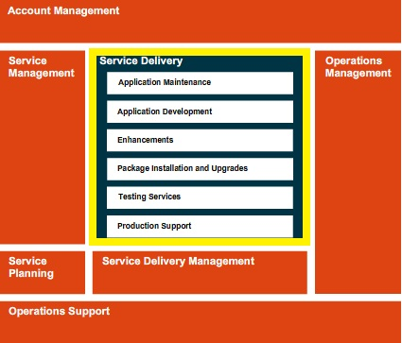

Now that you’ve learned about the six common functions, let’s take a closer look at each of the six AO-specific functions in the Service Delivery area.

* 8200 Application Maintenance
* 8300 Application Development
* 8400 Enhancements
* 8500 Package Installation and Support
* 8600 Testing Services
* 8700 Production Support

We’ll go into each of these functions on the next few pages.

|  |  |
| --- | --- |
| AO-Specific Functions: 8200 Application Maintenance  The first service we’ll look at, Application Maintenance, is a discipline grouping that defines the processes used to analyze, estimate, design, build, and test application changes necessary to:   * Restore service and minimize the adverse impact of an application-related service disruption (incident) by performing resolution activities, escalation and updates the Incident Record that cannot be completed by the service desk within the thresholds defined within the Service Catalogue or prevailing Service Level Agreement. * Resolve the underlying cause of service interruption, and minimize the adverse impact of an application-related service disruption by performing resolution activities, escalation, and problem record updates that cannot be completed by the service desk within the thresholds defined within the Service Catalogue or prevailing Service Level Agreement. * Complete the activities associated with request processing that cannot be completed by the service desk within the thresholds defined within the Service Catalogue or prevailing Service Level Agreement. * Analyze, design, build, and test workarounds and application changes necessary to resolve incidents and problems that cannot be completed by the service desk within the thresholds defined in the Service Catalogue or prevailing Service Level Agreement. * Analyze, estimate, design, build, and test application changes necessary to fulfill requests that cannot be completed by the service desk within the thresholds defined in the Service Catalogue or prevailing Service Level Agreement.   The white boxes in the diagram illustrate the disciplines that are described within this discipline grouping. The grey boxes link to disciplines from other common portions of the methodology (the orange boxes) that are used during the course of completing this work. |  |

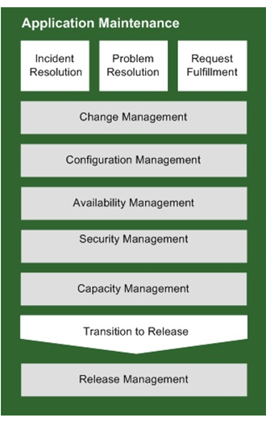

AO-Specific Functions: 8300 Application Development

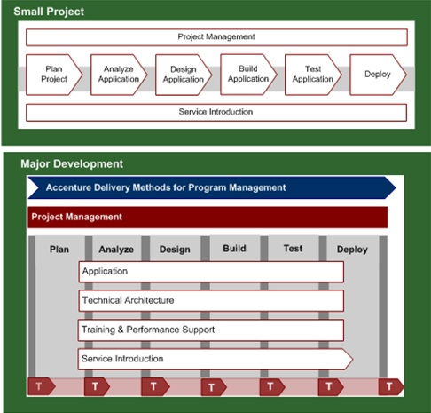

The Application Development discipline is used when developing a new application within a unit. It provides links to the two development Methods most commonly used within a unit:

* ADM for Small Project Development
* ADM for Custom Development

Use other development Methods as appropriate for the type of work. The Accenture Delivery Suite Wizard is available to help you select the correct method.

AO-Specific Functions: 8400 Enhancements

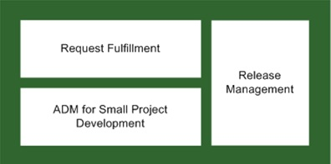

Enhancements are small changes to the functionality or operation of an existing application. They can range from very small cosmetic changes that require very limited development work to significant changes that require much more development and project management rigor

* Execute requests for enhancements to applications according to the Service Catalog
* Execute requests for enhancements  meeting delivery criteria in the Service Catalog and prevailing Service Level Agreements

Use processes defined in Request Fulfillment to respond to very small enhancement requests, such as cosmetic changes to reports and screens. Consult the Service Catalogue or unit policy for thresholds for enhancements that can be processed with Request Fulfillment

Use ADM for Small Project Development to respond to enhancement requests that exceed the threshold for being fulfilled with Request Fulfillment processes and are still within the 800 hours limit for Small Project Development and that meet the other criteria explained in the Criteria for Using ADM for Small Project Development.

Always use the outsourcing Release Management processes to deploy enhancements into production environment.

AO-Specific Functions: 8500 Package Installation and Upgrades

The Package Installation and Upgrades discipline grouping is used to execute requests to:

* Execute requests to install new software packages.
* Execute requests to install upgrades to existing software packages.
* Execute requests in accordance with the Service Catalog and in line with the prevailing Service Level Agreements.

Based on the business requirements specified in the request, select the appropriate Application Development Method to install or upgrade the selected software package.

* Use the Accenture Delivery Methods for Small Project Development if the project complies with the Criteria for Using ADM for Small Project Development.
* Otherwise, select the appropriate development method from the numerous options available. Consider using the Accenture Delivery Suite Wizard to help select the appropriate method(s). The ADS Wizard considers the type of project and the package involved (e.g., SAP, Oracle, PeopleSoft, etc.) when recommending ADS assets.
* Consider using the Accenture Delivery Methods for Program Management if the development and deployment of multiple packages is required to fulfill the request.

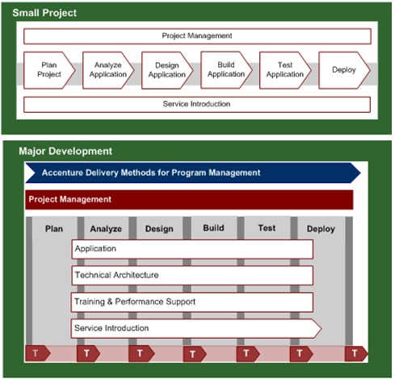

|  |  |
| --- | --- |
| AO-Specific Functions: 8600 Testing Services  The Testing Services discipline grouping defines the processes used to support and fulfill requests within the outsourcing unit where testing services are included in the Service Catalogue. Testing Services include   * Support request fulfillment within an outsourcing unit that includes testing services in the Service Catalogue. * Plan, analyze, design, prepare, and execute tests in response to an allocated request.   Testing services may be included in the Service Catalog and provided as part of Application Outsourcing. Analyze and respond to requests for testing allocated to Service Delivery using Request Management and Request Fulfillment processes. |  |

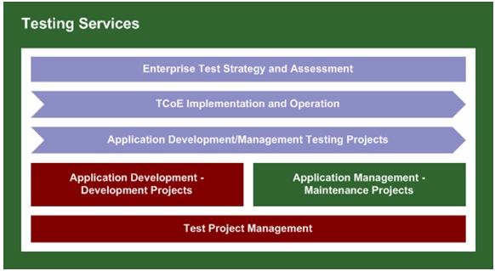

|  |  |
| --- | --- |
| AO-Specific Functions: 8700 Production Support  Production support services define how to:   * Operate, administer, and maintain applications on a day-to-day basis, as defined within the Service Catalogue or prevailing Service Level Agreement, at a level necessary for service to be considered available and of a quality that is fit-for-purpose. * Plan, implement, measure, and manage the applications on a day-to-day basis, as defined within the Service Catalogue or prevailing Service Level Agreement, to ensure thresholds of availability and quality are consistently met. * Communicate application availability, performance, and status to Service Management and application portfolio management resources in accordance with the agreed Communications Plan. |  |

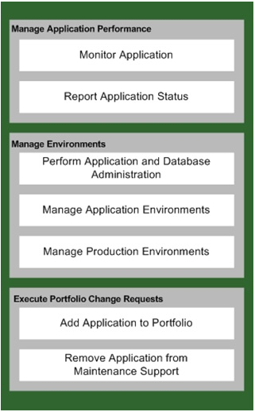

Testimonial: Key Success Factors

This testimonial from Rajeev Vijayan addresses the following the key success factors:

* Clarity, Transparency, and Scalability
* Proactive program management
* Knowledge Management
* User satisfaction tied to service levels
* Issue resolution tied to service levels
* Continuous improvement

How to Access

This section provides you with links to the online and downloadable versions of ADM for Application Management.

Online version:  
<https://methodology.accenture.com/core_outsrc_ops/#publish.app_mgt/guidances/roadmaps/Application%20Management%20Home_961BC454.html>

Downloadable version:

To download ADM for Application Management:

1. Visit the ADS portal [https://ads.accenture.com](https://ads.accenture.com/)
2. Navigate to Methods, Tools and More > Methods > Operations > Application Management
3. Click the download link

Topic Summary

This topic covered the following areas:

* The definition of Application Management
* The Method's structure and organization
* The six common functions and the six AO-specific Service Delivery functions that comprise ADM for Application Management

Course Summary Overview

This course was designed to help you read and work through all project stages in ADM. You have learned:

* That ADM is more than just a methodology. ADM provides a common language and common way to execute every Accenture project.
* About all of the ADM project stages, and the way activities and tasks explain to you how to complete your work.
* That activities address the perspective of the Team Lead/Planner.
* That tasks address the perspective of the Designers/Developers/Practitioners.
* That ADM task and activity pages contain a specific section that clarifies that task or activity’s relationship to other workstreams.
* How to easily access sample deliverables, templates, job aids, and step-by-step procedures for every task within ADM.
* How ADM helps to build quality into our work in each project stage.
* About the strong emphasis on Transition Point processes within ADM, whether you are working on a single or multi-location team.
* That ADM is a continually evolving methodology, and that we need to harvest your feedback and experience from your client engagements to continually reflect our most up-to-date best practices.
* That managing a project to ensure a positive outcome requires art and science, and how mastering ADM will lead you to apply a repeatable and proven approach.