Tugas RFC

Oleh Faisal Hafizh

# Summary

Membuat salah satu service Transport Management System dengan membuat database untuk pengecekan status pengiriman kargo dilengkapi dengan notifikasi.

# Problem & Motivation

Database untuk status pengiriman belum ada.

# Detailed Design

**Diagram**

Request kiriman

Add ke database ‘pengiriman’

Push notifikasi: Kiriman dalam perjalanan

Cek konfirmasi klien jika kiriman sudah sampai

Push notifikasi: kiriman sampai

Add ke database ‘selesai’

y

n

**API contract**

Format Response:

{

“status”: “success”,

“message”: “request berhasil masuk ke database”,

“data”: id,

}

{

“status”: “success”,

“message”: “kiriman dalam perjalanan”,

}

{

“status”: “success”,

“message”: “kiriman sudah sampai tujuan, request selesai”,

“data”: id,

}

Format Response Error:

{

“status”: “fail”,

“message”: “id tidak ditemukan”,

}

{

“status”: “fail”,

“message”: “gagal menambahkan ke database”,

}

**Design UI/UX**

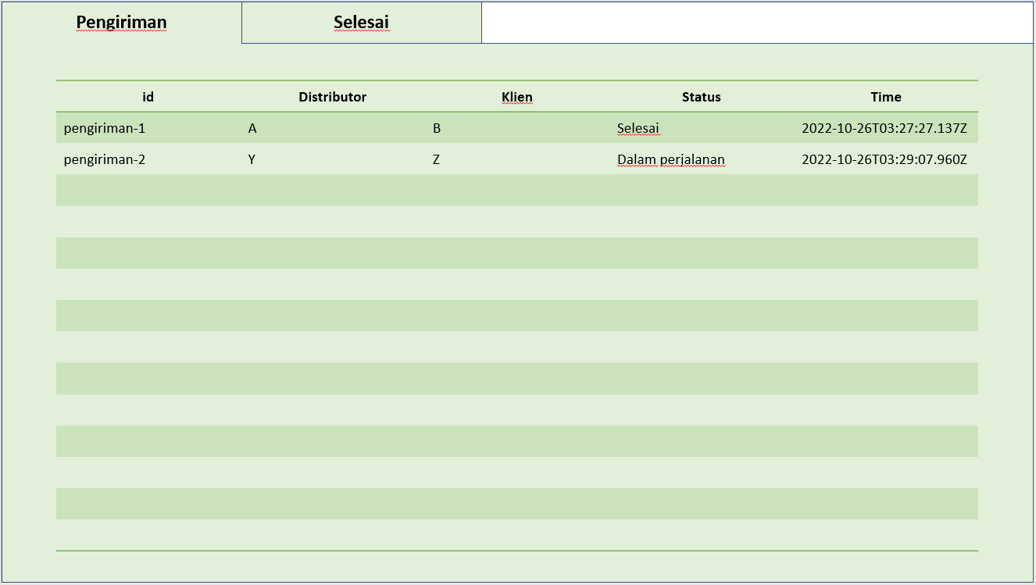

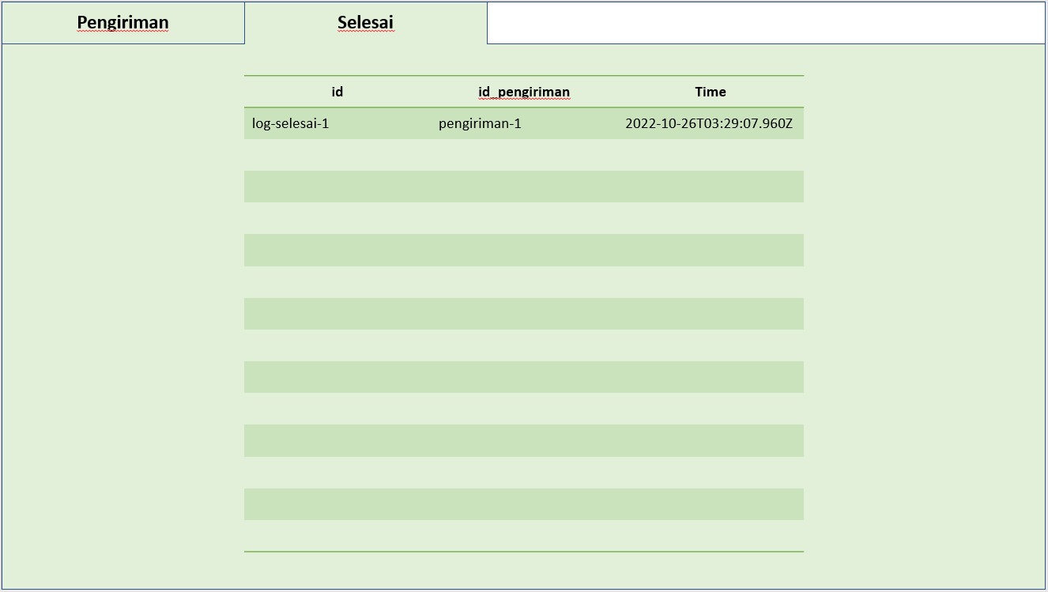

# Dependencies

Notif-service

# Milestone/Deployment Strategy

Phase 1:

* Analysis
* RFC
* Timeline and task

Phase 2:

* Create database
* Create, Read, Update Request pengiriman

Phase 3:

* Testing

Phase 4:

* Deployment

# Data Results

**Database baru**

**ERD**

|  |  |
| --- | --- |
| Pengiriman | |
| id | PK |
| distributor |  |
| klien |  |
| status |  |
| time |  |

|  |  |
| --- | --- |
| Selesai | |
| id | PK |
| id_pengiriman | FK |
| time |  |

**Table description**

Table ‘Pengiriman’:

|  |  |  |
| --- | --- | --- |
| Column | Type | Desc |
| id | varchar | id kargo pengiriman; Primary key |
| distributor | text | Nama distributor |
| klien | text | Nama klien |
| status | text | Status pengiriman; default: “dalam perjalanan”; menjadi “selesai” saat kiriman sampai |
| time | timestampz | Waktu mulai pengiriman (dalam format ISO) |

Table ‘Selesai’:

|  |  |  |
| --- | --- | --- |
| Column | Type | Desc |
| id | varchar | id log pengiriman selesai; Primary key |
| id_pengiriman | varchar | id pengiriman; foreign key |
| time | timestampz | Waktu kiriman sampai (dalam format ISO) |

# Drawbacks/Risks

# Alternatives

# Unresolved/Future Possibilities