NAMA: MUHAMMAD FAISAL JORDAN

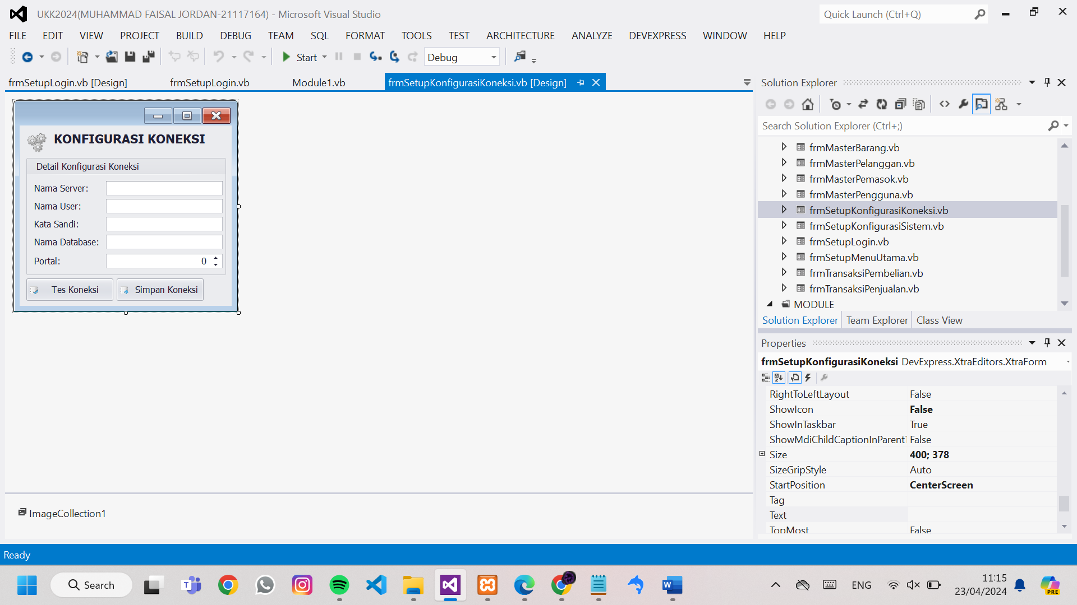

Imports MySql.Data.MySqlClient

Public Class frmSetupKonfigurasiKoneksi

'menampilkan isi my.settings ke komponen pada konfigurasi koneksi

Sub TampilMySetting()

txtNamaServer.Text = My.Settings.KonNamaServer

txtNamaUser.Text = My.Settings.KonNamaUser

txtKataSandi.Text = My.Settings.KonKataSandi

txtNamaDatabase.Text = My.Settings.KonNamaDatabase

txtPortal.Value = My.Settings.KonPortal

End Sub

Sub TesKoneksi()

'pengecekan inputan apakah sudah terisi apa belum

If txtNamaServer.Text = "" Or txtNamaUser.Text = "" Or txtNamaDatabase.Text = "" Or txtPortal.Value = 0 Then

MessageBox.Show("Nama Server, Nama User, Nama Database dan Portal wajib di isi.", "validasi", MessageBoxButtons.OK, MessageBoxIcon.Warning)

Exit Sub 'membatalkan koding tes koneksi

End If

Try

'melakukan koneksi berdasarkan inputan yang ada di komponen konfigurasi koneksi

Dim Alamat As String = "server=" & txtNamaServer.Text & ";user id=" & txtNamaUser.Text & ";password=" & txtKataSandi.Text & ";port=" & txtPortal.Value & ""

Dim Koneksi As New MySqlConnection(Alamat)

Koneksi.Open()

Koneksi.Close()

MessageBox.Show("Koneksi Berhasil.", "Informasi", MessageBoxButtons.OK, MessageBoxIcon.Information)

Catch ex As Exception

MessageBox.Show("Koneksi Gagal. " & ex.Message, "Informasi", MessageBoxButtons.OK, MessageBoxIcon.Warning)

End Try

End Sub

Sub SimpanKoneksi()

'pengecekan inputan apakah sudah terisi apa belum

If txtNamaServer.Text = "" Or txtNamaUser.Text = "" Or txtNamaDatabase.Text = "" Or txtPortal.Value = 0 Then

MessageBox.Show("Nama Server, Nama User, Nama Database dan Portal wajib di isi.", "validasi", MessageBoxButtons.OK, MessageBoxIcon.Warning)

Exit Sub 'membatalkan koding tes koneksi

End If

Try

'melakukan koneksi berdasarkan inputan yang ada di komponen konfigurasi koneksi

Dim Alamat As String = "server=" & txtNamaServer.Text & ";user id=" & txtNamaUser.Text & ";password=" & txtKataSandi.Text & ";port=" & txtPortal.Value & ""

Dim Koneksi As New MySqlConnection(Alamat)

Koneksi.Open()

Koneksi.Close()

'menyimpan hasil settingan ke my.setting

My.Settings.KonNamaServer = txtNamaServer.Text

My.Settings.KonNamaUser = txtNamaUser.Text

My.Settings.KonKataSandi = txtKataSandi.Text

My.Settings.KonNamaDatabase = txtNamaDatabase.Text

My.Settings.KonPortal = txtPortal.Value

My.Settings.Save()

Me.Close()

Catch ex As Exception

MessageBox.Show("Koneksi Gagal. " & ex.Message, "Informasi", MessageBoxButtons.OK, MessageBoxIcon.Warning)

End Try

End Sub

Private Sub frmSetupKonfigurasiKoneksi_KeyDown(sender As Object, e As KeyEventArgs) Handles Me.KeyDown

'tempat shortcut

Select Case e.KeyCode

Case e.Control And Keys.T

TesKoneksi()

Case e.Control And Keys.S

SimpanKoneksi()

Case Keys.Escape

Me.Close()

End Select

End Sub

Private Sub frmSetupKonfigurasiKoneksi_Load(sender As Object, e As EventArgs) Handles MyBase.Load

Me.KeyPreview = True

txtKataSandi.Properties.UseSystemPasswordChar = True

TampilMySetting()

End Sub

Private Sub SimpleButton1_Click(sender As Object, e As EventArgs) Handles SimpleButton1.Click

TesKoneksi()

End Sub

Private Sub SimpleButton2_Click(sender As Object, e As EventArgs) Handles SimpleButton2.Click

SimpanKoneksi()

End Sub

Private Sub PictureEdit2_EditValueChanged(sender As Object, e As EventArgs) Handles PictureEdit2.EditValueChanged

End Sub

End Class