NAMA : MUHAMMAd FAISAL JORDAN

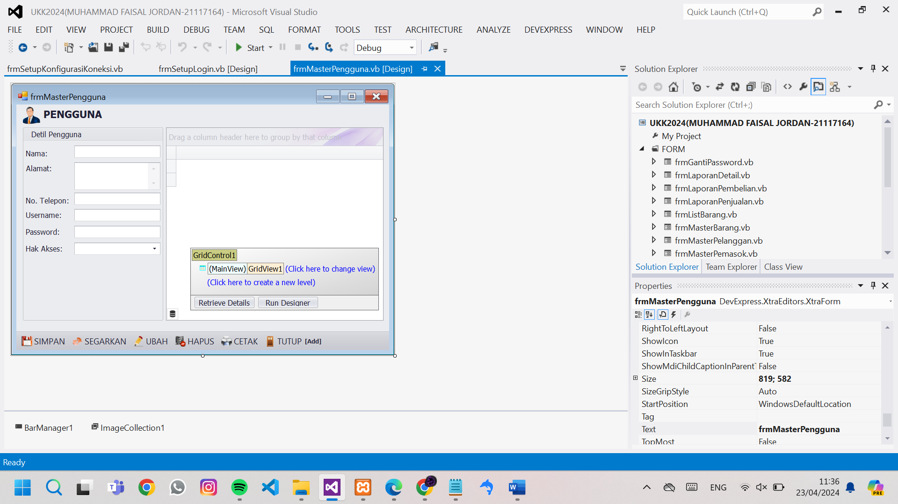

Public Class frmMasterPengguna

Dim Tampung As New DataTable

Dim ID As Integer

Sub TampilData()

Tampung = EksekusiSQL("select * from pengguna")

GridControl1.DataSource = Tampung

GridView1.Columns("PASSWORD").Visible = False 'sembunyikan password

GridView1.BestFitColumns() 'MERapikan tampilan isi kolom

End Sub

Sub Segarkan()

TampilData()

ID = 0

txtNama.Text = ""

txtAlamat.Text = ""

txtNomerTelepon.Text = ""

txtUsername.Text = ""

txtPassword.Text = ""

txtHakAkses.SelectedIndex = -1

txtNama.Focus() 'arahkan kursor ke txtnama

End Sub

Sub Simpan()

'validasi inputan

If txtNama.Text = "" Or txtUsername.Text = "" Or txtPassword.Text = "" Or txtHakAkses.Text = "" Then

MessageBox.Show("Nama, Username, Password, dan HakAkses wajib di isi.", "validasi", MessageBoxButtons.OK, MessageBoxIcon.Warning)

Exit Sub

End If

If ID = 0 Then

'input data baru

EksekusiSQL("INSERT INTO `pengguna`(`NAMA_PENGGUNA`, `ALAMAT`, `NOMOR_TELEPON`, `USERNAME`, `PASSWORD`, `HAK_AKSES`) VALUES ('" & txtNama.Text & "','" & txtAlamat.Text & "','" & txtNomerTelepon.Text & "','" & txtUsername.Text & "','" & txtPassword.Text & "','" & txtHakAkses.Text & "')")

Segarkan()

MessageBox.Show("Data sukses ditambahkan.", "Informasi", MessageBoxButtons.OK, MessageBoxIcon.Information)

Else

'ubah data lama

EksekusiSQL("UPDATE `pengguna` SET `NAMA_PENGGUNA`='" & txtNama.Text & "',`ALAMAT`='" & txtAlamat.Text & "',`NOMOR_TELEPON`='" & txtNomerTelepon.Text & "',`USERNAME`='" & txtUsername.Text & "',`PASSWORD`='" & txtPassword.Text & "',`HAK_AKSES`='" & txtHakAkses.Text & "' WHERE `ID_PENGGUNA`='" & ID & "'")

Segarkan()

MessageBox.Show("Data sukses diubah.", "Informasi", MessageBoxButtons.OK, MessageBoxIcon.Information)

End If

End Sub

Sub Ubah()

'pengecekan data pada tabel ada atau tidak

If GridView1.RowCount <= 0 Then

MessageBox.Show("data tidak ada.", "Peringatan", MessageBoxButtons.OK, MessageBoxIcon.Warning)

Exit Sub

End If

'MENGISIKAN DATA YANG DI PILIH PADA TABEL KE INPUTAN

ID = GridView1.GetFocusedRowCellValue("ID_PENGGUNA")

txtNama.Text = GridView1.GetFocusedRowCellValue("NAMA_PENGGUNA")

txtAlamat.Text = GridView1.GetFocusedRowCellValue("ALAMAT")

txtNomerTelepon.Text = GridView1.GetFocusedRowCellValue("NOMOR_TELEPON")

txtUsername.Text = GridView1.GetFocusedRowCellValue("USERNAME")

txtPassword.Text = GridView1.GetFocusedRowCellValue("PASSWORD")

txtHakAkses.Text = GridView1.GetFocusedRowCellValue("HAK_AKSES")

txtNama.Focus()

End Sub

Sub Hapus()

'pengecekan data pada tabel ada atau tidak

If GridView1.RowCount <= 0 Then

MessageBox.Show("data tidak ada.", "Peringatan", MessageBoxButtons.OK, MessageBoxIcon.Warning)

Exit Sub

End If

If MessageBox.Show("data akan di hapus . lanjutkan?", "Validasi", MessageBoxButtons.YesNo, MessageBoxIcon.Question) = Windows.Forms.DialogResult.Yes Then

'melakukan pengahapusan data

EksekusiSQL("delete from pengguna where ID_PENGGUNA= '" & GridView1.GetFocusedRowCellValue("ID_PENGGUNA") & "'")

Segarkan()

End If

End Sub

Sub Cetak()

GridControl1.ShowRibbonPrintPreview()

End Sub

Sub Tutup()

Me.Close()

End Sub

Private Sub frmMasterPengguna_KeyDown(sender As Object, e As KeyEventArgs) Handles Me.KeyDown

Select Case e.KeyCode

Case e.Control And Keys.S

Simpan()

Case Keys.F5

Segarkan()

Case Keys.F2

Ubah()

Case e.Control And Keys.D

Hapus()

Case e.Control And Keys.P

Cetak()

Case Keys.Escape

Tutup()

End Select

End Sub

Private Sub frmMasterPengguna_Load(sender As Object, e As EventArgs) Handles MyBase.Load

Me.KeyPreview = True 'mengaktifkan shortcut

EksekusiRapikanGridView(GridView1)

txtPassword.Properties.UseSystemPasswordChar = True

txtHakAkses.Properties.TextEditStyle = DevExpress.XtraEditors.Controls.TextEditStyles.DisableTextEditor

Segarkan()

End Sub

Private Sub BarButtonItem2_ItemClick_1(sender As Object, e As DevExpress.XtraBars.ItemClickEventArgs) Handles BarButtonItem2.ItemClick

Simpan()

End Sub

Private Sub BarButtonItem3_ItemClick(sender As Object, e As DevExpress.XtraBars.ItemClickEventArgs) Handles BarButtonItem3.ItemClick

Segarkan()

End Sub

Private Sub BarButtonItem4_ItemClick(sender As Object, e As DevExpress.XtraBars.ItemClickEventArgs) Handles BarButtonItem4.ItemClick

Ubah()

End Sub

Private Sub BarButtonItem5_ItemClick(sender As Object, e As DevExpress.XtraBars.ItemClickEventArgs) Handles BarButtonItem5.ItemClick

Hapus()

End Sub

Private Sub BarButtonItem6_ItemClick(sender As Object, e As DevExpress.XtraBars.ItemClickEventArgs) Handles BarButtonItem6.ItemClick

Cetak()

End Sub

Private Sub BarButtonItem7_ItemClick(sender As Object, e As DevExpress.XtraBars.ItemClickEventArgs) Handles BarButtonItem7.ItemClick

Tutup()

End Sub

End Class