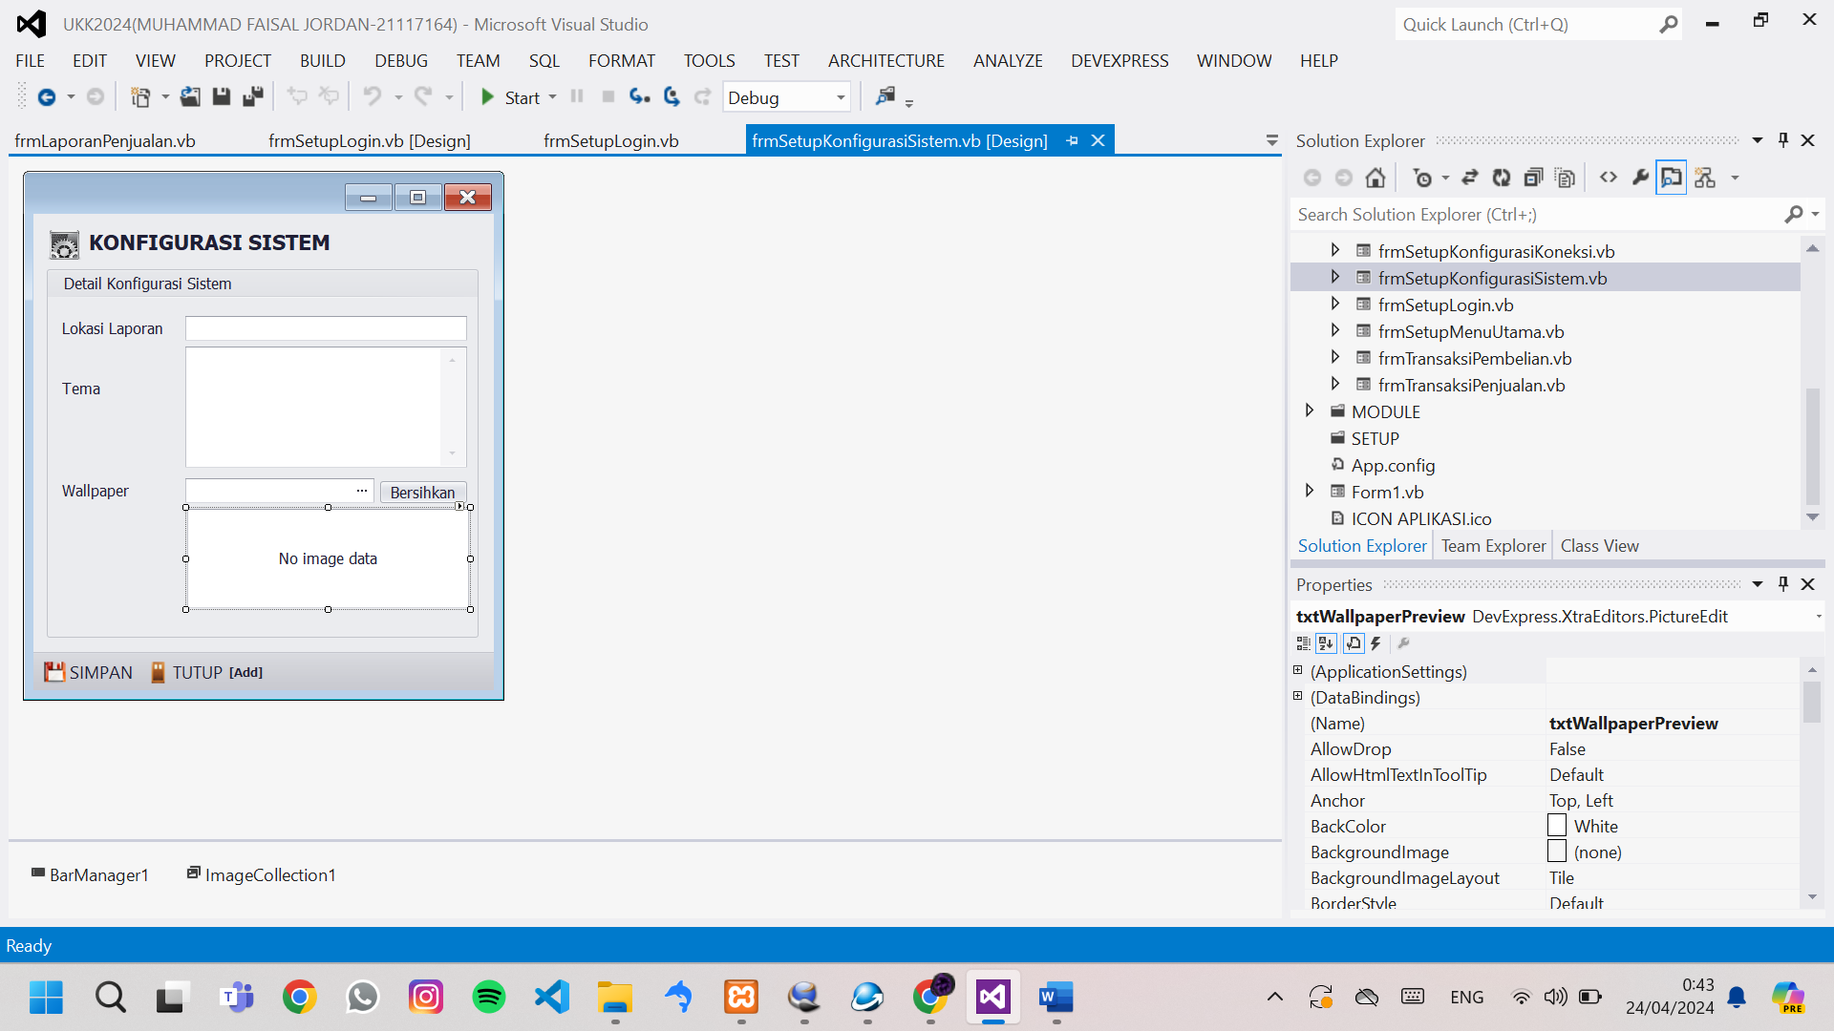

Imports DevExpress.XtraBars.Helpers

Imports DevExpress.LookAndFeel

Public Class frmSetupKonfigurasiSistem

Sub TampilWallpaper(ByVal LokasiGambar As String)

Try

txtWallpaperPreview.Properties.SizeMode = DevExpress.XtraEditors.Controls.PictureSizeMode.Stretch

txtWallpaperPreview.Image = Image.FromFile(LokasiGambar)

Catch ex As Exception

End Try

End Sub

Sub TampilPengaturan()

txtLokasiLaporan.Text = My.Settings.LokasiLaporan

'tampilkan isian tema ke galeri

DevExpress.Skins.SkinManager.EnableFormSkins()

DevExpress.UserSkins.BonusSkins.Register()

UserLookAndFeel.Default.SetSkinStyle(My.Settings.Tema)

SkinHelper.InitSkinGallery(txtTema, True)

txtWallpaper.Text = My.Settings.LokasiWallpaper

End Sub

Sub SimpanPengaturan()

My.Settings.LokasiLaporan = txtLokasiLaporan.Text

'simpan pilihan tema dari galerycontrol

Dim NamaSkin = txtTema.Gallery.GetCheckedItem.Value

If NamaSkin = "Xmas (Blue)" Then

NamaSkin = "Xmas 2008 Blue"

ElseIf NamaSkin = "Summer" Then

NamaSkin = "Summer 2008"

ElseIf NamaSkin = "Office 2013 White" Then

NamaSkin = "Office 2013"

End If

My.Settings.Tema = ""

My.Settings.LokasiWallpaper = txtWallpaper.Text

My.Settings.Save()

'tampilkan wallpaper ke dalam menu utama

Try

If My.Settings.LokasiWallpaper = "" Then

frmSetupMenuUtama.BackgroundImage = Nothing

Else

frmSetupMenuUtama.BackgroundImageLayout = ImageLayout.Stretch

frmSetupMenuUtama.BackgroundImage = Image.FromFile(My.Settings.LokasiWallpaper)

End If

Catch ex As Exception

End Try

Me.Close()

End Sub

Sub Tutup()

Me.Close()

End Sub

Private Sub frmSetupKonfigurasiSistem_KeyDown(sender As Object, e As KeyEventArgs) Handles Me.KeyDown

Select Case e.KeyCode

Case e.Control And Keys.S

SimpanPengaturan()

Case Keys.Escape

Tutup()

End Select

End Sub

Private Sub frmSetupKonfigurasiSistem_Load(sender As Object, e As EventArgs) Handles MyBase.Load

Me.KeyPreview = True

txtWallpaper.ReadOnly = True

TampilPengaturan()

End Sub

Private Sub txtWallpaper_ButtonClick(sender As Object, e As DevExpress.XtraEditors.Controls.ButtonPressedEventArgs) Handles txtWallpaper.ButtonClick

'koding untuk memilih gambar

Dim OPD As New OpenFileDialog

OPD.Filter = "JPG|*.jpg|PNG|*.png"

If OPD.ShowDialog = Windows.Forms.DialogResult.OK Then

txtWallpaper.Text = OPD.FileName

TampilWallpaper(OPD.FileName)

End If

End Sub

Private Sub SimpleButton1_Click(sender As Object, e As EventArgs) Handles SimpleButton1.Click

txtWallpaper.Text = ""

txtWallpaperPreview.Image = Nothing

End Sub

Private Sub BarButtonItem2_ItemClick(sender As Object, e As DevExpress.XtraBars.ItemClickEventArgs) Handles BarButtonItem2.ItemClick

SimpanPengaturan()

End Sub

Private Sub BarButtonItem7_ItemClick(sender As Object, e As DevExpress.XtraBars.ItemClickEventArgs) Handles BarButtonItem7.ItemClick

Tutup()

End Sub

End Class