[Zipguy](http://wiki.tcl.tk/13606) 2013-02-09 - You can find out my email address by clicking on [Zipguy](http://wiki.tcl.tk/13606).

This page has all of the screens from the program I copied from [Colors with Names](http://wiki.tcl.tk/16166).

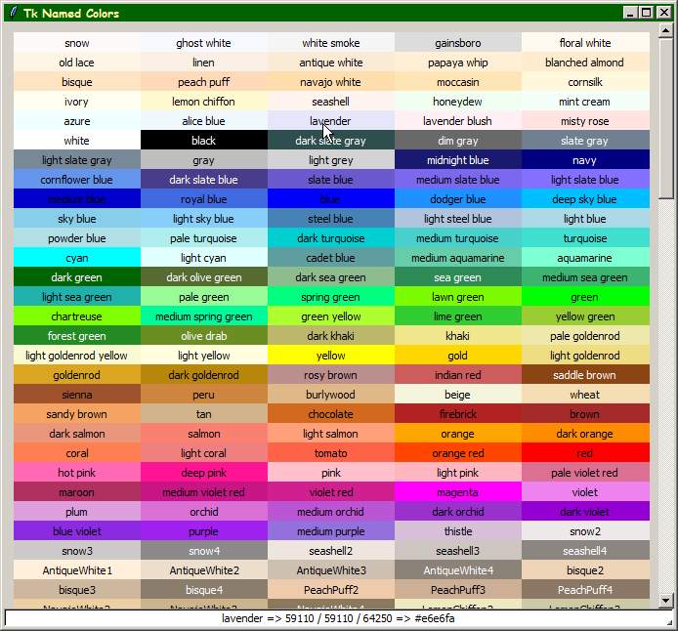

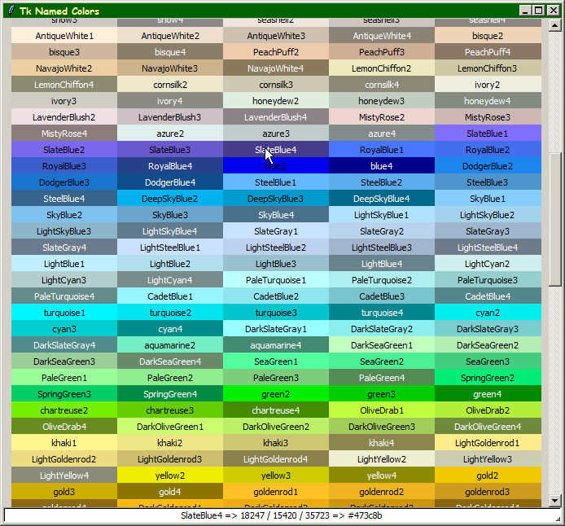

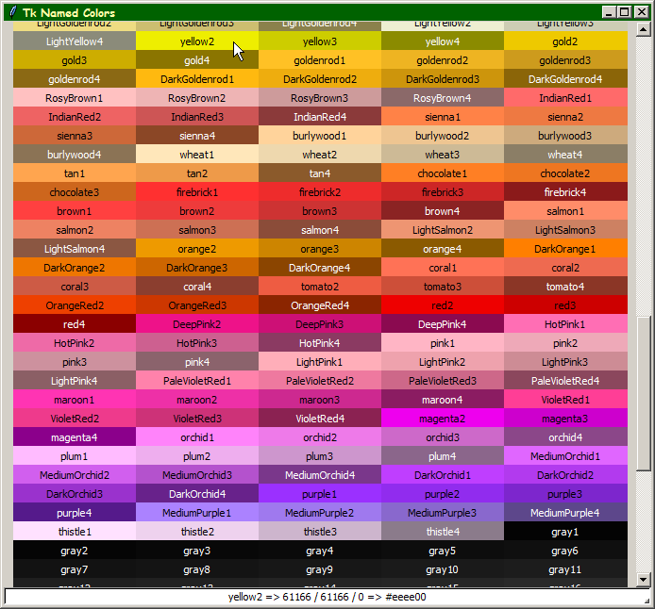

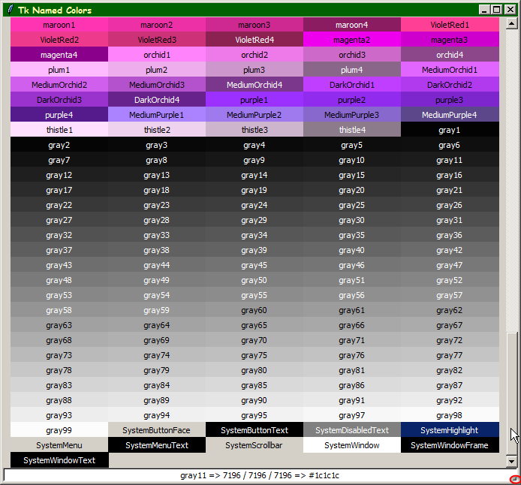

Notice the System colors (E.G. SystemButtonFace) named at the bottom of the screen above. This is based on Windows I think. I'm running Windows 7. Also, I like the way it will change the color your mouse is over. For example, grey11 is on the screen above.

You did try real hard to hide that little, tiny button but I did find it:

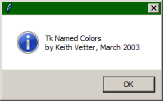

(it's in red somewhere above)