BLUETOOTH BASED HOME

AUTOMATION USING ARDUINO

**Abstract:**

Home automation systems have gained popularity in recent years, paralleling the advances in the concept of the Internet of Things. The current project presents the implementation of an inexpensive home automation system, within the framework of assistive technology. The system implementation is based on the Arduino microcontroller, with Bluetooth communications capability, and it is designed for use by the elderly and people with disabilities. The system is user-friendly, with an intuitive interface implemented on an Android based smart phone. Demonstrations show that the system facilitates control of home appliances, lights, heating, cooling systems and security devices by the intended users, i.e., the elderly and the disabled.

**Introduction:**

To develop a Bluetooth based home automation system with Arduino UNO Board and an Android application.

Remote controlled home automation system provides a simpler solution with Android application technology.

Remote operation is achieved by any smart-phone/Tablet etc., with Android OS, upon a GUI (Graphical User Interface) based touch screen operation.

**Project Proposal:**

This project is about “Home Automation System”. The fundamental idea of this simple [electronic project](http://electricaltechnology.org/2013/09/simple-electrical-electronics-projects.html) is to control home electrical appliances wirelessly through android mobile. It can be used for people who has disabilities with movement. Using this device people can control home appliances easily and wirelessly from anywhere in the home by using mobile app.

**Block Diagram:**

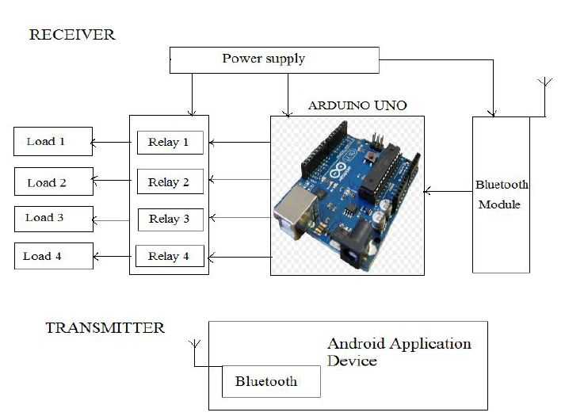

### ****Components:****

* 1. Aurduino UNO
  2. Bluetooth Module (HC-05)
  3. 4 Channel 5V Relay Module
  4. Jumper Wire
  5. 5V Power supply
  6. Android phone with Bluetooth

**Description of Components:**

**Arduino Uno**:

Arduino Uno is a microcontroller board based on the ATmega328P (datasheet). It has 14 digital input/output pins (of which 6 can be used as PWM outputs), 6 analog inputs, a 16 MHz quartz crystal, a USB connection, a power jack, an ICSP header and a reset button. [1]

Arduino is an open source computer hardware and software company, project, and user community that designs and manufactures [single-board microcontrollers](https://en.wikipedia.org/wiki/Single-board_microcontroller) and [microcontroller](https://en.wikipedia.org/wiki/Microcontroller) kits for building digital devices and interactive objects that can sense and control objects in the physical world.

Arduino board designs use a variety of microprocessors and controllers. The boards are equipped with sets of digital and analog [input/output](https://en.wikipedia.org/wiki/Input/output) (I/O) pins that may be interfaced to various expansion boards (shields) and other circuits. The boards feature serial communications interfaces, including [Universal Serial Bus](https://en.wikipedia.org/wiki/Universal_Serial_Bus) (USB) on some models, which are also used for loading programs from personal computers. The microcontrollers are typically programmed using a dialect of features from the programming languages [C](https://en.wikipedia.org/wiki/C_(programming_language)) and [C++](https://en.wikipedia.org/wiki/C%2B%2B). In addition to using traditional compiler tool chains, the Arduino project provides an [integrated development environment](https://en.wikipedia.org/wiki/Integrated_development_environment) (IDE) based on the [Processing](https://en.wikipedia.org/wiki/Processing_(programming_language)) language project. [2]

**Bluetooth Module (HC-05):**

* For the communication between mobile phone and microcontroller Bluetooth module (HC-05) is used.
* HC-05 is low power 1.8V operation and is easy to use with Bluetooth SPP (serial port protocol).
* Serial port Bluetooth module have a Bluetooth 2.0+EDR (enhanced data rate), 3Mbps modulation with complete 2.4GHZ radio transceiver and baseband. [3]
* Using Bluetooth profile and android platform architecture different type of Bluetooth applications can be developed.

**Relay:**

* Relay is basically an electromagnetic switch which can be turn on and off by an applying the voltage across its contacts. [4]
* In this project used a 5V 4-channel relay.

**Working Procedure:**

1. Bluetooth signal is sent by android device.
2. Signal data received by Bluetooth receiver.
3. Bluetooth module sends the data to Arduino through serial port (tx & rx).
4. Arduino processes the data and sends high/low signal to output pin.
5. Based on Arduino high/low signal the relay turns on/off electrical devices.

**Conclusion:**

So we can use this device to simplify our daily lifestyle. It is a robust and easy to use system. There is no need for extra training of that person who is using it. All the control would be in our hands by using this home automation system. This project can provide the facility of monitoring all the appliances with in the communication range through Bluetooth. The schematic of Arduino is open source, for the future enhancement of the project board can be extended to add more hardware features.

**REFERENCES:**

1. <https://store.arduino.cc/usa/arduino-uno-rev3> Accessed on 12th December 2017 at 10:30 pm.
2. <https://www.elexp.com/PDFs/01ARDUNO.pdf> Accessed on 12th December 2017 at 11:00 pm.
3. <https://wiki.eprolabs.com/index.php?title=Bluetooth_Module_HC-05> Accessed on 12th December 2017 at 11:30 pm.
4. <https://www.engineersgarage.com/electronic-components/relays> Accessed on 13th December 2017 at 12:00 pm.