Table of Contents

Installing the 64-bit Access database Engine 2

Testing file imports for various Excel file types (97,2003+, CSV) 3

Test 1: Import all the Excel file versions (.xls,.xlsx,CSV) 3

Test 2: Import all the excel file versions except Excel 97 (.xls) files 4

Installing Closed XML 5

# Installing the 64-bit Access database Engine

When you try to install the 64-bit Access driver on a machine with Microsoft Office preinstalled, you get this error message.

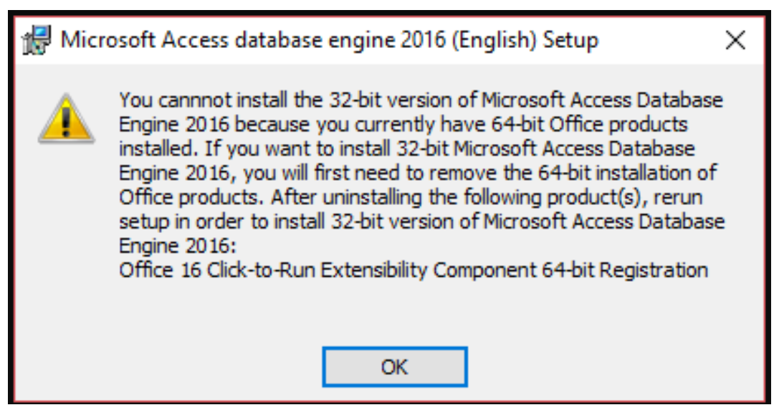

You can install access database with the following command.

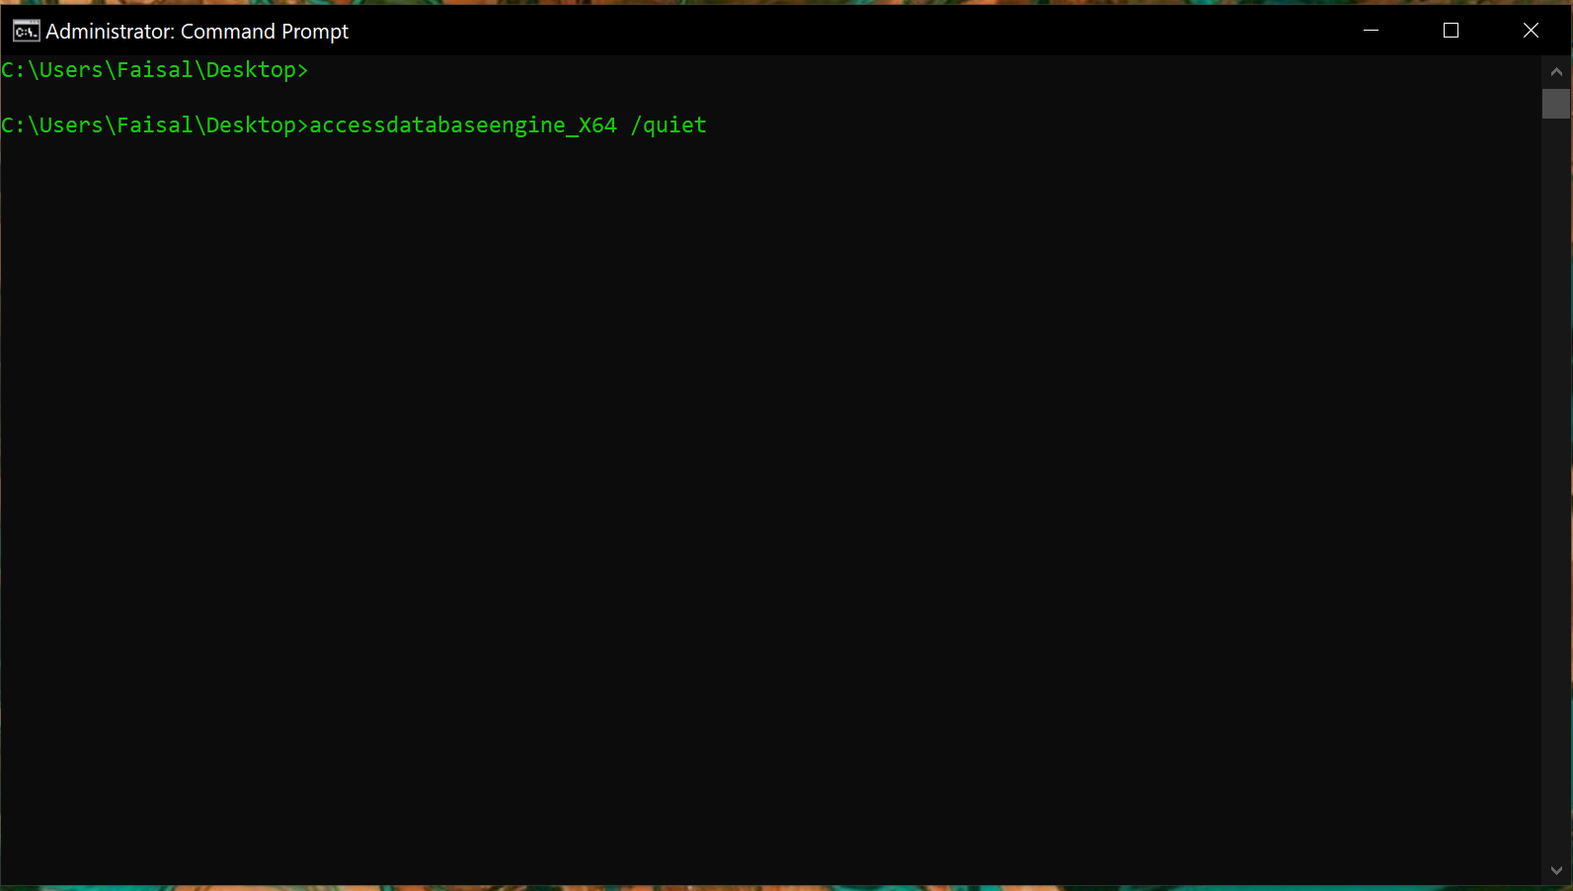

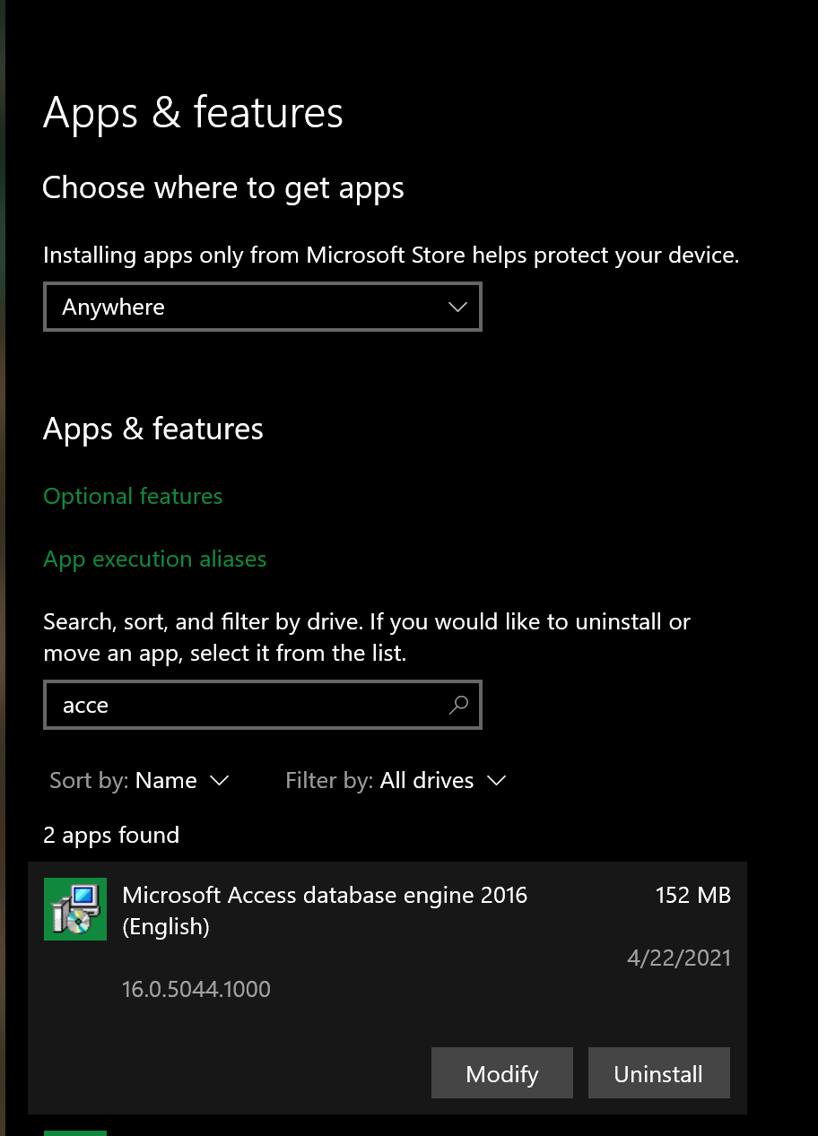  
This will be the only access database engine installed on the system and will be used as a baseline for all tests.

# Testing file imports for various Excel file types (97,2003+, CSV)

Create a package to import excel files of different versions using the Ace OleDb connection

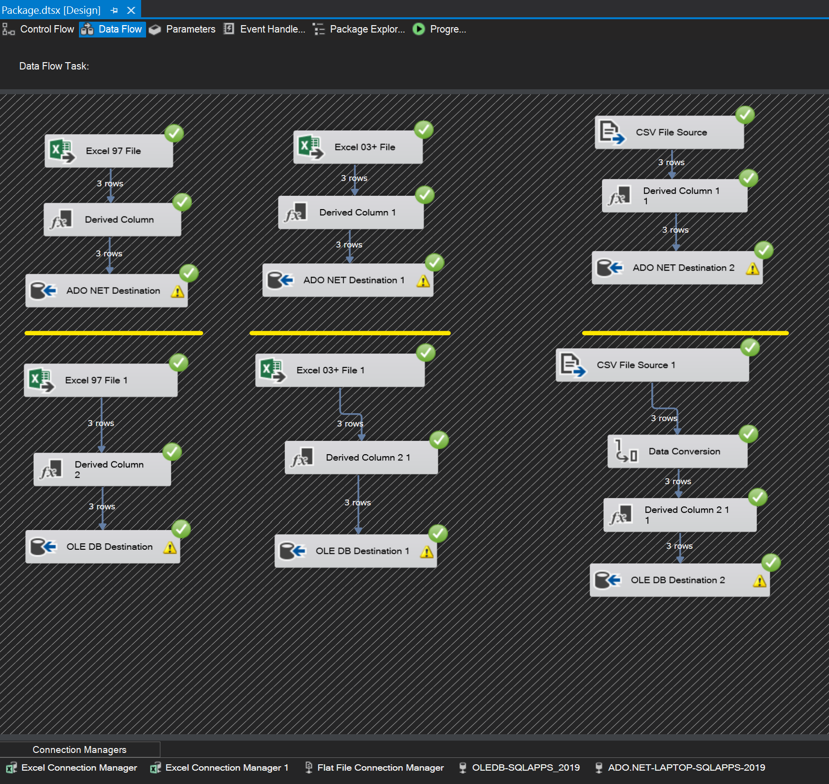

# Test 1: Import all the Excel file versions (.xls,.xlsx,CSV)

When running in 64-Bit mode the job fails with the following message.

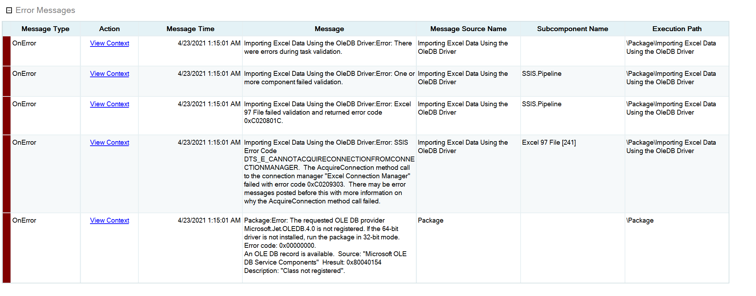

When running in 32-Bit mode the job successfully completes

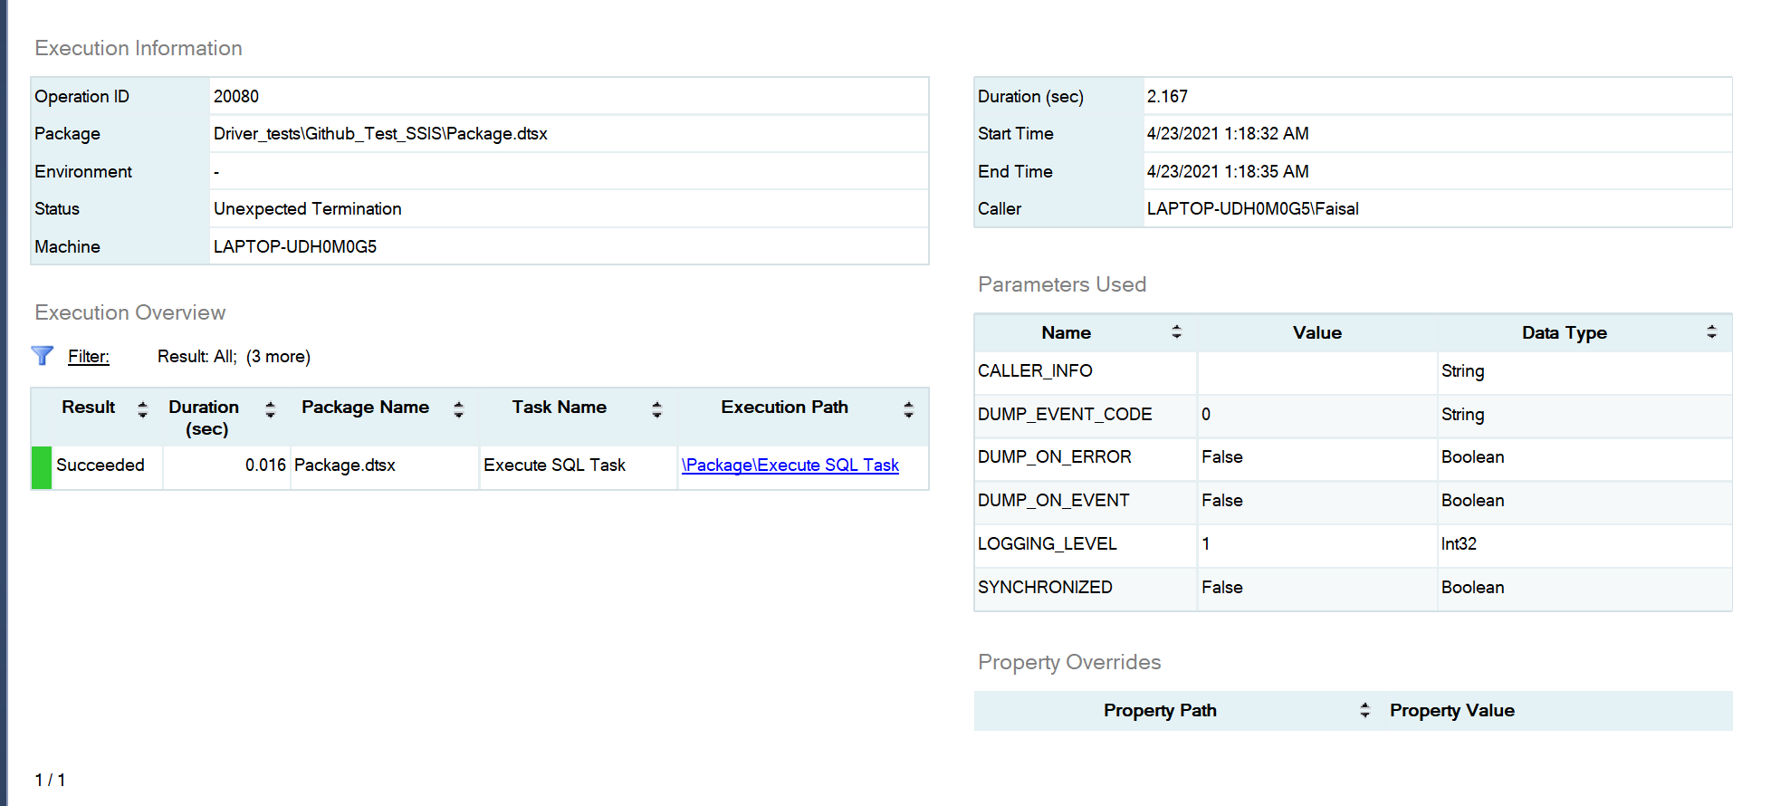

Database log

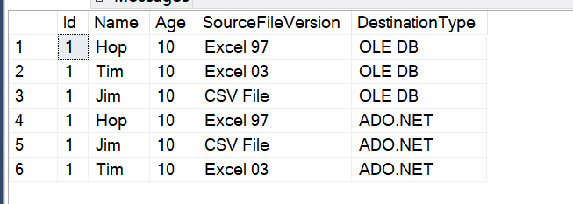

# Test 2: Import all the excel file versions except Excel 97 (.xls) files

When running in 64-Bit mode the job completes successfully

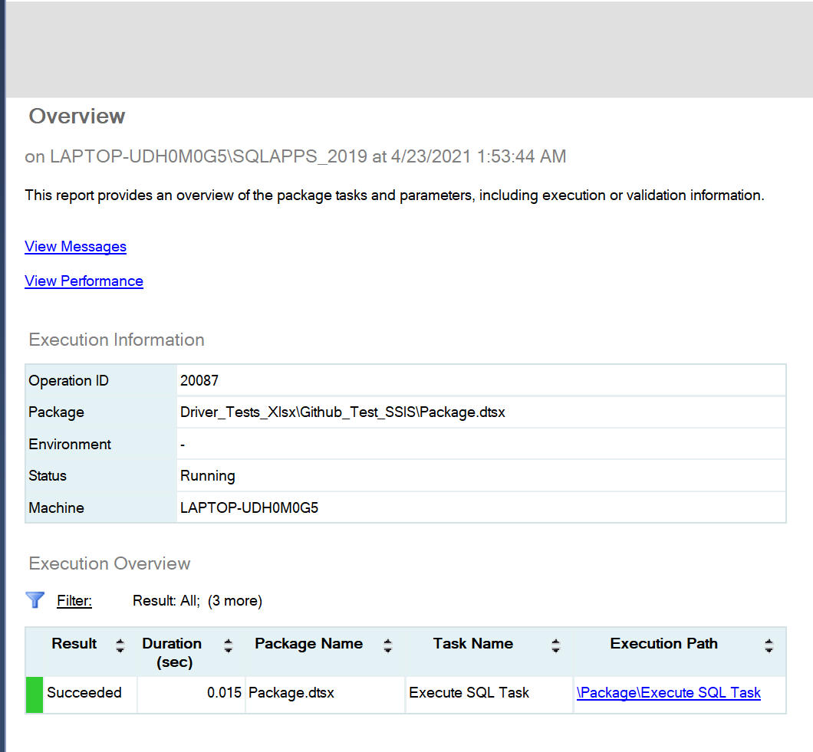

When running in 32-Bit mode the job completes successfully

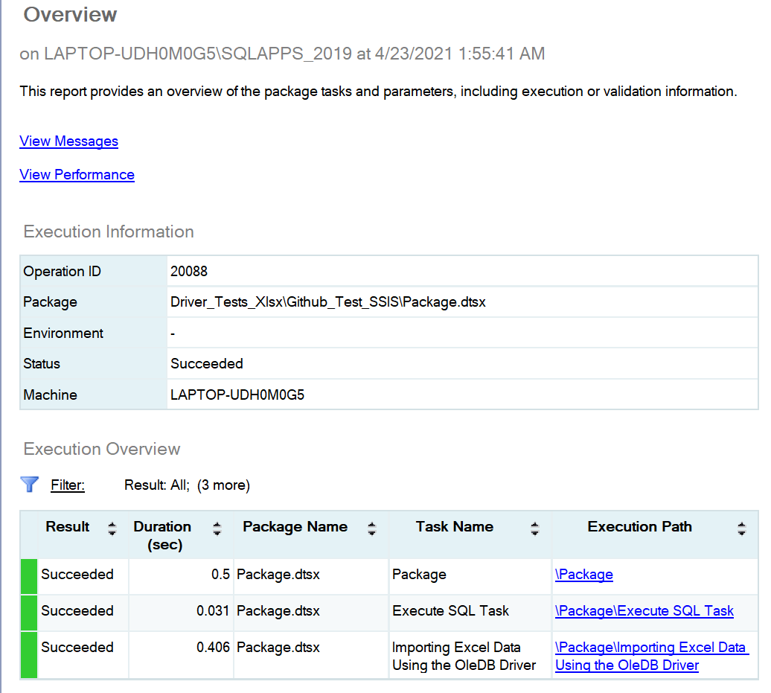

Database log

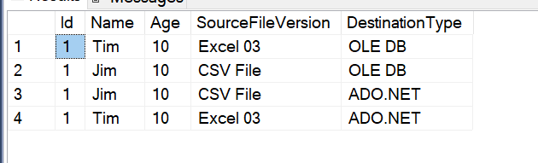

# Installing Closed XML

Added a script task and installed Closed XML v0.95.4

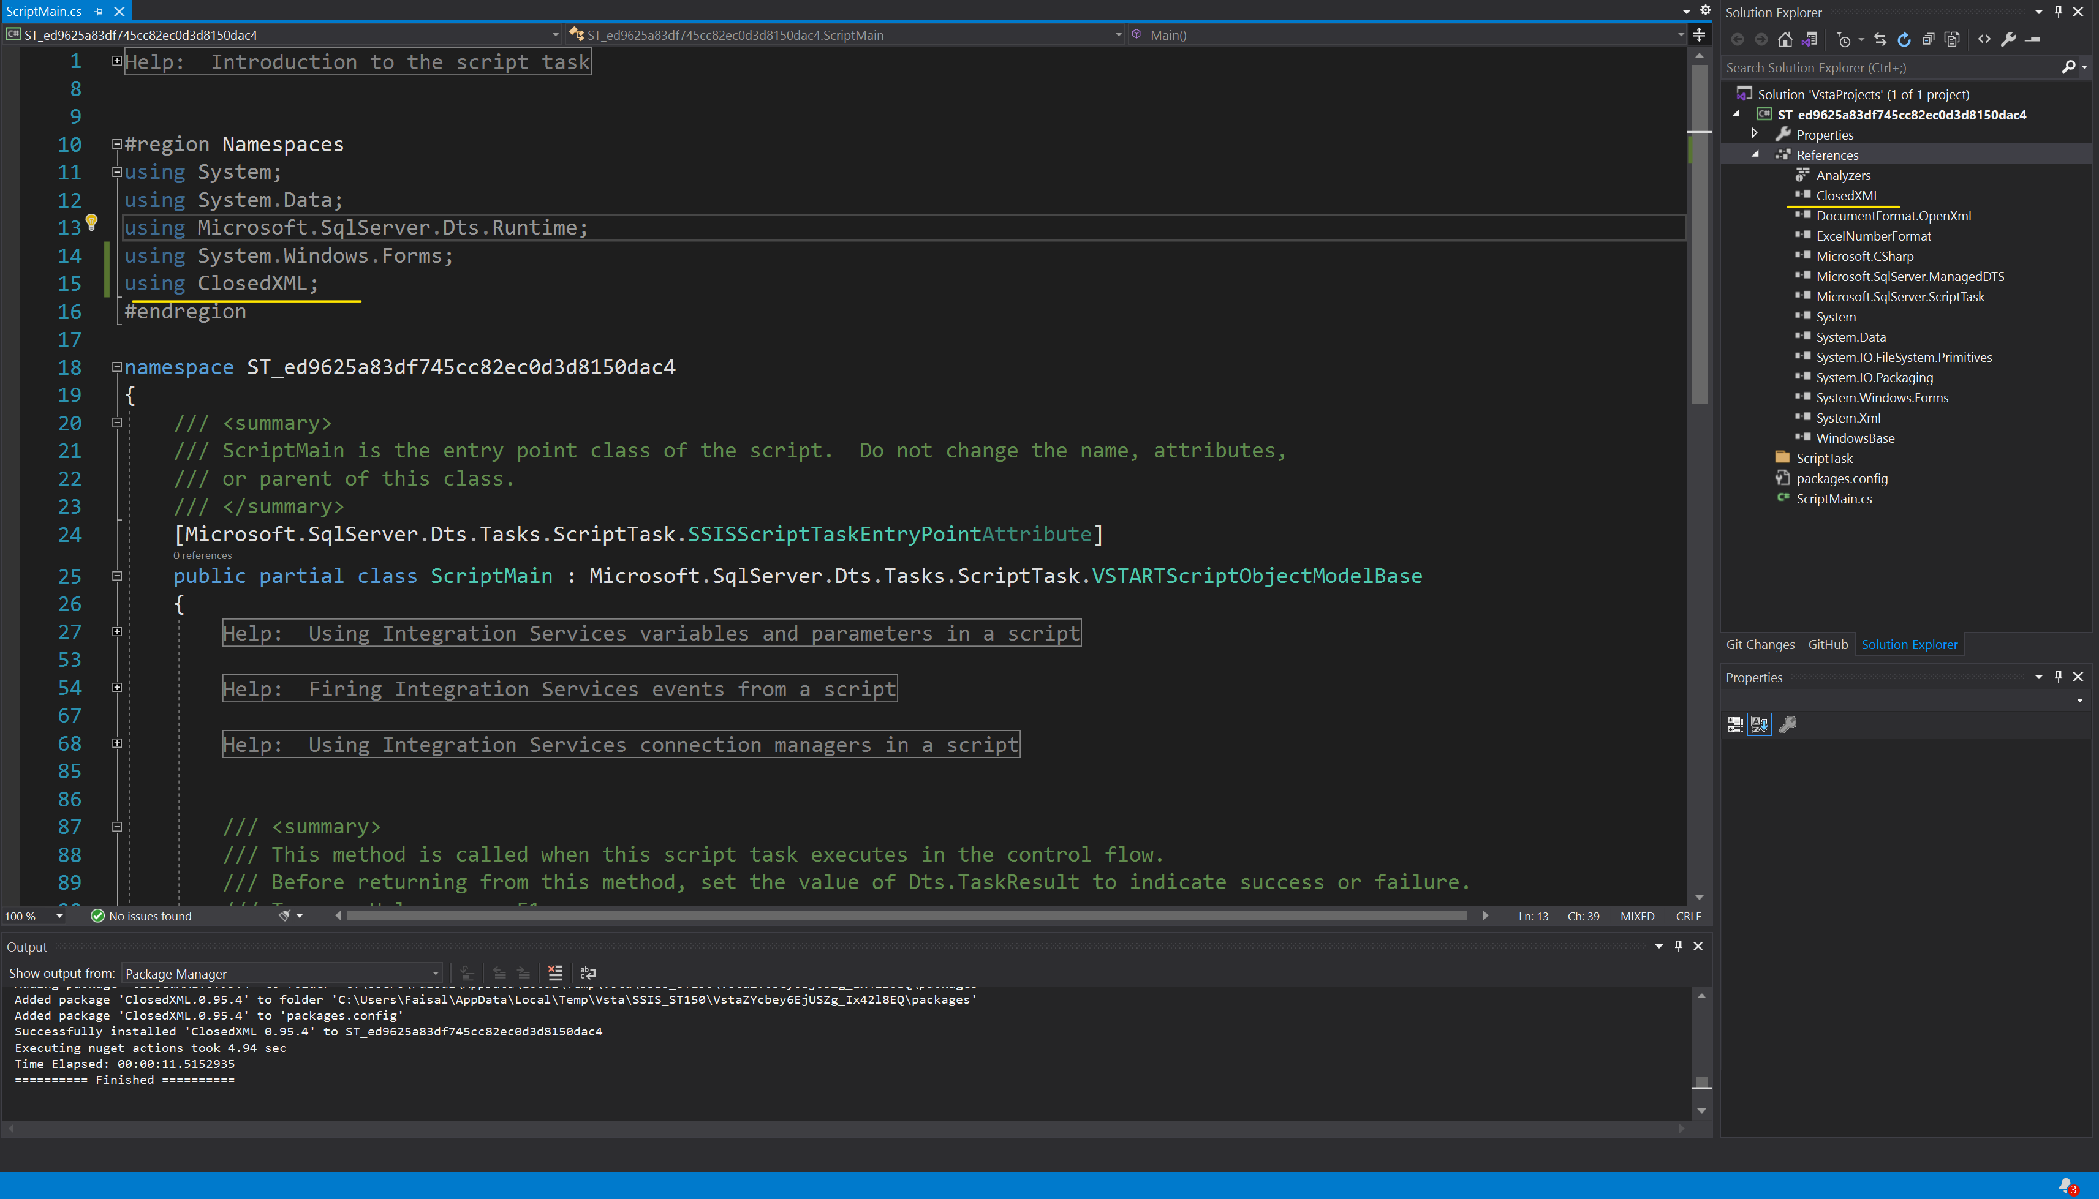

Saved the script task

Re-open the script task, the Closed Xml dll has been unloaded and the namespace has an warning confirming this.

