A1. Investigation and planning

Problem statement
The Scholarship Office administers Excellence Scholar and Access Scholar grants using spreadsheets, e-mail attachments and paper grade records. Duplicate semester entries, unverified grades, missed deadlines and inconsistent scholarship decisions delay renewal, and scholars cannot see whether their submission was received, verified or returned for correction. The Office needs a browser-based minimum viable system in which scholars submit semester academic summaries with a grade-document reference, and Scholarship Staff verify the evidence, evaluate policy compliance, record reasons and decide renewal.

Problem cause-effect analysis
ID | Cause | Effect | Addressed by
PCE1 | Records are scattered across spreadsheets, e-mail and paper with no unique-key rule. | Duplicate semester entries; staff cannot tell which record is current. | FR04, BR04
PCE2 | Grades are evaluated before the evidence is checked. | Decisions rest on unverified data and must be redone. | FR05, FR07, BR02
PCE3 | Deadlines are tracked by hand; no submission timestamp. | Late submissions are missed or judged inconsistently. | FR03, FR07, BR06
PCE4 | Policy thresholds live in staff memory and per-person spreadsheets; scholars get no status feedback. | Inconsistent decisions between programs; scholars repeatedly ask for status; renewal is delayed. | FR02, FR07, FR08, BR03, BR05

Scope and exclusions
In scope: Scholar and Scholarship Staff roles; scholar registration and program assignment; semester submission with validation and duplicate prevention; verification (Verified / Returned with reason) and correction; program-based compliance evaluation with reasons; explicit renewal decisions; dashboard, search and filters; audit history; persistence.
Exclusions: live Registrar API (the Registrar stays the source of official grades; the system never alters official grades), scholarship payment release, SMS gateway, machine-learning model, full appeal workflow, policy exceptions, and file upload (only a grade-document reference is stored).

Development tasks
ID | Task | Output
T1 | Create schema, keys, two policy records, test accounts, row-level security. | schema.sql, seed.sql
T2 | Implement scholar registration/assignment and semester submission with validation and duplicate check. | Submission form, submit_semester()
T3 | Implement verification, return-with-reason and correction/resubmission. | verify_submission(), resubmit_submission()
T4 | Implement compliance evaluation, renewal decisions, dashboard/search/filter, audit history, seed and run tests TC01-TC10. | evaluate_submission(), decide_renewal(), dashboard, test console

Risks and responses
ID | Risk | Response
R1 | Hosting or network access fails during the exam. | The app is static HTML/JS and runs from a local folder; README gives local run steps and the error is reported.
R2 | Access control implemented only by hiding buttons. | Enforce access with Postgres row-level security and SQL functions that check the caller role; prove it with TC08 and TC10.

A2. Stakeholders and elicitation
Stakeholder | Interest | Actual actor?
Scholar | Submit grades on time, see status, correct returned evidence, learn renewal result. | Yes - primary actor
Scholarship Staff | Verify evidence, apply policy consistently, record reasons, decide renewal, monitor progress. | Yes - primary actor
Registrar | Owns official grades; wants no unofficial grade altered. | No - source of truth only, no interaction with this system
Scholarship Office Head | Policy owner; wants dashboard totals and accountable decisions. | No - uses the Staff role in this MVP

Open-ended elicitation questions
- Q1 (verification): Walk me through how you check a scholar's grade document today. What makes you accept it, and what makes you send it back?
- Q2 (verification): When evidence is returned, what information should the scholar receive, and how should a corrected resubmission be handled?
- Q3 (deadlines): How do you currently decide whether a submission is on time, and what happens to one that arrives exactly at or just after the cut-off?
- Q4 (policy exceptions): Describe a case where you wanted to bend a policy rule. What was decided, who decided it, and how was the reason recorded?
- Q5 (access): Who should be able to see or change a scholar's record, and what problems have you had with the wrong person seeing it?
- Q6 (reports): Which numbers or lists do you need at the start of each semester, and how do you want to find a particular scholar?

A3. Requirements and business rules

Functional requirements
ID | Requirement (testable)
FR01 | The system shall authenticate users and enforce role access in the database: a scholar can read only their own submissions; staff can read and verify all submissions. Hiding buttons alone does not count.
FR02 | Staff shall register a scholar and assign exactly one of two persisted program policy records; evaluation shall read thresholds from that record.
FR03 | A scholar shall submit academic year, semester, GWA, enrolled units, failed, incomplete and dropped counts and a grade-document reference; the system shall record the submission timestamp and reject invalid input (GWA outside 1.00-5.00, negative or non-integer counts, missing reference) with a clear message.
FR04 | The system shall reject a second submission for the same scholar, academic year and semester.
FR05 | Staff shall mark pending evidence Verified or Returned; a reason is mandatory when returning.
FR06 | A scholar shall correct and resubmit a Returned submission; it returns to Pending verification and previous history is preserved.
FR07 | Staff shall evaluate only Verified submissions; the system shall show each policy check and list specific deficiency reasons (GWA, units, failed, incomplete, dropped, late) and set Compliant or With Deficiency.
FR08 | Staff shall explicitly record Approved or Held renewal with a note; Approved requires an evaluated Compliant record; scholars cannot change a decision.
FR09 | The dashboard shall show total assigned scholars, pending verification, compliant and with-deficiency counts for the selected semester, with search by student ID or name and filters by program and compliance.
FR10 | Data shall persist across refresh, and verification, evaluation and renewal changes shall be logged with actor, timestamp and note.

Non-functional requirements (measurable)
ID | Requirement | Measure
NFR01 | Performance: dashboard and search respond quickly. | Dashboard for 100 scholars loads in 3 seconds or less on a normal broadband connection; filter/search updates in under 1 second.
NFR02 | Persistence: no data loss on refresh or re-login. | 100% of saved submissions, decisions and history rows are present after refresh and a new session.
NFR03 | Security: no secret or write bypass in the client. | 0 service-role keys or passwords in source; 100% of data changes go through role-checking SQL functions; direct table writes are denied.
NFR04 | Usability: errors are clear and the task is quick. | Every rejected input shows a specific message within 1 second; a scholar completes a submission in 2 minutes or less.

Business rules
ID | Rule
BR01 | A scholar may access only their own records; Scholarship Staff may access all records. Only staff may verify, evaluate, assign programs and decide renewal.
BR02 | Missing or unverified evidence prevents final evaluation. Only Verified submissions may be evaluated. The Registrar remains the source of official grades; the system never alters them or releases payments.
BR03 | Policy selection: each scholar has one program. Excellence Scholar: GWA <= 2.00, units >= 18, failed 0, incomplete 0, dropped 0. Access Scholar: GWA <= 2.50, units >= 15, failed 0, incomplete 0, dropped <= 1. Grading scale: 1.00 best, 3.00 passing, 5.00 failing (smaller GWA is better). Thresholds are read from the program record.
BR04 | Duplicate prevention: one submission per scholar per academic year and semester (unique key).
BR05 | Renewal authority: only staff record Approved or Held. A record that is With Deficiency can only be Held. An evaluation flag never disqualifies automatically; submission status, academic compliance and award status are separate (a Verified submission can be With Deficiency while the award stays Active).
BR06 | Deadline 2026-11-06 17:00 Asia/Manila for both programs. A submission at the exact deadline is on time; after it is late. A late submission, once verified, produces With Deficiency with a lateness reason. Lateness uses the original submission timestamp (a correction does not reset it).

A4. UML use case model
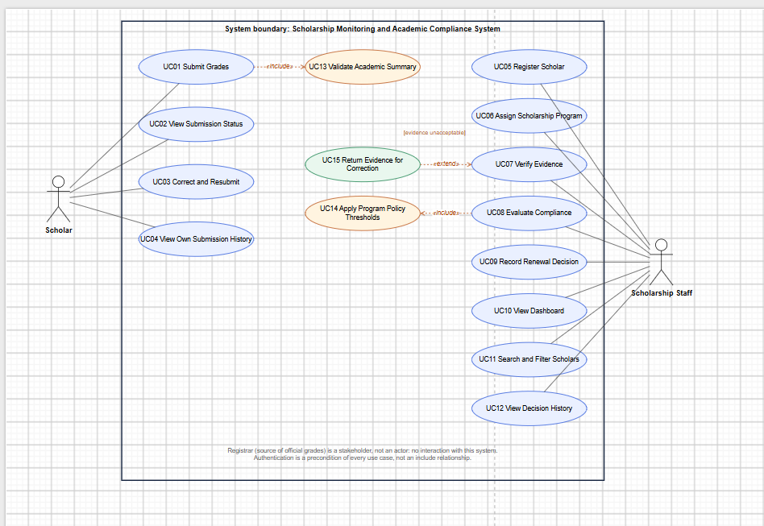
Figure 1. Use case diagram. Actors: Scholar and Scholarship Staff. Authentication is a precondition of every use case rather than an include relationship.

User goals
ID | Use case (user goal) | Actor
UC01 | Submit Grades | Scholar
UC02 | View Submission Status | Scholar
UC03 | Correct and Resubmit Returned Submission | Scholar
UC04 | View Own Submission History | Scholar
UC05 | Register Scholar | Staff
UC06 | Assign Scholarship Program | Staff
UC07 | Verify Evidence | Staff
UC08 | Evaluate Compliance | Staff
UC09 | Record Renewal Decision | Staff
UC10 | View Dashboard | Staff
UC11 | Search and Filter Scholars | Staff
UC12 | View Decision History | Staff

Relationship justification
- UC01 Submit Grades <<include>> UC13 Validate Academic Summary. Validation is mandatory reused behavior: every submission and every correction must pass the same checks (GWA range, non-negative integers, evidence reference). The arrow points from the including use case (UC01) to the included one (UC13).
- UC08 Evaluate Compliance <<include>> UC14 Apply Program Policy Thresholds. Evaluation can never run without reading the thresholds from the scholar's program record (BR03); the behavior is mandatory and shared, so it is an include.
- UC15 Return Evidence for Correction <<extend>> UC07 Verify Evidence. Returning is conditional added behavior: it happens only at the extension point "evidence unacceptable" and then requires a reason. Normal verification does not need it. The arrow points from the extending use case (UC15) to the base use case (UC07).

A5. Detailed use cases and data design

UC01 Submit Grades
Element | Description
Actor | Scholar (primary).
Trigger | The scholar opens the submission form for a semester and chooses Submit.
Preconditions | The scholar is authenticated and linked to a scholar record with an assigned program.
Main flow | 1. Scholar selects academic year and semester.  2. Scholar enters GWA, enrolled units, failed, incomplete and dropped counts.  3. Scholar enters the grade-document reference.  4. Scholar chooses Submit.  5. System validates the input (include UC13).  6. System checks that no submission exists for this scholar, year and semester.  7. System stores the submission with the current timestamp, status Pending, compliance Not Evaluated, renewal Undecided.  8. System writes a SUBMITTED history entry and shows the new row to the scholar.
Alternative flows | A1. The deadline has passed: the submission is still accepted and its timestamp later marks it late at evaluation (BR06).  A2. A previous submission for this period was Returned: the scholar uses UC03 instead of a new submission.
Exception flows | E1. Invalid GWA or negative/non-integer count (step 5): reject, message names the field, nothing saved (FR03).  E2. Duplicate period (step 6): reject with "Duplicate submission" message (FR04, BR04).  E3. Missing evidence reference: reject with message.  E4. Session expired / not linked: access denied message.
Postcondition | Exactly one Pending submission exists for the scholar and period, with timestamp and history entry; no official grade is changed.
Linked IDs | FR01, FR03, FR04, FR10; BR01, BR04, BR06; tests TC07, TC08, TC09.

UC08 Evaluate Compliance
Element | Description
Actor | Scholarship Staff (primary).
Trigger | Staff opens a submission and chooses Evaluate.
Preconditions | Staff is authenticated; the submission exists and its evidence is Verified (UC07).
Main flow | 1. Staff opens the submission detail.  2. Staff chooses Evaluate.  3. System confirms evidence status is Verified and the reference is present.  4. System loads the thresholds from the scholar's program record (include UC14).  5. System checks GWA, units, failed, incomplete and dropped counts against the thresholds (GWA boundary inclusive).  6. System compares the submission timestamp with the deadline (exact deadline is on time).  7. System stores each check result and the list of deficiency reasons.  8. System sets Compliant if every check passes, otherwise With Deficiency.  9. System logs EVALUATED with actor and timestamp and displays the checks and reasons.
Alternative flows | A1. Re-evaluation after a threshold or data change: the result is recomputed; an earlier Approved decision is reset to Undecided if the record is no longer Compliant.  A2. Staff proceeds to UC09 to record Approved or Held.
Exception flows | E1. Evidence is Pending or Returned: evaluation is blocked with a message (TC06).  E2. Evidence reference missing: evaluation blocked.  E3. Caller is a scholar: access denied (TC08).
Postcondition | The submission has compliance result Compliant or With Deficiency, specific reasons, evaluator and timestamp. Award status is unchanged and nothing disqualifies automatically.
Linked IDs | FR01, FR02, FR05, FR07, FR10; BR02, BR03, BR05, BR06; tests TC01-TC06.

Entity relationship diagram
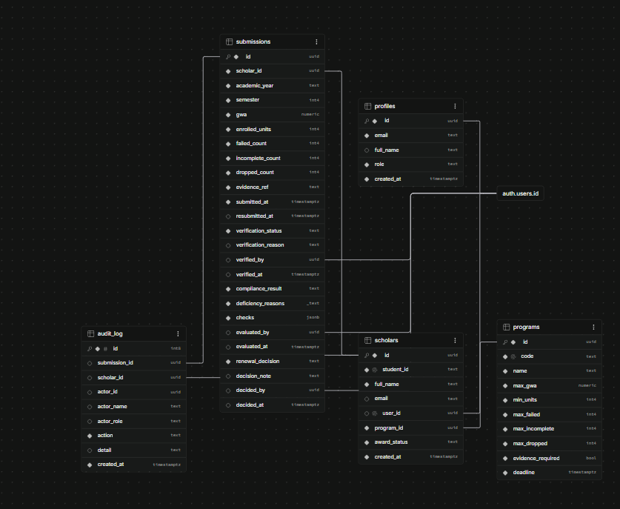
Figure 2. ERD (crow's-foot cardinalities shown as 1, 0..1 and 0..*).
Relationship | Cardinality | Key
PROFILES - SCHOLARS | 1 : 0..1 | scholars.user_id references profiles.id (a scholar may not have a login yet)
PROGRAMS - SCHOLARS | 1 : 0..* | scholars.program_id references programs.id (one program per scholar)
SCHOLARS - SUBMISSIONS | 1 : 0..* | submissions.scholar_id; unique (scholar_id, academic_year, semester)
SUBMISSIONS - AUDIT_LOG | 1 : 0..* | audit_log.submission_id; scholar-level events (registration, assignment) use scholar_id only

A6. Traceability
FR | Actor | Use case | Business rule | Implemented screen / function | Test and expected result
FR01 | Scholar, Staff | All UC | BR01 | RLS policies and is_staff(); all writes through SQL functions | TC08: scholar reads another record -> 0 rows; verify call -> Access denied.
FR03 | Scholar | UC01 (UC13) | BR04, BR06 | Scholar view "Submit semester academic summary"; submit_semester() | TC07: GWA 0.50 or count -1 -> rejected with clear message; valid input stored with timestamp.
FR07 | Staff | UC08 (UC14) | BR02, BR03, BR06 | Submission detail dialog "Evaluate"; evaluate_submission() | TC01-TC05: B01/B03 Compliant; B02 GWA reason; B04 units + incomplete; B05 failed + late. TC06: Pending record blocked.
FR08 | Staff | UC09 | BR05 | Detail dialog "Approve / Hold"; decide_renewal() | TC10: approve compliant B01, hold deficient B02, approve of B02 blocked, scholar cannot change decision.

Part II appendix - test results TC01 to TC10
Actual results below come from running the real SQL schema, seed and functions on a local PostgreSQL 16 database with a stand-in for Supabase auth (acting as the staff and scholar accounts). They prove the backend rules. Re-run the same checks in your own Supabase project (Test console tab for staff, "Access and validation self-test" for the scholar) and attach screenshots in the evidence column before submitting.
Test | Input / action | Expected | Actual | P/F | Evidence
TC01 | Evaluate B01 (GWA 2.00, 18 units, at 17:00:00 deadline) | Compliant | Compliant, no reasons; all 6 checks PASS | Pass | Backend run log; screenshot: ________
TC02 | Evaluate B02 (GWA 2.01) | With Deficiency, GWA reason | With Deficiency: "GWA 2.01 is above the maximum 2.00" | Pass | Backend run log; screenshot: ________
TC03 | Evaluate B03 (Access, 1 dropped) | Compliant | Compliant, no reasons | Pass | Backend run log; screenshot: ________
TC04 | Evaluate B04 (14 units, 1 INC) | Insufficient units and incomplete grade | With Deficiency: "Insufficient units: 14 enrolled, minimum is 15"; "Incomplete grade: 1 incomplete, allowed 0" | Pass | Backend run log; screenshot: ________
TC05 | Evaluate B05 (1 failed, 17:01) | Failing subject and late submission | With Deficiency: "Failing subject: 1 failed, allowed 0"; "Late submission: received 2026-11-06 17:01:00, deadline 2026-11-06 17:00 (Asia/Manila)" | Pass | Backend run log; screenshot: ________
TC06 | Evaluate and approve B06 (Pending) | Both blocked | Evaluation blocked: evidence is Pending. Renewal blocked: evidence is Pending, must be Verified first. | Pass | Backend run log; screenshot: ________
TC07 | Duplicate AY 2026-2027 S1; GWA 0.50; failed count -1 | Rejected with clear messages | "Duplicate submission..."; "Invalid GWA 0.50: it must be from 1.00 to 5.00 inclusive."; "Units and ... counts must be non-negative whole numbers." | Pass | Backend run log; screenshot: ________
TC08 | As scholar B01: read all submissions/scholars, read B02, call verify | Own rows only; verify denied | 1 submission and 1 scholar visible; B02 query returns 0 rows; "Access denied: only Scholarship Staff can verify evidence." | Pass | Backend run log; screenshot: ________
TC09 | Submit, staff Returns, scholar corrects, resubmit | Pending; history preserved | Status Returned then Pending; history SUBMITTED, RETURNED ("Blurry scan"), RESUBMITTED. Browser refresh check: ________ | Pass (backend) | Backend run log; screenshot: ________
TC10 | Approve B01, hold B02, approve B02, scholar decides, scholar direct UPDATE | Compliant approved; deficient held only; scholar denied | B01 Approved; B02 Held; approve B02 -> "Cannot approve: the record is With Deficiency"; scholar -> Access denied; direct UPDATE -> permission denied | Pass | Backend run log; screenshot: ________

