The Following Is Based On A True Story… Calling All Adults And Elderlies Who Are Suffering From Joint Pain, Muscle Soreness, And Stiff Joints!  
  
**“How ‘Conventional’ Over The Counter Joint Pain Medicine Caused An ‘Elderly Mother’ Her Precious MEMORIES, Took Away Her Mobility, Her Lifelong Skills As A Tailor And Finally Helped Us Found   
The Perfect Joint Care Solution!”**

**WARNING… Don’t Listen To ‘Some’ Of The Advice That Common ‘DOCTORS’ Dishes Out When It Comes To Joint Pain!   
Here’s What Really Happened…**

Dear Friend,   
  
If you or anyone dear to you is suffering from any kind of joint pain, then this could be the single most important letter that you’ll ever read.   
  
That’s right! My mother was a VICTIM of ‘Ignorance’ and ‘Incompetency’ that exists in the medical world today.   
  
While a lot of doctors in this world have undeniably helped countless people from their sickness and ailments, there are of course those who are NOT in the know and have been making things worse for others.   
  
I am not going to point any fingers here but the important thing that you’ll need to know is… people just do NOT know what they do NOT know.   
  
You see, at the ripe age of 64 years old, my poor mother started complaining about her dreadful knee pain and finger pain almost on a daily basis.   
  
Her pain and suffering were SURREAL… and at times she would complain that her fingers would get so stiff she couldn’t seem to move them at all!  
  
We took her to a local doctor and he said that she was suffering from Arthritis and prescribed her strong ‘Non-steroidal anti-inflammatory drugs’ also known as **NSAIDs.** She was to finish her medicine and continue to take similar anti-inflammatory drugs for as long as it was required!  
  
However, back then… we didn’t know that what she was prescribed wasn’t a REAL solution. In fact, it was nothing but a ‘painkiller’ to temporarily curb her discomfort.  
  
At first, these medicines seemed to help her a lot. She was no longer in pain and she seemed so much happier… but NOT FOR LONG.

**Little Did We Know That There Were Tons Of NASTY Side Effects Tied To These NSAIDs And The More She Took These Pills… The More Problems Would Arise!**

It was as if she was forced into a scary nightmare.  
  
She began having constant stomach aches and then she started to gain weight even when she was eating healthy and going on walks and basically trying to exercise as much as she could.  
  
And as time passes… the side effects would become more apparent to a point that it was absolutely devastating!  
  
So much so that after just 2 short years… I watched my mom gradually lose her ability to walk!

Needless to say, this was very depressing for the entire family and my mom just wasn’t the same happy woman that I once knew.  
  
What we did not realize was… the prolonged use of NSAIDs or anti-inflammatory over the counter medications was actually CAUSING more damage than helping!  
  
As things got worse… my mom started taking more of these ‘chemical’ filled medicines but to no avail. In fact, things became so bad that the pills were no longer as effective as it used to be and had almost no pain reducing effects anymore.

**And That Was Just The BEGINNING Of Our Worries…  
My Mom Was Starting To Become More And More Forgetful By The Day!**

She was not remembering things. At that time, we thought it was normal for her age. Turns out… it was the early signs of dementia and would later turn into Alzheimer’s disease which we only found out a year later because she was forgetting pretty much everything.   
  
Heck, she was eve having a hard time recognizing people’s faces.   
  
Her memories were all blurry, and she couldn’t move an inch without here wincing in agonizing pain. Her other abilities such as her lifelong skills as a tailor were all GONE!  
  
She was diagnosed with Alzheimer and her doctor literally told us that most chemical based anti-inflammatory MEDS are linked to people with dementia.  
  
*My HEART felt like it fell to the ground when I heard that!*  
  
What we thought was supposed to help her get better was the CULPRIT to her sufferings for the past 3 years all along!

She took those medicines in the hope of a cure, but instead it was making her condition worse in every possible way.  
  
I was shocked beyond words and I was… *ANGRY!*   
  
But no matter how we felt… there wasn’t much we could do.   
  
After the doctor’s recommendation, we took her off those harmful NSAIDs. These painkillers were never the solution, nor does it help solve the problem at the core.

Sure, it helped temporarily, but these chemical infused painkillers should NEVER be taken as a long term solution unless anyone wants to end up like my poor mother.

**I VOWED To Never Let Myself Or Anyone I Cared To Go Near These Medications… EVER!  
  
So You Can Imagine How I FELT When My Doctor Recommended These Same Medicines To Me….**

Right after those nasty episodes that my unfortunate mother had to go through, I started having joint pains myself in both my knee and hips.   
  
I didn’t know what caused it... maybe I overworked my body or maybe it was something I ate. All I knew was the pain was unbearable at times and I had to get myself checked.  
  
So when I finally went to see a doctor, you can imagine just how unimpressed I was when the first thing that my doctor recommended was also the same NSAIDs and anti-inflammatory medications that my mom used to take.

I literally gave him a look of disbelieve, but luckily, I managed to hold back my anger.   
  
I didn’t tell him my full story because he told me that I have early signs of arthritis wand and that there’s NOTHING ELSE he could do for me if I refused those MEDS.   
  
I didn’t blame him because I know this world is filled with a system where ‘the blind… leads the blind’. They couldn’t possibly know everything… doctorates or not.  
  
So I took the matter into my own hands.   
  
***I Was As Desperate As I Was Determined!***  
I started doing some research to see what others did.   
There had to be others in my situation!  
  
So I spent countless hours every night on my computer and started stomping on forums and the Social Media to see what worked and if there were any remedies that could help me stop my joints from giving me such a hard time.  
  
It was a do or die situation because I surely was not going to take any of those harmful pills that cause my mom to lose her memories!

**And Slowly But Surely, Thanks To My Perseverance, Little Clues Begin To Trickle Out Of Hiding…**

Everywhere I go, I began to see a pattern where people from across the world… especially from Asian countries, have been using traditional and holistic remedies for centuries to help them achieve a healthier and vibrant lifestyle.   
  
They used potent herbs and natural ingredients to help alleviate their pain and ailments.  
They used them as a way to cure and treat sickness and also as a way of prevention.  
They mixed different ingredients to make concoctions and serums to improve their general well being.   
  
I knew I was on to something. I began researching on different plants and these so called herbs and I was able to find many of these wonderful ingredients that had minimal side effects compared to those chemical based pharmaceuticals.   
  
I compiled a list of the best and potent ingredients that I found and hastily purchased them all from all over the world in hope to help me stop my joint problems once and for all.  
  
*And Guess What?*  
In less than a month of consuming these herbs, I was seeing a significant improvement in my joint health!  
  
The soreness that was bothering me was gone… and so was the stiffness in my hips. I felt like a NEW MAN.   
  
My energy levels were through the roof and I was able to focus and concentrate better than I was when I was in my teenage years.  
  
The best part of this all is that I felt no side effects or whatsoever and these herbs that I used help reduce my pain while strengthening my bones and rebuilding the cartilage in my joints!  
  
Needless to say… with the help of my formula, I began to see a gradual improvement in my mom’s chronic joint problems too!  
  
That’s when I KNEW… I had to share this with the world!

**Get Ready For… Joint Care Choice, My Special All Natural Formula For Joint Care Protection.  
  
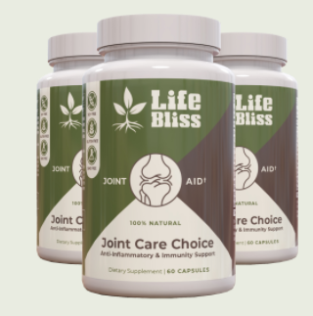  
**

Thanks to months of careful research and after a few iterations to my formula, I was able to create the perfect blend that’s geared towards helping people to reduce the discomfort of their joints, improve their flexibility and also at the same time improve their overall health… all without any disastrous long term side effects that may rob people off their ‘living’ potentials.  
  
I made sure that every ingredient that I use in my formula is safe and harmless under normal circumstances and I wanted Joint Care Choice to be a supplement to help others feel alive and strong again.

**Here’s What I Included In Joint Care Choice To   
Ensure Maximum Absorption And Fast Healing Effects To Help Improve Joint Health Like Never Before!  
  
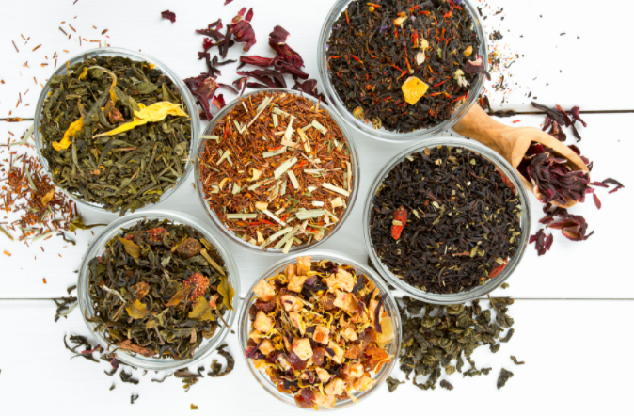**

**Holistic Joint Care Ingredient #1 - Horsetail Extract**Increases calcium absorption and is used traditionally to battle against structural diseases.

**Holistic Joint Care Ingredient #2 - Standardized 65% Boswellia Serrata Extract**

This nutrient is used to stop unwanted enzymes in the body from causing inflammation.

**Holistic Joint Care Ingredient #3 - Elderberry Extract**

Conventionally used to reduce swelling, and boost the body’s natural immune system.

**Holistic Joint Care Ingredient #4 - Celery Seed Extract**

Supports bone health, promotes red blood cells, and packed with anti-bacterial properties.

**Holistic Joint Care Ingredient #5 - Celery Seed Extract**

The ginger root is high in antioxidants, reduces pain, swelling, and serves as a powerful boost for the immune system.

**Holistic Joint Care Ingredient #6 - White Willow Bark Extract**

Works similarly to aspirin and used widely in many countries as a natural pain reliever.

**Holistic Joint Care Ingredient #7 - Turmeric Root Extract**

Clinically proven ingredient known to help significantly reduce knee pain in people with osteoarthritis.

**Holistic Joint Care Ingredient #8 - Olive Leaf Extract**

A wonderful herbal ingredient that’s proven by Scientists to be effective when used to treat gout, arthritis, rheumatoid arthritis, and osteoarthritis.

**Holistic Joint Care Ingredient #9 - Pumpkin Seed Extract**

Used widely as a potent ingredient to fight arthritis and rheumatism.

**Holistic Joint Care Ingredient #10 - Bioperine® Black Pepper Fruit Extract**This extract is key when it comes to increasing the absorption rate, making our joint care formula complete.

**Here’s What My All Natural Joint Care Choice Formulation Can Do For You!**

* Reduce the Rate of Collagen Degradation
* Eliminate Joint Pain and discomfort
* Anti-Inflammation and Immunity Support
* Improved Joint Flexibility and Reduced Inflammation
* Rebuild Cartilage Tissue and Improve Bone Density
* Healthy Cellular Regeneration
* Fast and Effective Absorption Rate
* Solves the Root Of The Problem
* Zero Side Effects
* 100% Vegan Formula Perfect for Any Diet

**See What Other People Are Saying About Joint Care Choice!**

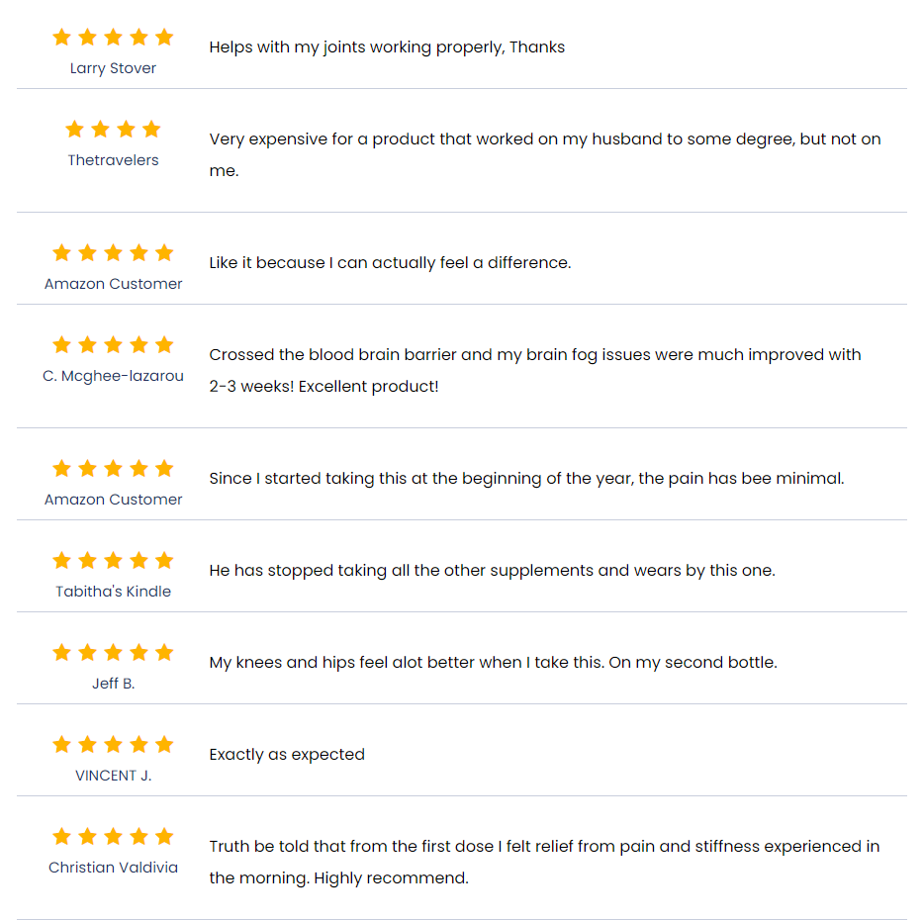

**Here’s How You Can Start Using Joint Care Choice   
and Give Your Joints the Best Holistic Care That   
They Rightfully Deserve!**

Imagine, just months from now, you and those you care for, or anyone who is suffering from pain and discomfort at their joint… being able to smile freely and live a life FREE from the worries of a weak knee or wrist pain.  
  
Your joint health will be in tip top condition and your entire wellbeing at a much improved state where you’ll be able to enjoy tons of outdoor activities with a much more flexible body and feel more vibrant than you’ve ever felt for the past few years.  
  
That’s right! Joint Care Choice is your best buddy when you need a reliable yet natural anti-inflammatory and anti-oxidant, helping you stay strong as you give your joints a natural boost.  
   
Click On The Button Below To Find Out More About Joint Care Choice And See For Yourself How You Can Start Enjoying Purchase Them At A Discounted Price, Free Shipping And A Full Risk-Free Money Back Guarantee.

[Yes, Thanks! Please Take Me There Now!]



[Shop Joint Care Choice Here!]

