10alytics
Threat Intelligence Capstone Project
Harmony Health Threat Investigation
Prepared by
Faith Ejele
SOC Analyst
10alytics | 2026
SOC Investigation Report: Email 1, Microsoft Credential Phishing

Document details
Title | Threat Intelligence Capstone Project: Harmony Health Threat Investigation
Report subject | Email 1: suspected Microsoft account-suspension credential phishing
Prepared by | Faith Ejele, SOC Analyst
Organisation / year | 10alytics, 2026
Report date | 26 October 2026
Email received | Tuesday 14 April 2026, 15:22:09–15:22:17 UTC (the header calls it Monday)
Method | Static, desk-based analysis of original .eml screenshots and lab screenshots. No live execution.
Disposition | High-priority suspected credential phishing. Credential theft and account compromise are NOT confirmed.
Handling | Internal – Confidential. Contains defanged indicators.
Evidence base | Email 1 SOC report (Email1_Microcredential_Analysis, 12 pages) with 23 original lab screenshots; Part A desk-based report

Contents
1. Executive summary
2. Scope, evidence and method
3. Header inspection
4. Received chain and timestamps
5. SPF, DKIM and DMARC
6. Message content analysis
7. Indicators and enrichment
8. Attachment analysis
9. Timeline and links to other cases
10. Risk assessment
11. Evidence gaps and limitations
12. Recommendations
13. Final conclusion
Appendix A: Suggested static lab commands
Appendix B: Original lab screenshots

1. Executive summary
Verdict: High-confidence credential-phishing attempt. Credential theft and compromise are not confirmed.
The email claims to come from "Microsoft Account Team" and says the recipient's Microsoft account has been suspended after unusual sign-in activity. It tells the recipient to verify their identity within 24 hours through a link, or face permanent account deletion, loss of email and OneDrive files, and cancellation of the Microsoft 365 subscription. The link leads to login-microsoft365-verify[.]top, a domain Microsoft does not own.

Key findings
- Four domains, one of them Microsoft's. The From address is account-security@microsoft.com, but the Return-Path and Message-ID use mailer-srv-dispatch[.]xyz, the Reply-To uses account-ms365-verify[.]top, and every link uses login-microsoft365-verify[.]top. Only one of the four domains is Microsoft's.
- Authentication failed. Google's Authentication-Results report SPF, DKIM and DMARC as failed. The DKIM signature value is a visible placeholder (a run of "A" characters followed by "B" characters), so it was never a real signature.
- Deceptive links. The HTML shows https://support.microsoft.com as the link text, but the link points to the phishing domain. The URL token (7a8b9c0d1e2f3a4b5c6d7e8f9a0b1c2) is a simple repeating sequence, not a random value.
- Attachment content is partly known. The PDF decodes to a tiny one-page file with a "MICROSOFT ACCOUNT VERIFICATION" lure and the same phishing URL as plain text. The visible bytes show no JavaScript, launch or open actions. It has not been hashed.
- Sender IP reputation. 185.220.101.47, the claimed sending IP, is shown by AbuseIPDB at 100% confidence with 6,846 reports and a Tor exit-node tag. The lookup was taken about 16 October 2026, six months after the email.
- Timing. The Date header, Message-ID and Received times agree (15:22:09 to 15:22:17 UTC, 8 seconds). The weekday error is explained by a DKIM timestamp that decodes to 14 April 2025, a Monday.
- No confirmed impact. No evidence shows that any recipient clicked, entered credentials or opened the attachment.

Overall confidence
Confidence that this is a phishing attempt: high. Confidence in the routing and authentication details: low to medium, because they come from screenshots of an .eml, not gateway logs. Several features of the sample (placeholder DKIM value, patterned token, recipient analyst@targetcorp.com, file name email1_microsoft_credential_harvest.eml, 2025 epoch values) suggest it may be a training sample. It is analysed as if live, as the process requires.

2. Scope, evidence and method

2.1 Evidence reviewed
Source | Content used
Email 1 SOC report (Email1_Microcredential_Analysis, 12 pages) | Header inspection, authentication results, indicators, attachment findings and 23 original lab screenshots.
Original .eml screenshots (email1_microsoft_credential_harvest.eml) | Full headers with four Received hops, DKIM-Signature, plain-text and HTML bodies, and the PDF MIME part.
AbuseIPDB and header-analyser screenshots | Reputation for 185.220.101.47 and a hop table for the message.
Base64 decoder and HxD screenshots | The decoded start and content of the PDF attachment.
PART A: Desk-based Analysis; Email 2 SOC report | Earlier extract for this email, and a DNS/mail diagnostic for mailer-srv-dispatch[.]xyz found in the Email 2 screenshots.

2.2 Method and evidence standards
- Header inspection, Received-chain timing, authentication review, content analysis, indicator enrichment and static attachment review. Nothing was executed.
- Headers can be forged, so values in an untrusted message are recorded as reported. In a genuine chain only the hops added by the receiving organisation's servers are trustworthy; lower hops are supplied by the sender.
- A DMARC policy does not show what a gateway did. An IP named in the body is a claim by the sender, not the SMTP source. Private and loopback addresses are not external senders.
- Reputation screenshots show a past lookup. An empty or clean result does not prove safety.

3. Header inspection

3.1 Message metadata
Subject | [Action Required] Your Microsoft Account Has Been Suspended - Verify Now
From | Microsoft Account Team <account-security@microsoft.com>
Reply-To | ms-support@account-ms365-verify[.]top
Return-Path / envelope | noreply@mailer-srv-dispatch[.]xyz
To / Delivered-To | analyst@targetcorp.com
Date | Mon, 14 Apr 2026 15:22:09 +0000
Message-ID | <20260414152209.XK3m8@mailer-srv-dispatch[.]xyz>
Priority | X-Priority: 1 (Highest); X-MSMail-Priority: High
Mailer signs | X-Mailer: PHPMailer 5.2.27; X-PHP-Originating-Script: 1000:mailer.php; Exim 4.94; HELO localhost.localdomain
X-Originating-IP | 185.220.101.47
Structure | multipart/mixed containing multipart/alternative (text/plain and text/html, both quoted-printable) and an application/pdf attachment (base64)

3.2 Identity comparison
Header | Value | Assessment
From | account-security@microsoft.com | Claimed identity; does not align with the envelope sender
Return-Path | noreply@mailer-srv-dispatch[.]xyz | Unrelated, low-cost .xyz domain
Message-ID | …@mailer-srv-dispatch[.]xyz | Matches the Return-Path, not the From
Reply-To | ms-support@account-ms365-verify[.]top | A second lookalike domain; replies would go to the attacker
Link domain | login-microsoft365-verify[.]top | A third lookalike domain; used for every link in the message

The sender-side headers X-Spam-Status ("No, score=-1.2") and X-AntiAbuse ("Original Domain - targetcorp.com") sit inside the original message header block, below the From, Date and Subject lines. They were therefore added by the sending side and should not be taken as the recipient's own spam verdict. The empty X-Source, X-Source-Args and X-Source-Dir fields and the X-AntiAbuse block resemble headers added by shared-hosting mail servers, which would fit a compromised or rented web host, though this is not established here.

4. Received chain and timestamps
Four hops are shown, from earliest to delivery:
Hop | From → by | Timestamp as shown | UTC equivalent | Trust
1 | from [185.220.101.47] (helo=localhost.localdomain) → webmail.mailer-srv-dispatch[.]xyz, ESMTP | 14 Apr 2026 15:22:11 +0000 | 15:22:11 | Sender-supplied
2 | from webmail.mailer-srv-dispatch[.]xyz ([127.0.0.1]) → mail.mailer-srv-dispatch[.]xyz, ESMTPA (Exim 4.94) | 14 Apr 2026 15:22:14 +0000 | 15:22:14 | Sender-supplied; loopback, not an external sender
3 | from mail.mailer-srv-dispatch[.]xyz [185.220.101.47] → mx.google.com, ESMTP, TLS 1.2 (ECDHE-RSA-AES128-GCM-SHA256) | 14 Apr 2026 08:22:16 -0700 (PDT) | 15:22:16 | Receiving side (if genuine)
4 | → 10.114.72.133, SMTP, id q5csp2847102lad | 14 Apr 2026 08:22:17 -0700 (PDT) | 15:22:17 | Receiving side (internal, private IP)

- The Date header (15:22:09 UTC), the Message-ID stamp (20260414152209) and the four Received times (15:22:11 to 15:22:17 UTC) agree with each other. The message went from first hop to delivery in about 6 seconds, which a header-analyser screenshot also shows as a 0-second delay.
- The "-0700 (PDT)" offset for the Google hops is correct for April.
- Hop 3 is the key hop: it records 185.220.101.47 as the address that connected to Google. If the receiving hops are genuine this is the real SMTP peer; if not, it is only a claim. It needs to be confirmed against original gateway logs. Tor exit relays commonly block outbound SMTP, so a Tor exit as a direct mail peer is unusual (general knowledge, not tested here).
- Hop 1, X-Originating-IP and the PHP script header indicate the message was submitted through a web mail form or PHP script (mailer.php), with the client address recorded as 185.220.101.47.

Timestamp anomalies
- The Date header and the body both call 14 April 2026 a Monday. It was a Tuesday.
- The DKIM timestamp (t=1744644136) and the MIME boundary suffix (…1744644129) decode to 14 April 2025, 15:22:16 and 15:22:09 UTC. That is exactly one year earlier, and 14 April 2025 was a Monday. The weekday error and the epoch values are therefore consistent with a message built in 2025 whose year was later changed, or a generator that mixes years.
- The body says the "unusual sign-in" occurred at 14:58:33 UTC, 23 minutes 36 seconds before the Date header. The sign-in claim cannot be verified.

5. SPF, DKIM and DMARC
Control | Reported result (Authentication-Results: mx.google.com) | Validation status
SPF | fail: "domain of microsoft.com does not designate 185.220.101.47 as permitted sender"; smtp.mailfrom=noreply@mailer-srv-dispatch[.]xyz. Received-SPF also fail; client-ip=185.220.101.47. | Not reproduced. The wording evaluates microsoft.com although the envelope sender is mailer-srv-dispatch[.]xyz, so the extract is internally loose.
DKIM | fail (signature did not verify); header.i=@microsoft.com; header.s=selector2; header.b=Xk9LmQ3z. Signature d=microsoft.com, rsa-sha256, relaxed/relaxed. | Not reproducible. The b= value is "AAAA…" followed by "BBBB…=", a placeholder, and does not match header.b=Xk9LmQ3z.
DMARC | fail (p=REJECT sp=REJECT dis=QUARANTINE); header.from=microsoft.com; reason: From domain does not align with envelope sender mailer-srv-dispatch[.]xyz | Gateway action unverified. A REJECT policy with a QUARANTINE disposition suggests a local override; where the message landed is unknown.

A genuine Microsoft message would be signed with a key published by Microsoft. A signature claiming d=microsoft.com that fails to verify fits spoofing, and the placeholder value indicates the signature was never real. All of this is untrusted text, so it supports the conclusion but cannot establish it on its own.

6. Message content analysis
The plain-text and HTML parts differ slightly, which is itself a mild anomaly, but they carry the same lure.
Feature | Observation
Greeting | Plain text: "Dear Microsoft Account User". HTML: "Dear Account User". Neither uses the recipient's name.
Banner | HTML: "URGENT: Your Microsoft Account Has Been Suspended" in an orange banner on a Microsoft-blue (#0078d4) header with Segoe UI styling.
Sign-in claim | HTML only: IP 91.108.56.122, Kyiv, Ukraine, "Unknown Windows device", 14 Apr 2026 14:58:33 UTC. Designed to alarm the reader and unsupported by any evidence.
Pressure | 24 hours to verify or the account is permanently deleted; loss of all email and OneDrive files; Microsoft 365 cancellation.
Call to action | Verify My Account Now: hxxps://login-microsoft365-verify[.]top/signin/recover?token=7a8b9c0d1e2f3a4b5c6d7e8f9a0b1c2&ref=account_suspend (quoted-printable escapes decoded).
Token | The token runs 7a 8b 9c 0d 1e 2f 3a 4b 5c 6d 7e 8f 9a 0b 1c 2, a simple repeating sequence, not a random value. A real per-recipient token would not look like this.
Link text mismatch | The support line shows the visible text https://support.microsoft.com but the href points to hxxps://login-microsoft365-verify[.]top/support. The unsubscribe and privacy links also point to the phishing domain.
Support number and address | Lists 1-800-642-7676 (appears to be a published Microsoft support number; not verified here) and "One Microsoft Way, Redmond, WA 98052". Real contact details add credibility.
Disclaimer | "Microsoft will never ask for your password via email" appears while the message asks the recipient to sign in on an unrelated site.

7. Indicators and enrichment

7.1 Indicators
Indicator | Role | Notes
185.220.101.47 | Claimed sending IP / X-Originating-IP | AbuseIPDB: Tor exit node; see 7.2
mailer-srv-dispatch[.]xyz | Return-Path, Message-ID, sending hosts | webmail. and mail. subdomains named in Received headers
account-ms365-verify[.]top | Reply-To domain | Lookalike; not mentioned in the earlier Part A extract
login-microsoft365-verify[.]top | Phishing link domain | All links: /signin/recover, /support, /unsubscribe, /privacy
91.108.56.122 | Alleged sign-in IP (body claim) | Not SMTP infrastructure for this email; is the sending IP in Email 5
127.0.0.1; 10.114.72.133 | Loopback; private receiving relay | Not external senders; 10.114.72.133 also seen in Email 2
account_verification.pdf | Attachment | About 606 bytes; SHA-256 not calculated
1000:mailer.php; PHPMailer 5.2.27 | Sending script and library | Hunting aid, not proof of abuse on its own
Message-ID 20260414152209.XK3m8@… | Identifier | Mail-log search

7.2 AbuseIPDB result for 185.220.101.47 (B-01 to B-05)
Field | Value shown
Abuse confidence score | 100% (Critical)
Reports | 6,846 reports from 649 distinct reporters; first reported 22 September 2021
Tag | TOR EXIT NODE
ISP / usage type | Network for Tor-Exit traffic / University/College/School
ASN / hostname | AS60729 / tor-exit-47.for-privacy.net (domain for-privacy.net)
Location | Germany, Berlin
Recent top report types | Web App Attack 128, Hacking 85, Brute-Force 45, Port Scan 24, Bad Web Bot 19, Other 53
Recent top reporter countries (60 days) | Turkey 58, Germany 49, United States 20
Most recent reports visible | 13–16 October 2026 (web exploits, brute force, VPN login attempts, port scans)

- The page says the latest report was "7 hours ago" and the newest listed report is 16 October 2026 16:00:07 UTC, so the lookup was taken at about 23:00 UTC on 16 October 2026. That is 185 days after the email and 10 days before this report. The earlier source report listed the lookup date as not established; this derivation closes that gap.
- The reports shown are web attacks, brute force and scanning, not spam or phishing. They show the address is a heavily abused Tor exit, not that it sent this email.
- Tor exits are shared by many users, so the IP identifies the exit relay, not a particular attacker. It cannot attribute the message to a person or group.
- The header-analyser screenshot (B-06) flags the 185.220.101.47 hop as blacklisted and the first webmail hop as clear.

7.3 Domain check for mailer-srv-dispatch[.]xyz
The Email 2 lab report contains a DNS and mail diagnostic for mailer-srv-dispatch[.]xyz, next to a cropped header line that matches this email's Received chain. At the time of that check the domain returned no DNS record, no MX record, no DMARC record and an unresolvable web name (9 errors, 1 warning, 8 passed; blacklist checks clean). The check date is not shown. A domain that does not resolve is consistent with a throwaway sending domain, but it does not show that the domain never sent mail in April.
No VirusTotal, MalwareBazaar or reputation result was supplied for the domains in this email. The Kali screenshot shows those sites open in browser tabs, but no results are visible. An absent result does not prove a domain is safe.

8. Attachment analysis: account_verification.pdf
Property | Finding
Declared | Content-Type application/pdf; name="account_verification.pdf"; Content-Disposition attachment; base64
Magic bytes | The decoder output begins 25 50 44 46 2D 31 2E 34, which is "%PDF-1.4" (B-11). The file is a PDF by signature.
Size and structure | The HxD view runs to offset 0x25E, so the file is about 606 bytes: Catalog, Pages (one page), a Letter-size page (MediaBox 0 0 612 792), a Helvetica font and a single content stream, then xref, trailer (Size 5) and startxref 437, ending %%EOF.
Visible content | Text "MICROSOFT ACCOUNT VERIFICATION REQUIQED" ("REQUIRED" is misspelt in the file), "Click here", and the plain-text URL https://login-microsoft365-verify[.]top/signin/recover.
Active content | In the bytes shown there is no /JavaScript, /JS, /OpenAction, /Launch, /URI action, /Annots entry or embedded file. The URL is page text in the content stream, not a link annotation.
Decode quality | The hex shows 0x00 bytes where ">>" would be expected (for example "R>" then 00 then "endobj"). These appear where the base64 text contains "+" characters, and the decoder page appears to have mishandled "+". The decode is therefore imperfect and the PDF structure in the screenshot is damaged. Only the first line of text renders (B-14).
Hash | SHA-256 not calculated: the original attachment bytes were not supplied

Conclusion: the screenshots show a minimal lure PDF whose purpose is to push the reader to the same phishing URL. The visible bytes show no exploit or active content, but this is a reading of a partly corrupted decode, not a validated structural analysis. The earlier statement that the PDF is "not malicious" is only partly supported: the visible content is benign in form, but a reproducible examination of the original file is still required.
Screenshots B-15 and B-16 show the DKIM text (bh= and b=) pasted into the base64 decoder, producing a single byte (6E). This is an unrelated test decode of the signature fragment, not of the attachment.

9. Timeline and links to other cases
Date / time (2026) | Event
14 April, 14:58:33 UTC | Time of the alleged "unusual sign-in" quoted in the HTML body (unverified).
14 April, 15:22:09–15:22:17 UTC | Email created, relayed and delivered to analyst@targetcorp.com (8 seconds).
15 April, 17:47 UTC | Email 2 (invoice BEC) delivered to the same domain through the same receiving relay.
16 October, about 23:00 UTC | AbuseIPDB lookup for 185.220.101.47 (185 days after the email).
26 October | This report (195 days after the email).

- Link to Email 5. Email 5 (Bank of America) uses the same two IP addresses in swapped roles: 185.220.101.47 is its alleged "suspicious login" source, and 91.108.56.122 is its claimed sending IP. This may point to one actor or template and should be recorded as a link.
- Link to Email 2. Both were delivered to targetcorp.com through the private relay 10.114.72.133, one day apart. Both carry a placeholder DKIM value (A/B here, C/D in Email 2) and a DKIM timestamp and MIME boundary that decode to the same date one year earlier. Their sending infrastructure differs.

10. Risk assessment
Factor | Rating | Reasoning
Likelihood of phishing | High | Four-domain identity mismatch, link-text mismatch, failed and placeholder authentication, urgency and threats.
Potential impact | High | Microsoft credentials can unlock email, OneDrive and single sign-on to other services.
Evidence of compromise | None seen | No click, sign-in or credential submission is in the evidence.
Evidence quality | Medium | Complete .eml text and reputation pages are visible in screenshots, but the original file, gateway logs and attachment bytes are missing.
Overall priority | High | Check sign-in logs for the recipient from 14 April onward.

MITRE ATT&CK mapping
Technique | ID | Relevance
Phishing: spearphishing link | T1566.002 | Verification link on a lookalike domain
Phishing: spearphishing attachment | T1566.001 | PDF lure (content partly read)
Phishing for information | T1598 | Credential capture page
Impersonation | T1656 | Microsoft Account Team
Acquire infrastructure: domains | T1583.001 | Three lookalike or throwaway domains
User execution: malicious link | T1204.001 | Only if the recipient clicked

11. Evidence gaps and limitations
Check | Status | Note
Original .eml | Screenshots only | Headers readable; not independently authenticated
SPF / DKIM / DMARC reproduction | Not done | Reported values only; DKIM value is a placeholder
Gateway disposition and mailbox location | Not verified | DMARC policy does not show the action taken
Live reputation | Partly done | AbuseIPDB for one IP (about 16 Oct 2026); none for the three domains
Attachment hash and structure | Not done | PDF read from a partly corrupted web decode; redo from the .eml
User interaction (click, credentials) | No evidence | Needs proxy, DNS, endpoint and sign-in records
Authenticity of the sample | Uncertain | Placeholder DKIM, patterned token, 2025 epoch values and lab-style naming suggest a training sample

12. Recommendations

12.1 Immediate (first working day)
- Establish exposure. Find out whether the recipient clicked the link, submitted credentials or opened the PDF. Search proxy, DNS and endpoint logs for login-microsoft365-verify[.]top, account-ms365-verify[.]top and mailer-srv-dispatch[.]xyz.
- Check the account. Review Microsoft sign-in logs for the recipient from 14 April, and reset the password and revoke sessions if anything is unusual. Check for new mailbox rules or forwarding.
- Contain. Block the three domains and the landing URLs at the mail and web gateways, and search mail logs for other messages with the same script headers (1000:mailer.php, PHPMailer 5.2.27) or the Message-ID pattern.
- Handle safely. Do not visit the live links from a corporate network; use an isolated environment if inspection is needed.

12.2 Short term (this week)
- Get the originals. Retrieve the original .eml and attachment from the mail system with a record of who collected them, then repeat the SPF, DKIM and DMARC checks.
- Static attachment analysis. Decode the PDF with a command-line tool (not a web decoder), hash it, extract its objects and URIs and check for active content (see Appendix A).
- Enrich indicators. Run dated lookups on the three domains and 185.220.101.47, including registration data and passive DNS. Record tool, date and result.
- Correlate cases. Review the link with Email 5 (shared IPs) and Email 2 (shared recipient domain and relay), and record whether the cases belong to one campaign.

12.3 Longer term
- Enable multi-factor authentication, preferably phishing-resistant, for Microsoft 365 accounts.
- Add gateway rules for link text that differs from the link target, for newly registered or high-abuse top-level domains, and for external mail that claims to be from Microsoft.
- Report the domains to the registrars, hosting providers and Microsoft.
- Use this case in awareness training: urgent account-suspension notice, mismatched link, reply to a different domain.

13. Final conclusion
The evidence shows a deliberate attempt to steal Microsoft credentials. The sender impersonates Microsoft from unrelated infrastructure, authentication failed (with a placeholder signature), the links point to a lookalike domain, and the attachment repeats the same lure. The evidence does not show that anyone clicked, that credentials were submitted or that the account was compromised.
Final disposition: High-priority suspected credential phishing; no confirmed compromise. Check the recipient's sign-in logs and click activity first.

Appendix A: Suggested static lab commands
For use on the original attachment extracted from the .eml, in an isolated environment. Nothing is executed.
ripmime -i email1_microsoft_credential_harvest.eml -d out/
base64 -d account_verification.b64 > account_verification.pdf
file account_verification.pdf
sha256sum account_verification.pdf
pdfinfo account_verification.pdf
strings -a account_verification.pdf | grep -E "/JS|/JavaScript|/OpenAction|/Launch|/URI|/AA|/EmbeddedFile"
pdfdetach -list account_verification.pdf
pdfimages -list account_verification.pdf

Using base64 -d on the original part avoids the corruption seen in the web decoder, where "+" characters were read as zero bytes.

Appendix B: Original lab screenshots
The 23 images below are reproduced from Email1_Microcredential_Analysis.docx in their original order. They are documentary screenshots, not independently validated mail or threat-intelligence records. The "What it shows" line is the analyst reading of each image for this report.
Figure B-01. Header excerpt with AbuseIPDB lookup
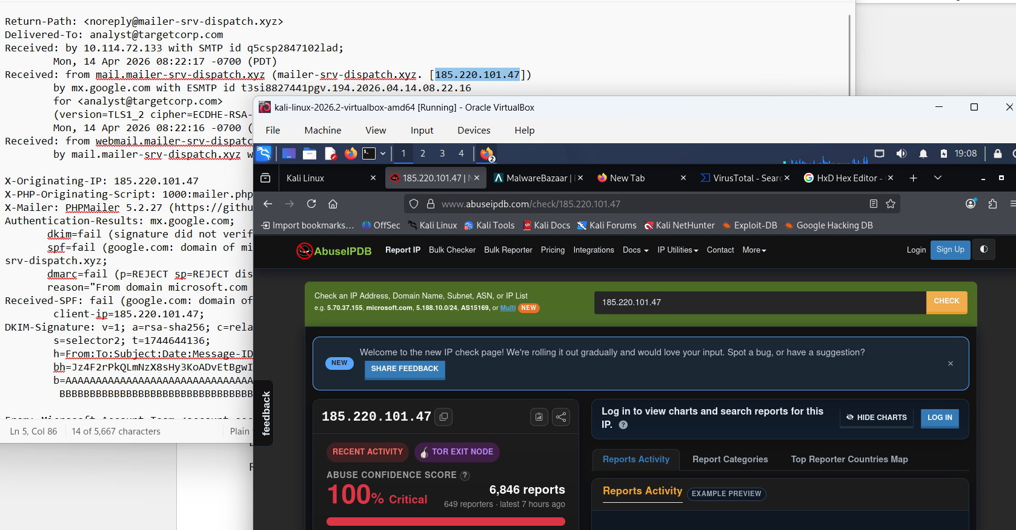
What it shows: Top of the headers (Return-Path, Delivered-To, Received lines, X-Originating-IP, X-Mailer, Authentication-Results) with a Kali VM browser open on AbuseIPDB for 185.220.101.47: 100% confidence, 6,846 reports, Tor exit node. Tabs for MalwareBazaar, VirusTotal and HxD Hex Editor are also open.
Figure B-02. AbuseIPDB: network details
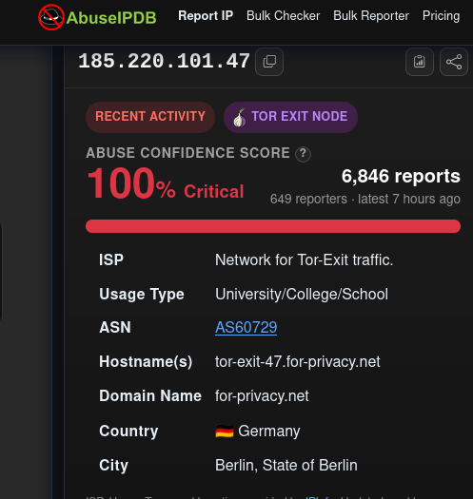
What it shows: ISP "Network for Tor-Exit traffic", usage type University/College/School, ASN AS60729, hostname tor-exit-47.for-privacy.net, Berlin, Germany; 649 reporters, latest report 7 hours ago.
Figure B-03. AbuseIPDB: report summary
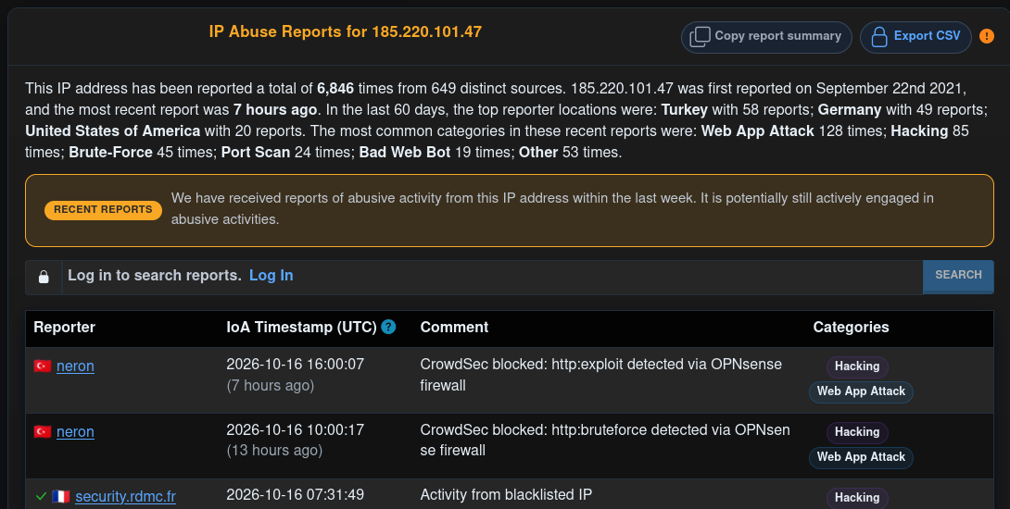
What it shows: First reported 22 September 2021; top reporter countries in the last 60 days (Turkey, Germany, United States); common categories (Web App Attack, Hacking, Brute-Force, Port Scan); first reports dated 16 October 2026.
Figure B-04. AbuseIPDB: recent reports (16 and 15 October 2026)
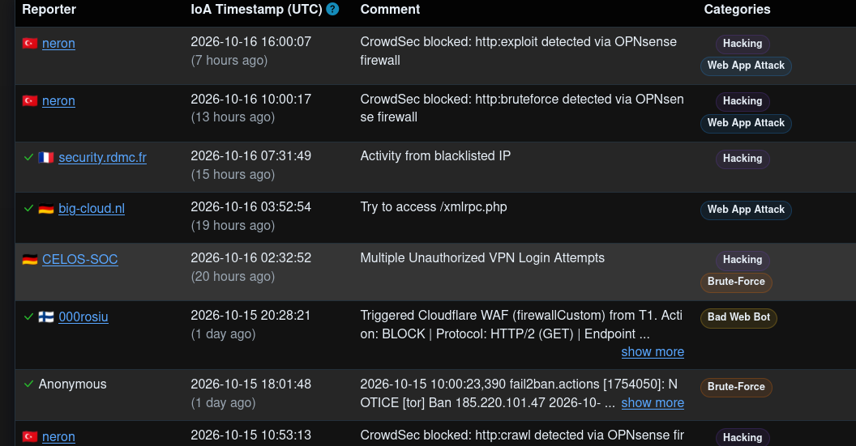
What it shows: CrowdSec/OPNsense blocks for HTTP exploit and brute force, blacklisted-IP notes, an /xmlrpc.php probe, unauthorised VPN login attempts, a Cloudflare WAF block and a fail2ban Tor ban.
Figure B-05. AbuseIPDB: earlier reports (13 and 14 October 2026)
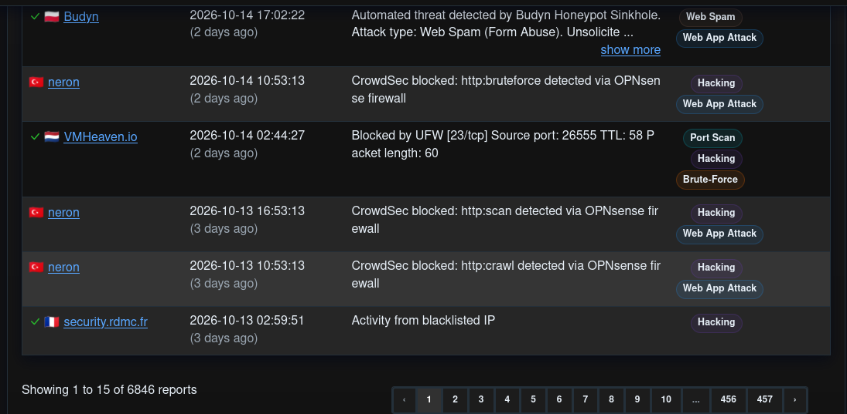
What it shows: Honeypot web-spam, brute force, a UFW-blocked port 23 scan and crawl/scan blocks; page 1 of 457, 6,846 reports in total.
Figure B-06. Header analyser: hop table
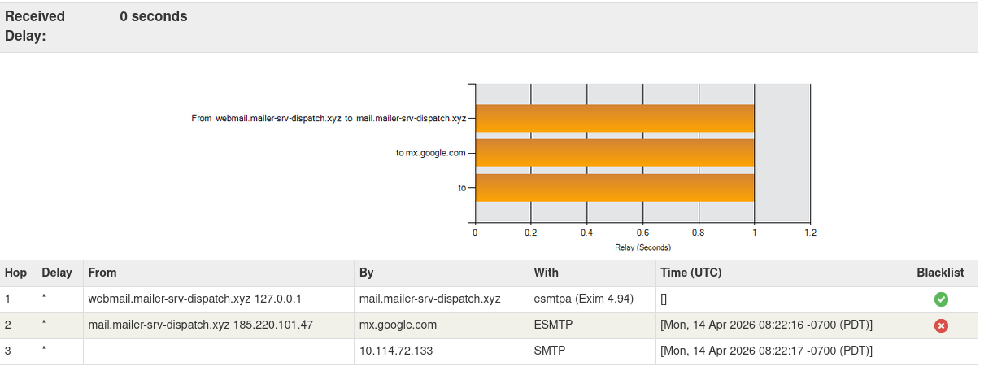
What it shows: Three hops with timestamps 08:22:16 and 08:22:17 PDT, 0-second received delay, and a red blacklist marker on the 185.220.101.47 hop (green on the webmail hop).
Figure B-07. Header text: lower Received hops through Message-ID
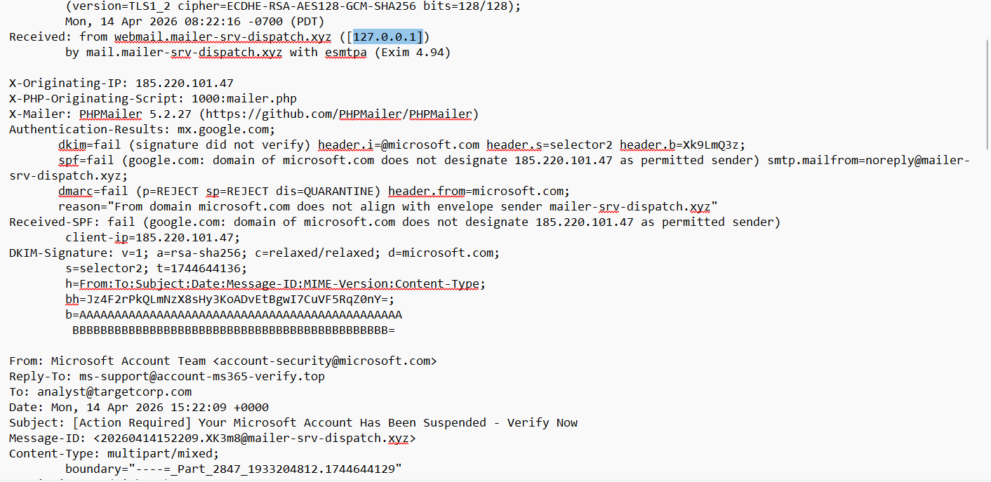
What it shows: Webmail hop via 127.0.0.1 to Exim 4.94, X-Originating-IP, PHP script and PHPMailer headers, Authentication-Results (DKIM, SPF, DMARC fail), DKIM-Signature with placeholder b= value, then From, Reply-To, To, Date, Subject, Message-ID and boundary.
Figure B-08. Header text: message headers
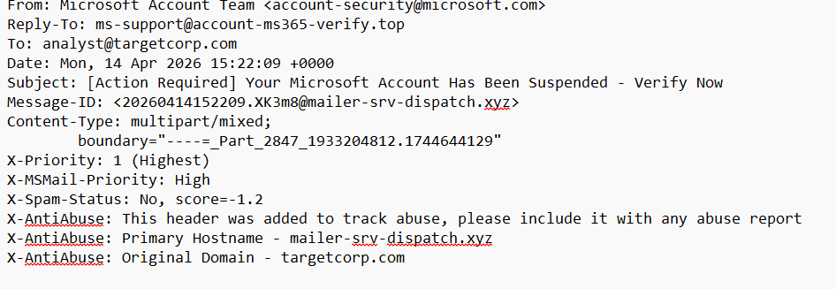
What it shows: From account-security@microsoft.com, Reply-To ms-support@account-ms365-verify.top, Date 15:22:09 +0000, X-Priority 1, X-Spam-Status score -1.2 and X-AntiAbuse lines.
Figure B-09. Plain-text body (quoted-printable)
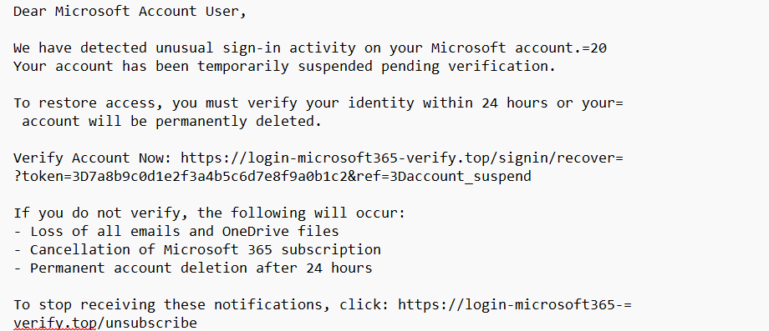
What it shows: Greeting, suspension notice, 24-hour deadline, verification URL with token, consequences and the unsubscribe link, all on the phishing domain.
Figure B-10. Attachment base64 excerpt
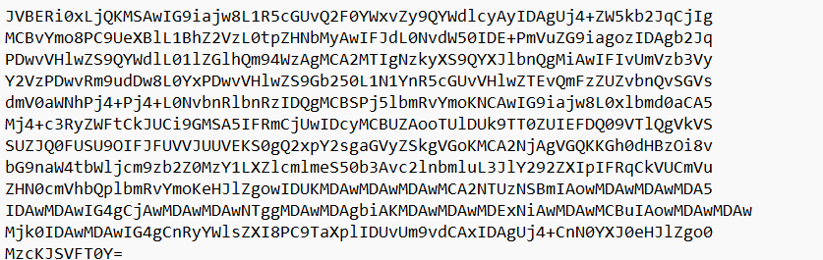
What it shows: Base64 text beginning JVBERi0xLjQK, which decodes to "%PDF-1.4".
Figure B-11. Base64 decode tool with hex output
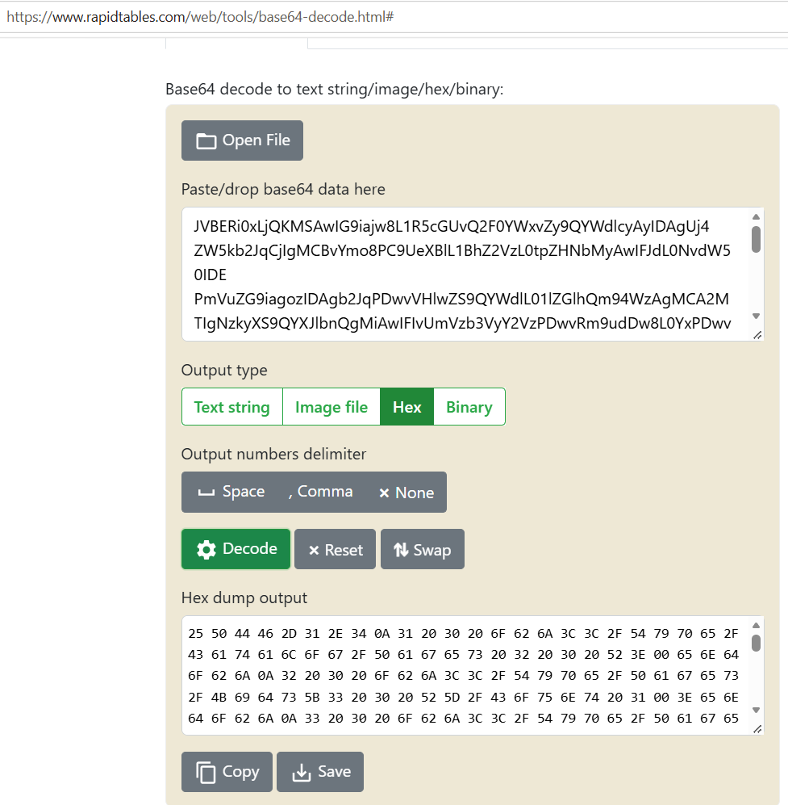
What it shows: Web base64 decoder with the attachment pasted; hex output starts 25 50 44 46 2D 31 2E 34 ("%PDF-1.4") followed by Catalog and Pages objects. Zero bytes appear where ">>" is expected.
Figure B-12. HxD hex editor (empty)
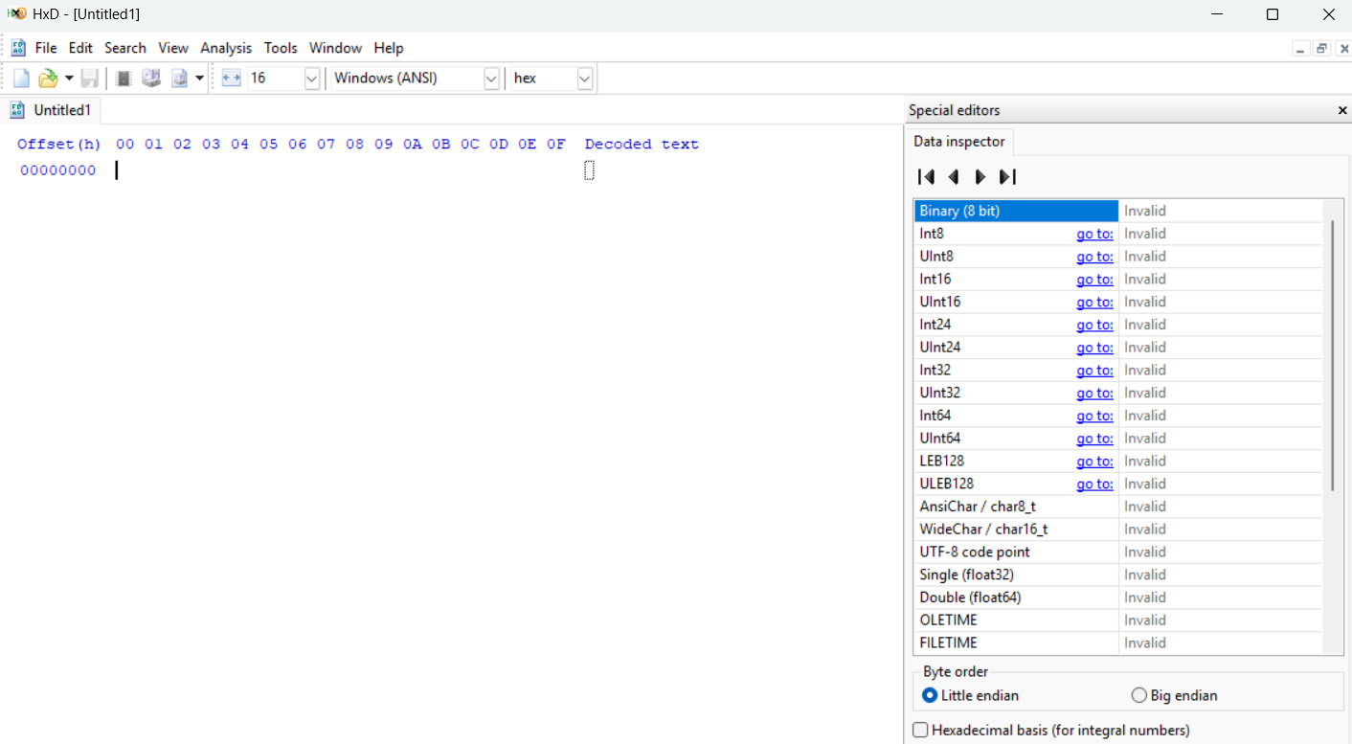
What it shows: A new, empty HxD window before the decoded bytes were pasted.
Figure B-13. HxD hex editor: decoded PDF bytes
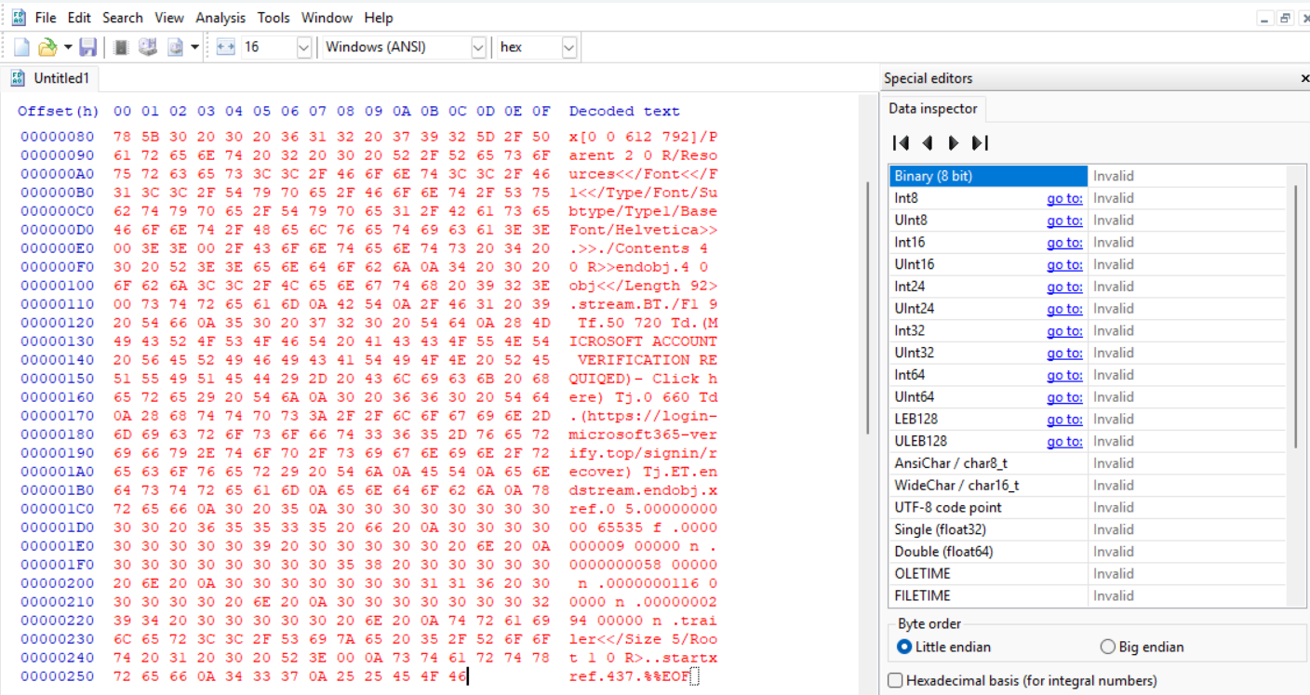
What it shows: From offset 0x80 to 0x25E: page object, Helvetica font, content stream with the lure text and the phishing URL, xref table, trailer and %%EOF.
Figure B-14. Rendered PDF text
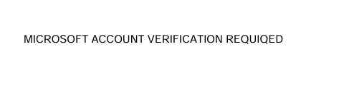
What it shows: The text that displays when the decoded PDF is viewed: "MICROSOFT ACCOUNT VERIFICATION REQUIQED".
Figure B-15. Base64 tool: DKIM fragment test
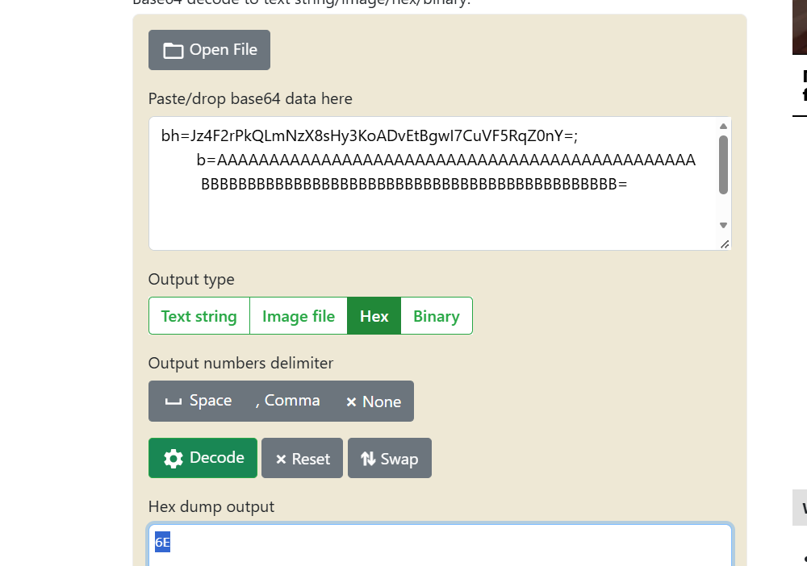
What it shows: The DKIM bh= and b= text pasted into the decoder, giving a one-byte hex output (6E). Unrelated to the attachment.
Figure B-16. HxD: single byte
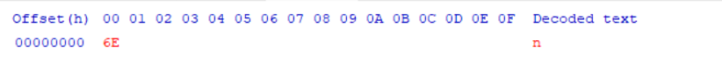
What it shows: The one byte (6E, "n") from the DKIM fragment test.
Figure B-17. Original .eml: top headers
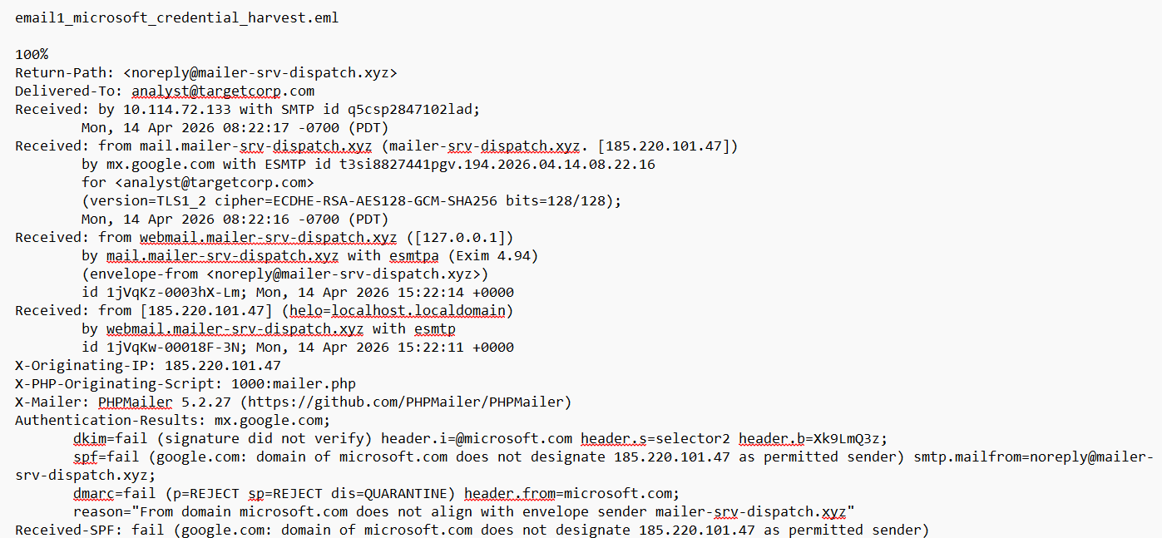
What it shows: File email1_microsoft_credential_harvest.eml: Return-Path, Delivered-To, all four Received hops with timestamps, X-Originating-IP, PHP script, X-Mailer and Authentication-Results.
Figure B-18. Original .eml: DKIM signature through multipart
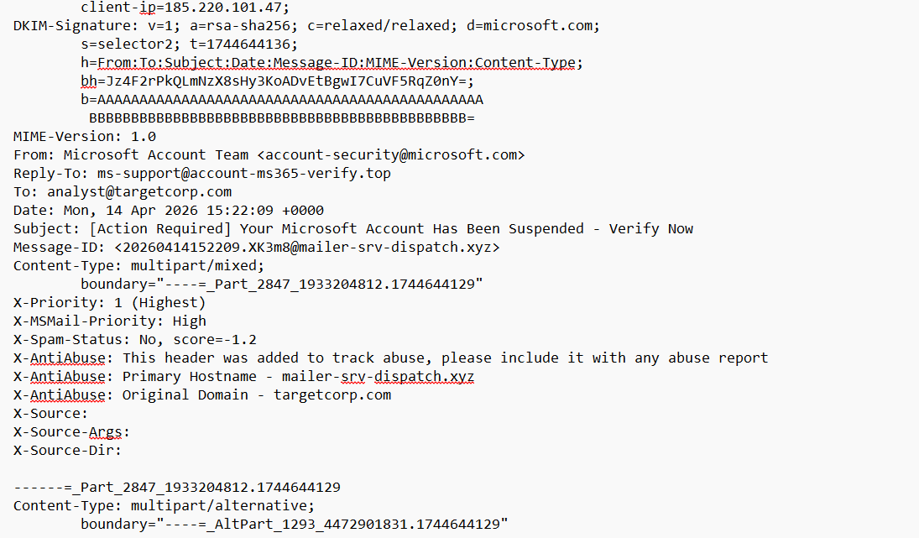
What it shows: DKIM-Signature (d=microsoft.com, t=1744644136, placeholder b=), From, Reply-To, Date, Subject, Message-ID, boundary, priority, X-AntiAbuse and empty X-Source lines.
Figure B-19. Original .eml: plain-text part
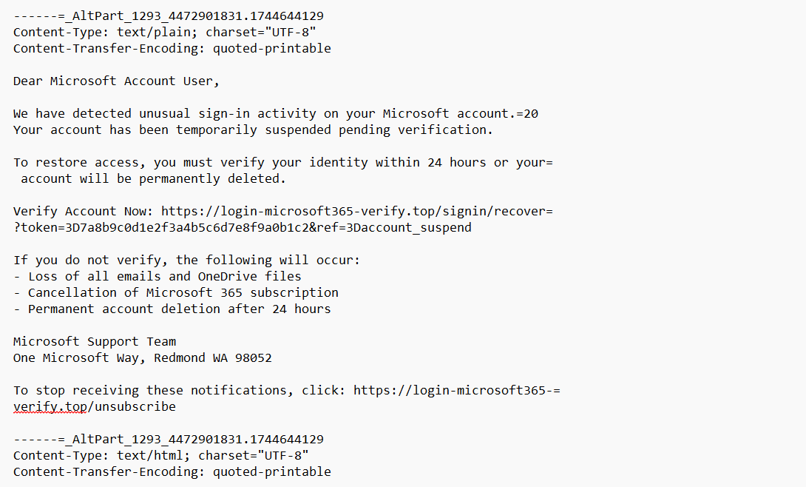
What it shows: Plain-text body with the verification link, consequences, Redmond address and unsubscribe link; start of the HTML part.
Figure B-20. Original .eml: HTML source (styles)
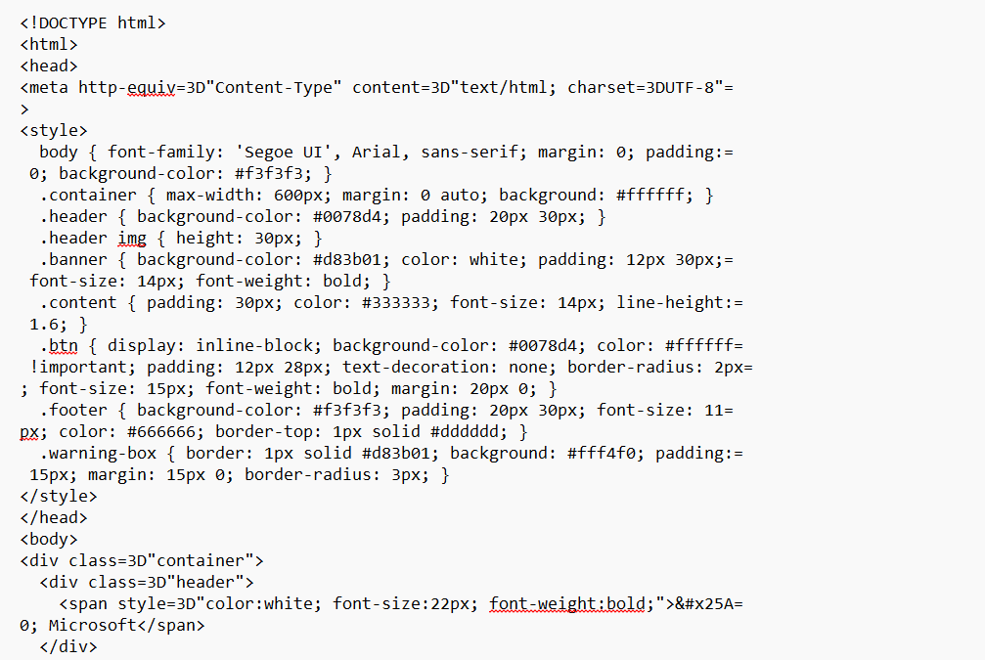
What it shows: Style rules copying Microsoft branding: Segoe UI, #0078d4 header, orange banner, warning box and button.
Figure B-21. Original .eml: HTML body
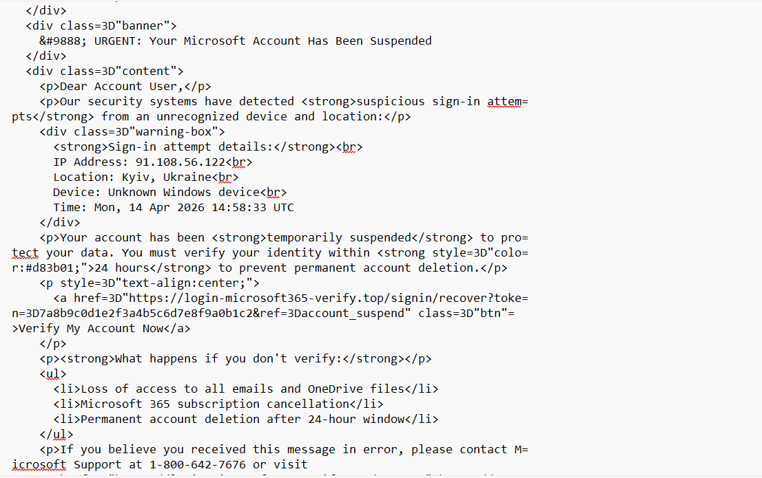
What it shows: "URGENT" banner, sign-in attempt details (91.108.56.122, Kyiv, Ukraine, 14:58:33 UTC), 24-hour threat, the "Verify My Account Now" button and the consequences list.
Figure B-22. Original .eml: HTML ending
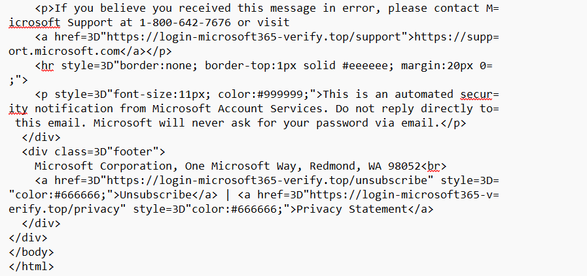
What it shows: Support phone number, link text support.microsoft.com pointing to the phishing domain, automated-notice disclaimer, footer with unsubscribe and privacy links on the phishing domain.
Figure B-23. Original .eml: PDF MIME part
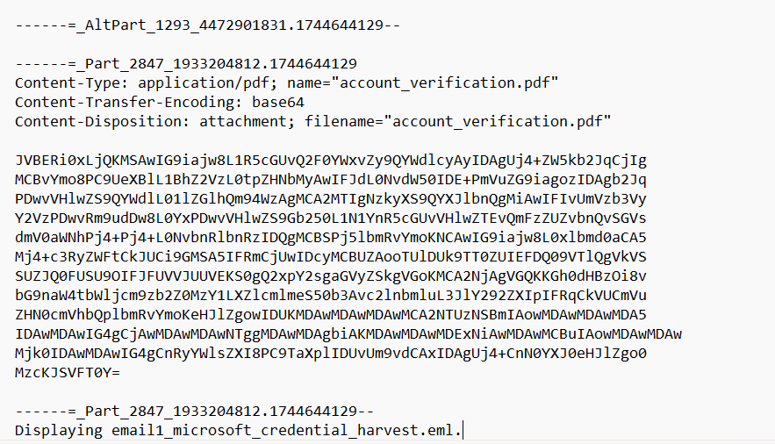
What it shows: The application/pdf part named account_verification.pdf with base64 content and closing boundary, in the mail client view of the .eml.

End of SOC Investigation Report.

